Standards, Quality and Improvement Plan
Sunnyside Primary School

Standards and Quality Report for session: 2018-2019
Improvement Plan for session: 2019-2020
Context Of The School

Sunnyside Primary School is a non-denominational school built in 1894, with an extension built in 1998 and which situated close to the centre of Alloa, Clackmannanshire. The school is one of three Primary Schools serving Alloa Town Centre and is part of the Alloa Academy Learning Community. Our catchment area comprises a broad social-economic mix.

Sunnyside Primary School is a two-story building set in a highly built up area, surrounded by houses and consists of 13 classrooms, Nurture Classroom (the Pod), Nursery, Support for Learning base, Library, Gym Hall, Dining Hall and a range of offices. Each classroom is well-equipped with an interactive whiteboard, netbooks, pcs and i-Pads.

The current primary roll is 321 and we have a nursery roll of 82. There are 14 class teachers, a peripatetic Nursery teacher, a part-time EAL teacher, a full-time PE teacher and a part-time PE teacher to deliver 2 hours of quality PE per week and to support class teachers’ reduced class contact. The school is led and managed by the Head Teacher, 2 Depute Head Teachers and 3 Principal Teachers. The school has 2 senior early years and childcare educators in the nursery, 7 early years and childcare educators and an early years’ assistant. There are part-time specialist teachers for Chanter, Violin and Brass. 12 support staff work across the school to support the pupils and there are 4 administration staff.

During this session there have been several changes to staffing – a Depute Head Teacher was appointed and took up post in January 2019, a class teacher was seconded to a cluster primary school in January 2019 and subsequently one principal teacher took over the teaching in that class; another class teacher resigned November 2018 resulting in our raising attainment teacher taking over the teaching in that class. One of our nursery seniors was absent through long-term illness leaving only one in post for approximately 4 months. This has left a vacancy for a new nursery senior which will be appointment in the new session. Two newly qualified teachers have been employed for their probationary year.

The Head Teacher is currently engaging in the Scottish College of Educational Leadership’s Excellence in Headship programme and one of the Depute Head Teachers and one of the Principal Teachers are engaging with Stirling University’s MSc Professional Education and Leadership programme.

Our Vision
At Sunnyside Primary School, we believe in inclusion and equity for all. We believe that every child should have the opportunity to learn, to try new things, to make mistakes, to be able to learn from them and to be successful.

We should try to keep healthy and it. We have the right to feel safe at school and should be able to ask for help and know that we will receive it.

Bullying of any kind is not allowed and is not in keeping with our values. We should be respectful to each other and understand that everyone’s opinions should be herd.

We are proud of our school and community.

Our Values
- Respect,
- Inclusion
- Effort
- Resilience
- Integrity
- And … Fun!

The Scottish Index of Multiple Deprivation highlights that 43% of our families live in deciles 1 & 2 and 23% are in receipt of Free School Meals. Therefore, it is important to recognise the differences of opportunity and the challenges that result. 10% of our pupils have English as an Additional Language and 35% receive support for learning in some format or other (32% of these pupils are identified as living in deciles 1 and 2 or in receipt of Free School Meals).

Attainment in Primary 1, 4 & 7 - 2018/2019

This session, attainment for all aspects of English and Literacy and for Mathematics and Numeracy in primaries 1 and 7 have continued to increase. In primary 4, however whilst attainment in Listening and Talking has increased marginally, all other areas of English and Literacy and Mathematics and Numeracy has decreased compared to previous cohorts. Specific interventions have been put in place to close these gaps and our tracking of individuals’ progress highlight that these children are achieving at a faster pace, leading us to propose that the interventions are beginning to have an impact upon their individual attainment.

Primary 1
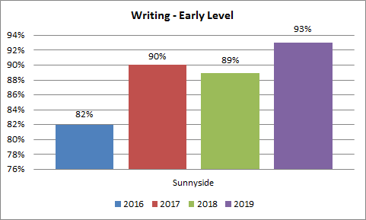
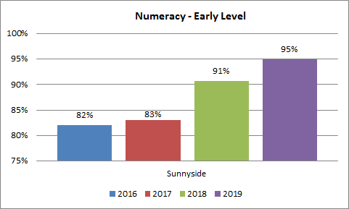
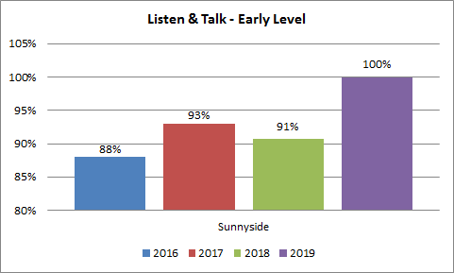
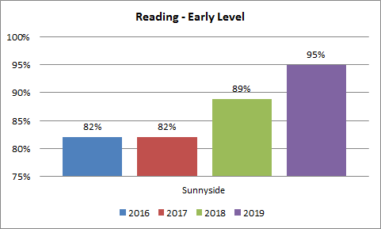

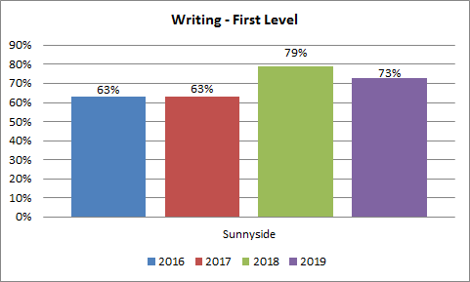
Primary 4
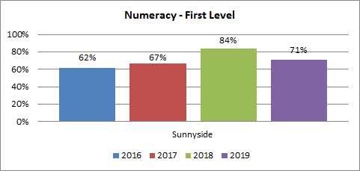
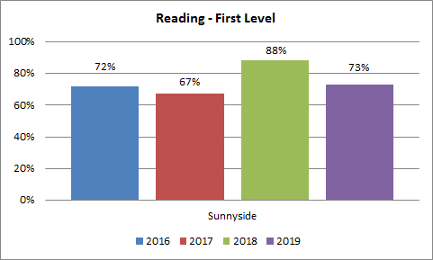
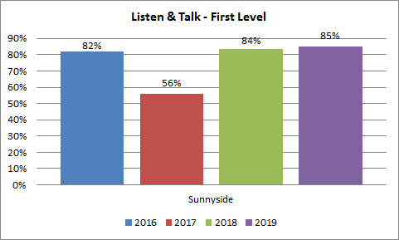
Primary 7
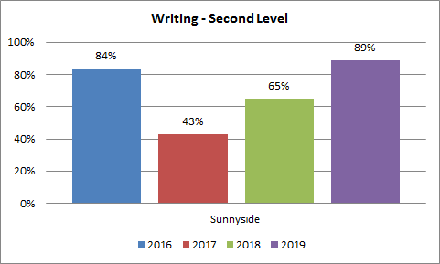
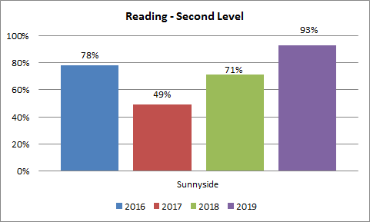
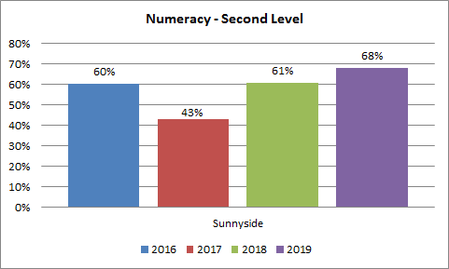
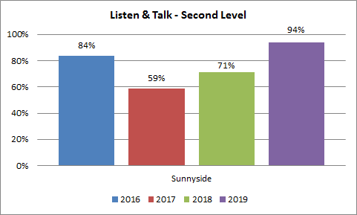
Our attainment statistics highlight that our PEF interventions are making a positive impact upon reducing the poverty-related attainment gap between the children living in deciles 1 & 2 and all other deciles in all areas of English and Literacy and Mathematics and Numeracy in primaries 1, 2, 3 and 5. In primary 6 the gap has reduced in all areas except Reading where there is a 10% increase and in primary 7 the gap has reduced in Listening & Talking however increased in Reading by 4%, 5% in Writing and 15% in Maths. In primary 4 the gap has increased in all areas – Reading 3%, Writing 19%, Listening & Talking 14% and Maths 30%. These statistics relate to different cohorts of children and as already discussed, with the exception of primary 4, attainment in all other stages is increasing.

The Scottish Government allocated £135 000 to Sunnyside Primary School for session 2018/19 in order to allow us to continue with our priorities. Next session (2019/20) we have been allocated £115 560 to further embed this work.

Our PEF priorities will remain the same and we continue to ensure that they are closely aligned to the school improvement agenda. These priorities are:

- As part of our collegiate working with Alloa Learning Community we aim to continue to engage with Speech and Language service to deliver the LIFT project (£6369).
- As a school we aim to ensure consistency in high quality learning and teaching with a particular focus upon monitoring, supporting and challenging teachers in their practice across the whole school, especially regarding pace and challenge in literacy and numeracy for those children in SIMD 1 & 2
  - Support for Learning Teacher (0.2 FTE - £10787)
  - Depute Head Teacher with a particular focus upon Learning, Teaching and Assessment (£68254).
- To enhance parental engagement and to develop family learning programmes, we will continue to employ a Family Support Worker who will work alongside the Depute Head Teacher (PEF) and parents to lead this point (£13488). The impact of this focus will be to continue to improve attendance, late-coming and exclusion statistics and for a greater number of families, who do not normally engage with school, to start to engage and feel more able to support their children’s learning.

Review of Progress for session: 2017 – 2018

Cluster Priority: Raising Attainment in Literacy
NIF Priority  To improve attainment in literacy  To close the attainment gap between the least and most advantaged children/young people  NIF Driver  - Teacher Professionalism  - School Leadership  - Parental Engagement  - Assessment of children’s progress  - School Improvement  - Performance Information | HGIOS4/HGIOELC QIs/Identified Themes  1.3 Leadership of change  2.3 Planning, Teaching and Assessment  3.1 Ensuring well-being, equity and Inclusion  3.2 Raising Attainment and Achievement
Progress and impact:

- Clackmannanshire Reading Project

In order to raise the profile of reading and the skills children need to develop to become confident and competent readers, the Alloa cluster of schools are participating in an authority-wide initiative in consultation with Professor Sue Ellis.

All staff have engaged in CLPL in strategies to enhance children’s learning experiences in reading and reading engagement. Staff have been supported in embedding these strategies by our Improving Outcomes Principal Teacher and this has led to a greater understanding of the principals of equitable literacy and more consistency in implementation. The use of running records has ensured that children are reading at an appropriate text-level to ensure sufficient challenge and book banding has allowed for easier access to identifying text-level appropriate books. Paired reading takes place across the whole school.

The over-reliance on phonics based reading books in the early years undermined the philosophy around the reading project and those reading books not engaging children. A decision was therefore made to return to Oxford Reading Tree as the core reading scheme supplemented by picture books and novels.

A reading attitude survey of children highlighted increased positive mindset in relation to reading and this is also evident during classroom observations and discussions of learning with children. Children now see themselves as readers.

Children’s progress is monitored very closely and where necessary additional 1:1 tutoring sessions are provided to ensure that they make the best possible progress. Children from deciles 1 & 2 are prioritised for additional support, but not to the exclusion of other children who were experiencing difficulty.

Teacher Professional Judgements data highlights that there is a significant increase in the number of children in primary 1 and primary 7 who have achieved expected levels in reading. The data is not so positive for children in primary 4 however upon closer examination, where children have not achieved expected levels in primary 4 their rate of progress has increased over the past year.
 | P1 |  |  |  | P4 |  |  |  | P7
 |  | School | Authority | National |  | School | Authority | National |  | School | Authority | National
Reading |  | 95% | 82% | 81% |  | 73% | 76% | 77% |  | 92% | 73% | 79%

- LIFT Project

This is the second year of a three year project working with Speech and Language colleagues to:

- Improve the spoken language skills for all children regardless of their socio-economic background
- Develop an excellent visual environment within the nursery
- Improve the skills and confidence of nursery educators in using evidence based interventions to improve spoken language skills including children with specific communication needs
- Improve skills, knowledge and confidence of parents and carers in improving the spoken language skills of their children

Further training in all aspects has resulted in increased confidence amongst all early years’ staff and is having positively impacting upon the quality of interactions with children.

Throughout this session we have been working towards Silver level of the visual Environment Award which encourages the children to recognise print and symbols and to allow them to become more independent. This work is ongoing however children are engaging well with visuals and have developed a sense of ownership towards their own learning and the nursery environment.

Parental engagement events have taken place throughout the year and were very well attended. The events have allowed parents and carers to have an understanding of the project and to how best support their child at home. Feedback from parents has highlighted their change in attitude from questioning their child to a more narrative approach thereby extending their child’s language abilities.

Data highlights that this initiative is continuing to have a significant impact on practice and on children’s attainment.

- Positive language building strategies now represent 59% of interaction compared to 38% from August baseline measures. Notably staff have worked hard to increase their use on repeat +1 and describing.
- The charts below highlight 50% of children now have age appropriate information content, compared to only 12% prior to intervention. The number of children in the severe category has also greatly reduced from 75% to 38%.

- Improving Pedagogy and Equity

This is the first year of a two year project working with the Tapestry Partnership and Clackmannanshire Authority to improve pedagogy across the school and ensure equity for all. The project focuses upon 5 Key Strategies:
- Ensuring understanding of expected learning and criteria for success
- Using classroom discussions, questions and tasks that motivate and elicit evidence of learning
- Providing feedback that moves learning forward
- Providing opportunities for learners to support each other’s learning
- Providing opportunities for learners to take responsibility for their own learning

This project is led by class teachers and learning assistants who volunteered to attend a Masterclass led by Dylan William and subsequent Tapestry training sessions and roll this training out to colleagues during collegiate sessions. These collegiate sessions were supplemented by in-house training.

Formal sharing classroom practice visits and informal class ‘drop-ins’ by the leadership team highlights a greater consistency in the use of formative assessment across the school and collegiate dialogue has shown that staff confidence is increasing. The quality of learning intentions and success criteria is improving and in most classes children are co-constructing success criteria with their teachers. Weekly ‘bonus ball’ meetings with focussed groups of children has shown that they are now taking more ownership of learning and are now more able to talk ‘the language of learning’ being more aware of their strengths and next steps.

- Moderation

In order to achieve consistency of understanding regarding what achievement of a level in literacy would look like across the cluster, principal teachers met to agree learning milestones at early, first and second level. These milestones have supported class teachers in their professional judgements and have resulted in increased confidence.

All cluster schools attended a CLPL event led by our Attainment Advisor on ‘The Moderation Cycle’ which allowed for a greater understanding of the 8 aspects of moderation and the importance of ensuring effective moderation of all aspects

In school, staff met to further discuss the moderation cycle and agreed to focus this session on learning intentions to reflect the standards within the E’s and O’s and to ensure success criteria are clear, relevant and measurable and in evaluating learning to ensure that learning, teaching and assessment reflects an appropriate balance between ongoing and periodic assessment. This work linked very well with the work relating to Pedagogy and Equity and has resulted in an improvement in the quality of learning intentions and success criteria and a greater consistency in their use. All staff now have a greater understanding of what effective assessment looks like.

All class teachers are taking part in weekly reflections with children to inform planning. This has led to greater ownership of learning and understanding of their strengths and next steps for children. They are now more able to talk ‘the language of learning’.

Moderation of a level takes place through termly attainment meetings with the leadership team and milestones are being used to track pupil progress in Literacy. In numeracy developments are ongoing.

Moderation of assessment evidence within school throughout the session has allowed for TPJ (teacher professional judgements) to be validated and staff’s knowledge of progress through children’s learning journey has increased.
Next Steps:
- Continue to participate in LIFT project through the implementation of Year 3 (cluster priority)
- Continue to embed Equitable Literacy strategies to ensure consistency across the whole school and develop their use to engage writing (cluster priority)
- Continue to embed the use of Formative Assessment across the school to enhance pedagogy and equity for all (cluster priority)
- Continue to develop knowledge and understanding of all aspects of the Moderation Cycle (cluster priority)

School Priority 1: Developing Young Workforce
NIF Priority  Improvement in employability skills and sustained, positive school leaver destinations for all young people.  NIF Driver  - School Improvement  - School Leadership  - Assessment of Children’s Progress  - Parental Engagement | HGIOS4/HGIOELC QIs/Identified Themes  1.1 leadership of change.  1.2 Leadership of learning.  1.4 Leadership and management of staff  2.2 Curriculum  2.7 Partnerships  3.2 Raising Attainment and Achievement  3.3 Increasing creativity and employability
Progress and impact:

Teaching practice was evaluated against the Career Education Standard and phase curriculum pathways were introduced for Digital Literacy, Computing Science, Enterprise and the World of Work. Class teachers engaged in CLPL activities relating to the effective use of these pathways to plan high quality learning experiences for children. This has ensured that teachers have a clear understanding of ‘Developing the Young Workforce’ priorities and in ensuring creative and stimulating lessons are planned to ensure children develop the appropriate skills.

Learning walls are displayed in classrooms and skills for learning are clearly displayed for learning activities and discussed with children. This has led to children developing a greater understanding of the skills of learning and supporting them to understand their own strengths and next steps.

We have continued to develop and strengthen our links with local businesses, schools, universities and colleges this session ensuring that children’s learning experiences are contextualised in real-life scenarios and around the World of Work. For example, primary 7 were supported by a local solicitors to take part in a national competition – Legal Challenge. Our children were Regional Winners for 3 out of the 4 categories. Primary 3 and our ECO Committee worked with Butterfly Conservation Scotland to develop our school garden and make it more butterfly and insect friendly. This work was also well supported by parents and the wider community.

Teachers’ confidence in the teaching of digital skills and using digital technology to enhance learning and teaching has improved over the past session. They have attended CLPL activities both within the school and at Authority level and there is now a clearer vision and policy with regards to Digital Literacy and Cyber Resilience. Children are more aware of their duties and responsibilities as digital citizens and have a greater understanding of digital skills and devices as production tools and not merely consumption. Our work has been recognised by Digital Schools Scotland through their national awards scheme.

Next Steps:
- Continue to embed phase progression pathways and ensure creative, stimulating and real-life learning experiences are planned at all stages.

School Priority 2: R4L (Readiness for Learning)
NIF Priority  Improvement in children and young people’s health and wellbeing  NIF Driver  - Teacher Professionalism  - Parental Engagement  - School Improvement | HGIOS4/HGIOELC QIs/Identified Themes  1.3 Leadership of change  2.2 Curriculum  2.3 Personalised Support  2.7 Partnerships  3.2 Ensuring Wellbeing, Equality and Inclusion
Progress and impact:

Playground Developments

This session we have continued to embed outdoor learning to enhance learning experiences across the school wherever possible and develop playground in line with NME principles. A playground committee consisting of staff, pupils and parents surveyed classes to determine what was liked and disliked and what further improvements could be made. These suggestions were acted upon and the playground was further developed. This has led to pupils and parents feeling that their views and opinions are listened.

The playground offers a variety and choice of activities to allow children to self-regulate their behaviour. Observations highlight that children are now much more engaged in imaginative and creative play and there are much fewer incidents of negative behaviour. Children who would normally have to attend break and lunch clubs for support during these times are now able to access the playground safely and effectively and children are now able to return to class ready to learn.

N.M.E.

In order to ensure consistency of approach and increase staff confidence with regards to NME (neuro-sequential model of education) all staff participated in CLPL in this approach. To further increase knowledge and understanding they also completed Clacks Academy modules relating to NME and R4L. This has resulted in almost all staff feeling confident in understanding and using NME strategies.

Primary 6 and primary 7 pupils were also taught the principles and strategies regulating in them being able to understand and identify when they are calm, alert, etc. and are able to identify which strategy will help to regulate them in order to be reading to learn. Three pupils were identifies in each primary 6 and primary 7 class to allow us to measure impact. This data highlights those children’s increased ability to self-regulate. For the wider primary 6 and primary 7 cohort, almost all pupils are able to identify when they require something to help them regulate and to choose an appropriate strategy.

In order to support wider implementation N.M.E. and R4L across the authority, we were asked by our educational psychology team to produce a video of good practice which was shared at a CLPL event and members of staff took part in a podcast which explained our approach and the impact that this has had for our children.

An information session with parents explained the philosophy around the strategies and offered suggestions as to how these can support their children at home. An information leaflet followed up this advice. Parents’ feedback from both these initiatives was very positive will all parents agreeing that this was essential for our children.

Support Worker

Poor attendance and late-coming can have a significant impact on children’s learning. Our support worker continued to work with parents to try to improve these statistics this session. Phone calls, letters and home visits were made to highlight the importance of attendance in school and families were challenged and supported to building morning routines that allow children to be in school on time. This has resulted in a 0.66% improvement in attendance across the whole school for all children. Our average attendance for the school is 94.84% There has also been a 25.81% improvement in late-coming for children whose attendance is less than 95%.

Children have been identified through review meetings and teacher feedback to receive targeted individual and group work to help them better manage their emotions, to develop resilience skills and enhance their readiness for learning. Pupil engagement has been mixed and the programmes have been adapted to suit pupil preferences. This has resulted in less disruptions in classes and children engaging more with their learning.

Throughout this session, pupil work has had to be prioritised to ensure that children’s emotional, social and learning needs are met. This therefore has meant that the parental engagement work that had been planned could not go ahead. Parental engagement will be a priority for next session.

Emotion Works

In order to support children in developing emotional language, awareness and understanding a programme was introduced this session across the whole school. Due to competing priorities, this had to be delayed and was only introduced after Easter. Baseline assessments have been developed and will allow us to measure the progress in children’s understanding of emotions. This programme will be developed further and implemented next session.

Building Resilience

A programme to support the development of resilience in children was introduced this session and implemented through our weekly assemblies with follow up work being done in classes. This has resulted in consistency of the message being given throughout the whole school community and the development of pupil understanding of what resilience is and what strategies they can use to become more resilient in all aspects of life, home, school and in the future.
Next Steps:
- Playground Committee to continue to develop playground to ensure enough variety and choice of activities to allow children to self-regulate
- Continue to embed R4L and NME in everyday practice
- Develop parental engagement and family learning programmes (priority 1)
- Further develop implementation programme for Emotion Works and implement across the whole school (priority 2)
- Continue to roll-out the Building Resilience resource through assemblies (priority 2)

Self-Evaluation 2018-19

 | Quality Indicator | School Self – Evaluation  2018-19 | Inspection Evaluation  (If during 2018-19)
 | What is our capacity for continuous improvement? | 3
1.3 | Leadership Of Change | 4
2.3 | Learning, Teaching And Assessment | 3
3.1 | Ensuring Wellbeing, Equity And Inclusion | 4
3.2 | Raising Attainment And Achievement | 4
2.2 | Curriculum – Learning Pathways | 3
2.7 | Partnerships | 3

 | Quality Indicator | Nursery Self – Evaluation  2018-19 | Inspection Evaluation  (If during 2018-19)
 | What is our capacity for continuous improvement? | 3
1.3 | Leadership Of Change | 4
2.3 | Learning, Teaching And Assessment | 3
3.1 | Ensuring Wellbeing, Equity And Inclusion | 4
3.2 | Securing Children’s Progress | 3
2.2 | Curriculum – Learning Pathways | 3
2.7 | Partnerships | 3

2016 – 2020 School Self Evaluation/Plan for QI Engagement
QI |  | 2017 - 18 | 2018 - 19 | 2019 - 20 | 2020 - 21 | Comments
1.1 | Self-Evaluation for Self-Improvement | √ | √ | √ | √ | Continue to develop self-evaluation processes
1.2 | Leadership of Learning | √ | √ | √ | √
1.3 | Leadership of Change | √ | √ | √ | √ | School is on an improvement journey – distributive leadership in infancy
1.4 | Leadership and Management of Staff
1.5 | Management of Resources To Promote Equity | √ |  | √ |  | Continue to target reduction in poverty attainment gap
 | Leadership And Management Overall |  | √ | √ | √
2.1 | Safeguarding and Child Protection |  | √ |  | √
2.2 | Curriculum | √ | √ | √ | √ | Focus on numeracy, health & wellbeing, 1+2 MfL
2.3 | Learning, Teaching and Assessment | √ | √ | √ | √
2.4 | Personalised Support | √ | √
2.5 | Family Learning |  | √ | √ | √ | Priority for family engagement
2.6 | Transitions |  |  | √
2.7 | Partnerships | √ | √ | √
 | Learning Provision Overall | √ | √ | √ | √
3.1 | Ensuring Wellbeing, Equality and Inclusion | √ | √ | √ | √ | Continue to target reduction in poverty attainment gap
3.2 | Raising Attainment and Achievement | √ | √ | √ | √ | CLPL re understanding standardised assessments across the school
3.3 | Increasing Creativity and Employability | √ | √ | √ | √
 | Successes and Achievements Overall |  | √ | √ | √ | More robust tracking of wider achievements through the use of Learning Journals

Improvement Plan for session: 2019-20

Cluster Priority 1: Learning & Teaching

SIP | 
PEF | 

Please remember that PEF priorities should be specifically targeted at closing poverty related gaps.
Cluster/ Establishment | Sunnyside Primary School | Total PEF Allocation | DHT - £68254  SfL Teacher (0.2) - £10787  S&LT - £6369 | Links to SAC | Universal from SAC
 |  | (For PEF Priorities only) Cost of this priority
Headteacher | D Penman | Accountable Person | Emma Cuthbert (1)  Angie Ross (2)  Denise Penman (3)  Denise Penman (4) | Improving Outcomes Manager | Cathy Quinn

Outcome (Transformational)
Please detail proposed intervention in terms of outcomes for learners. (Consider What will change? For whom? By how much? By when?)

As a cluster we will improve attainment in literacy through Teacher professionalism, learning and teaching pedagogy, assessment, within contextually adapted environments to raise attainment and reduce the poverty related attainment gap.

With a focus this session on:

- Equitable Literacy – To continue to engage with the Equitable Literacy Project to raise attainment in all aspects of literacy, whilst establishing a reading and literacy culture across the cluster; to have a common approach to improve the reading abilities of our children. Attainment data across the cluster in relation to reading (NGRT and SNSA), writing and listening and talking, will be measured to track progress and improve TPJ data.

- LIFT Project - To continue to engage with Speech and Language service to deliver the LIFT project Cohort 1: Redwell PS, Sunnyside PS and ABC Nursery are entering Year 3. Cohort 2: Park PS are entering Year 2; In the first year in the Alloa Cluster 46% of pre-school children (Jan 2018) were below their age equivalent on standardised measures for expressive language. Following intervention, 58% of pre-school children are now demonstrating spoken language skills within normal limits. Adult-child interactions have improved following intervention but further improvements are expected. 44% of interactions are still either directive or questioning instead of child led commentating, describing and interpreting. This has reduced from 72% at the beginning of the project. Aim to continue to improve language skills in early years.

- Improving Pedagogy and Equity - Engage with the Tapestry and ‘Education Scotland - Moderation Cycle’ to ensure that Learning Intentions reflect standards in the E’s and O’s and that the Success Criteria are clear, relevant and measurable. Further engagement with the Tapestry to enhance teacher professionalism and pedagogy to ensure consistency of skilled questioning and quality feedback to support excellent learning and teaching across the cluster.

- Moderation -Engage with the Tapestry and ‘Education Scotland - Moderation Cycle’ to ensure that the standards within the E’s and O’s are regularly used and that Benchmarks are used to moderate learners progress.

Rationale for this proposal?
What will you do? What evidence do you have that this will be effective?

- Equitable LIteracy– – To have a common approach to improve the literacy abilities of our children. Attainment data across the cluster in relation to reading (NGRT and SNSA) will be measured to track progress.

- LIFT Project – In the Alloa Cluster 46% of pre-school children (Jan 2018) are below their age equivalent on standardised measures for expressive language. Following intervention, 58% of pre-school children are now demonstrating spoken language skills within normal limits. Adult-child interactions have improved following intervention but further improvements are expected. 44% of interactions are still either directive or questioning instead of child led commentating, describing and interpreting. This has reduced from 72% at the beginning of the project

- And 4. Improving Pedagogy and Equity/Moderation – To engage with Dylan Wiliam - Tapestry to ensure there is consistency in high quality pedagogy. This will take place across the cluster and wider Authority. We will develop a shared understanding of the standards and expectations, through the implementation of the Local Authority’s Assessment and Moderation Strategy.
Who has been consulted?
Heads of Establishment, Parents and Educational Psychologist have been consulted.

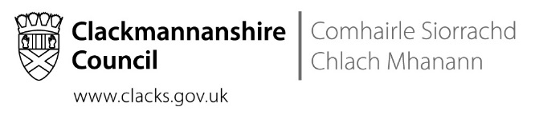

NIF Priority | NIF Driver(s) | HGIOS 4 QIs
To improve attainment in literacy  To close the attainment gap between the least and most advantaged children/young people | 1. Teacher Professionalism  2. School Leadership  3. Parental Engagement  4. Assessment of children’s progress  5. School Improvement  6. Performance Information | 1.3 Leadership of change  2.3 Learning, Teaching and Assessment  3.1 Ensuring well-being, equity and Inclusion  3.2 Raising Attainment and Achievement

Start Date | Time Allocation | Progress Review Dates | Completion Date
Aug 2019 | 10 months | Monthly at Cluster Meetings | June 2020 (for this phase)

Outcomes - What change will happen? To whom? By when? (Short and medium term outcomes can relate to others but long term outcomes should always relate to learners) | Measurement Plan - What evidence will you gather to measure impact? When? | RAG (This can be done on each of the dates noted above)
 |  | Date | RAG
Short (Aug-Oct 2019)  - Equitable Literacy - Staff will have a greater understanding of the purpose and strategies taught through appropriate instructional text.  - LIFT – Staff will deliver SLT interventions for listening, narrative and spoken language skills in all settings (cohort 1 & 2). Staff will receive support from SLT to deliver vocabulary intervention.  - Improving Pedagogy and Equity  SMT and TLC Leaders will have greater awareness of what effective questioning and quality feedback  - Moderation  Agreed learning milestones across the cluster to demonstrate achievement of a level within literacy | - Consistent approaches within each school in using instructional text to increase comprehension and understanding - Learning Walks, pupil voice, Standardised Assessment data. Teacher self-evaluations, observations  - Cohort 1& 2: Staff are now confident in supporting children using appropriate interventions with minimal SLT support (targeted and universal). The visual environment supports communication - Cohort 1 & 2: Video analysis, staff evaluations, tracking input in each setting. Visual environment audit  - TLC Leaders are sharing good practice informally with the staff team - QA L&T observations, professional dialogue, progress and attainment meetings, pupil learning conversations  - There will be consistency of understanding across the cluster of the evidence required to validate achievement of a level within literacy - Learning milestones are used as part of learning and teaching and assessment process | October 2019
Medium (Nov 19 – March 20)  - Equitable Literacy– children will be confident in their understanding of comprehension and reading strategies.  Staff will increase planned opportunities for writing that links to text  - LIFT - Cohort 1& 2: Parents are engaging in partnership working between Nursery and Home with SLT support e.g. family learning events.  Cohort 1 only: staff will take an active role in passing on key messages to parents about supporting their children’s language at home.  - Improving Pedagogy and Equity -  Class teachers will have greater awareness of higher order thinking through quality questioning, and will begin to implement through a planned approach  - Moderation  Teacher confidence is validated through moderation of assessment evidence within schools.  Class teachers confidence in TPJ will be improved | - Through approaches children are able to participate in discussions in relation to text with increasing depth and inference.  Children will be more motivated and have an increased range of vocabulary to support writing - observations, professional dialogue, progress and attainment meetings, pupil learning conversations, pieces of writing  - Cohorts 1&2: Staff will gain confidence in passing on key messages to parents - Cohorts 1&2: Attendance at parent events, parent questionnaires, staff questionnaires around confidence.  - Class teachers are improving the quality of questioning to improve understanding of where children are on their learning - QA L&T observations, professional dialogue through TLCs, progress and attainment meetings, pupil learning conversations  - Increased knowledge of progress through children’s learning journey - TPJ in Dec 19 submitted with confidence to LA | March 2020
Long ( April – June 20)  - Equitable Literacy  Children’s progress will have increased in reading, writing and listening and talking.  - LIFT  Cohort 1 & 2: data will evidence an increase in age equivalent in spoken language.  The adult (staff and parents) will be using more commentating language when supporting the child.  The resources and processes will be in place to ensure the initiative is sustainable for future years.  - Improving Pedagogy and Equity -  Class teachers will have greater understanding of quality feedback to inform next steps in learning.  - Moderation  Teacher confidence is validated through moderation of assessment evidence across the cluster | - Children’s attainment will increase in line with a virtual comparator using the BGE tool, across all aspects of literacy - Standardised Assessment scores, NRGT, TPJ and  L&T observations  - Cohorts 1&2: Children’s listening and spoken language will improve - Cohorts 1&2: S&L assessments and analysis (x2), Early Years Milestones and Progression Pathways. Video analysis and audit of spoken environment.  LIFT GLOW tile.  - Class teachers are using effective feedback related to SC and LI to meet the needs of all children and identify next steps in learning - QA L&T observations, professional dialogue through TLCs, progress and attainment meetings, pupil learning conversations  - Accuracy of reporting TPJ across the cluster - Progress and pace of learning is tracked consistently across the cluster | May 2020
Priority 1: Parental Engagement

SIP | 
PEF | 

Please remember that PEF priorities should be specifically targeted at closing poverty related gaps.
Cluster/ Establishment | Sunnyside Primary School | Total PEF Allocation | DHT - £68254  Family Support Worker - £ 13488 | Links to SAC | Early Intervention Worker
 |  | (For PEF Priorities only) Cost of this priority
Headteacher | D Penman | Accountable Person | P Mathis | Improving Outcomes Manager | Cathy Quinn

Outcome (Transformational)
Please detail proposed intervention in terms of outcomes for learners. (Consider What will change? For whom? By how much? By when?)

Parental engagement activities aim to:
- enable parents to support children in their learning across HWB, Literacy and Maths along with other curricular areas.
- make further effective use of all communication channels available to target those families who require support in these areas
- build sustainable relationships with all parents.
- continue utilising comprehensive consultation and evaluation. This will include finding out what sort of support families would like to see enacted by the school to achieve the aims proposed above.

We will strive to ensure equal access to opportunities at school and remove barriers to participation and learning for all children. We aim to minimise opportunities for income stigma and exclusion by reducing the pressures which school costs place on low family incomes. We aim to support families in accessing financial entitlements and maximise incomes – leading to improved cognitive development and school achievement.

We aim to continue to involve parents in decisions affecting them and the life of the school and promote further parental engagement, this will be shown through increased parental engagement numbers at events.

Rationale for this proposal?
Within our primary school setting, 43% of children are living within deciles 1-2 of the Scottish Index of Multiple Deprivation (SIMD) and 22% of children are in receipt of free school meals. This is significantly higher than the national average, meaning that a large proportion of children at Sunnyside could be impacted by greater levels of poverty.
In Scotland and the rest of the United Kingdom, poverty has a demonstrable impact on attainment (MacLeod, 2012; Ellis et. al, 2015; Gorard & Siddiqui, 2019). There is the potential that some of this impact may be negated through not only improved nutrition, but that attainment can increase through improved parental engagement (Goodall, 2017).
What will you do? What evidence do you have that this will be effective?

Providing families with guidance and skills to develop and support learning at home has been shown to foster cognitive gains, extend the classroom experience and enhance real life application of skills to a variety of problem-solving contexts (Roy and Giraldo-García, 2018), benefitting children as they progress from education and into lifelong learning and work.

Who has been consulted?

Parents have previously been consulted in the 2019-20 session, and will continue to be consulted about parental engagement activities and the cost of the school day. Feedback will be gathered from events and activities to aid in the review and development of parent groups and workshops.

Pupil council/representatives will be asked what they feel would benefit their learning at home and the sort of activities we could be promoting with parents.
NIF Priority | NIF Driver(s) | HGIOS 4 QIs
Closing the gap between the most and least disadvantaged pupils. | Parental Engagement | 1.3 Leadership of Change  1.5 Management of resources to promote equity.  2.5 Family Learning  2.7 Partnership

Start Date | Time Allocation | Progress Review Dates | Completion Date
August 2019 | 9 months | December 2019, March 2020, May 2020 | June 2020

Outcomes - What change will happen? To whom? By when? (Short and medium term outcomes can relate to others but long term outcomes should always relate to learners) | Measurement Plan - What evidence will you gather to measure impact? When? | RAG (This can be done on each of the dates noted above)
 |  | Date | RAG
Short  Family learning will be bespoke to the needs of our community.  Parents will able to access relevant information and resources to support family learning.  The impact of the cost of the school day on learners and families will be evidenced.  Parental representation in the life of the school will increase. | Consultation results, calendar of events and attendance records.  Website, Twitter, Parental Engagement events/clubs.  Consultation results and subsequent analysis.  Survey results, consultation figures, working groups or party numbers, attendance records | December 2019
Medium  Learners and families will experience greater equity through development of an action plan around the cost of the school day.  Parents will volunteer within the school, tying into Literacy, Numeracy and STEM.  Parents will be able to utilise information technology to aid the reporting and communication process as well as sharing wider achievements.  Pupils and parents will travel to and from school using safe and healthy routes, avoiding cars where possible.  Attendance will increase and lateness will continue to decrease. | Parent Council minutes, any focus group minutes. Subsequent policies and protocols.  Expressions of interest and discussions, register of parental volunteers for staff.  Learning e-Portfolios, Twitter and Website Stats.  School Travel Plan, Meeting minutes from collaborative working group (parents, JRSO, WoW).  Family Support Worker | March 2020
Long  Increased parental volunteering and involvement in the life of the school.  Promotion of community ethos, developing further trust and transparency including in the development school literature and policy.  Improve communication with parents and families.  Sustainable family learning activities will form part of the ongoing school session with a variety of partners from across the community. | Parental involvement registers, volunteer numbers.  Parent council meeting minutes/focus group discussions/emails and minutes.  Parental consultation on parental involvement & engagement and school improvement priorities. Minutes of discussions/meetings including  School events calendar. | May 2020
Priority 2: Curriculum
SIP | √
PEF

Please remember that PEF priorities should be specifically targeted at closing poverty related gaps.
Cluster/ Establishment | Sunnyside Primary School | Total PEF Allocation | N/A | Links to SAC
 |  | (For PEF Priorities only) Cost of this priority
Headteacher | Denise Penman | Accountable Person | Sinead Jones  Alanna Belford  Rebecca Smith | Improving Outcomes Manager | Cathy Quinn

Outcome (Transformational)
Please detail proposed intervention in terms of outcomes for learners. (Consider What will change? For whom? By how much? By when?)

The curricular areas that we will focus on are Numeracy, 1+2 Modern Foreign Languages and Health and Wellbeing.

Within the curriculum we aim to:

- provide clear guidance on the progression of teaching and learning
- use a variety of teaching strategies
- ensure consistency in teaching approaches across the school
- provide high quality learning experience for all learners
- raise attainment particularly in literacy, numeracy and health and wellbeing
- ensure support and challenge for all learners
- ensure our curriculum is broad, balanced, creative and based upon real-life scenarios to ensure children are confident and motivated in their learning.

We will consult with all stakeholders to gain feedback throughout the process. This will include children, staff, parents and external agencies.

Rationale for this proposal?
Please detail the information/data which has prompted this work. For PEF priorities please detail the poverty related gap which you are addressing and the evidence of this gap.

Numeracy – Through consultation with staff it has become apparent that there is a need for clear guidance on teaching of Numeracy. There is a need for consistency in terms of how Numeracy is planned for, taught and assessed. Within Clackmannanshire there are many initiatives which we must consider. Within our school in session 2018-2019 95% of P1s achieved Early Level, 71% of P4s achieved First and 68% of P7s achieved Second.

1+2 Modern Foreign Languages – In order to fully embed 1+2 Modern Foreign Languages within the Scottish Governments timetable of August 2021 there is a need to audit and evaluate current practice and ensure effective programmes of work are in place for French from Primary 1 to Primary 7 and German from Primary 5 to Primary 7.

Health and Wellbeing – There is a need to review our Health and Wellbeing curriculum around Food and Health, Substance Misuse and Relationships, Sexual Health and Parenthood. Current practice will be audited and effective programmes of work developed in order to ensure that children’s learning experiences allow them develop the skills and knowledge around these areas.

What will you do? What evidence do you have that this will be effective?

The Education Endowment Foundations details the impact that different factors can have on attainment. One which has the biggest impact is metacognition and self-regulation. Therefore our aim is to equip our children with a variety of strategies which they can use to support their learning. By teaching a range of approaches and strategies children can then choose which best suits in different situations. Throughout this process children will be encouraged to engage in discussions around their learning to ensure confidence in their understanding and learning.

It is important that we offer a curriculum that is engaging and motivating to children and ensures a balance and breadth across all experiences and outcomes of a Curriculum for Excellence to ensure that children develop appropriate skills for learning, life and work.

Information will be shared with staff through in school collegiate events, authority led collegiate events and in class support.

Who has been consulted?

We have consulted with children, staff, parents and external agencies.

NIF Priority | NIF Driver(s) | HGIOS 4 QIs
Improvement in attainment, particularly in literacy and numeracy.  Closing the attainment gap between the most and least disadvantaged children.  Improvement in children’s and young people’s health and wellbeing  Improvement in employability skills and sustained, positive school leaver destinations for all young people | - School leadership  - Teacher professionalism  - Parental engagement  - Assessment of children’s progress  - School improvement  - Performance information | 1.2 Leadership of learning  1.3 Leadership of change  2.2 Curriculum  2.3 Learning, teaching and assessment  3.1 Ensuring well-being, equity and inclusion.  3.2 Raising attainment and achievement

Start Date | Time Allocation | Progress Review Dates | Completion Date
August 2019 | 10 months | December 2019, March 2020, May 2020 | June 2020

Outcomes - What change will happen? To whom? By when? (Short and medium term outcomes can relate to others but long term outcomes should always relate to learners) | Measurement Plan - What evidence will you gather to measure impact? When? | RAG (This can be done on each of the dates noted above)
 |  | Date | RAG
Short  - Numeracy - Develop an understanding of where children are in their learning; Discover how all stakeholders feel regarding the teaching of Numeracy; Class teachers will plan to cover a variety of curriculum organisers using trackers.  - 1+2 Modern Foreign Languages - Clear understanding of children’s learning experiences and teacher confidence in teaching French (P1 – P7) and German (P5 – P7)  - Health & Wellbeing – Clear understanding of children’s learning experiences and teacher confidence in teaching Food & Health, Substance Misuse and Relationships, Sexual Health and Parenthood education | - Results of baseline assessments.  P1 – Red, Amber, Green.  P2-P2 – Maths age.  Parents and pupil feedback.  Use of trackers evident in forward plan meetings, through classroom observations, tracking meetings.  - 1 + 2 MfL audit/ evaluation results  - Health & Wellbeing audit/evaluation results | December 2019  September 2019  September 2019
Medium  - Numeracy - Consistency in the teaching of Numeracy across stages. Pupils will be equipped with a variety of strategies to use within addition, subtraction, multiplication and division.  - 1+2 Modern Foreign Languages – develop a programme of study to support the implementation of L2 French language from Nursery to P7; L3 German language P5 to P7  - Health & Wellbeing – develop a programme of study to support the implementation of Food & Health, Substance Misuse, Sexual Health & Parenthood education | - Records from planning and tracking meetings as well as classroom observations. Results from Maths Challenge. Learning conversations with children.  - Clear, progressive and robust programme of work for teachers to follow to ensure quality learning experiences for children  - Clear, progressive and robust programme of work for teachers to follow to ensure quality learning experiences for children | March 2020  November 2019  November 2019
Long  - Numeracy - Children will have improvements in their standardised scores as well as maths age. Gaps in learning will be identified and information used to forward plan.  - 1+2 Modern Foreign Languages – increased teacher confidence in delivering 1 + 2 Modern Foreign languages curriculum  - Health & Wellbeing – increased teacher confidence in delivering Food & Health, Substance Misuse, Sexual Health & Parenthood education | - MALT standardised assessment results. Results evaluated and analysed to discover gaps in learning.  - Teacher questionnaire; classroom observations  - Teacher questionnaire; classroom observations | May 2020  May 2020  May 2020

