SUNNYSIDE PRIMARY SCHOOL NEWSLETTER

August 2019

Dear Parents/ Carers,

Welcome back! I hope you had a lovely summer holiday. It is wonderful to see the children return to school excited for the new session.

Our primary 1 children have settled into school routines well and are beginning to find their way around the school building.

It is lovely to see the children in their school uniform. Uniform is extremely important to help develop a sense of belonging and pride in the school.

The primary 7 children are particularly enjoying their new ‘senior’ colours and the black looks very smart.

This summer we held our first Summer Club for families, the club was a great success with children from Nursery to P7 attending with parents.

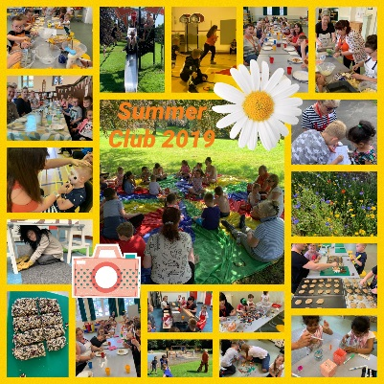
At the club all were involved in preparing fresh, healthy meals together as well as taking part in a variety of play based family learning activities such as games, workshops and scavenger hunts.

The Summer and Supper club also helps families to make links with our partners in the local community and build new friendships.

We look forward to continuing our Supper Club, with further information to follow.

Communication

At Sunnyside Primary School we are constantly looking for ways to share what is happening and what the children are experiencing and learning in school. Our main methods for this are:

School Website:
Our school website can be found at https://blogs.glowscotland.org.uk/cl/sunnysideprimary/
This provides a wealth of important information for you. The website will be updated regularly with important events and also with class learning blogs where you can see what children have been learning on a weekly basis. Alongside this, the class teacher will post information about planned learning for each term as well as information about timetable and events.

Twitter:
Our Twitter page is used routinely to share work and important information regarding last minute news and events etc. Please follow us on @sunnyside_ps

Please remember that for anyone who does not have access to electronic devices paper copies of all newsletters can be obtained from the school office.

Learning Journals
One of the main methods of reporting children’s progress to parents is through the Learning Journals. Children’s records have been transferred to their new classes and teacher comments will be posted in due course. This is an excellent opportunity for you to learn about your child’s learning as it happens and therefore the information is always up-to-date when it is posted. The Learning Journals are also an opportunity for you to engage with process and comment on the post.

Further information will be available at our Parent Information Evening or through our parent guides on the website http://sunnyside.clacks.sch.uk.

Should you require support in accessing the Learning Journals, please do not hesitate to contact us.

School Events

We aim to give as much notice as possible for any events that may be coming up this session. In order to keep you informed and allow you to plan, a calendar of events has been attached to this newsletter for your information. Please note that these may be subject to change however we will endeavour to give as much notice as possible should changes be necessary.

Attendance/ Punctuality

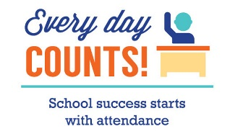
In order for children to achieve, they must attend school regularly. If your child’s attendance is at 90% this is equivalent to having one month’s absence; should this continue from P1 – S5 then in effect they will lose a whole year’s schooling.

At Sunnyside Primary School we monitor the attendance of all pupils and aim to promote good attendance for all. We hope to work closely with parents and carers to ensure that this happens.

Similarly, good timekeeping is essential. Please ensure your child comes to school for 9.00am. The school doors will open at 8.50am to allow them to enter the building calmly and prepare for the day ahead.

Children who enter through the front door after 9.00am will be recorded as late.

Should your child be absent, or you know that they will be late due to medical appointments etc. please inform the school by phoning and leaving a message on the school’s answer machine before 9.15am

Standards & Quality Report 2018-19

Our Standards and Quality Report for last session has now been published and can be found on the school website; a summary of which has been ‘tweeted’ this week.

School Information

School Security
In order to ensure the security of Sunnyside Primary School and the safety of all children and staff within, please ensure that you only enter the building through the front door where you will be asked to sign in and you will receive a visitor’s badge.

P1 – P3 End of Day Procedures
In order to ensure children are safe at the end of the day, our policy is for children in primaries 1 – 3 to be released to a known adult. Class teachers will not allow a child to go from school unless this adult is present.

Please note that any changes to the adult picking your child up should be communicated either in writing or to the school office.

As always, class teachers are available at the end of the day to answer any questions or queries you may have, however please allow all children from the class to be released before approaching the member of staff as it is important that their attention is focussed on the children until they are safely collected.

Car Park
The school car park is for staff and visitors only and is not a pedestrian entrance into the school.

It is dangerous for parents and carers to use the car park for dropping of and collecting children to and from school and nursery and also to use it as a ‘short cut’ into the playground.

Many thanks for your co-operation in this matter. We all wish to see that our children remain safe and healthy.

Dogs in the Playground
Can I please remind you that dogs should not be brought into the school playground. Thank you.

Clackmannanshire Policy on Smoking
Clackmannanshire has a policy of no smoking in all establishments and grounds. This also includes the use of vaping devices.

ParentPay
To reduce the need for pupils to carry money to school, lunches and breakfast club can be paid through ParentPay. Everyone should have received a letter giving further information and also including your username and password. Further information is available on www.parentpay.com

Should you have any difficulties accessing this, please contact the school office.

Annual Data Check, Medical and Excursion Forms
The Annual Data Check Forms, Medical forms and Excursion forms have been sent out via school bags. It is important that these forms are checked and completed and returned to us as soon as possible but by Friday 6th September at the latest so that we can ensure that our school records are correct.

Flu Immunisation
Letters have been sent out regarding upcoming flu vaccinations for all primary aged children. Included with these letters are consent forms. Please ensure that the consent forms are returned by Friday 6th September This session the vaccinations will take place on Monday 4th November.

As always, should you have any comments, queries or suggestions, please do not hesitate to contact me.

Yours sincerely,

Denise Penman
Head Teacher

