Nursery Newsletter
June 2019

Dear Parents/Carers,

Last Term:
It has been a busy term so far and there have been lots of exciting things going on in the Nursery, however there are still lots of things in the diary that are coming up.

Staffing Update

As you have been aware Mrs Gentleman has not been at Sunnyside for a while. She has taken up a new post within the Authority. We wish her all the best in her new venture.

LIFT - Language is fun together

LIFT continues to be an integral part of literacy development in the Nursery. We have had another very successful LIFT Event on Wednesday 22nd May. Many parents and carers came along and spent time participating in our activities and learning sessions.

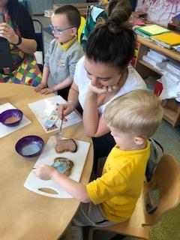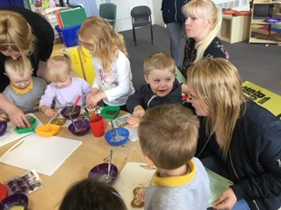

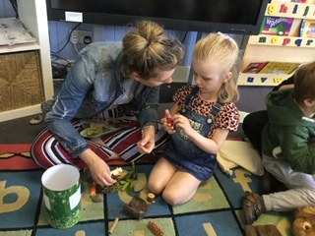

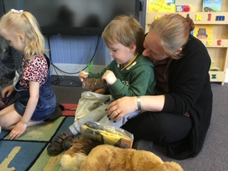

Graduation
Our Graduation Ceremony is due to take place on Wednesday 26th June at 10am.
We will only be hosting one graduation so all preschool children moving on to Primary 1 should attend.

We have had a few parents send in baby photos, but if we could ask you to do this as soon as possible, we would be very grateful. Please put the photograph in a sealed envelope with your child’s name on the front. All photographs will be returned.

Transition Events

Transition lunches have now taken place and these were well attended. The children have had the opportunity to visit the dinner hall, try a school meal and participate in the lunchtime routines.

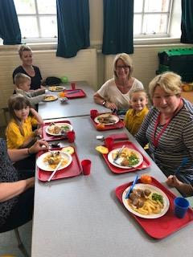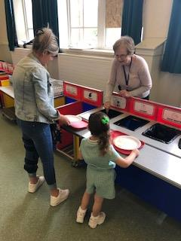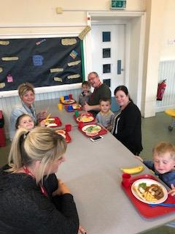

A Parental Information Evening
Due to our ongoing issues with Norovirus unfortunately we have had to cancel our P1 Information Evening.
We have put together an information brochure, P1 induction pack and covering letter which should give you all the information you require. We will also upload our P1 transition Power Point to the website.
The induction pack contains different information leaflets about our curriculum, a letter about arrangements for the first day of school and a clothing grant form should you require one.

Meet the teacher Sessions:
Again this year we are having two different opportunities for children to come along and spend time in their new Primary 1 class with their Primary 1 teacher. Children are welcome to attend both of these. If your child is attending Nursery during one of the sessions, staff will bring the children along. Parents are still welcome to attend during these session and can wait in the hall.

Wednesday 19th June 10am-11am
Thursday 27th June 1.30-2.30pm

During the session on Wednesday 19th June parents/carers will have a short tour of the school whilst their child is in their new class.

Teddy Bear’s picnic
Our Teddy Bear’s Picnic is always an exciting time for the children as they get to meet their BIG Buddy. Again, there have been two sessions planned to accommodate morning and afternoon nursery children. Children who do not attend Nursery on the day of the Picnic should choose to attend one of the sessions. Most people have selected a date on the return slip with the Transition Newsletter. The Picnic will take place on:

Monday 17th June 10.15-11am and 1.45-2.30pm

Your Big Buddy is looking forward to meeting their wee buddy.

Have a brilliant Summer holiday and we look forward to welcoming you all back on Wednesday 22nd August 2019

Denise Penman
Headteacher

