Learning Journals Policy
November 2018

Rationale
In line with the National Improvement Framework (ScotGov, 2016) and the Clackmannanshire NIF Action Plan (2018) we are introducing Learning Journals as part of our parental reporting strategy.
Parents who take on a supportive role in their children's learning make a difference in improving achievement and behaviour. The active involvement of parents can help promote a learning community in which children and young people can engage positively with educators and their peers.
– Clacks Council, 2018
By communicating with parents, and involving them in the reporting and discussion of learning; including wider success throughout the year, we aim to promote dialogue around learning and remove potential barriers around parental engagement.
We aim to create a more holistic view of assessment and reporting, as an ongoing process, rather than a summative report.

Why learning journals?
- Online Progress Record and Reporting System.
- Interactive to share learning and wider achievement.
- Secure
- App and Website based.
- Transitional from Nursery.
- Exportable (Printable/Shareable)
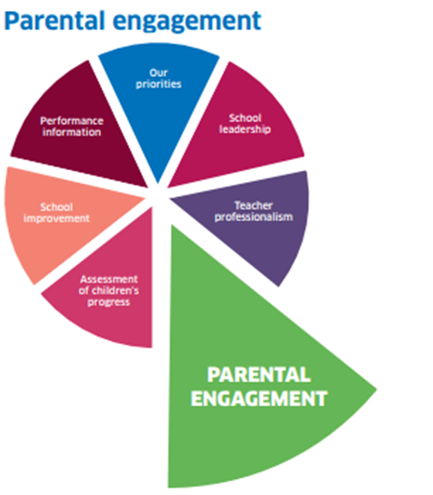

Guidance on the use of learning journals:

Expectations:
One entry per term for each of the curricular areas:
- Literacy
- Numeracy
- Health and Wellbeing
Plus, one entry for each additional curricular area, over the course of the session:
- Expressive Arts
- Social Studies
- Technology
- Religious and Moral Education
- Science
IDL entries are allowed, with up to 3 curricular areas selected.
Grouped entries are acceptable, so long as learning intentions are relevant to every child within the group. Next steps may require further differentiation through editing the entry.

Observations:
- Observation should be built from learning intention (intentions covered if IDL). This should not focus on the activity.
- Photos can be added of individuals or their work, do not upload group photos with identifiable children.
- Link CfE statements (pathways where appropriate) and traffic light against these.
- Next steps should be formative and linked to success criteria.

Parental contributions:
Parents/carers may comment on posts and upload their own entries to share wider achievement, however this should not be used as a platform for open dialogue.
All parent communication should be carried out over the phone or face to face.
- If a parent comments negatively let a member of the Senior Leadership Team know ASAP.
- If a parent asks a question via comments please discuss this using the established channels above.
If a parent forgets their log in please refer them to the office, where the designated ICT leader (Phill Mathis) can be notified.

