Parental Engagement Feedback.
On Friday 21st of Parental Engagement and Reporting Survey closed, what follows is a summary of the results. We would like to take this moment to thank all who responded to this survey, it is your feedback that will enable us to reflect on what we have done and continue to make progress.
The survey was completed by 54 respondents, approximately 21.5% of our families, taking on average 23 minutes to complete.
What you said…
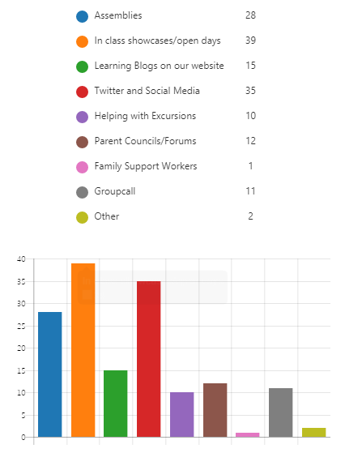
When asked about methods of parental engagement you stated that you find the following types most helpful:
- Assemblies
- In class showcases/open days.
- Class Learning Blogs on our website.

Overall Communication
You rated communicating with the school as 3.81 out of a possible 5. Comments included:
“The teachers are approachable at the end of the day. The smt are at all entrances to the school and the office are very helpful”
“… the school have an open door policy. However, when you are working it’s hard to get in. It would be great to have an opportunity to ask questions to the class teacher via Twitter/Facebook DM.”
“… I certainly dont feel like there is any resistance or barriers in play any time I've needed to be heard. Parent council facebook page are fantastic at engagement!”

Paper Reports
When asked about the usefulness of school paper reports, you rated the current format at 3.85 out of 5. Reasons for this rating included:
“Paper reports and newsletters are much easier to read…”
“Good source of information”
“The school reports seem to have been scaled down in recent years and do not contain lots of information. In some cases it seems to be general info …”

Parent Information Evenings
You rated Parent Information Evenings as the most useful ongoing method of communication with the school, giving them an average rating of 4.44 out of 5. Reasons for this rating included:
“They are the only chance that parents have to ask questions to class teachers”
“Helps to find out how my child is progressing”
“I usually find these meetings useful. I would be keen to see 2 sessions being maintained for this academic year”

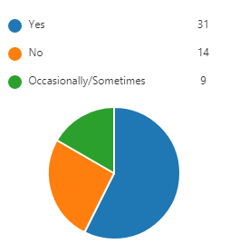
Internet Based Communication
When asked if you engaged with online school communication 83% of parents stated that they engaged with social media either frequently or occasionally. 76% of respondents also stated that they felt comfortable navigating our website.

When asked about what we could do to improve this comments included:
“ The nursery learnings logs was a great idea. We accessed it all the time and it was nice to get a full view of our daughter’s week and how she was getting on and developing.”
“Get a new, more relatable and recognisable address.”
“I have never accessed the website. Twitter is lovely, it gives a fun snapshot of learning, however it always seems to be the same teachers posting.”
“Not using twitter, parent council on Facebook is helpful”

Flexibility and suitability of Engagement Opportunities.
When asked if the school provides enough flexibility to allow parents and carers to engage in learning 79.5% of respondents said yes. When asked how to further improve this, you said:
“Evening sessions would be preferable for working parents.”
“Advise parents of lines of communication/opportunities for engagement. Appropriate notice of events etc.”
“Class dojo so us parents are kept informed daily is a must”
“…there are huge improvements in communication, however this needs to filter through to all teaching staff”

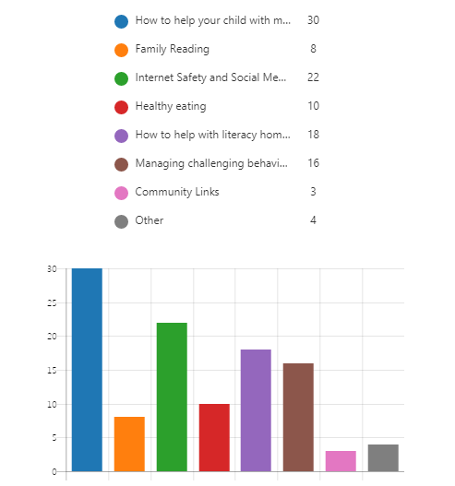
When asked about what sort of workshops the school should run to aid parental engagement with learning you provided the responses illustrated below:
This clearly shows a desire for the school to assist parents in understanding maths, internet safety and literacy.
When asked about when these sessions should be held 74% of respondents stated that early evening is the best time for them, with 24% citing directly after school. When asked about venues 100% of respondents would like these sessions to take place at Sunnyside.

Further comments
We asked for any further comments, and this is a random selection what you said:
“I do see a huge difference with attempting to engage parents and I do see the work behind the new website it is making a difference and thanks for that”
“Only thing I would like to see from Sunnyside is the online journal carried on from Nursery. I’ve seen other schools systems such as class dojo where the teacher can update the parents daily! I think this would be very beneficial.”
“Keep up the good work communicating is becoming easier and it's great to see the SMT every morning”

What we will do.
Parental Engagement Channels.
- Continue to offer further open days and showcases to allow pupils to share learning within the school environment (please see annual calendar of events).
- Schedule and deliver assemblies for each class, each session (please see the yearly calendar of events).
- Continue to use learning blogs and social media channels to share learning.
- Continue to work in collaboration with our Parent Council to aid in the dispersal of information (please note that their Facebook is run by the Parent Council, not by the school).
- Continue to offer 2 parental engagement evenings this school year.
- Implement the use of notice boards to share communications.
- Continue to improve our website with more information and posts for regular updates.
- We will carefully consider the use of Learning Journals in the Primary School, however these require a considerable budget allocation. In the meantime, we will continue to promote Class Learning Blogs and e-portfolios (within P5-7) as a way for children to share learning with family members.

Parental Engagement focuses
- We will review our parental engagement events and work towards implementing support for family learning around maths, literacy and internet safety.

Additional Notes
After seeking advice from our ICT management, we have decided not to utilise Class Dojo – data is stored outside the EU and therefore we cannot be 100% certain that it complies with Data Protection guidelines.
After careful consideration we have decided not to implement direct use of social media for teacher and parent communication. Parents are able to email the school, via the website. This can then be directed to the class teacher, who will respond in turn. We will continue to utilise regular channels of communication, such as telephone and face to face appointments.
We will also feedback your comments to teachers.
Thank you for your assistance and feedback, it has been extremely useful.

