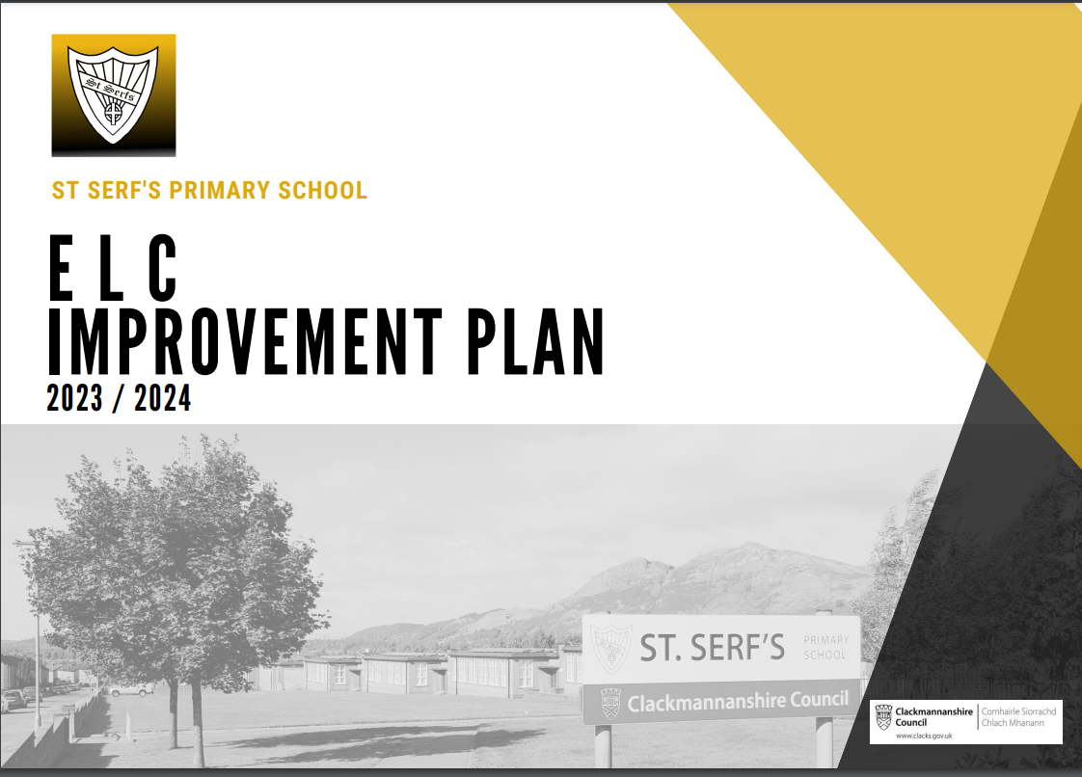

Improvement Plan 2023/2024

St Serf’s Early Learning and Childcare Centre

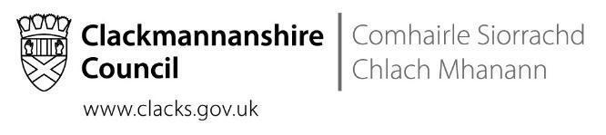
Our sh
Overview

Headteacher: | Mrs N Ferguson

Priority | Long Term Improvement Outcome | Accountable Person
1 | By June 2024, our ELC will provide consistent approaches to early language and communication which support learners to acquire the language skills required to access learning experiences and make progress towards their individual targets. | N. Ferguson
2 | By June 2024, our ELC will provide high quality learning experiences that develop early numeracy skills and are embedded in our practice. | N. Ferguson
3 | By June 2024, our ELC will have robust approaches to the assessment and tracking of 2-year-old learners to ensure that learning experiences are tailored to support them to meet key developmental milestones. | N. Ferguson

Priority 1

Long Term Improvement Outcome

By June 2024, our ELC and Primary 1 will provide consistent approaches to Early Language and Communication which supports learners to acquire the language skills needed to access learning experiences and make progress towards their individual targets.

NIF Priority | NIF Driver(s) | HGIOS4/HGIOELC QIs
Improvement in children and young people's health and wellbeing.  Closing the attainment gap between the most and least disadvantaged children.  Improvement in attainment, particularly in literacy and numeracy.  Improvement in employability skills and sustained, positive school-leaver destinations for all young people.  Placing the human rights and needs of every child and young person at the centre of education. | School and ELC leadership  Teacher and practitioner professionalism  Parent/carer involvement and engagement  Curriculum and assessment  School and ELC improvement  Performance Information | 1.3 Leadership of change  2.3 Learning, teaching and assessment  3.1 Ensuring wellbeing, equity and inclusion  3.2 Raising attainment and achievement / securing children’s progress
Rationale
Our ELC was involved in the LIFT project with the Speech and Language therapy service over an extended period of time and was successful in adopting strategies in daily practice as part of our universal and targeted approaches to support. Now that the formal project has come to an end, we need to ensure that high quality interactions with learners continue to be at the heart of our practice and ensure that targeted supports are in place to develop the language and communication skills in our learners that are essential for them to move forward with their wider learning and development.
In February, following extensive self-evaluation activities, we made changes to our learning environment to better meet our learners needs. This has worked well and we note that our learners are better regulated and making better progress through engaging in learning experiences that are tailored to their interests. It is now important that we work on our visual environment to ensure that the changes that have been made are reflected in the resources that we are using to support learners with their communication. We have established targeted ELC groups to ensure that learners have support that is tailored to their individual needs – ongoing support has been received from out link Speech and language Therapist to ensure that groups are purposeful and staff are skilled in the delivery of interventions.

Following our Team Around the Child meetings this term, we reflected that it would also be beneficial for our learners to have more consistent support at home and ELC, this was also highlighted at a PEEP session as a potential form of support. It was agreed that PEEP sessions with our link Speech and Language Therapist would be provided to ensure that families are building on the successes that we see in the ELC.

This session training has supported practitioners in our wider school community, including staff in early primary stages to benefit from direct input from Speech and Language Therapy in Early Language and Communication strategies and interventions. Next session one of our ELC Educators, who is skilled in the delivery and assessment of ELC interventions, will support staff in school to ensure that high quality support for our learners is sustained as they make the transition to school. She will support by modelling interventions and supporting the planning process to ensure that learning is progressive.

Priority 2

Long Term Improvement Outcome
By June 2024, our ELC will accurately assess learners’ progress in numeracy and provide high quality learning experiences that develop early numeracy skills and are embedded in our practice.
NIF Priority | NIF Driver(s) | HGIOS4/HGIOELC QIs
Improvement in children and young people's health and wellbeing.  Closing the attainment gap between the most and least disadvantaged children.  Improvement in attainment, particularly in literacy and numeracy.  Improvement in employability skills and sustained, positive school-leaver destinations for all young people.  Placing the human rights and needs of every child and young person at the centre of education. | School and ELC leadership  Teacher and practitioner professionalism  Parent/carer involvement and engagement  Curriculum and assessment  School and ELC improvement  Performance Information | 1.3 Leadership of change  2.2 Curriculum  2.3 Learning, teaching and assessment  3.1 Ensuring wellbeing, equity and inclusion  3.2 Raising attainment and achievement / securing children’s progress
Rationale
Over the previous two sessions, staff in the ELC have worked hard to ensure that learners are assessed using Numeracy Trajectories and that assessments feed into planning and the tracking of progress effectively. They have also supported learners in Primary 1 with blocks of targeted interventions to support recovery following the pandemic and an increase in the pace of learning. In the ELC, Learning Groups have been established to provide targeted support for learning to ensure that they are supported and challenged as appropriate. These have been very successful; learners enjoy attending groups and engagement is high. Practitioners are able to engage in higher quality professional dialogue during planning, moderation and tracking meetings to outline learners’ strengths and next steps. The dissemination of information from the learning groups along with the assessment information from the Numeracy Trajectories has begun to have an impact on practice in the wider ELC areas. Educators are incorporating this evidence into the provocations and interactions that they are having with learners every day, to enrich the learning process and support the application of learning through learner-led interests. It is vitally important to build on progress made this session and ensure that approaches are well-understood and embedded in the practice of all educators to raise attainment and achievement in numeracy.

orit

Long Term Improvement Outcome

By June 2024, our ELC will have robust approaches to the assessment and tracking of 2-year-old learners to ensure that learning experiences are tailored to support them to meet key developmental milestones.
NIF Priority | NIF Driver(s) | HGIOS4/HGIOELC QIs
Improvement in children and young people's health and wellbeing.  Closing the attainment gap between the most and least disadvantaged children.  Improvement in attainment, particularly in literacy and numeracy.  Improvement in employability skills and sustained, positive school-leaver destinations for all young people.  Placing the human rights and needs of every child and young person at the centre of education. | School and ELC Leadership  Teacher and practitioner Professionalism  Parent/carer involvement and engagement  Curriculum and assessment  School and ELC improvement  Performance Information | 1.3 Leadership of change  2.2 Curriculum  2.3 Learning, teaching and assessment  3.1 Ensuring wellbeing, equity and inclusion  3.2 Raising attainment and achievement / securing children’s progress
Rationale
At present, our 2-year-old learners are tracked utilising a range of information from observations to trackers from ‘Pre-birth to Three’ with Realising the Ambition informing practice and supporting professional judgements too. As part of our self-evaluation this session, we identified the need to better understand the development of our youngest learners in order to provide learning opportunities that are developmentally appropriate. Previously, our 2-eayr-olds had their own learning environment where planning was tailored to meet their needs. Since the transition to the main playroom, we feel that we are not yet fully incorporating them into our practice making learning opportunities more ad-hoc and less well-tailored to their needs and interests. We have begun to highlight 2-year-olds in our planning meetings and ensure that we are all aware of their targets and interests but this needs to be embedded and used to routinely track their progress towards the developmental milestones.
In addition to our own need to improve this area of practice, the local authority are keen to gather and analyse more high quality data about our youngest learners to track their progress to understand how to support the development of key skills. This would, in turn, support practitioners to provide a strong foundation for learners and ensure that they start school having reached the appropriate developmental milestones and ready to take the next step in their learning journey. With this in mind, a new tracking tool is being developed to support the gathering of consistent information. We have recognised the need, in our own establishment, to ensure that the assessment information that sits behind such tracking data is based on a strong body of evidence. We have visited other establishments this session to explore potential options and to identify good practice elsewhere. We have agreed to introduce the Schedule of Growing Skills assessment next session as a means of gathering consistent developmental information about our 2-year-olds. This supports us to fall in line with other settings in our ‘hub’ and with Educational Psychology and paediatrics, both of whom utilise this tool as part of their assessment information. Colleagues from Tulach have agreed to support us with the adoption of this new approach.

