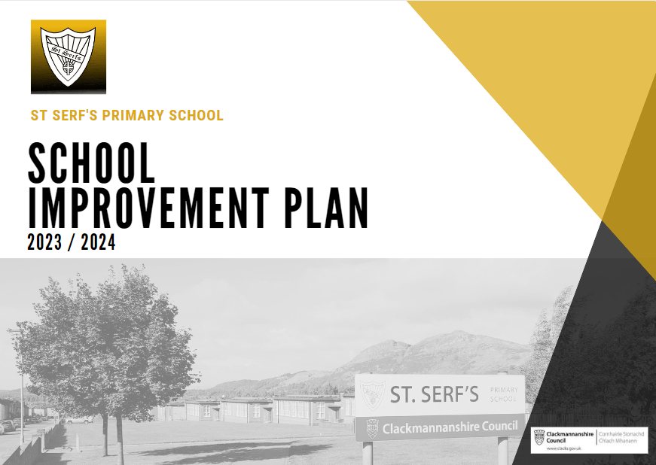
Improvement Plan 2023/2024

St Serf’s Primary School

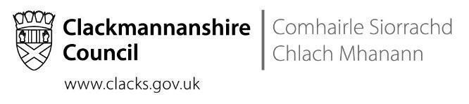
Our sh
Overview

Headteacher: | Mrs N Ferguson

Priority | Long Term Improvement Outcome | Accountable Person
1 | Our school and ELC will provide enriched learning experiences for all children leading to improved attainment across the curriculum.  Specifically during 23/24, 25% of learners who live in Quintile 1, will be back on track across the school, culminating in 80% of learners in total to be on track and working within the national expectation. | N Ferguson
2 | 75% of identified learners in St Serf’s will achieve the national expectation, or above, for their age and stage in Literacy by 2024.  In 2023/2024, focus will be on the following year groups:  P4 - 29% of targeted learners in Quintile 1 will be on track  P7 - 20% of targeted learners in Quintile 1 will be on track | N Ferguson
3 | 75% of identified learners in St Serf’s will achieve the national expectation, or above, for their age and stage in Numeracy by 2024.  In 2023/2024, focus will be on the following year groups:  P4 - 23% of targeted learners in Quintile 1 will be on track  P7 - 30% of targeted learners in Quintile 1 will be on track | N Ferguson

Priority 1

Long Term Improvement Outcome

Our school and ELC will provide enriched learning experiences for all children leading to improved attainment across the curriculum.
Specifically during 23/24, 25% of learners who live in Quintile 1, will be back on track across the school, culminating in 80% of learners in total to be on track and working within the national expectation.

NIF Priority | NIF Driver(s) | HGIOS4/HIGIOELC QIs
Improvement in children and young people's health and wellbeing.  Closing the attainment gap between the most and least disadvantaged children.  Improvement in attainment, particularly in literacy and numeracy.  Improvement in employability skills and sustained, positive school-leaver destinations for all young people.  Placing the human rights and needs of every child and young person at the centre of education. | School and ELC leadership  Teacher and practitioner professionalism  Parent/carer involvement and engagement  Curriculum and assessment  School and ELC improvement  Performance Information | 1.3 Leadership of change  2.3 Learning, teaching and assessment  3.1 Ensuring wellbeing, equity and inclusion  3.2 Raising attainment and achievement / securing children’s progress
Rationale
Raising Attainment in our children’s learning is of the utmost priority for St Serf’s Primary School. In order for this to be achieved, we need to focus on delivering excellent learning and teaching consistently across both our ELC and Primary School. The transition points for our learners must be exemplary and we continue to ensure that the work of the ELC is reflected in Primary 1 and beyond.
It is also imperative that our successful small group intervention strategy continues into 23/24, where specific learners are targeted, using our Pupil Equity Fund (PEF) Learning Assistants to deliver these small groups. Our universal approach to all learners must also continue with the specific target of improving attainment for all. This journey started 2 years ago and now moving into its 3rd year, we are beginning to see extremely positive results with regards to attainment figures across the school.

In Session 22/23, our teachers continue to develop a skills based curriculum, based on the needs of our learners. In P1, there was a significant attainment gap across the curriculum. In P1, 27 learners in total, 56% of learners who live in Quintile 1 (IMD is a measure of relative deprivation for small, fixed geographic areas of the UK) as opposed to a small number of learners who live in Quintile 5. All learners who live in Quintile 5 have achieved Early level across the curriculum and 73% of learners who live in Quintile 1 have achieved.
Therefore, looking to Session 23/24, as these learners move into P2, our PEF funding will be used to target 27% of our learners who live in Quintile 1 to ensure they achieve Early level across the curriculum in the first quarter of Primary 2 and thus bringing them in line with the majority of their peers. All other learners will continue to receive a universal approach to their learning with continued small groups run by our Support for Learning teacher as well as our Early Years intervention team.

The picture in P4 was similar, still with an attainment gap across the curriculum. There are currently 23 learners in total, 65% of learners who live in Quintile 1 as opposed to a small number of learners who live in Quintile 5.
All learners who live in Quintile 5 achieved First Level with 67% of learners who live in Quintile 1 achieving First Level across the curriculum. There continues to be a significant attainment gap at this stage therefore looking to Session 23/24, as these learners move into P5, the targeted support across the curriculum will be aimed at 30% of learners who live in Quintile 1 who will continue to be supported to achieve First Level across the curriculum.

It is imperative that our focus remains to raise the attainment of all. By continuing to deliver excellent learning experiences suitable for a 21st century school, a skills based curriculum for all of our learners, our poverty related attainment gap between learners should continue to reduce and our figures of academic attainment continue to improve.

Priority 2

Long Term Improvement Outcome
At least 75% of identified learners in St Serf’s will achieve the national expectation, or above, for their age and stage in Literacy by 2024.
In 2022/2023, focus will be on the following year groups:

P4 - 29% of targeted learners in Quintile 1 will be on track
P7 - 20% of targeted learners in Quintile 1 will be on track
NIF Priority | NIF Driver(s) | HGIOS4/HIGIOELC QIs
Improvement in children and young people's health and wellbeing.  Closing the attainment gap between the most and least disadvantaged children.  Improvement in attainment, particularly in literacy and numeracy.  Improvement in employability skills and sustained, positive school-leaver destinations for all young people.  Placing the human rights and needs of every child and young person at the centre of education. | School and ELC leadership  Teacher and practitioner professionalism  Parent/carer involvement and engagement  Curriculum and assessment  School and ELC improvement  Performance Information | 1.3 Leadership of change  2.2 Curriculum  2.3 Learning, teaching and assessment  3.1 Ensuring wellbeing, equity and inclusion  3.2 Raising attainment and achievement / securing children’s progress
Rationale
Improvements to raise attainment in Literacy continue to be the utmost priority for our school. Analysis of Literacy attainment over a period of 3 years from 2020/2021 – 2022/2023 highlights several points, the majority of which is extremely positive. The findings of this are highlighted below.
At Early Level, in Reading in 2022/23, 81% of learners achieved; an improvement on the 3 year average and an increase on the rate in 2021/2022. This rate is significantly higher than the authority average of 76.2%. There is a similar picture with Writing at Early Level where 77.8% of learners achieved, 3.9% above the authority average. Overall, in a combined percentage of learners achieving Literacy at Early Level, which includes the above and Listening and Talking, 77.8% of learners have achieved, compared to authority average of 71.7%. This is a good result.

At First Level, in Reading in 2022/2023, 82.6% of learners achieved; this is a significant improvement on the 3 year average and a significant increase on the rate in 2021/2022. Whilst we cannot compare cohorts of learners, the consistent approach to Literacy being delivered across stages is now having the desired effect on attainment. In Writing, we have seen similar progress, 73.9% of learners achieving First Level, 15% above the authority average. Overall, the combined Literacy attainment for First Level is 73.9%, 17.8% higher than the authority average.

Finally, at Second Level, 86.4% of learners achieved Second Level in Reading, higher than the 3 year average and significantly higher than the rate in 2021/2022, 12% higher than the authority average. SNSA results also demonstrate that the percentage of learners “on track” is higher than the CfE achievement rate for Second Level. In Writing, 77% of learners achieved Second Level, higher than the 3 year average and the rate in 2021/2022. This rate is also significantly higher than the authority average of 65%. With SNSA results, our learners are above the National Average with the percentage of learners who are “on track” is higher than the CfE achievement rate for Second Level in Writing. Overall, the combined Literacy attainment for Second Level is 72.7%, 9.4% higher than the authority average.

We are continuing with standardised assessments across all stages, 3 times per year, which highlights gaps in learning, and with our programme of interventions, we are able to begin to solve these gaps. This is allowing us to see significant progress in attainment in Literacy over time. Our Learning Assistants play a vital role in delivering small group interventions and are at the heart of our intervention programme. In Literacy, we have identified our use of the Active Literacy programme is working, teaching our children to read and spell correctly. This approach will continue to have a significant long term impact on our learners’ attainment.

orit

Long Term Improvement Outcome

75% of identified learners in St Serf’s will achieve the national expectation, or above, for their age and stage in Numeracy by 2024.
In 2022/2023, focus will be on the following year groups:

P4 - 20% of targeted learners in Quintile 1 will be on track
P7 - 30% of targeted learners in Quintile 1 will be on track
NIF Priority | NIF Driver(s) | HGIOS4/HIGIOELC QIs
Improvement in children and young people's health and wellbeing.  Closing the attainment gap between the most and least disadvantaged children.  Improvement in attainment, particularly in literacy and numeracy.  Improvement in employability skills and sustained, positive school-leaver destinations for all young people.  Placing the human rights and needs of every child and young person at the centre of education. | School and ELC Leadership  Teacher and practitioner Professionalism  Parent/carer involvement and engagement  Curriculum and assessment  School and ELC improvement  Performance Information | 1.3 Leadership of change  2.2 Curriculum  2.3 Learning, teaching and assessment  3.1 Ensuring wellbeing, equity and inclusion  3.2 Raising attainment and achievement / securing children’s progress
Rationale
Improvements to raise attainment in Numeracy remain a priority. Analysis of Numeracy attainment over a period of 3 years from 2020/2021 – 2022/2023 highlights several points, the majority of which is positive. The findings of this are highlighted below.

At Early Level In Numeracy in 2022/23, 85.2% of learners achieved; an improvement on the 3 year average and 16% improvement on last year’s attainment. This rate is higher than the authority average of 79.9% and also slightly higher than the national figure from 2022 of 83.6%. With SNSA results, learners performed better in Numeracy with 92.6% achieving. The percentage of learners “on track” is higher than the CfE achievement rate for Early Level in Numeracy. This is a good result and learners continue to show depth to their knowledge at Early level and their application of Numearcy skills continues to be strong.

At First Level, 69.6% of learners achieved in Numeracy, significantly higher than the 3 year average and an increase of 27% on last year’s attainment figures. This rate is also higher than the current authority average of 59.2% and the authority average in 2022 which was 66.1%. This year’s achievement figures are slightly less than the national average from 2022 which was 74.9%. The poverty-related attainment gap between the achievement rate for learners in St Serf’s who live in Quintile 1 compared to learners who live in Quintile 5 has reduced significantly in 2022/23 compared with previous years, and learners in Quintile 1 who achieved First level have outperformed both authority and national figures, 66% against 59.2%. However learners from our least deprived areas still outperform learners from our most deprived areas although this gap is reducing. SNSA results demonstrate that the percentage of learners “on track” is significantly lower to the CfE achievement rate for First level however these results would appear to be inaccurate.

At Second Level, 77% of learners achieved in Numeracy, a slight increase on the 3 year average and more than 10% higher than the Authority average of 66%. The Authority average in 2022 was 67%. The gap narrowed in 2022/2023 compared to 2021/2022, however learners from our least deprived areas still outperformed learners from our most deprived areas. Currently 69% of learners who live in Quintile 1 achieved Second Level compared to all learners from Quintile 5 achieving. Our poverty related attainment gap between learners from least deprived areas to most deprived areas continues to decrease, with a current gap at Second Level of 30%. SNSA results demonstrate that 78% of learners are on track which is in line with the attainment figure delivered. This would suggest that our learners’ results are accurate with ability.

Now with standardised assessments in place across all stages, we have a clear baseline where our pupils are with their learning. Our priority remains to regularly assess our pupils, plan deliver targeted support, intervention and challenge to address significant gaps and meet individual needs. Our Learning Assistants play a vital role in delivering small group interventions and are at the heart of our intervention programme. In Numeracy, we need to identify and develop a St Serf’s approach to delivering numeracy, ensuring concrete, pictorial and abstract is the foundation of our approach. This approach will continue to have a significant impact on our learners’ attainment, across all stages of the school.

