Improvement Plan 2021/2022

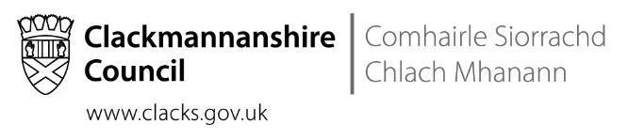
Overview

Headteacher: | Emma Tomlinson

Total PEF Allocation: | £12,681

Priority | Long Term Improvement Outcome | Accountable Person | Cost  (for PEF priorities only)
1 | Health and Wellbeing  By May 2022, all children will have high quality learning and teaching experiences through a Health and Wellbeing curriculum that embeds the UNCRC, Readiness for Learning approaches, Outdoor Learning and our school values. | Jen Sneddon  Supported by Kerra Doyle, Gillian Farrow, Rebeka Peddie, Wendy Jack. | Readiness for Learning Classroom and Whole School Resources (1600)  Outdoor Learning/Nurture Areas Resources (£2000)
2 | Literacy  By May 2022, we will increase writing attainment at all levels by developing our knowledge and practices in the teaching of writing for all educators, children and families. | Teresa Barker  Supported by Susie Gallagher, Rachel McMahon, Eilidh Tedford, Shona Thomson | Staff Writing CLPL (£2000)  IT Subscriptions (£2600)  Digital Devices e.g. ipads/laptops with Talk to Text software (£2000)
3 | Science, Technologies, Engineering and Maths  Improved STEM pedagogy of all staff in ELC/school and application of this knowledge to improve the learning experiences and outcomes of children. | Emma Tomlinson  Supported by Paula Bingham, Leza Corkish, Susan Lavery and Elaine McInally. | Early Level Play Resources (£1000)  Early Level STEM/Outdoor Learning Resources (£1000)

Priority 1

Long Term Improvement Outcome
(Aspirational, Transformational; relates to improved outcomes for learners)
Health and Wellbeing

By May 2022, all children will have high quality learning and teaching experiences through a Health and Wellbeing curriculum that embeds the UNCRC, Readiness for Learning approaches, Outdoor Learning and our school values.

NIF Priority | NIF Driver(s) | HGIOS4/HIGIOELC QIs
Improvement in children and young people's health and wellbeing  Closing the attainment gap between the most and least disadvantaged children  Improvement in attainment, particularly in literacy and numeracy  Improvement in employability skills and sustained, positive school-leaver destinations for all young people | School Leadership  Teacher Professionalism  Parental Engagement  Assessment of Children’s Progress  School Improvement  Performance Information | 1.3 Leadership of change  2.3 Learning, teaching and assessment  3.1 Ensuring wellbeing, equity and inclusion  3.2 Raising attainment and achievement / securing children’s progress

Rationale
- Continued impact of COVID-19 crisis and remote learning.
- 19% increase in the number of children involved in the Staged Intervention process across Session 2020/21.
- Children’s HWB Survey data – May 2021.
- Children’s, Families and Staff Outdoor Learning Survey data – May 2021.
  - Children’s Focus Groups – Outdoor Learning Audit.
- Emma Tomlinson - Into Headship Strategic Change Initiative and Action Plan.
- Session 2020/2021 Attainment Data – TPJs, SNSAs, SOFAs.
- Continued development of Health and Wellbeing planners to support learning and teaching.
- The need to fully embed our Building Positive Relationships Policy at all levels.
- The need to develop our approaches to Outdoor Learning across the school.
- School grounds and green spaces being underutilised to support high quality learning experiences that address the needs of learners.
- UNCRC becoming law in Scotland in November 2021.

Improvement Outcomes | Measures | Key Actions | Who? | By when | Milestone Updates/Comments
Review of Building Positive Relationships Policy and approaches, including developing GIRFEC principles and the UNCRC. | Publication of final document.  Evidence of use of policy throughout classes and playground.  Reduction in incident referrals to SLT.  Leuven Scale within Pupil Tracker.  Pupil HWB Survey Data – October 2021/April 2022. | To consult with focus groups of all stakeholders on policy.  To re-launch Building Positive Relationships Policy at the start of the session with all stakeholders, including with new staff and families.  Ensure consistent use of approaches across the Strathdevon community.  All staff to attend CLPL sessions on UNCRC.  Raise awareness and knowledge of The Wellbeing Indicators across the school community.  Introduction of Wellbeing Wednesdays to promote Health and Wellbeing through the Wellbeing Indicators. | Jen Sneddon  HWB Working Group  All Staff | November 2021
Embed Readiness for Learning pedagogy and approaches across the whole school community. | Progression of staff completion of R4L Level 2 Modules.  Observations of R4L approaches by SLT and EP colleagues.  Documentation of and attendance to R4L priorities and outcomes within GIRFEC paperwork.  Pupil HWB Survey Data – October 2021/April 2022.  Boxhall Profiles  Engagement in Seasons for Growth programme.  Parental and pupil feedback following Seasons for Growth programme.  Leuven Scale within Pupil Tracker. | All staff to complete R4L Level 2 Modules, including all new staff.  Staff to complete R4L Play Modules.  Establish Nurture Group (s) and build capacity/knowledge within the staff team. | Jen Sneddon  HWB Working Group | February 2022
Develop progressive and contextualised HWB planners. | Teacher Evaluations of HWB Planners.  Attainment and Tracking Meetings. | Complete contextualised HWB planners for Early, First and Second Levels: November – June. | Jen Sneddon  HWB Working Group | May 2022
Embed outdoor learning pedagogy and practices within the HWB curriculum. | Pupil, Parent and Staff Outdoor Learning Survey Data – May 2021/May 2022.  Evaluation of AHT Into Headship Strategic Change Initiative Action Plan. | Implementation of Local Authority Outdoor Learning Strategy.  Consultation with all stakeholders on development of Strathdevon Outdoor Learning Policy.  Identification of CLPL requirements of staff.  Development of Outdoor Nurture Classrooms.  Develop outdoor environment for learning and teaching. | Emma Tomlinson  Outdoor Learning Development Group  HWB Working Group  All staff | May 2022
Strengthen/improve the Strathdevon Community, focussing on promoting the school values, leadership for all and sharing/celebrating the successes of all. | Increase in use of the Strathdevon Blog by all classes.  Increase in the use of Twitter by all classes.  Each class and staff member to have a leadership role.  Increase in sharing and celebrating success with the wider school community. | Class sections regularly updated on the Strathdevon Blog.  Twitter access for all classes, including adherence to Social Media Acceptable Use Guidelines.  Review of current communication platforms/tools.  Review of current practices e.g. approaches to assemblies, house points, sharing learning.  Develop collaborative leadership teams across the school involving all stakeholders e.g. re-establishing committees. | Jennifer Sneddon  Class Teachers  Learning Assistants  ELC Staff | December 2021
Develop an Anti-Bullying Policy. | Pupil HWB Survey Data – October 2021/April 2022.  Leuven Scale within Pupil Tracker. | Consultation with all stakeholders on Anti-Bullying Policy.  Create an Anti-Bullying Policy in consultation with all stakeholders. | Jen Sneddon | December 2021

Priority 2

Long Term Improvement Outcome
(Aspirational, Transformational; relates to improved outcomes for learners)
Literacy

By May 2022, we will increase writing attainment at all levels by developing our knowledge and practices in the teaching of writing for all educators, children and families.

NIF Priority | NIF Driver(s) | HGIOS4/HIGIOELC QIs
Improvement in children and young people's health and wellbeing  Closing the attainment gap between the most and least disadvantaged children  Improvement in attainment, particularly in literacy and numeracy  Improvement in employability skills and sustained, positive school-leaver destinations for all young people | School Leadership  Teacher Professionalism  Parental Engagement  Assessment of Children’s Progress  School Improvement  Performance Information | 1.3 Leadership of change  2.3 Learning, teaching and assessment  3.1 Ensuring wellbeing, equity and inclusion  3.2 Raising attainment and achievement / securing children’s progress

Rationale
In Session 2020/21, writing attainment was adversely affected during remote learning across all stages. Writing during the period of remote learning has been the curricular area which children were least likely to engage in and parents had least confidence in supporting. Consequently, Strathdevon’s writing attainment across most classes (P2- P7) has reduced overall and we seek to improve this by May 2022.

Improvement Outcomes | Measures | Key Actions | Who? | By when | Milestone Updates/Comments
Work towards a whole school progression for writing. | Teacher Evaluations  Attainment and Tracking Meetings  Online Pupil Tracker  TPJs, SNSA data, SOFA data. | Evaluate the writing progression across the school.  Create an agreed whole school writing progression. | Teresa Barker  Literacy Working Group | May 2022
Improve writing pedagogy across the school. | Pupil and Staff Literacy Surveys  TPJs, SNSA data, SOFA data.  Attainment and Tracking Meetings. | All staff working collaboratively across all levels to share skills and expertise to ensure continuity of the curriculum and teaching and learning approaches.  Target attainment gaps in writing across all stages.  A coherent approach to supporting children with dyslexia.  Increase the frequency of writing opportunities for all children across the school.  Identification of CLPL requirements of staff.  Provision of relevant CLPL opportunities for staff.  Audit of writing resources across the school.  Share writing approaches with families e.g. family workshops at different stages. | Teresa Barker  Literacy Working Group  Class Teachers  Support for Learning Teacher  Learning Assistants  ELC Staff | May 2022
Continue to improve Literacy approaches, in line with Our Literacy - The Clackmannanshire Way | Pupil and Staff Literacy Surveys  TPJs, SNSA data, SOFA data.  Attainment and Tracking Meetings | Develop an integrated approach to Literacy at all levels.  Revisit and enhance reading environments across the school including the Reading Hub and outdoor reading areas.  Continue to refresh reading texts as appropriate.  Continue to target any attainment gaps in reading, writing, listening and talking across all stages.  Continue to improve the equitable access to digital technologies to support reading and writing.  Promotion of Active Learn as a core resource for reading.  Evaluate and agree how to use Active Learn and develop a consistent approach across the school. | Teresa Barker  Class Teachers  Support for Learning Teacher  Learning Assistants  ELC Staff | May 2022

Priority 3
Long Term Improvement Outcome
(Aspirational, Transformational; relates to improved outcomes for learners)
Science, Technologies, Engineering and Maths

By May 2022, all children will experience improved learning, teaching and assessment through practical play experiences, developing skills for life, learning and work and the development of our STEM curriculum.

NIF Priority | NIF Driver(s) | HGIOS4/HIGIOELC QIs
Improvement in children and young people's health and wellbeing  Closing the attainment gap between the most and least disadvantaged children  Improvement in attainment, particularly in literacy and numeracy  Improvement in employability skills and sustained, positive school-leaver destinations for all young people | School Leadership  Teacher Professionalism  Parental Engagement  Assessment of Children’s Progress  School Improvement  Performance Information | 1.3 Leadership of change  2.3 Learning, teaching and assessment  3.1 Ensuring wellbeing, equity and inclusion  3.2 Raising attainment and achievement / securing children’s progress

Rationale
Our Education Scotland Inspection Report published in February 2020 highlighted a gap in our provision of STEM education. In addition, the Confederation of British Industry (CBI) suggests that more than 82% of businesses… want to see [primary] schools developing pupils’ skills relating to STEM and a recent Clackmannanshire labour market profile suggests that jobs density is at 54% compared to 84% nationally.

Given local employment rates and the current labour market, it is important to help our children to become competitive within the local community and beyond, and to develop the skills which employers require.

A high-quality STEM curriculum will help children to gain the skills required to succeed in today’s, and tomorrow’s challenging world.

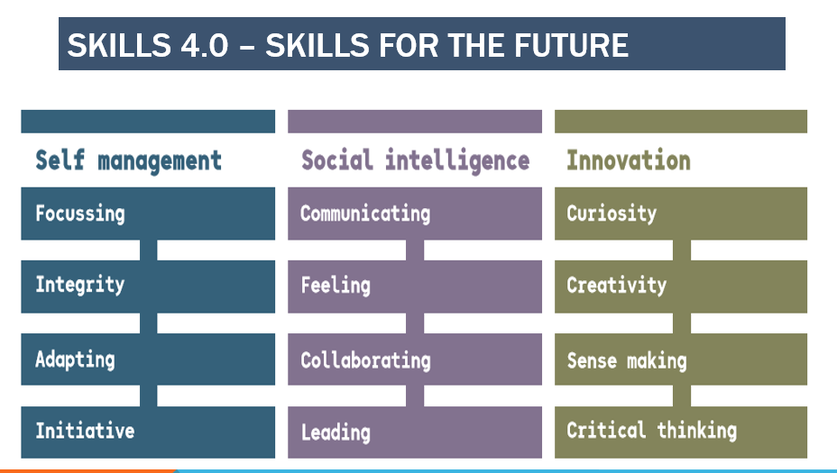

“The Scottish Government and major employers in...STEM-based industries in Scotland have expressed widespread concern about the future supply of well qualified, highly skilled scientists and technicians to meet demand in the above sectors of industry and more widely across the economy.” (Seagg, 2012)

Research and data also demonstrates the significance of developing skills in STEM subjects in the future labour market.

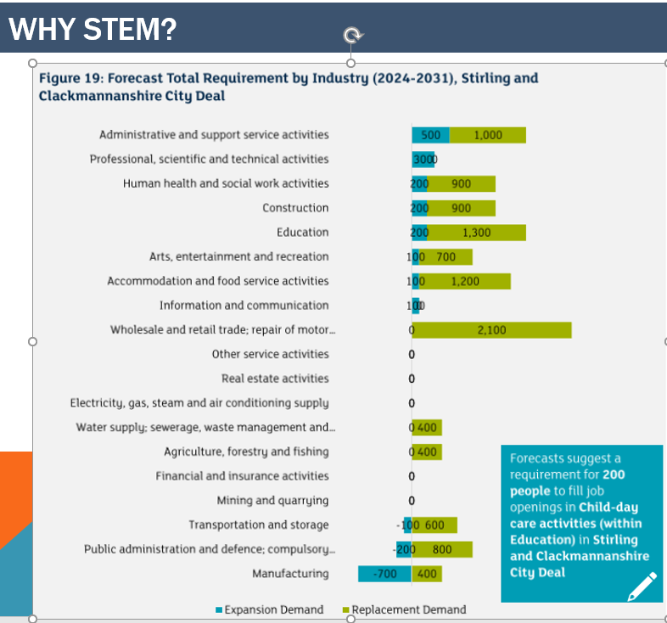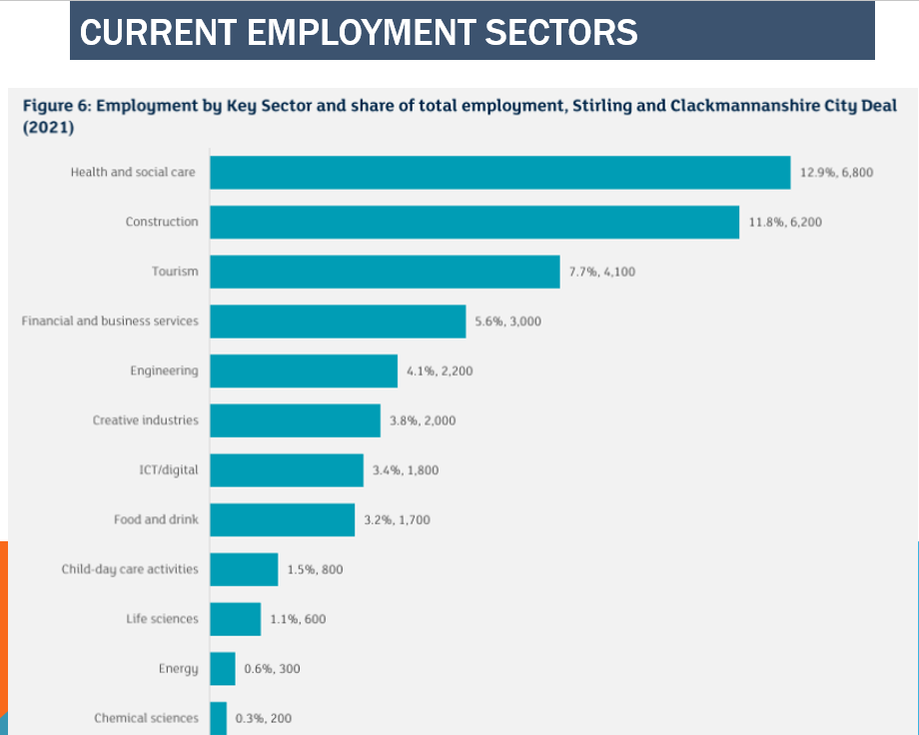

This is echoed internationally. See for example;
The Science and Engineering Education Advisory Group (SEEAG) action plan contains the following five work streams designed to address these concerns: (1) building capacity and expertise of teachers; (2) practical support for teachers and learners; (3) increasing children and young people's engagement with, and understanding of, real life science, engineering and technology…”
https://www.ejmste.com/article/the-effect-of-integrative-stem-instruction-on-elementary-students-attitudes-toward-science-5353
4 https://www.voced.edu.au/content/ngv:51724
Seeag (2012) Supporting Scotland's STEM education and culture: Science and Engineering Education Advisory Group second report. 2012. Available at: https://www.voced.edu.au/content/ngv:5172
Departamento de Didácticas Específicas, Universidad de Burgos, SPAIN (2018) The Effect of Integrative STEM Instruction on Elementary Students’ Attitudes toward Science.Available at: https://www.ejmste.com/article/the-effect-of-integrative-stem-instruction-on-elementary-students-attitudes-toward-science-5353
Australian Government (2013) Science, Technology, Engineering and Mathematics in the National Interest: A Strategic Approach. Retrieved on 21 August 2017 from http://www.chiefscientist.gov.au/wp-content/uploads/STEMstrategy290713FINALweb.pdf.
http://www.nomisweb.co.uk/reports/lmp/la/1946157409/report.aspx
https://www.skillsdevelopmentscotland.co.uk/media/44684/skills-40_a-skills-model.pdf

Improvement Outcomes | Measures | Key Actions | Who? | By when | Milestone Updates/Comments
Improved STEM pedagogy across all levels. | SSERC CLPL evaluation forms.  Revisit childrens’ and staff survey from 20/21 in Nov 21. | Some staff will continue onto year two of the SSERC programme and ensure staff can source all SSERC resources and lessons.  SSERC CLPL dates to be selected and offered as additional CLPL to all educators.  Investigate use Clacks STEM-powered Glow tile. | Emma Tomlinson  Paula Bingham  Leza Corkish  Susan Lavery  Elaine McInally | May  2022
Develop Science planners to improve curriculum, learning, teaching and assessment. | Attainment and tracking meetings.  Planning documentation showing evidence of tracking of STEM experiences and outcomes.  Physical evidence of STEM learning across the school. | Research and search for updated Science planners.  Investigate use Clacks STEM-powered Glow tile.  Improve links with Alva Academy to support.  Share practice with other primary schools in and out of the local authority. | Emma Tomlinson  Paula Bingham  Leza Corkish  Susan Lavery  Elaine McInally | May 2022
Develop the use of play pedagogy across Early Level and in P7 to enhance STEM learning and teaching. | Early Level Team meetings.  Pupil Focus Groups.  Staff Surveys.  Attainment and Tracking Meetings. | Emma Tomlinson participating in Leading the Early Level Through Play Pedagogy course for leaders.  Sharing knowledge and learning from this course with Early Level Team.  Leza Corkish to adopt ELC planning approaches.  P1/P7 Buddies to participate in collaborative STEM learning.  Early Level Team meetings. | Emma Tomlinson  Paula Bingham  Leza Corkish  Susan Lavery  Elaine McInally | May 2022
Effective use of awarded STEM grant to promote the development of digital technologies.  Continued work towards the STEM Nation Award. | Revisit staff survey from 20/21 in Nov 21.  ELC documentation of STEM journey.  Parental engagement in STEM sessions. | Completion of the actions proposed in funding application, including close work with Tablet Academy. | Susan Lavery  Emma Tomlinson  Paula Bingham  Leza Corkish  Elaine McInally | May 2022
Improved engagement and use of STEM resources available to enhance the learning experiences for children. | Increased use of STEM resource boxes and inventory to be used for staff. | STEM resource boxes need to be labelled and inventory of this for staff.  Agreement required regarding care and return of STEM resources. QR code on box to log in out electronically. | Emma Tomlinson  Paula Bingham  Leza Corkish  Susan Lavery  Elaine McInally | February  2022
Increase all educator’s knowledge and understanding of assessment, moderation and application of TPJ in Maths/Numeracy Achievement of a Level. | TPJs, SNSA data, SOFA data.  Attainment and Tracking Meetings  Comparison to national levels of attainment. | Assessment and Moderation CLPL for Emma Tomlinson and Leza Corkish.  Roll out of Assessment and Moderation CLPL to all staff.  Regular quality assurance and moderation activities – including effective use of SNSAs and SOFAs data. | Leza Corkish  Emma Tomlinson | May 2022

