Standards and Quality Report 2025 - 26

Establishment Name: St Bernadette’s RCPS

Section B1 - School Context
Our Context
St. Bernadette’s RC Primary is a denominational school serving Alva, Menstrie and Tullibody. We are situated at the foot of the Ochil Hills, We have strong links to our parish and local community. The school roll in June 2026 was 90. Our associated denominational high school is St. Modan’s RC High School. Our expected school roll for August 2026 is 90 children, organised across four composite classes. While we are a small school, our community is multicultural and diverse. We welcome families from all over the world, with 18% of our children speaking English as an Additional Language (EAL).
Our reputation as a nurturing and inclusive school means that many families of children with additional support needs choose to join us. Currently, 46% of our learners receive tailored support to help them progress. This includes our neurodivergent learners; while the national average for autistic learners in Scottish schools is 2.6%, 7.2% of our children have a diagnosis of ASD, and we support a significant number of others who are currently waiting for an assessment.
Our community brings together children from a wide variety of socio-economic backgrounds. We look at this through the Scottish Index of Multiple Deprivation (SIMD) to help us allocate our equity funding where it is needed most. About 38% of our children (35 learners) live in SIMD 1–2 neighbourhoods, while 21% (19 learners) live in SIMD 9–10 areas, and 23% of our families receive support with school clothing grants and free school meals based on family income.

School Vision and Aims
Our ethos is rooted in our Faith. All members of our school community are encouraged to live the Gospel Values, loving and supporting each other while striving to develop our unique gifts and abilities. We aim to enable each of our children to achieve their God – given potential.
Our vision for our children is that they;  - develop a strong connection to their environment and a determination to contribute to it;  - are empowered to make choices that enhance their health and wellbeing throughout their lives;  - develop the skills for learning, life and work that they will need to thrive in the workplace. | 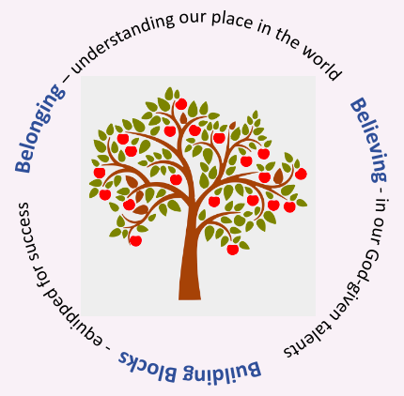

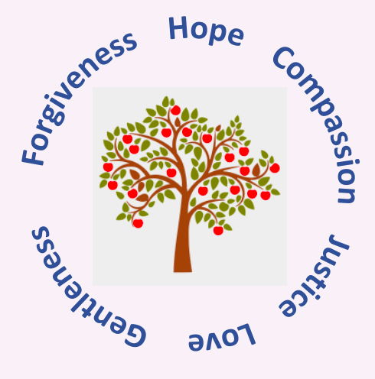 | Our Values
  Our children understand that these Gospel Values underpin our relationships and set out our expectations of how we live and work as a family.
  - Forgiveness
  - Hope
  - Compassion
  - Justice
  - Love
  - Gentleness

The Socio-economic Context
Our Gospel Values support us in our quest to be an inclusive and welcoming school for all of our children and families. We believe that our diversity is our strength. Our school is fortunate to include children whose families come from all over the world. 18% of our children have English as an Additional Language. Our reputation as a nurturing and inclusive school has led families to seek us out when their children have additional support needs, 46% of our children are on staged intervention. The National Autism Implementation Team Society report that ‘2.6% of learners in Scottish schools are autistic’ but the rate of children in our school with an ASD diagnosis is 7.2% and we have a significant number of young people waiting for a neurodevelopmental difficulties assessment.

The Scottish Index of Multiple Deprivation (SIMD) is the measure that the Scottish Government uses for identifying the places in Scotland where people are experiencing disadvantage across different aspects of their lives. According to this measure, 35 out of 90 of our children are living in SIMD 1-2, the most disadvantaged households. This represents 36% of all our children. The number of children in SIMD 9-10, the most advantaged households, is 19. This represents 21% of all our children. 23% of our children qualify for free school meals on the basis of family income.
At St Bernadette’s RCPS, our self-evaluation is grounded in our Catholic ethos and our commitment to ensuring every child is known, valued and supported. We use a wide range of evidence, including attainment data, tracking and monitoring, learning visits, sampling of work and planning. Our recent inspection report has been central in shaping our improvement focus, particularly around consistency in learning, teaching and assessment in numeracy. We draw on HGIOS4 and Developing in Faith, alongside feedback from pupils, parents, staff and parish partners, to evaluate the impact of our nurturing approaches, targeted literacy and numeracy interventions, and our strong emphasis on wellbeing and inclusion.

Self-evaluation is collaborative across our school community. There is strategic oversight while staff contribute through professional dialogue, moderation and daily observations of learner progress. Pupil voice is gathered through leadership groups and class discussions, and parents and partners offer valuable insight that supports our most vulnerable learners and informs PEF-funded interventions. We ensure assessment data is robust through triangulation of professional judgement, learners’ work and standardised assessments, supported by national benchmarks and regular moderation within school and across the cluster. This ensures our data is reliable, meaningful and used effectively to respond to inspection findings and drive improvement for all learners.

Section B2 – Performance Information
Attainment:
In 2025-26, our children’s attainment rose in all areas of Literacy and Numeracy.

Year | Listening & Talking % | Reading % | Writing % | Numeracy %
2022-23 | 88 | 88 | 71 | 81
2023-24 | 88 | 86 | 77 | 79
2024-25 | 93 | 86 | 81 | 78
2025-26 | 94 | 91 | 87 | 85

We do not break the figures into Early, First and Second Levels as the cohorts are small – this is in line with Scottish Government practice.

Tracking the Attainment Gap:
Our School Improvement Plan every year prioritises reducing the difference in attainment between our most and least disadvantaged pupils i.e. SIMD 1&2 and SIMD 9&10. This year, I am calculating the Attainment Gap using the national figures for children living in SIMD 9&10 to ensure consistency in measuring the Attainment Gap as we have a relatively small number of children living in SIMD 9&10 with wide variations between classes.

Year | Children in SIMD 1 & 2  Achieving Levels  Reading | Children in SIMD 9-10  Achieving Levels (nationally)  Reading | Attainment GAP  Reading
2022-23 | 83% | 88% | 5%
2023-24 | 79% | 89% | 10%
2024-25 | 81% | 89% | 9%
2025-26 | 86% | 89% | 3%

Year | Children in SIMD 1 & 2  Achieving Levels  Writing | Children in SIMD 9-10  Achieving Level (nationally)  Writing | Attainment GAP  Writing
2022-23 | 67% | 84% | 17%
2023-24 | 68% | 86% | 18%
2024-25 | 70% | 86% | 16%
2025-26 | 76% | 89% | 13%

Year | Children in SIMD 1 & 2  Achieving Levels  Listening & Talking | Children in SIMD 9-10  Achieving Level (nationally)  Listening & Talking | Attainment GAP  Listening and Talking
2022-23 | 72% | 93% | 21%
2023-24 | 83% | 93% | 10%
2024-25 | 89% | 93% | 4%
2025-26 | 79% | 94% | 15%

Year | Children in SIMD 1 & 2  Achieving Levels  Literacy | Children in SIMD 9-10  Achieving Level (nationally)  Literacy | Attainment GAP  Literacy
2022-23 | 78% | 82% | 4%
2023-24 | 68% | 84% | 16%
2024-25 | 73% | 84% | 11%
2025-26 | 86% | 89% | 3%

Year | Children in SIMD 1 & 2  Achieving Levels  Numeracy | Children in SIMD 9-10  Achieving Level (nationally)  Numeracy | Attainment GAP  Numeracy
2022-23 | 78% | 88% | 10%
2023-24 | 83% | 89% | 6%
2024-25 | 76% | 89% | 13%
2025-26 | 79% | 89% | 10%

This year we saw real and encouraging progress for our children in SIMD 1&2, with clear improvements across Reading, Writing and overall Literacy. Reading rose from 81% to 86%, and Writing increased from 70% to 76%, showing that the support and targeted approaches we put in place are making a noticeable difference for our most disadvantaged learners. The biggest shift was in overall Literacy, which jumped from 73% to 86%, almost closing the gap completely and representing a significant step forward compared to last year.
Numeracy also improved slightly, but the gap has stayed the same, which tells us that our current strategies are not yet having the impact we need in this area.
The drop in Listening & Talking, however, is a clear concern. Attainment fell from 89% to 79%, widening the gap again after several years of steady improvement. This shows that we need to refocus on communication, confidence and structured talk, particularly for children who need more support. Overall, the data shows strong progress in Literacy, but Listening & Talking now needs targeted attention to ensure equity across all areas.

Attendance
Our overall attendance average is 92% . 35% of our learners have an attendance below 95%.
There was a clear link between attendance and attainment with children who have a higher attendance rate enjoying more success.

Section B2 - Review of Progress to June 25
School Priority One:
Belonging: By June 2026, our school will develop a Health and Wellbeing curriculum, which is underpinned by UNCRC, R4L, Laudato Si, delivering a consistent approach to supporting regulation, empathy and resilience in every class. As a result, almost all learners will be more engaged in their learning for sustained periods of time, resulting in progress in learning and attainment.

NIF Priority:
- Improvement in children and young people's health and wellbeing
- Improvement in employability skills and sustained, positive school-leaver destinations for all young people
- Placing the human rights and needs of every child and young person at the centre of education
- Closing the attainment gap between the most and least disadvantaged children and young people

NIF Driver:  1. a globally respected, empowered, and responsive education system  4. high levels of achievement across the curriculum for all learners, with action to close the poverty-related  attainment gap  5. highly skilled workforce supporting ASN  6. improving relationships and  behaviour, and attendance | HGIOS4 QIs:  1.3 Leadership of change  2.3 Learning, teaching and assessment  3.1 Ensuring wellbeing, equity and inclusion  3.2 Raising attainment and achievement / securing children’s progress
Actions
- Staff collaboratively designed a Health and Wellbeing programme linked to Rights Respecting Schools, ensuring a shared and consistent approach across the school.
- Collegiate planning strengthened staff confidence and consistency in delivering agreed strategies.
- Children’s understanding of neurodiversity was developed through assemblies, class discussions and House Groups.
- UNCRC was embedded in class charters and restorative conversations, reinforcing rights-based language and expectations.
- RRSA and UNCRC learning was communicated regularly to families through ClassDojo and newsletters.
- The school successfully achieved the Silver Rights Respecting Schools Award.
Impact
- Children consistently demonstrate a stronger understanding of neurodiversity and are more confident in expressing their feelings.
- Pupils routinely engage in restorative, rights-based conversations, showing greater empathy, respect and responsibility.
- There is a clear improvement in relationships and classroom climate, contributing to a more inclusive, settled and supportive learning environment.
- Children report a strong sense of belonging, and this is reflected in the positive ethos observed across the school.
- Families highly value the school’s nurturing, inclusive approach, frequently highlighting the strong relationships and personalised support their children receive.
- Staff report that embedding UNCRC and Gospel Values has significantly strengthened consistency of expectations and enhanced emotional regulation across classes.
Next Steps
- Continue to embed rights-based practice and neurodiversity awareness across the curriculum.
- Sustain and strengthen work towards GOLD RRSA.

School Priority Two:
Building Blocks: Children’s attainment in Literacy and Numeracy will increase by at least 5%.
Our numeracy attainment will increase to meet the local authority stretch aims.
NIF Priority:
- Closing the attainment gap between the most and least disadvantaged children
- Improvement in attainment, particularly in literacy and numeracy
- Improvement in employability skills and sustained, positive school-leaver destinations for all young people
NIF Driver:  School Leadership  Teacher Professionalism  Parental Engagement  Assessment of Children’s Progress  School Improvement  Performance Information | HGIOS4 QI:  1.3 Leadership of change  2.3 Learning, teaching and assessment  3.1 Ensuring wellbeing, equity and inclusion  3.2 Raising attainment and achievement / securing children’s progress
Actions
- Staff engaged in professional learning to develop a shared understanding of high-quality learning, teaching and assessment using the Clackmannanshire LTA guidance.
Actions
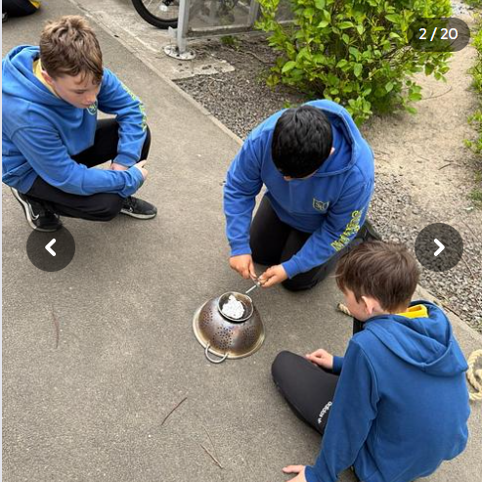
- Staff designed a Health and Wellbeing programme linked to Rights Respecting Schools, ensuring a shared and consistent approach across the school.
- Collegiate planning strengthened staff confidence and consistency in delivering agreed strategies.
- UNCRC was embedded in class charters and restorative conversations, reinforcing rights-based language and expectations.
- RRSA and UNCRC learning was communicated regularly to families through ClassDojo and newsletters.
- The school successfully achieved the Silver Rights Respecting Schools Award.
- Staff attended CLPL on Outdoor Learning and have worked with partners to implement this throughout the school.
- Staff designed a pathway for Outdoor Learning and play.
- Outdoor learning was further embedded across stages to support regulation, resilience and belonging. Staff used outdoor spaces intentionally to promote positive relationships, provide and enhance wellbeing-focused learning experiences.
Impact
- Children consistently demonstrate a stronger understanding of neurodiversity and are more confident in expressing their feelings.
- Pupils routinely engage in restorative, rights-based conversations, showing greater empathy, respect and responsibility.
- There is a clear improvement in relationships and classroom climate, contributing to a more inclusive, settled and supportive learning environment.
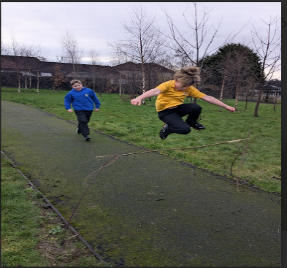
- Children report a strong sense of belonging, and this is reflected in the positive ethos observed across the school.
- Families highly value the school’s nurturing, inclusive approach, frequently highlighting the strong relationships and personalised support their children receive.
- Staff report that embedding UNCRC and Gospel Values has significantly strengthened consistency of expectations and enhanced emotional regulation across classes.
- Outdoor learning has had a positive impact on children’s wellbeing and engagement. Learners demonstrate increased confidence, resilience and cooperation during outdoor tasks, and staff note improved regulation and focus when returning to classroom learning.
- Targeted learners, including those requiring additional support, show increased participation and reduced dysregulation when outdoor learning is used as part of their planned support.
Next Steps
- Continue to embed rights-based practice across the curriculum.
- Sustain and strengthen work towards GOLD RRSA.
- Develop a progressive outdoor learning framework aligned to Health and Wellbeing, ensuring all classes access high-quality outdoor experiences that support regulation, resilience and belonging.
- Provide professional learning to build staff confidence in using outdoor spaces to enhance wellbeing and support learners with additional needs.
- Increase opportunities for targeted outdoor interventions to support emotional regulation and readiness to learn.
Teachers co-created a quality assurance calendar to ensure consistency in outdoor learning and play across all classes.
- Learning conversations were introduced to support children in identifying their next steps based on their previous targets.
- Staff collaborated to strengthen daily learning and teaching, sharing strengths and planning together.
- A teachers undertook training in the Education Scotland/Clacks Writing Programme to improve the quality and consistency of Writing teaching.
- Reading environments were enhanced across classes to promote reading for enjoyment and develop a stronger reading culture.
- Targeted small-group and 1:1 support was provided for children not yet meeting expected levels in Literacy and Numeracy.
- Staff co-created a moderation calendar to ensure consistency in assessment across the school.
- Termly learning conversations supported children in understanding their progress and co-creating next steps.
- Families were invited to Numeracy learning experiences in class workshops to strengthen home–school partnerships and support digital learning.

Impact
- Staff now demonstrate a stronger and more consistent understanding of high-quality learning, teaching and assessment.
- Children are more confident in identifying their progress and next steps, contributing to increased engagement and ownership of learning.
- Writing teaching has improved across stages, with clearer progression and increased learner confidence.
- Reading environments are more engaging and purposeful, supporting improved motivation and enjoyment of reading.
- The school’s commitment to reading has been recognised through achieving Reading School Accreditation, evidencing a sustained improvement in reading culture.
- The school achieved the Silver Communication Award, demonstrating significant progress in communication, language development and inclusive communication practice.
- Targeted support has ensured that children experiencing difficulty receive timely, focused intervention, improving confidence and readiness to learn.
- Moderation activities have strengthened the reliability and consistency of assessment judgements across the school.
- Families report feeling better equipped and more confident in supporting learning at home following numeracy learning.
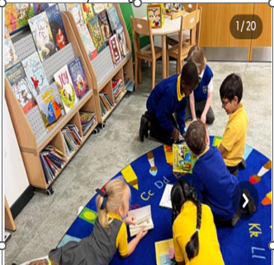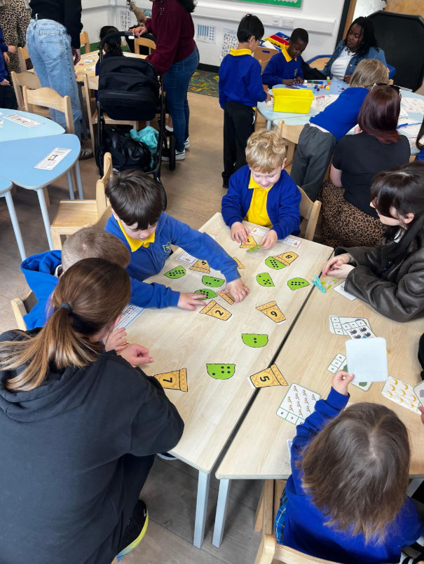
Next Steps
- Continue to embed high-quality learning and teaching across Literacy and Numeracy to ensure consistency across all classes.
- Continue to enhance Reading for enjoyment and build on Reading School Accreditation.
- Maintain targeted support for children requiring additional help in Literacy and Numeracy.
- Strengthen assessment and moderation practices to ensure robust, reliable data.
- Build on family engagement by offering further opportunities to support learning at home.

School Priority Three:
By June 2026 Children will understand the significance of Pope Francis’ invitation to engage in the Global Compact with a focus on 3 of the 7 core commitments. All staff will reflect on their role as Catholic teachers and the responsibilities inherent in the Charter ensuring the development of engaging learning opportunities in RE across the 4 contexts..
NIF Priority:
- Closing the attainment gap between the most and least disadvantaged children
- Improvement in attainment, particularly in literacy and numeracy
- Improvement in employability skills and sustained, positive school-leaver destinations for all young people
NIF Driver:  School Leadership  Teacher Professionalism  Parental Engagement  Assessment of Children’s Progress  School Improvement  Performance Information | HGIOS4 QI:  1.3 Leadership of change  2.3 Learning, teaching and assessment  3.1 Ensuring wellbeing, equity and inclusion  3.2 Raising attainment and achievement / securing children’s progress
Actions
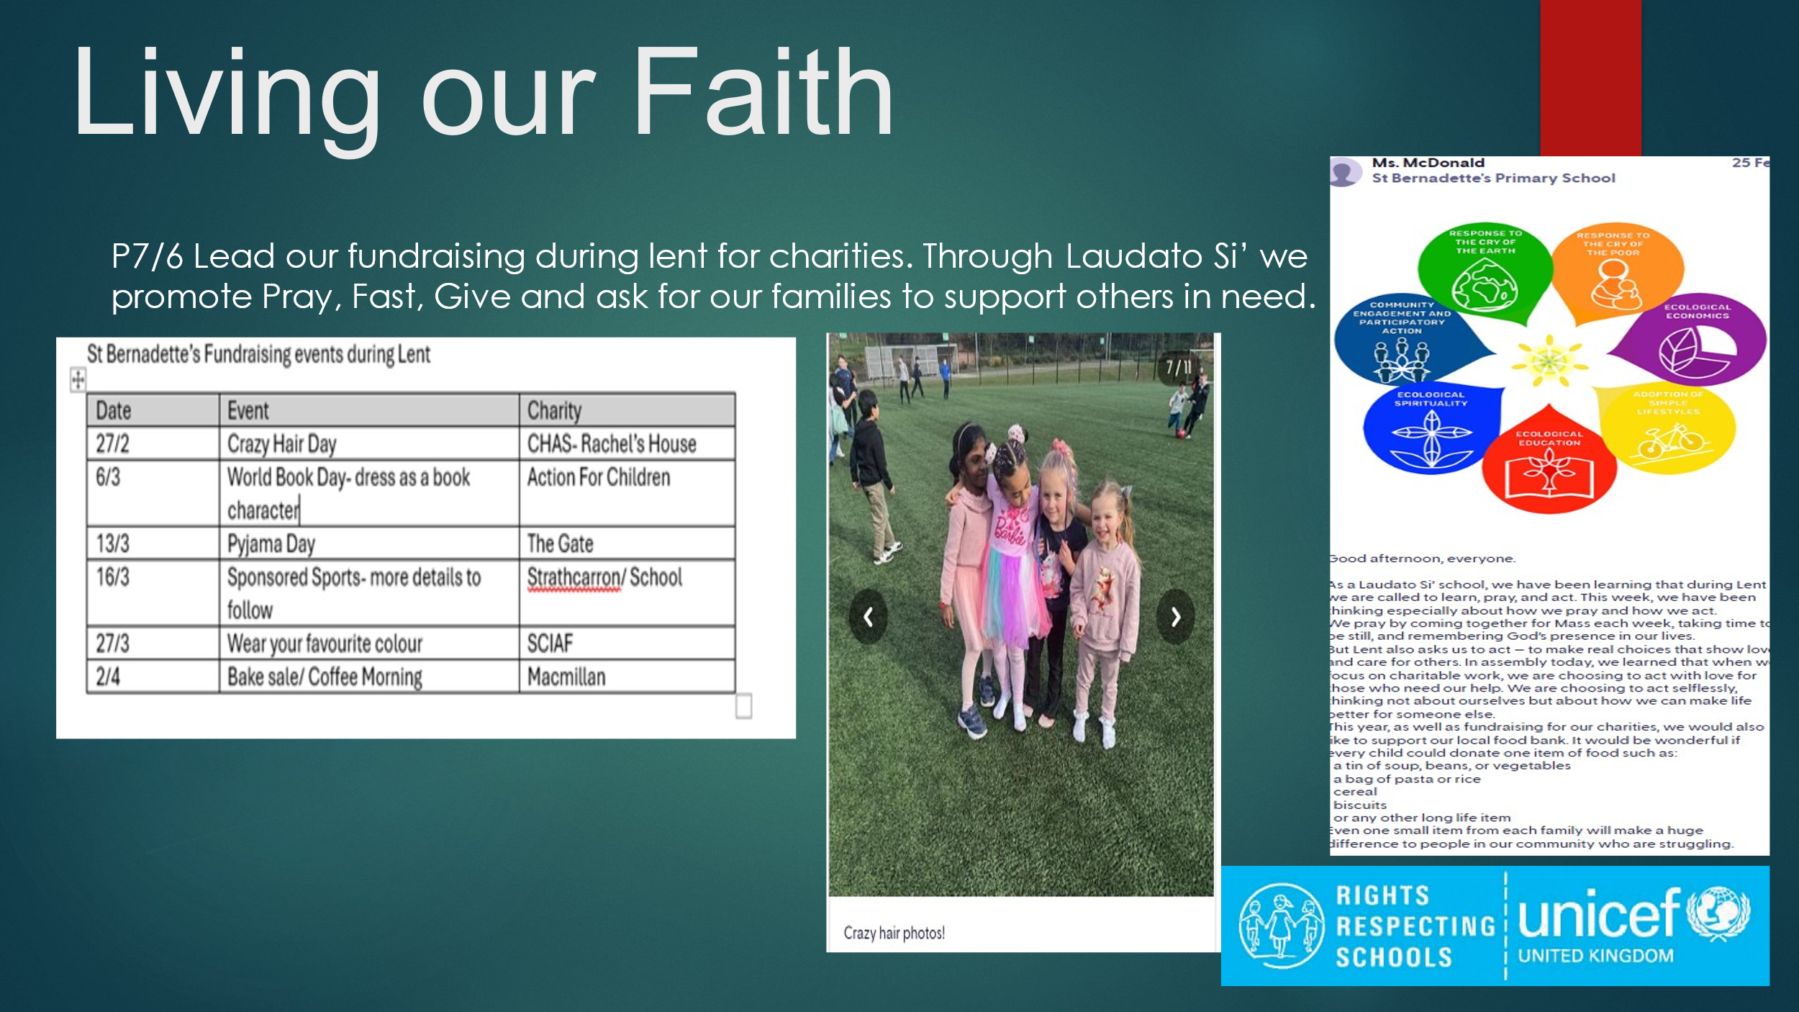
- Staff engaged in professional learning on the Global Compact on Education and explored how the seven commitments align with Laudato Si’, particularly care for creation, human dignity and solidarity.
- Teachers reflected on their vocation as Catholic educators using the Charter for Catholic Schools, identifying how their practice supports the mission of the St Modan’s Learning Community.
- RE learning was planned across the four contexts to ensure breadth, depth and relevance, with explicit links to Laudato Si’ and Catholic Social Teaching.
- Assemblies, liturgical celebrations and class learning explored themes of stewardship, justice, peace and global responsibility.
- Children participated in reflection, discussion and creative activities to deepen understanding of the Global Compact commitments and their relevance to daily life.
- Partnerships with St Modan’s, parish and community were strengthened to support shared faith experiences, transition and opportunities for service.

Impact
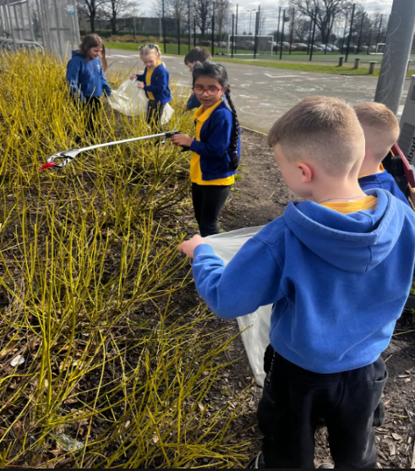
- Children demonstrate a clearer and more confident understanding of Pope Francis’ Global Compact on Education.
- Learners show increased awareness of stewardship and care for creation, reflecting the principles of Laudato Si’ in their attitudes and actions.
- Children engage more confidently in reflection, discussion and prayer, showing greater spiritual maturity, empathy and global awareness.
- Staff demonstrate a stronger understanding of their vocation as Catholic educators and how the Charter and Laudato Si’ shape their daily practice.
- RE learning across the four contexts is now more engaging, relevant and connected, with improved consistency in planning and delivery.
- Collaboration within the St Modan’s Learning Community has strengthened shared expectations, supported transition and enhanced children’s sense of belonging within the wider Catholic community.
- Our Minnie Vinnie group have had an impact by arranging and organising a small foodbank in school. Theyu have also made visits to the Orchard Care home.
- Parish and community partnerships have deepened children’s lived experience of faith, contributing to a stronger Catholic ethos across the school.

Next Steps
- Continue to embed the Global commitments and Laudato Si’ across learning, liturgy and wider school life.
- Further develop staff confidence in planning high-quality RE across the four contexts.
- Strengthen opportunities for pupil leadership in faith actions, social justice and stewardship.
- Deepen collaboration within the St Modan’s Learning Community to enhance shared practice and transition.
- Continue to build parish partnerships to enrich children’s lived experience of faith.

Children’s Feedback:

I like outdoor learning and I like when the lady from the woods came and made popcorn with us.

I have liked maths and play.I am happy I can read now, I like reading.

Outdoor learning is great because you can learn to teamwork and problem solve.

outdoor learning because we learned to make a wooden cookie and how to start a fire.

Outdoor learning because we learned to make a wooden cookie and how to start a fire.
I have really enjoyed silent reading because the classroom is quiet and it's relaxing.

I liked doing outdoor learning this year and I think I am getting better at maths.

Parents Feedback:
High quality teaching of numeracy, literacy and reading, very good homework to reinforce learning at home and interesting & engaging ways the school teaches different topics and links learning together.

The ethos - gospel values. Relationships with families. The kindness of staff to families and young people. Staff commitment. The leadership.

Great community feel and nurtures my child’s natural interests well while developing in all areas. Teaching standard very good and my daughter has developed so much this year

I love the schools values and respect for others.

Staff feedback:
Outdoor learning training and delivery with Jenni significantly increased staff confidence and expanded the range of high-quality outdoor experiences offered to pupils. Children demonstrated greater engagement, resilience and enjoyment in learning beyond the classroom.

We are proud to achieve the Silver Communication Award, recognising our commitment to making the school accessible for all learners. This work has helped ensure that every child can engage meaningfully with learning, regardless of their communication needs.

Our new Health and Wellbeing planners, which supports our focus on children’s rights, has created a consistent, nurturing environment for all. We are proud to have effort this recognised as we achieved the UNCRC Silver Award. Daily check-ins, class charters, and programmes like Cool in School and God’s Loving Plan have helped children feel safe, supported and confident.

In numeracy, the introduction of Zeta Maths and small-steps progression supported targeted teaching and helped close gaps in number skills. Pupils showed improved accuracy, confidence and independence in core numeracy tasks.

The implementation of the Cypic writing programme has had a clear and positive impact on pupils’ attainment this year. Teaching is now more structured, with children’s targets made explicit and progress consistently monitored through visible run charts. This approach has strengthened pupils’ engagement and motivation, as they can clearly see their achievements and understand the steps needed to reach their next goals.

Laudato Si’ has led to pupils taking greater ownership of our community, shown through actions such as litter picking and caring for local spaces, helping them develop pride and responsibility in looking after the world around them.

Our Health and Wellbeing work continued to strengthen emotional literacy and readiness to learn. Consistent use of emotional-regulation strategies, alongside explicit teaching on recognising and managing feelings, supported pupils to develop resilience and positive coping strategies. Children increasingly demonstrated the ability to identify emotions, seek support appropriately and reflect on their own wellbeing.

Section B3 - Evaluation of Quality Indicators
Quality Indicator | School Self- | Inspection Evaluation
 | Evaluation (1-6) | Date: September 2025
1.3 Leadership of change | 4
2.3 Learning, teaching and assessment | 4 | 4
3.1 Ensuring wellbeing, equality and inclusion | 5
3.2 Raising attainment and achievement | 4 | 4

