Standards and Quality Report 2024 - 25

Establishment Name: St Bernadette’s RCPS

Section B1 - School Context
Our Context
St. Bernadette’s RC Primary is a denominational school serving Alva, Menstrie and Tullibody. We are situated at the foot of the Ochil Hills, We have strong links to our parish and local community. The school roll in June 2025 was 92. Our associated denominational high school is St. Modan’s RC High School.

School Vision and Aims
Our ethos is rooted in our Faith. All members of our school community are encouraged to live the Gospel Values, loving and supporting each other while striving to develop our unique gifts and abilities. We aim to enable each of our children to achieve their God – given potential.
Our vision for our children is that they;  - develop a strong connection to their environment and a determination to contribute to it;  - are empowered to make choices that enhance their health and wellbeing throughout their lives;  - develop the skills for learning, life and work that they will need to thrive in the workplace. | 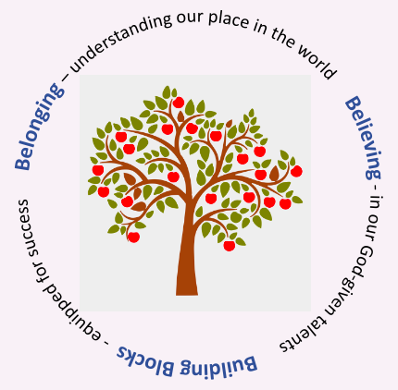

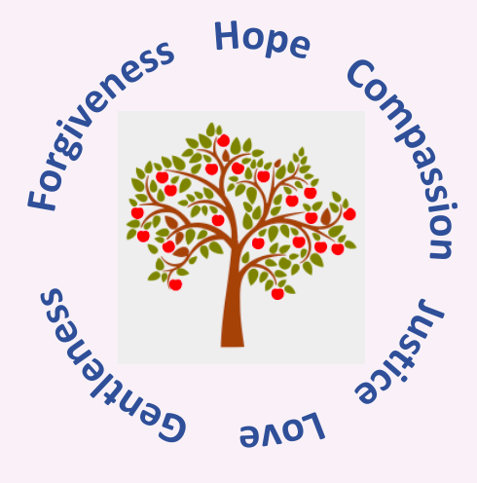 | Our Values
  Our children understand that these Gospel Values underpin our relationships and set out our expectations of how we live and work as a family.
  - Forgiveness
  - Hope
  - Compassion
  - Justice
  - Love
  - Gentleness

The Socio-economic Context
Our Gospel Values support us in our quest to be an inclusive and welcoming school for all of our children and families. We believe that our diversity is our strength. Our school is fortunate to include children whose families come from all over the world. 18% of our children have English as an Additional Language. Our reputation as a nurturing and inclusive school. 46% of our children are on staged intervention. The National Autism Implementation Team Society report that ‘2.6% of learners in Scottish schools are autistic’ but the rate of children in our school with an ASD diagnosis is 7.2%

The Scottish Index of Multiple Deprivation (SIMD) is the measure that the Scottish Government uses for identifying the places in Scotland where people are experiencing disadvantage across different aspects of their lives. According to this measure, 35 out of 97 of our children are living in SIMD 1-2, the most disadvantaged households. This represents 36% of all our children. The number of children in SIMD 9-10, the most advantaged households, is 22. This represents 27% of all our children. 23% of our children qualify for free school meals on the basis of family income.

Section B2 – Performance Information
Attainment:
In 2024-25, our children’s attainment rose in all areas of Literacy and Numeracy.
Year | Listening & Talking % | Reading % | Writing % | Numeracy %
2021-22 | 92 | 84 | 69 | 75
2022-23 | 88 | 88 | 71 | 81
2023-24 | 88 | 86 | 77 | 79
2024-25 | 93 | 86 | 81 | 78
We do not break the figures into Early, First and Second Levels as the cohorts are small – this is in line with Scottish Government practice.

Tracking the Attainment Gap:
Our School Improvement Plan every year prioritises reducing the difference in attainment between our most and least disadvantaged pupils i.e. SIMD 1&2 and SIMD 9&10. This year, we are calculating the Attainment Gap using the national figures for children living in SIMD 9&10 to ensure consistency in measuring the Attainment Gap as we have a relatively small number of children living in SIMD 9&10 with wide variations between classes.

Year | Children in SIMD 1 & 2  Achieving Levels  Reading | Children in SIMD 9-10  Achieving Levels (nationally)  Reading | Attainment GAP  Reading
2021-22 | 78% | 87% | 13%
2022-23 | 83% | 88% | 5%
2023-24 | 79% | 89% | 10%
2024-25 | 81% | 89% | 9%

Year | Children in SIMD 1 & 2  Achieving Levels  Writing | Children in SIMD 9-10  Achieving Level (nationally)  Writing | Attainment GAP  Writing
2021-22 | 67% | 83% | 16%
2022-23 | 67% | 84% | 17%
2023-24 | 68% | 86% | 18%
2024-25 | 70% | 86% | 16%

Year | Children in SIMD 1 & 2  Achieving Levels  Listening & Talking | Children in SIMD 9-10  Achieving Level (nationally)  Listening & Talking | Attainment GAP  Listening and Talking
2021-22 | 94% | 91% | -3%
2022-23 | 72% | 93% | 21%
2023-24 | 83% | 93% | 10%
2024-25 | 89% | 93% | 4%

Year | Children in SIMD 1 & 2  Achieving Levels  Literacy | Children in SIMD 9-10  Achieving Level (nationally)  Literacy | Attainment GAP  Literacy
2021-22 | 56% | 81% | 25%
2022-23 | 78% | 82% | 4%
2023-24 | 68% | 84% | 16%
2024-25 | 73% | 84% | 11%

Year | Children in SIMD 1 & 2  Achieving Levels  Numeracy | Children in SIMD 9-10  Achieving Level (nationally)  Numeracy | Attainment GAP  Numeracy
2021-22 | 56% | 86% | 30%
2022-23 | 78% | 88% | 10%
2023-24 | 83% | 89% | 6%
2024-25 | 76% | 89% | 13%

Attendance
Our overall attendance average is 92% . 35% of our learners have an attendance below 95%.

There was a clear link between attendance and attainment with children who have a higher attendance rate achieving more success.

Section B2 - Review of Progress to June 25
School Priority One:
Belonging: Almost all children, staff and families have a greater awareness and understanding of neurodiversity. We have developed a more informed and inclusive learning community leading to a decrease in the anxiety reported by our neurodiverse learners.

NIF Priority:
- Improvement in children and young people's health and wellbeing
- Improvement in employability skills and sustained, positive school-leaver destinations for all young people
NIF Driver:  - School Leadership  - Teacher Professionalism  - Parental Engagement  - School Improvement | HGIOS4 QIs:  - 1.3 Leadership of change  - 2.3 Learning, Teaching and assessment  - 3.1 Ensuring wellbeing, equity and inclusion
Actions:

- Our P4-7 teachers became familiar with the LEANS planning.
- There was collegiate planning to implement the strategies.
- Primary 4-7 team taught the classes.
- Our P1-3 teachers taught neurodiversity through reading and drama.
- There was awareness raising around neurodiversity in assemblies and House groups.
- Our children took part in house groups on UNCRC and RRSA and neurodiversity.
- RRSA and UNCRC communicated with families through dojo and newsletters.
Impact:
- Our children have a better understanding of neurodiversity and feel enabled to talk about how they are feeling.
- Our families continue to feel that they and their children are valued members of our school community.
- Our children continue to report a strong sense of belonging to our school community.

- Children can talk openly about differences and understanding of needs. Neurodiverse children feel less anxious/ annoyed / worried/scraed.
- We achieved the Bronze Award for Rights Respecting school.
Evidence:
Our children from P3-7 were asked to fill in a survey about how they felt about the Leans programme.
Almost all of our children agreed or strongly agreed with the questions they were asked. This shows that our children have a better understanding and awareness of Neurodiversity.

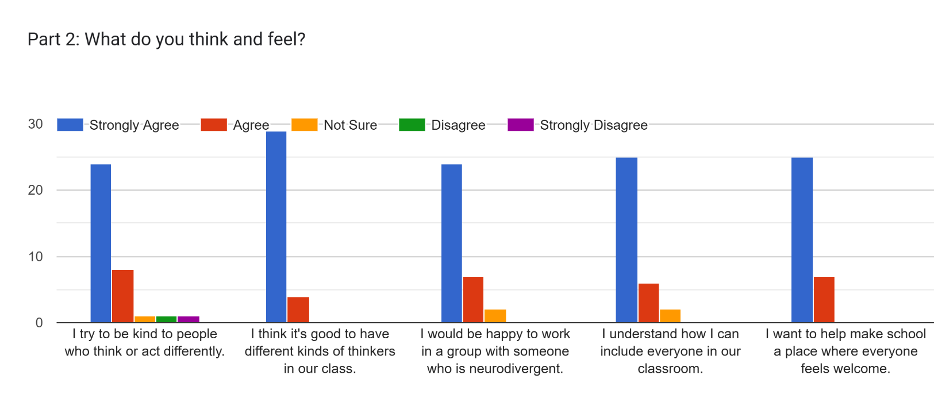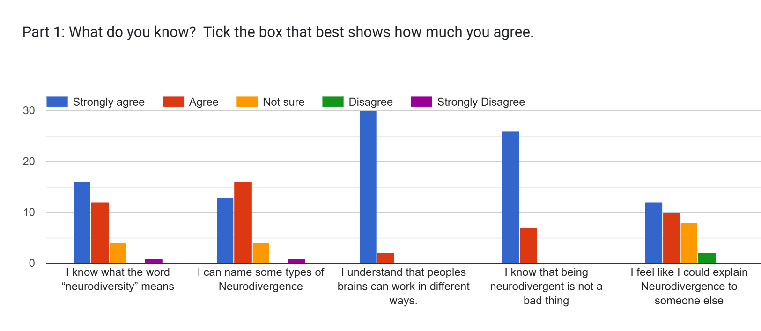
The children were asked; Has taking part in LEANS helped you feel more positive in school?
Some of our response:
Yes, it helped me feel more positive as it helps me as I never knew what it was
Yes it has very much.
It has a bit because before if I would get annoyed if someone annoyed me but I realised that it’s not their fault and some people can’t help it.
A bit. Because I can understand other people.
It has made me more positive in school because it helped me understand how people are different
Yes it has helped me understand why people do somethings different.
It has made me more positive in school because I know how to include everyone.
Yes because I know what neurodiversity means.
Yes because now I know more about neurodivergence.

The children were asked; What is one thing you learned about neurodiversity from the LEANS programme?

The responses included:

Not everyone thinks the same

That fairness and equality are different.

That everyone’s brains work in so many different ways.

That nobody is perfect.

The children were asked; How can you help include neurodivergent classmates?
Responses included;
Explain things differently
Be calm and friendly.

Play, include and be welcoming
If someone is alone play or talk to them

Be patient and fair, giving help if needed.

Families’ comments March ‘25

Our families are supportive of our school; the school is praised for its warm, welcoming, and friendly atmosphere, where children feel safe and loved.
Feedback shows parents are extremely happy and satisfied with their children's progress and wellbeing throughout the year.
Parents appreciate the open and approachable nature of staff, which fosters strong home-school partnerships.

- “Friendly and safe environment for my children to learn.”
- “Has a great family feel, all staff are approachable and happy to help.”
- “Respect, friendship, love for learning, faith”
- “A very welcoming and family feel/community. We are listened to. Child voice”
- “Support for ASN children.”
- “A sense that they genuinely care about our children and create a caring supportive community.”
- “Adapts to all learners.”
- “Nurturing towards children.”
- “Understanding of each child’s needs.”

Teacher’s comments May 25

The Leans programme has been extremely beneficial. The children enjoyed the stories and the discussions. They could relate it to real life and were able to understand why some of us need extra support just to make things fair. It helped Neurodivergent children understand why they also need support and allowed them to feel more included and respected.

UNCRC has had a daily presence in our classroom with it woven into our class charter highlighting our rights but also that with rights come responsibilities. It is also woven through our Gospel Values and referred to during restorative conversations. The children have also benefitted from House Group UNCRC sessions informing of them of these rights and responsibilities. A Laudato Si House Group focusing on protecting our planet and the poor also connected to the UNCRC articles.

Following the delivery of the LEANS (Learning About Neurodiversity at School) programme, pupils demonstrated a significantly increased understanding of neurodiversity and inclusion. They showed greater empathy, were more able to recognise and celebrate differences in how people think and learn, and could confidently suggest ways to support one another. This has positively influenced classroom relationships and fostered a more inclusive and respectful learning environment.

Embedding the UNCRC into our class charter and school culture has empowered pupils to understand their rights and the rights of others. This has strengthened their sense of responsibility and active participation in the school community. Children are more confident in expressing their views, supporting one another, and contributing to a rights-focused and nurturing environment.

Next Steps:
- We will continue to build on our success in raising awareness of neurodiversity, by discussions in class.
- We will continue to work on achieving the Silver RRSA award.

School Priority Two:
Building Blocks: The attainment of children living in SIMD 1 & 2 will rise to at least 73% in writing.
NIF Priority:
- Closing the attainment gap between the most and least disadvantaged children
- Improvement in attainment, particularly in literacy and numeracy
- Improvement in employability skills and sustained, positive school-leaver destinations for all young people
NIF Driver:  School Leadership  Teacher Professionalism  Parental Engagement  Assessment of Children’s Progress  School Improvement  Performance Information | HGIOS4 QI:  1.3 Leadership of change  2.3 Learning, teaching and assessment  3.1 Ensuring wellbeing, equity and inclusion  3.2 Raising attainment and achievement / securing children’s progress
Actions:
- P3-7 teachers are trained in the strategies of the Education Scotland National Writing Programme
- Our children experienced highly effective teaching and learning in writing.
- Children living in SIMD 1 & 2 received additional support
- The PEF-funded learning assistant was familiar with the strategies of the Education Scotland National Writing Programme and supported our children living in Quintile 1 who required additional support in achieving a level of writing.
- Teachers and support assistants were trained in the new resource.
- The use of speech to text technology was expanded for learners with additional support needs.
- Read and Write ( a literacy support tool) was introduced to our P6/7 learners with additional support needs.
Impact:
- Children’s attainment in Writing increased from 78% to 89%. Our strategic focus on writing has yielded a significant increase in attainment, rising from 78% to 89%, which directly correlates with a reported increase in pupil confidence and self-belief in their writing ability.
- The poverty related attainment gap is the difference in the average attainment of children living in SIMD1-2 and the average attainment of children living in SIMD 9-10. The writing attainment for our children living in SIMD 1&2 rose from 68% to 70%
Evidence:
The Attainment results for P1, P4 and P7 children are shown below:
Year | Writing %
2021-22 | 69
2022-23 | 71
2023-24 | 78
2024-25 | 89

Next steps:
- All staff will be trained on the Education Writing programme. Writing will continue to be a priority in our school improvement plan.

Section B3 - Evaluation of Quality Indicators
Quality Indicator | School Self- | Inspection Evaluation
 | Evaluation (1-6) | Date: No inspection yet
1.3 Leadership of change | 4
2.3 Learning, teaching and assessment | 4
3.1 Ensuring wellbeing, equality and inclusion | 4
3.2 Raising attainment and achievement | 4

