

St Bernadette’s RC Primary School

**School Handbook**

2025/26

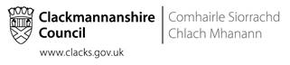

|  |  |  |  |  |  |  |  |  |  |  |  |  |  |  |  |  |  |  |  |  |  |  |  |  |  |  |  |  |  |  |  |  |  |  |  |  |  |  |  |  |  |  |  |  |  |  |  |  |  |  |  |  |  |  |  |  |  |  |  |  |  |  |  |  |  |  |  |  |  |  |  |  |  |  |  |  |  |  |  |  |  |  |  |  |  |  |  |  |  |  |  |  |  |  |  |  |  |  |  |  |  |  |  |  |  |  |
| --- | --- | --- | --- | --- | --- | --- | --- | --- | --- | --- | --- | --- | --- | --- | --- | --- | --- | --- | --- | --- | --- | --- | --- | --- | --- | --- | --- | --- | --- | --- | --- | --- | --- | --- | --- | --- | --- | --- | --- | --- | --- | --- | --- | --- | --- | --- | --- | --- | --- | --- | --- | --- | --- | --- | --- | --- | --- | --- | --- | --- | --- | --- | --- | --- | --- | --- | --- | --- | --- | --- | --- | --- | --- | --- | --- | --- | --- | --- | --- | --- | --- | --- | --- | --- | --- | --- | --- | --- | --- | --- | --- | --- | --- | --- | --- | --- | --- | --- | --- | --- | --- | --- | --- | --- | --- | --- |
| |  |  |  | | --- | --- | --- | | **Contents** | | **Page** | | **1.** | **Chief Education Officer’s foreword** | **3** | | **2.** | **Curriculum For Excellence** | **5** | | **3.** | **Headteacher’s Welcome** | **6** | | **4.** | **School Information** | **7** | | **5.** | **Organisation of the School Day** | **8** | | **6.** | **Term Dates 2025-26** | **8** | | **7.** | **Registration and Enrolment** | **10** | | **8.** | **Attendance and absence** | **10** | | **9.** | **School Uniform** | **11** | | **10** | **School Meals/ Free School Meals** | **11** | | **11.** | **Travel to and from school** | **13** | | **12.** | **School security** | **14** | | **13.** | **Compliments, Enquiries and Complaints Procedure** | **15** | | **14.** | **School Health Service** | **15** | | **15.** | **Insurance Cover** | **18** | | **16.** | **Parents Welcome** | **19** | | **17.** | **Parental Involvement and Engagement** | **19** | | **18.** | **Parent council** | **20** | | **19.** | **Parentzone Scotland** | **22** | | **20.** | **Children’s Rights** | **22** | | **21.** | **Pupil Council** | **22** | | **22.** | **School Ethos** | **23** | | **23.** | **Pupil Conduct** | **25** | | **24.** | **Curriculum for Excellence** | **26** | | **25.** | **Getting It Right For Every Child (GIRFEC)** | **35** | | **26.** | **Additional Support Needs** | **36** | | **27.** | **Education Psychology Service** | **38** | | **28.** | **Transitions** | **39** | | **29.** | **School Improvement** | **41** | | **30.** | **Transferring Educational Data** | **42** | | **31.** | **Websites** | **45** | | **32.** | **Glossary** | **46** | |  |  |  | |  |  |  | |  |

1. **Chief Education Officer’s Foreword 2025/26**

**Clackmannanshire Council People Directorate**

It is an exciting time in education across Scotland. Within the Clackmannanshire People Directorate we provide a wide range of services for children, young people, families and communities and we are committed to lifelong learning, giving children the best possible start in life as they progress from nursery to school and beyond.

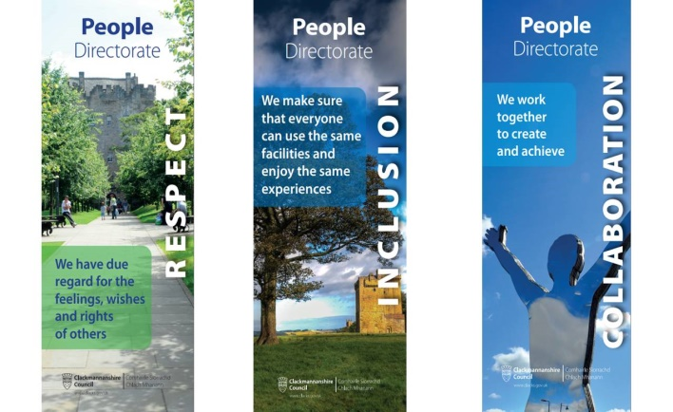Despite the recent and ongoing global challenges, our mission to educate, protect, support and promote the achievements, health and wellbeing of every child and young person has ensured our children continue to flourish. Much of our work is undertaken in partnership with other services, agencies, communities, children, young people and their families. Improvements and a relentless focus on wellbeing is delivered in collaboration across educational establishments, services and with other regional and national partners.

With the full support of our Headteachers, Elected Members, Chief Executive, our corporate colleagues and partners, we are committed to our values of Respect, Inclusion and Collaboration - raising attainment, tackling inequity and ensuring that high aspirations and positive outcomes are the expected norm for every child in Clackmannanshire. Health and wellbeing, safety of our pupils and staff and educational attainment continue to be at the forefront of our minds.

We are committed to ensuring that the views of our children, families, communities and partners are taken into account when planning and delivering our services. We are committed to UNCRC which has recently been incorporated into Scot’s law. Shared ownership and awareness of the education values is key.

* Respect – we have due regard for the feelings, wishes and rights of others
* Inclusion – we make sure that everyone can enjoy the same experiences
* Collaboration – we work together to create and achieve

Parents and carers, who have always been the most important educators of their own children, assumed an even greater role during lockdown, supporting their children to continue learning in whatever way possible, whilst keeping them safe and well. I believe we now need to strengthen parental involvement in education and continue to provide flexible systems to enable parental engagement and representation.

I encourage you to get involved in whatever way you can, be that via Twitter, Class Dojo or other in school activities to help you support your child’s learning. Read with your child every day! Ask them what they have learned that day and get them to show you! Look out for opportunities to learn together as a family!

We are all ambitious for our children and young people and together we can ensure the best possible future for all in Clackmannanshire.



**Colin Bruce**

**Chief Education Officer**

**Clackmannanshire**

**Footnote:** If you want a printed copy of this handbook, please ask the school.

It may be possible to offer some assistance in helping to translate all or part of this handbook to parents whose first language is not English. Enquiries should be directed to the school in the first instance.

Disclaimer

The information in this school handbook is considered to be correct at the time of publication (Dec 2025), however, it is possible that there may be some inaccuracy by the start of the school term in August 2026.

# Curriculum for Excellence

## Learning Entitlements

### In addition to the entitlements of Curriculum for Excellence our education provision will reflect local needs and circumstances. Therefore, at different stages of their education, our learners will have opportunities to:

* Link aspects of their learning to the local environment and its heritage
* Participate on a residential experience where possible
* Participate in arts, sports and cultural events
* Participate in environmental projects
* Participate in a community project
* Participate in outdoor learning experiences
* Access appropriate technology
* Be consulted on and contribute to the decision making process in school
* Experience work based learning
* Develop collaborative, social, leadership and other life skills
* Access academic and vocational learning experiences
* Access learning experiences designed and / or delivered by relevant partners
* Reflect upon and be pro active in planning and making choices about their own learning
* Engage with learners in other countries and demonstrate knowledge of their culture.

### How can you help?

By law, you must make sure your child receives education.

As a parent, you can help your child by:

* making sure your child goes to school regularly;
* encouraging and supporting your child with any homework given;
* showing that you are interested in how your child is getting on at school;
* encouraging your child to respect the school and the whole school community; and
* being involved in the school.

Throughout this handbook the term ‘parent’ has the meaning attributed in the Standards in Scotland's Schools Act 2000 and the Scottish Schools (Parental Involvement) Act 2006. This includes grandparents, carer or anyone else who has parental responsibility for the child.

**3. Headteacher’s welcome**



Dear Parents and Carers,

In St Bernadette’s we aim to create a warm, caring ethos in which children are encouraged and enabled to reach their potential.

Our staff are dedicated to the wellbeing of our children. They work co-operatively with our families and other partners to provide the best possible education for our children. We create a happy and purposeful atmosphere in school where everybody is respected and valued. Our staff build excellent relationships with pupils and parents.

Our pupils exhibit a very high standard of personal behaviour in school largely due to the individual care and guidance we offer and the support we receive from our families.

This school brochure is intended to provide information about the school and covers areas that may be of interest. It will not answer all the questions you may have so please do not hesitate to contact me. I will be happy to discuss any other matters with you.

In August 2019, we moved to our new home in the Tullibody South Campus. While enjoying the new facilities shared with Abercromby Primary and Tulach Nursery, we maintain our distinct ethos and Catholic Identity. This is not a school merger, we remain separate schools.

We are proud of our school and our achievements and would be delighted to show them to you.

Yours sincerely

Kirsty McDonald

Acting Headteacher

**4. School Information**

**School address**: **Tullibody South Campus**

**The Orchard**

**Tullibody**

**FK10 2SD**

**Telephone number: 01259 452321**

# Fax number: 01259 210874

**Email address:** **stbernadette@edu.clacks.gov.uk**

**Website:** [**http://www.st-bernadettes.clacks.sch.uk/**](http://www.st-bernadettes.clacks.sch.uk/)

**Acting Headteacher Ms Kirsty McDonald**

**Acting Headteacher email: clkmcdonald@glow.sch.uk**

**Roll of the School: 92**

**Number of Classes: 4**

**Denominational Status: Roman Catholic**

**Stages of School**: **Primary 1 to Primary 7**

Any parent or carer wishing to enrol their child in St Bernadette’s should contact Ms McDonald. Our Nursery – P1 transition programme involves our future P1 pupils visiting the school, meeting their class teacher and spending time with future classmates.

**5. Organisation of the School Day**

**Primary 1 pupils attend school on a full- time basis after the first week.**

Start time 9.00am

Morning Break 10.30am

Lunch Time 12noon-12.45pm

Finish Time 3.00pm

**Gym days for pupils are on a Monday and Tuesday**

**Assembly is on a Friday afternoon.**

**6. School Term Dates 2025/26**



We operate a set pattern of school holidays.

**Autumn term:** Starts on the Monday of the second full week in August.(as the first 2 days are normally staff development days pupils will start on the Wednesday)

**October holiday:** Two weeks  starting on the Monday of the second full week in October.

**Christmas holiday:** Two full weeks to include two public holidays on 1st and 2nd January.

**Easter holiday:** The first Monday in April, for two weeks, regardless of when Easter weekend falls.

| **Event** | **Date** |
| --- | --- |
| Autumn term begins (**Staff only** - staff development days): | Monday & Tuesday 11 & 12 August 2025 |
| Autumn term begins (**Pupils**): | Wednesday 13 August 2025 |
| Autumn term ends: | Friday 10 October 2025 |
| October holiday begins: | Monday 13 October 2025 |
| October holiday ends: | Friday 24 October 2025 |
| Winter term begins: | Monday 27 October 2025 |
| Staff development day (pupils off) | Friday 28 November 2025 |
| Winter term ends | Friday 19 December 2025 |
| Christmas holiday begins: | Monday 22 December 2025 |
| Christmas holiday ends: | Friday 2 January 2026 |
| Spring term begins: | Monday 5 January 2026 |
| Staff development days (pupils off) | Monday & Tuesday 9 & 10 February 2026 |
| Spring half-term holiday begins: | Wednesday 11 February 2026 |
| Spring half-term holiday ends: | Friday 13 February 2026 |
| Spring term ends: | Thursday 2 April 2026 |
| Spring holidays begin: | Friday 3 April 2026 (Good Friday) |
| Spring holidays end: | Friday 17 April 2026 |
| Summer term begins: | Monday 20 April 2026 |
| May public holiday: | Monday 4 May 2026 |
| Summer term ends: | Friday 26 June 2026 |
| Summer holidays begin: | Monday 29 June 2026 |
| Summer holidays end: | Friday 7 August 2026 |

|  |
| --- |
| **Staff Development Days**   * Monday 11 August 2025 * Tuesday 12 August 2025 * Friday 28 November 2025 * Monday 9 February 2026 * Tuesday 10 February 2026 |

**7.Registration and enrolment**

For information on School Enrolment, please refer to the Clackmannanshire Council website - <https://www.clacks.gov.uk/learning/schoolenrolment/>

## **8.Attendance and absence**

It is the responsibility of parents of a child of school age to make sure that their child is educated. Most do this by sending their child to school regularly.

For more information on attendance and punctuality at school, please refer to the Clackmannanshire Council website - <https://www.clacks.gov.uk/learning/attendanceandpunctuality/>

**9.School Uniform**

Parents are asked to co-operate with the school in encouraging their child to follow the school’s dress code.

All items with the school logo and ties are available from the following local supplier:

**Scotcrest UK**

**153 West Stirling Street**

**Alva**

**FK12 5EN**

**Tel : 01259 761827**

**email :** **alva@scotcrest.co.uk**

website : <https://scotcrestschools.co.uk/Find-Your-School/Clackmannanshire/St-Bernadettes>

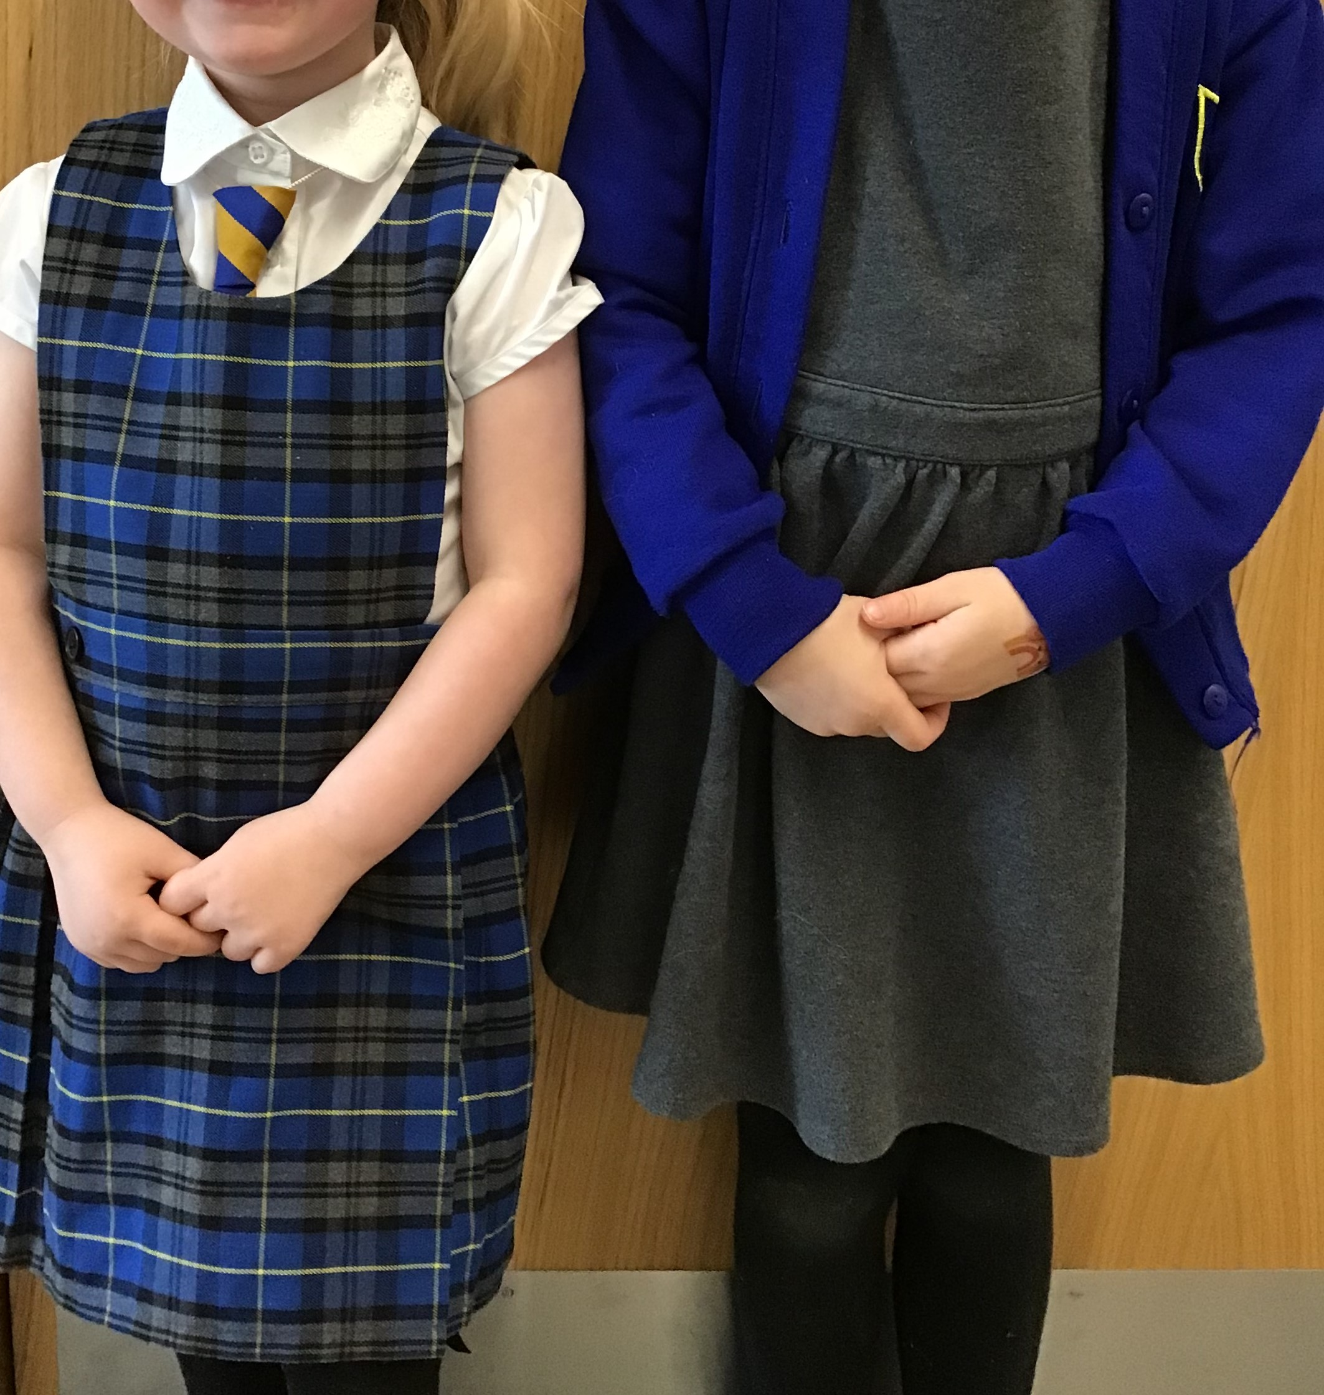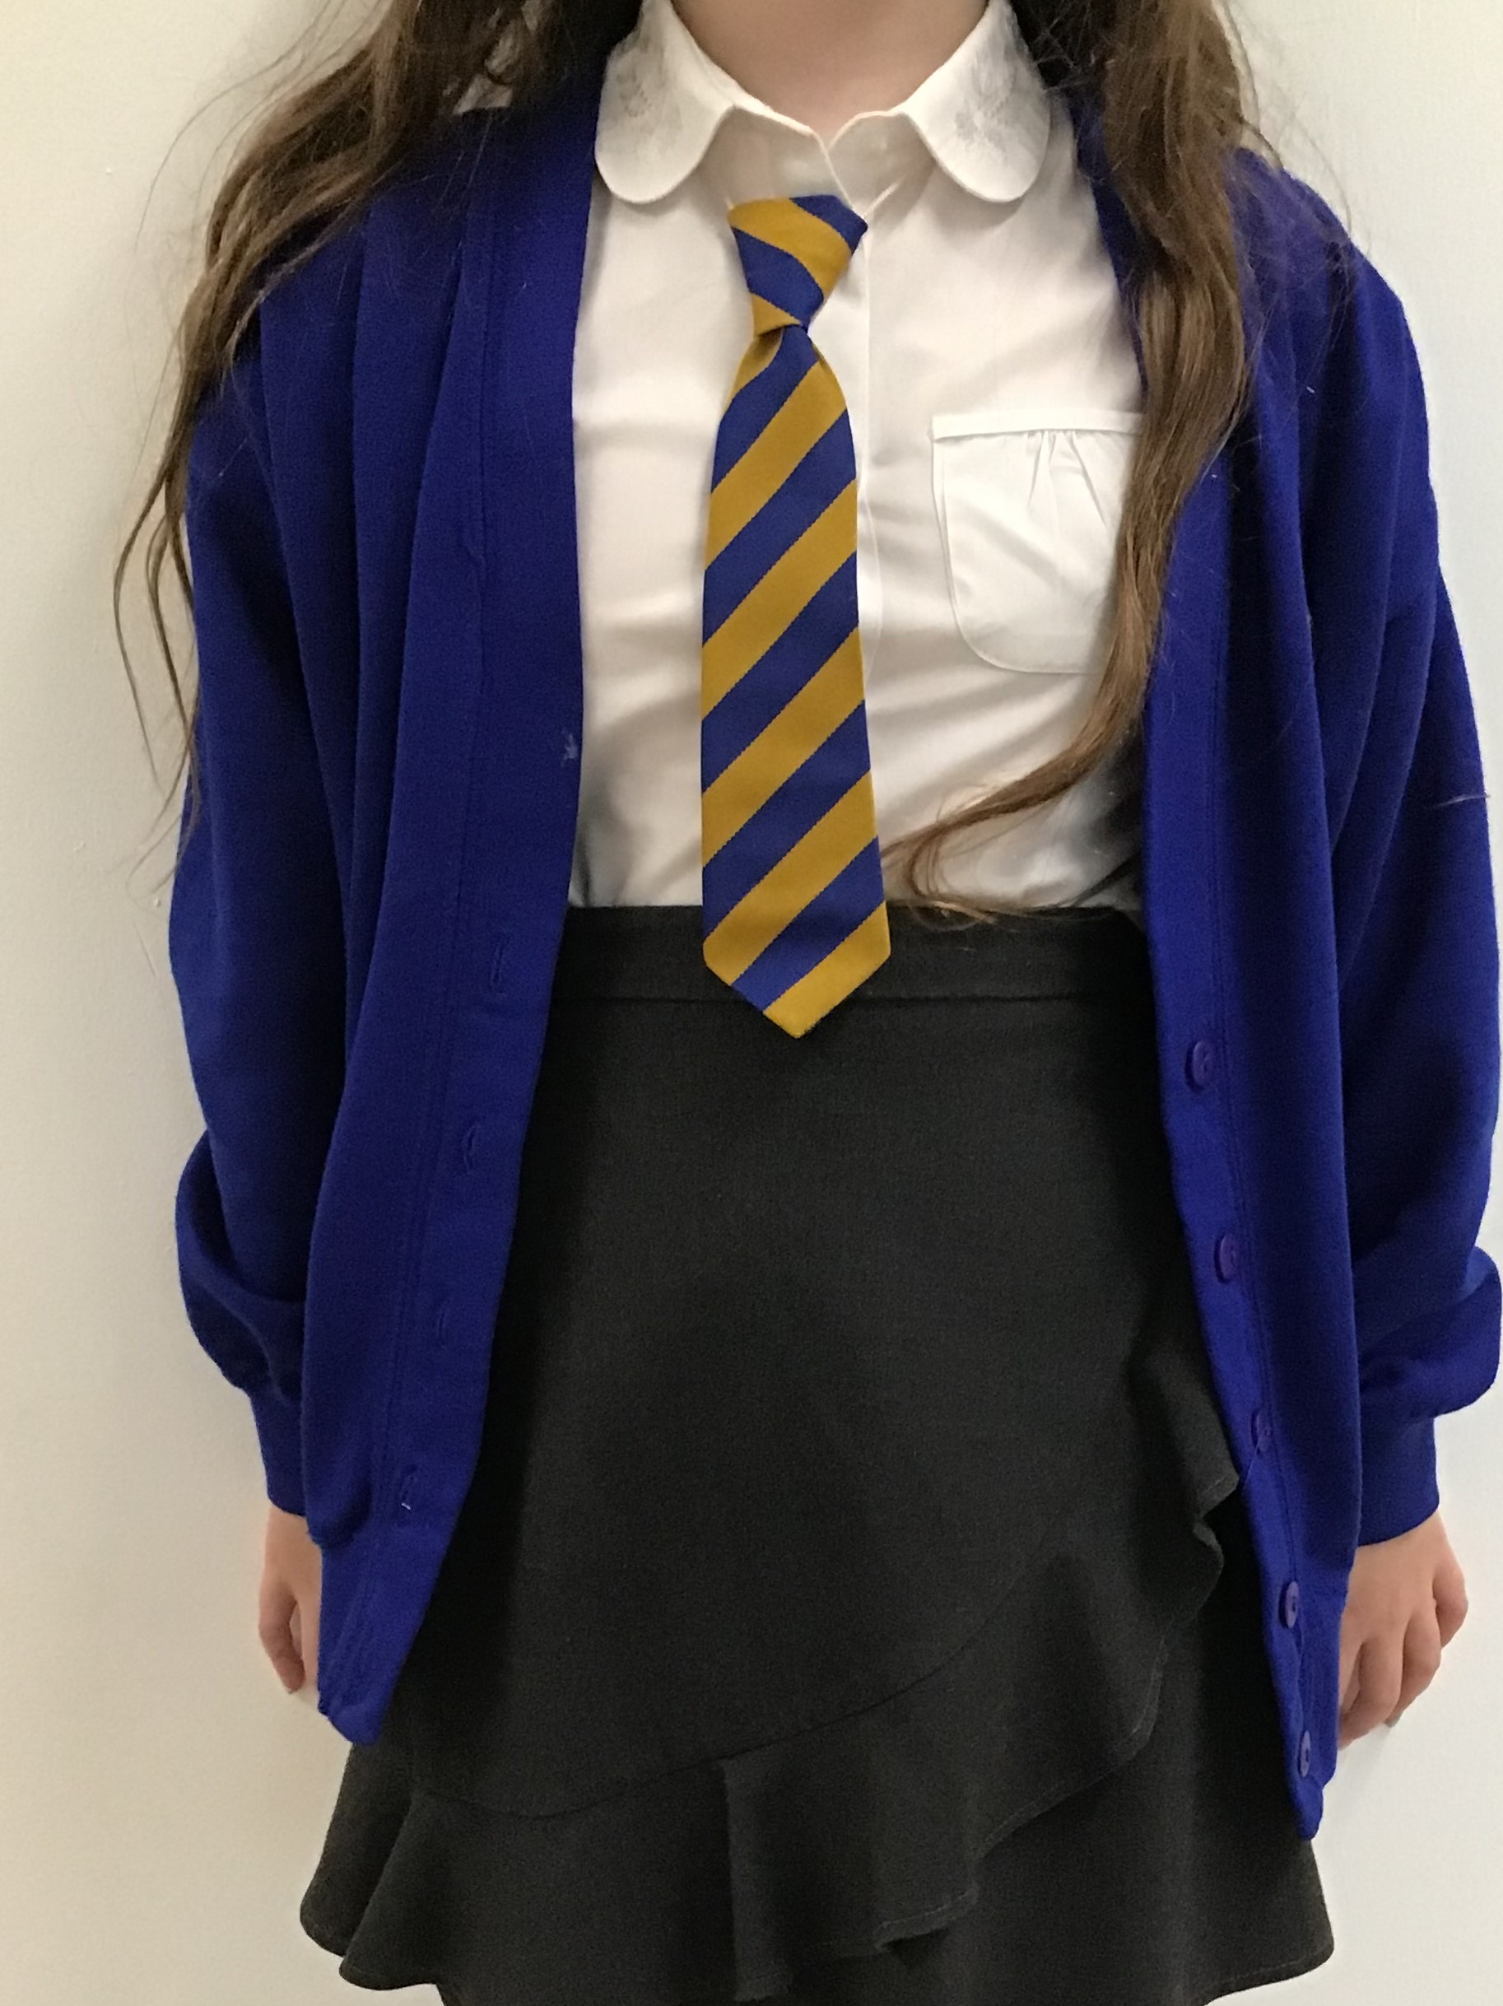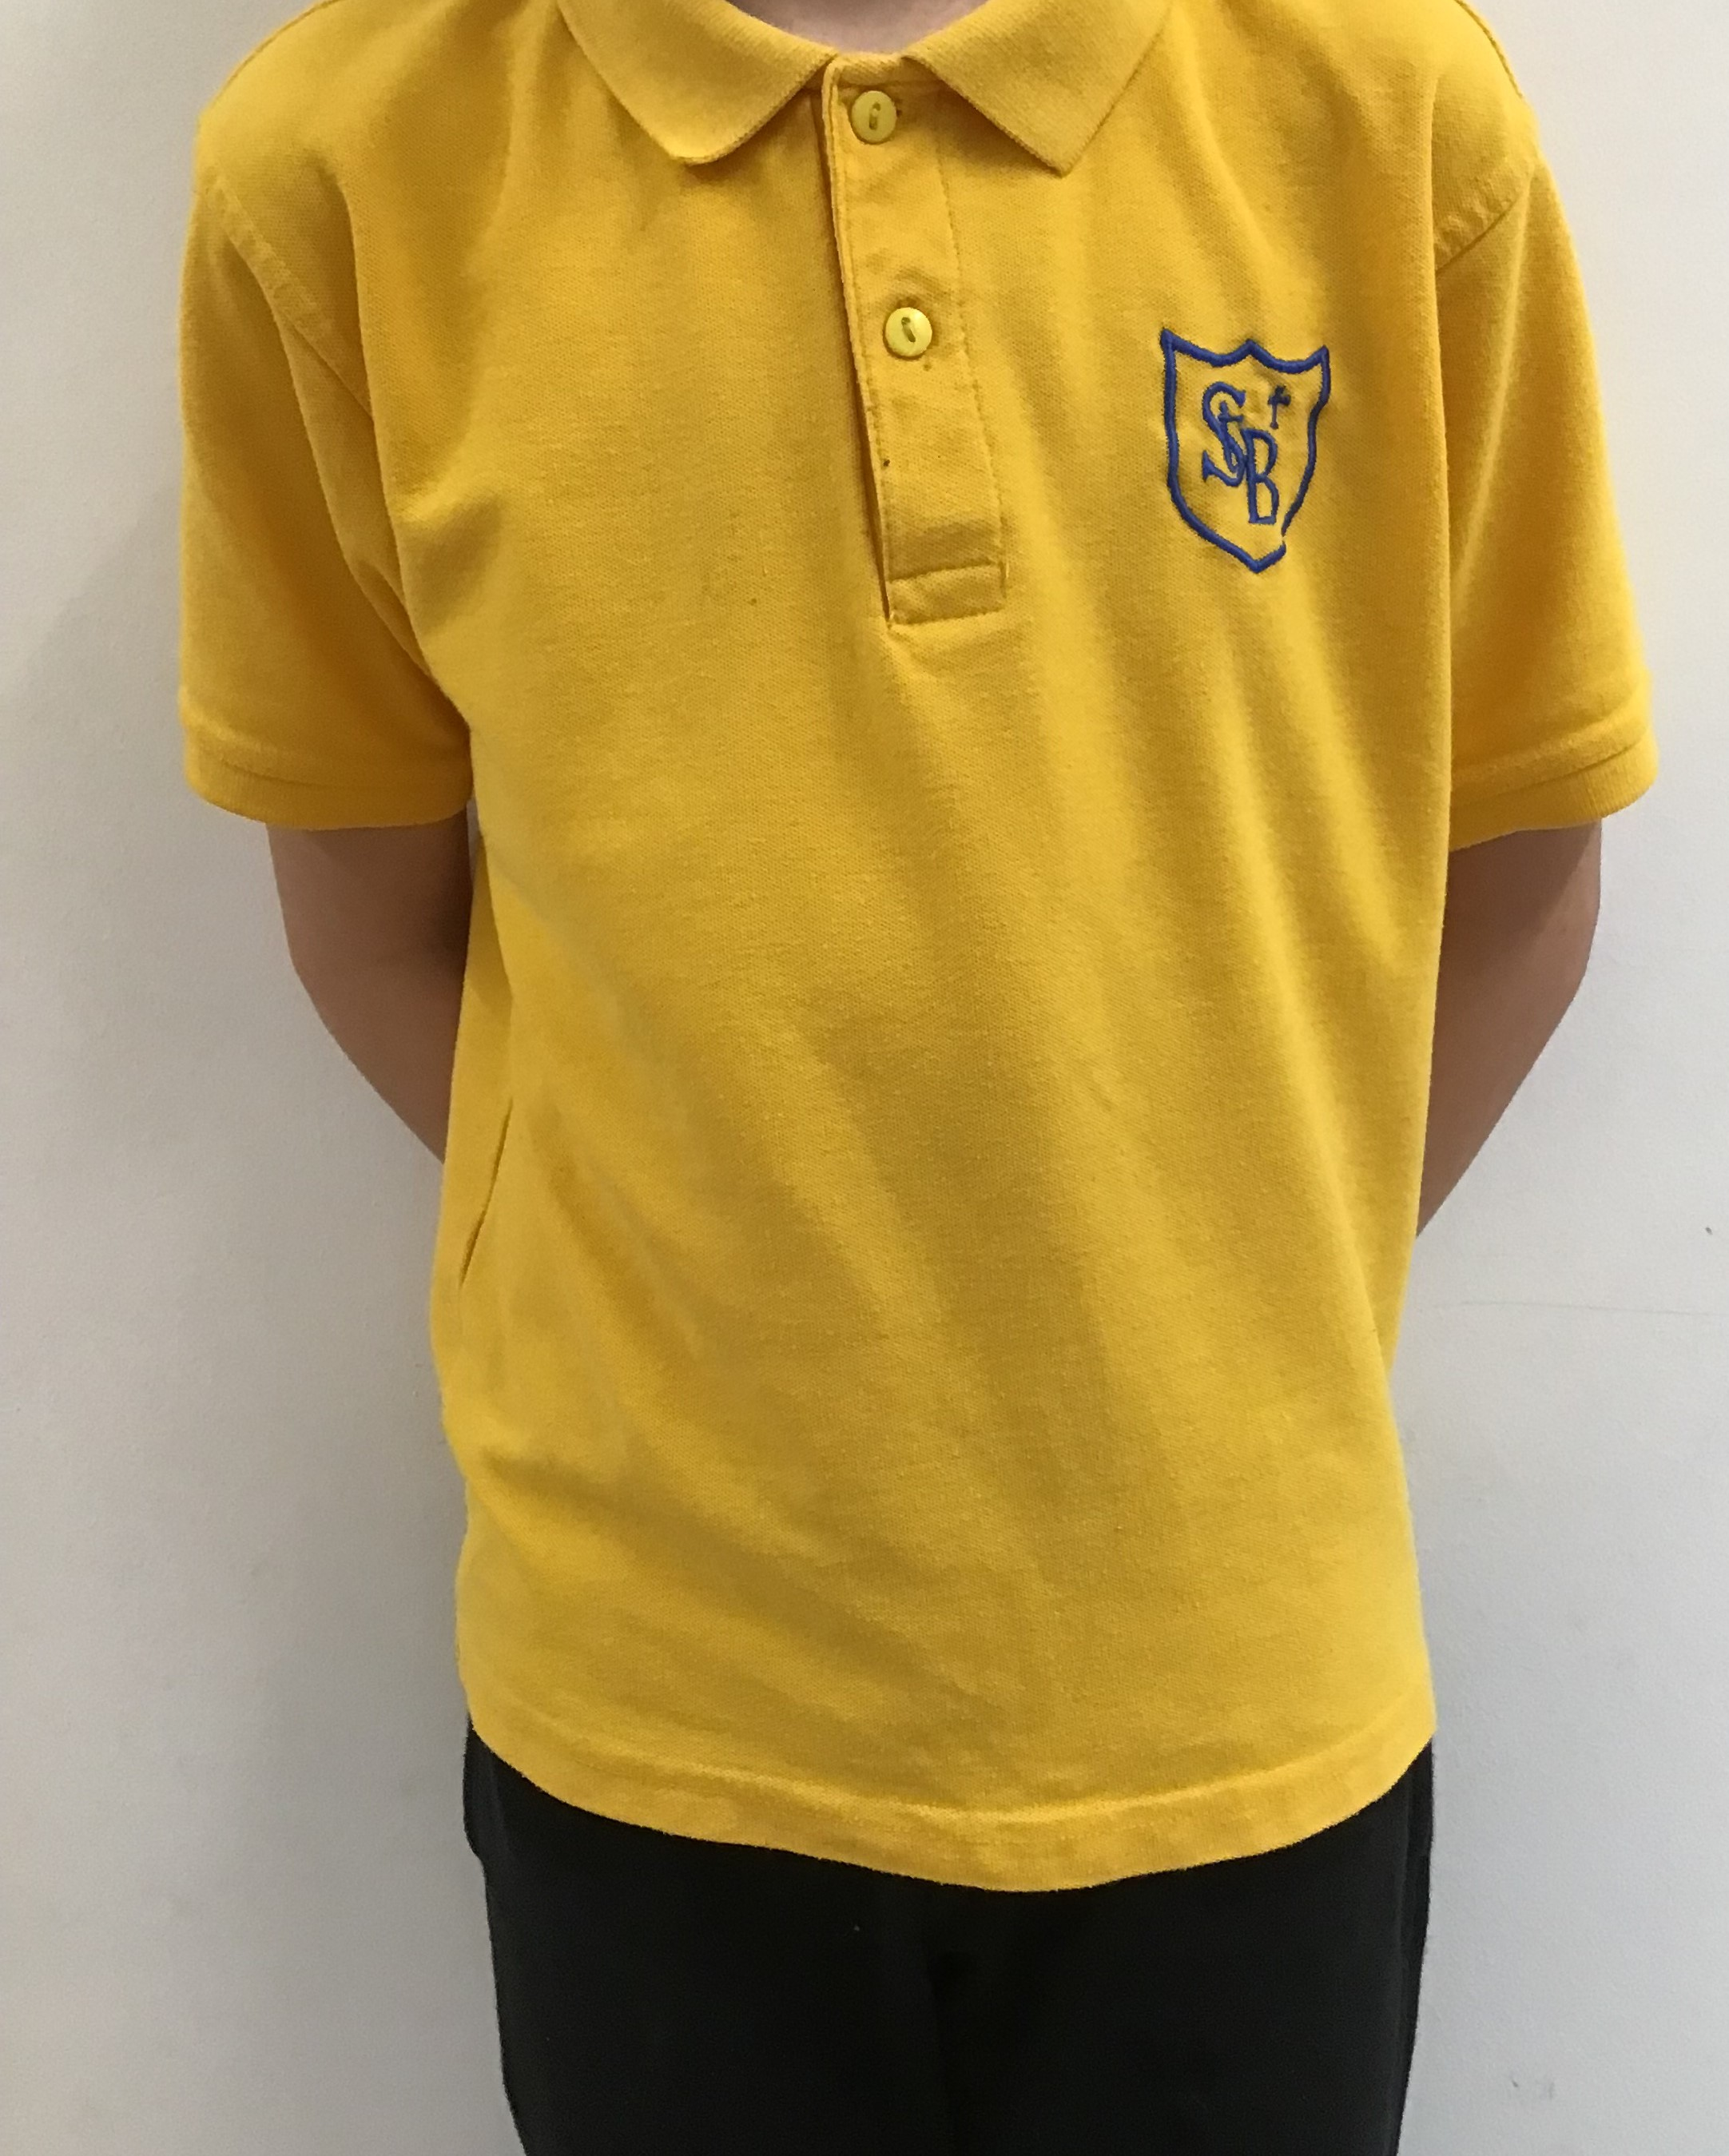

Uniform is particularly important on our shared campus.

* Royal blue jersey or sweatshirt with School badge £9.95
* Dark grey or black trousers or skirts £9.99
* White shirt and school tie £14 & £4
* Gold polo shirt £7.95
* School jackets and fleeces are also available from Scotcrest.
* Black school shoes

**PE Clothing**

Pupils must remove all jewellery for PE lessons. A plain white t-shirt or gold t-shirt with school logo and dark shorts or jogging trousers/leggings can be worn on PE days. Pupils should change into gym shoes or light trainers. Children should not have laced shoes if they cannot tie them independently.

If you have any queries regarding the school’s dress code, please contact the Headteacher.

**10.School Meals**

All pupils in P1 to P5 receive a free school meal as well as those families on qualifying benefits.

Where a pupil is in P1 to P5 and parents meet the eligibility criteria, the parent should apply for free school meals in order to receive free breakfast club, holiday food payments and the Family Bridging Payments. Those that are eligible will also receive a clothing grant payment.

Children in Clackmannanshire can access food during the school day:

* At breakfast
* At morning break
* At lunchtime

Full details of lunches served in our primary schools can be found in the Council's website <https://www.clacks.gov.uk/learning/freeschoolmeals/>

The current price of a school meal is £2.45

**Breakfasts**

A breakfast service is provided in your child’s school.

The service is available free of charge to children entitled to free school meals through the successful application for a clothing grant/free school meal. All other children can have a breakfast for **£1.40.** In this school, service starts at 8.30am.

#### The primary school breakfast comprises:

* Tea, fresh semi skimmed milk or water.
* A piece of fresh fruit or a glass of fresh, unsweetened apple or orange juice
* Cereal with milk. There is a choice of three cereals.
* Toast or crusty bread with spread and a choice of jam or cheese.

Morning break

All primary schools in Clackmannanshire operate a Milk Scheme. Under the Scheme, all children who are entitled to free school meals, through the successful application for a clothing grant/free school meal, will be given a 200ml carton of chilled, semi-skimmed milk, free of charge, unless the parent opts out of the Scheme. Other children and their parents can choose to opt-in to the Scheme and pay 75p per week.

Please provide your child with a healthy snack for morning break.

**Lunchtime**

Packed lunches and school dinners are eaten together in the lunch hall.

Special menu days are held throughout the year e.g. Christmas, St Valentines Day.

The Service constantly reviews raw ingredients and recipes. Where possible, we try to source produce locally and plan to put together a “tasting panel” of pupils to check out new recipes.

Pupils who go home for lunch leave school at 12 noon and must be back by 12.45pm.

**Snacks and Lunches**

We support healthy snack and food, we do not allow any fizzy drinks in school.

We do not allow nuts or nut products in school as part of snacks or lunches. Our “Nut-Free Policy” means that the following items should not be brought into school:

• Packs of nuts

• Peanut butter sandwiches

• Nutella spread Sandwiches

• Fruit and cereal bars that contain nuts

• Chocolate bars or sweets that contain nuts

• Cakes made with nuts

**Making Payments**

We accept payments online for items such as dinner money, school trips and uniform. Using the secure website called ParentPay you are able to pay online using your credit or debit card. ParentPay is our preferred method of making payments to school. For further information, please click on this link:

<https://www.clacks.gov.uk/learning/schoolpaymentservice/>

**Medically Prescribed Diets**

Parents with a child/ren on a medically prescribed diet should contact the Headteacher.

**Free School Meals and Clothing Grants**

Some families may be eligible to apply to Clackmannanshire Council for free school meals and / or a payment towards the cost of footwear and clothing. For more information on clothing grants, please refer to the Clackmannanshire Council website - <https://www.clacks.gov.uk/learning/schoolclothinggrants/>

**Application Forms for Clothing Grant and Free School Meals** including eligibility criteria are available from Clackmannanshire Hubs or can be downloaded from the Clackmannanshire Council website – <https://www.clacks.gov.uk/learning/schoolclothinggrants/> and <https://www.clacks.gov.uk/learning/freeschoolmeals/> .

The forms have to be completed by the parent and evidence of income received may have to be provided. Please note that an application has to be made for each school year.

More information or help with completion of the form can be obtained from Education Service on 01259 450000.

# 11.Travel to and from School

Parents should remind their child(ren) that, in the interests of safety, good behaviour is expected from all pupils travelling on school transport.

Children should be reminded by parents that, wherever possible, they should only cross the road where there is a crossing patrol and should exercise care on walking to and from school.

Parents are requested, when dropping off/collecting children from school, that they do not park near the pedestrian exit or in any location which causes an obstruction and they take care not to restrict the view of the school crossing patrol.

**Transport for Primary and Secondary School Children (Excluding Placing Requests)**

Free school transport is provided to and from your home address to your child’s catchment school if they are distance entitled. For more information on school transport, please refer to the Clackmannanshire Council website - <https://www.clacks.gov.uk/learning/hometoschooltransport/>

# General Supervision

Before school begins supervision is very limited, therefore pupils should not arrive at school until as near to the school start time as possible.

**Accessibility Strategy**

All Local Authorities must have an Education Accessibility Strategy, with a three year plan of what they are going to do to make schools and Early Learning Centres accessible for children and young people with disabilities and their families. The link to the strategy can be found here <https://local.clacks.gov.uk/learning/accessibilitystrat/>

During intervals school helpers supervise the children. In addition, the Headteacher and Janitor are on call to cope with any difficulties which may arise. There is always access to the building and the children are made aware of this.

## **12. School security**

Clackmannanshire Council has introduced procedures to ensure the safety and security of pupils and staff when attending or working in a school. We use a number of security measures including a visitors’ book, badges and escorts, while visitors are within the school building. Normally, anyone calling at a school for any reason, will be asked to report to the school office. The school staff then can make the necessary arrangements for the visit.

# Wet Weather Arrangements

In wet weather pupils are allowed into school during breaks and at lunchtime. However, as supervision during these periods is limited, it is especially important that they exercise good behaviour. Children having school lunches may remain in school during wet weather but, again, supervision is limited.

Parents Meetings

All of our schools offer opportunities for parents to discuss their child's progress with teachers through arranged meetings. Arrangements vary from school to school but all parents will be advised of when these meetings will take place. In addition to these set dates, parents are able to contact the school at any time to ask for information or for a meeting.

Communication with Home

From time to time your child will bring home important and routine communications from the school. Parents are encouraged to check their child’s schoolbag for these communications. Enquiries of any kind should be addressed to the Head Teacher in the first instance.

# Unexpected Closures

Most closures will be notified to you in advance, but there are occasions when the children may be dismissed early without warning, e.g. as a result of power cuts or severe weather. In the event of an early school closure please ensure that your child knows where to go if you are not usually at home during the day. To help us keep you informed it is important that you make sure we have the most up to date emergency contact information for your family. We will keep in touch using text messaging, via the Clackmannanshire Council website, social media or via information broadcast on Central FM.

## **Mobile devices**

Education establishments develop their own mobile device policies in consultation with pupils, parents and staff. For more information on this topic, please contact your child’s school.

**Equality**

The council is required to work towards advancing equality of opportunity for all people and to foster good relations between people. The council is committed to eliminating discrimination on the grounds of race, sex, disability, sexual orientation, religion/belief, age, marriage or civil partnership, transgender status, pregnancy/maternity or poverty.

13 Compliments, Enquiries and Complaints Procedure

Clackmannanshire Council Education Service would like you to be completely satisfied with your child's education. We encourage feedback on our services from parents, pupils and members of the public. We are interested in feedback of all kinds, whether it be compliments, enquiries or complaints.

Sometimes, customers may feel that the services provided are not what they wished for and they may wish to complain. If you, or your child has a complaint about the service provided by the school, please let us know.

**How do I complain?**

Complaints can be made to schools in writing, by email, on the telephone, in person or by using the Clackmannanshire Council online complaints form on the website.

**Who do I complain to?**

Parents must first consult the school regarding their complaint – unless there are exceptional circumstances. Clackmannanshire Council is implementing a Child Friendly Complaints process. If parents are complaining on behalf of their child, if the child can understand the issue and express their views, the child will be asked their opinion and/or asked to give for informed consent if they want their parent to proceed with the complaint on their behalf.

**What else do I need to know?**

Please note that schools can only respond to complaints about a service that they or Clackmannanshire Council provides or a service we have contracted from a third party.

The Council’s complaints handling procedure sets a time limit for making a complaint of six months from when the customer first knew of the problem

You can find out more about the Council’s Complaint Procedure from the Clackmannanshire Council website - <https://www.clacks.gov.uk/council/commentsandcomplaints/>

# 14. School Health Service

# The School Nursing Service within NHS Forth Valley consists of School Nurses, Trainee School Nurses and School Nursing Family Support Workers who work across three localities: Falkirk, Stirling and Clackmannanshire.

School Nurses are experienced registered nurses who have completed an additional Post Graduate Qualification in Public Health.

School Nursing is a transforming role which focuses on prevention, early intervention and support for school aged Children and Young People aged 5-19.

School Nurses concentrate primarily on ten priority areas under the overall headings of vulnerable children and families, mental health and wellbeing, and risk-taking behaviour.

* Emotional Health and Wellbeing
* Substance Misuse
* Child Protection
* Domestic Abuse
* Looked after children
* Homelessness
* Youth Justice
* Young Carers
* Sexual Health
* Transitions

Children and Young People and their parents/carers seeking support can complete the request for contact form on the website.

Operating hours are Monday to Friday, 8:30 am to 4:30 pm, including school holidays but excluding public holidays.

As part of the child health programme there is a routine health review offered to all primary 1 children.

Flu Vaccine

All primary and secondary school pupils are eligible for the flu vaccine, which is given in schools as a painless nasal spray. Consent packs containing a letter, leaflet and consent form will be sent home to parents and carers of school children on return to school in August. Secondary pupils can self-consent, though they are encouraged to speak to a parent or carer first.

Primary and secondary school pupils are vaccinated by NHS Forth Valley’s Immunisation staff in their school. The school flu vaccination programme runs from September – December.

Young People Vaccinations

From January to the end of February, the Td/IPV vaccine and the meningitis ACWY vaccine is delivered in schools and is offered to all young people who are in S3 (around 14 years of age).

From the end of February to the end of March the Human Papillomavirus (HPV) vaccine is delivered in schools and offered to every S1 pupil (first dose) and S2 (second dose).

Oral Health Improvement

Oral Health Improvement in Forth Valley is delivered collaboratively by the Health Improvement Service, Public Dental Service, Oral Health Improvement (OHI) team and Public Health Nutrition (AHP Dietetics).

Childsmile is a national programme which aims to improve the dental health of children in Scotland.

For more information on the main elements of the programme, visit the Childsmile website, or contact the Childsmile Team at [fv.childsmileforthvalley@nhs.scot](mailto:fv.childsmileforthvalley@nhs.scot).

Infectious Diseases

Colds, flu and gastroenteritis are the most common infections affecting children of school age. It is important that you keep your child off school in the early stages of flu and while they still have diarrhoea.

It is also important that your child understands how to prevent picking up and spreading such infections. You will be able to get further advice about good health from staff in your Health Centre or GP Practice.

For advice about early detection and treatment for other infectious diseases e.g. chickenpox and mumps, please consult your GP or Nurse.

Head Lice

Head lice are spread through head to head contact at home, while playing or in school.

Regular wet combing of your child’s hair using a head lice detection comb is the best way to catch this possible problem at an early stage.

The only way to be sure that your child has head lice is to find a live louse. If you find live lice, get the correct lotion from your doctor, health visitor or pharmacist. Shampoos and other treatments are not effective.

One treatment is two applications of the treatment lotion, seven days apart. If this is not followed then re-infection is likely.

Advise family members and close friends that your child has head lice and that they should check their own hair. Only treat if live lice are found. Don’t be shy about advising others of this possible problem because you would likely tell family and friends about other infections which might affect them.

Regular wet combing of your child’s hair with the head lice detector comb is the best protection as it allows you to detect the condition and treat it speedily.

Further advice can be accessed online

[Head lice and nits - NHS (www.nhs.uk)](https://www.nhs.uk/conditions/head-lice-and-nits/)

**Clinics**

From time to time some children are asked to attend clinics (eye clinics, dentist, doctor, etc). Please inform the school of these visits and arrange for your child to be collected if he/she must leave school to attend the clinic.

No child will be allowed away from school during school hours unless accompanied by a responsible adult or unless written permission to do so has been given by the parent.

# Medicine administration

# The administration of medicines prescribed by a doctor is undertaken at the discretion of the Headteacher but schools are generally happy to co-operate with parents in doing so. In order to safeguard the health and safety of children, procedures are drawn up by Clackmannanshire Council Education Services.

When a child is prescribed medication by a doctor or a dentist and parents require the school to administer this, the relevant request Form should be completed. Prescribed medication should be clearly marked with your child’s name, the date prescribed, how often it has to be taken and for how long.

Clackmannanshire Council liability insurance does not provide indemnity to employees for administering non- prescribed medicines.

For medical appointments during school hours, please notify the school by letter and collect your child from the school.

**15. Insurance Cover for School Children**

**Public Liability**

**Personal Injury**

Clackmannanshire Council has in force a Public Liability policy which operates in respect of claims for injury to any school child whilst in the control of the Council or employees, but the onus is on the claimant to prove that the Council have been negligent.

**Pupil’s Property**

Each session, unfortunately but inevitably, pupil’s property is lost, damaged or stolen from school. Parents are therefore discouraged from allowing their children to carry expensive items of personal belongings to the school and are reminded that a standard household policy can be extended to provide a degree of cover for personal items taken away from the home.

Any claim made for loss or damage to the property left in the care of the school will have to be submitted, in the first instance to Education Service, and the claim will only be settled if it is shown that the Council can be held legally liable for the loss.

**Personal Accident Cover/Travel Insurance**

The Council has in force Personal Accident Cover and Travel Insurance for all school trips within the UK and Abroad which has been organised by the school. The Insurance Section, Kilncraigs, Alloa should be advised of all school trips by the school detailing number of pupils, number of teachers, number of nights, itinerary and trip destination.

## 

## 

## 

## **16.Parents Welcome**

All Clackmannanshire Council schools welcome parental involvement and engagement. Research has shown that when parents are involved children do better in school.

We recognise that the support of our children’s families is crucial in ensuring that our children have the best possible experience at St Bernadette’s.

**Communication methods**

Open Door Policy – the Acting Headteacher is available for all parents and carers at any time providing they are not teaching or in another meeting. Please either pop in to the school office or phone for an appointment. Teachers, the Acting Headteacher are also available in the playground at 3pm on most days.

* Sway newsletters are emailed on a regular basis to keep parents informed.
* Class Dojo is used by class teachers and the senior management team to share information with families.
* Letters – further information that requires a response may be sent out in letter form.
* School website contains information about the school.
* Text messaging and emails – Please ensure that you update email addresses and phone numbers as email and text are increasingly important in our communication with families.
* Questionnaires – families’ views are essential in our improvement planning and self-evaluation work. We greatly appreciate all responses.
* School events such as Parents Nights, Open Evenings, Sharing our Learning, Pupils and Parents as Partners meetings are all ways to build our school community and to ensure that our partnership working is strong and supportive of our children.

**Emergency Contact Information**

**At the start of each school session, parents will be issued with the annual data check form. Please ensure that this is completed and returned to the school. It is also important that you let us know if there are changes to your telephone number(s) or to those of your emergency contacts throughout the year.**

**17.Parental Involvement and Engagement**

**Opportunities to get involved**

* Meetings - Parents and carers are welcome in the school to discuss any aspect of their child’s development and progress. To avoid disappointment, it is advisable to make an appointment.
* Pupil Progress Meetings
* Parents and Pupils as Partners - We invite parents to meet with pupils to discuss the School Improvement Plan priorities and to inform decision-making.
* Sharing our Learning – Families are invited into their child’s class at different points in the year to share in their child’s learning.
* We are keen to encourage parental interest and involvement within the School. If you have time to help in any way please contact the Headteacher.

**18. Parent Councils**

* Parents are welcomed to be:
* involved with their child’s education and learning;
* be active participants in the life of the school; and
* express their views on school education generally and work in partnership with the school.
* All parents / carers are automatically members of the Parent Forum at this school. As a member of the Parent Forum all parents can expect to –
* receive information about the school and its activities;
* hear about what partnership with parents means in our school;
* be invited to be involved in ways and times that suit you;
* identify issues you want the Parent Council to work on with the school;
* be asked your opinion by the Parent Council on issues relating to the school and the education it provides;
* work in partnership with staff; and
* enjoy taking part in the life of the school in whatever way possible.

Parent Councils are the formal representative body for parents / carers with children attending school. Parent Councils are different in each school to enable them to meet the needs of parents / carers locally.

The Parent Forum decides how their representatives on the Parent Council are chosen and how the Parent Council operates. Parents / carers are encouraged to volunteer or put themselves forward to be chosen as representatives of the Parent Council if they wish.

The main aims of the Parent Council are:

* To support the school in its work with pupils
* To represent the views of parents
* To promote contact between the school, parents, pupils, providers of nursery education and the community
* To report to the Parent Forum
* To be involved in the appointment of senior promoted staff.
* To raise funds for the school for the benefit of pupils (in some schools the PTA/PA fulfils this role).

**Parent Council Welcome**

Hello and welcome for the new school year to all St Bernadette’s RC primary families.

The parent council is a great way to meet other parents, become involved in decision making, events and fundraising to support our school.

We aim to work together with the headteacher and the school staff to build relationships between the school, parents and pupils. We use our platform at Parent Council meetings to represent the views of our parent community on matters affecting the education and welfare of our pupils and work in partnership with the school to organise and support events, fundraising activities and celebrate the achievements of the pupils and the performance of the school.

We’d love you to join us at our parent council meetings.

We also have a fundraising and parental engagement group who get together to raise funds and organise events. Please join in if you can, whether it be an hour a month, running an event, volunteering when possible, we welcome any help you can give us. Your involvement will really can make a difference to the wonderful work and support that all the teachers and staff at St Bernadette’s RC Primary do for our kids.

We have a wonderful group of parents that are strongly involved, so please come and make our team bigger and stronger

The role bearers for the 2024/2025 academic year are:

* Mrs Ashley Murdoch (Co-Chair)
* Mrs Laura Salmon (Co-Chair)
* Mr Lawrence Duke (Secretary)
* Mr Giuseppe Paladini (Treasurer)

The Parent Council can be contacted through the school. The Parent Council Facebook page is called 'Parent Group for St Bernadette's Primary School'. If you are not a member, you will need to ask to join as it is a closed group for families of our children.

We use Class Dojo to advertise our meetings and events.

If you feel like you would like to get involved or have any suggestions/concerns please send us an email. You can also email the Parent Council, our address is stbernadettespc@gmail.com

We are really grateful for all the support we receive from our parent community and we look forward to meeting you all over the coming year.

Best wishes,

Ashley and Laura

For more information on parental involvement or to find out about parents as partners in their children’s learning, please contact the school or visit the Parentzone website at www.parentzonescotland.gov.uk.

Connect is the national organisation for PTAs and PAs in Scotland, Parent Councils are members too, and it runs an independent helpline service for all parents. They can be contacted by phone on 0131 474 6199, or email on info@connect.scot or write to Connect, Mansfield Traquair Centre, 15 Mansfield Place, Edinburgh, EH3 6BB.

**19. Parentzone Scotland**

[Parentzone Scotland](https://education.gov.scot/parentzone) is a unique website for parents and carers in Scotland, from early years to beyond school. The website provides up-to-date information about learning in Scotland, and practical advice and ideas to support children’s learning at home in literacy, numeracy, health and wellbeing and science. Information is also available on Parentzone Scotland regarding additional support needs, how parents can get involved in their child’s school and education.

Parentzone Scotland also has details about schools, including performance data for school leavers from S4-S6 and links to the national, local authority and school level data on the achievement of Curriculum for Excellence levels.

**20.Children’s Rights - United Nations Convention on the Rights of the Child (UNCRC)**

The UNCRC (Incorporation) (Scotland) Act 2024 was made law on the 16th of July 2024. This means that all services provided by Councils, including schools and ELCs, must take account of children’s rights in any decisions, plans or complaints. A child is anyone under the age of 18.

All children have a right to -

* Have their voice heard and their opinion considered in any matter that affects them
* Freedom from violence, abuse and neglect
* Privacy and confidentiality
* Access to primary and secondary education
* All adults must act in the child’s best interests - this is a top priority

Most schools and ELCs in Clackmannanshire are working towards their Rights Respecting Schools (RRS) award which puts children’s rights at the heart of everything they do. Children and adults learn about children’s rights which enables children to reach their full potential. If you want to know more about RRS, please ask any staff member.

More information about our Children’s Rights work will follow during the session as the UNCRC Act is implemented. You can find out more about UNCRC in this leaflet for parents -[Parent Club UNCRC - Your guide to children's rights.pdf](https://www.parentclub.scot/sites/default/files/inline-files/Parent%20Club%20UNCRC%20-%20Your%20guide%20to%20children%27s%20rights.pdf)

**21.Pupil Council**

**Pupil Voice and Leadership**

Children are asked for their views on a regular basis in class and at assemblies. They can take on roles representing their peers on committees and at meetings. Involving our children and families in decision-making is important to our development as a school and we are keen to find new ways to do this. Laudato Si is a sustainability initiative based on Pope Francis’ teachings on the need to be ‘good stewards’ of the Earth. The programme offers leadership opportunities.

Children also represent the school at sporting events and, in P7, receive training and opportunities to act as Sports Young Leaders at afterschool clubs. The Sports Young Leaders were involved in changing our House Groups. All children voted and we also asked for Parental votes. It was decided the House groups are based on our Gospel Values: Love, Hope, Forgiveness and Gentleness. All senior pupils are trained as Young Leaders and are asked to take on responsibilities across the school as buddies and playground helpers. The curriculum is designed to allow pupils to lead projects across the school; e.g. SCIAF fundraising.

We are establishing 4 Leadership Groups in school: Laudato Si, Rights Respecting School, Equity and Environment. The children in these groups will lead their learning and share during assemblies.

**22.School Ethos**

Our ethos is rooted in our Faith. All members of our school community are encouraged to live the Gospel Values, loving and supporting each other while striving to develop our unique gifts and abilities. We aim to enable each of our children to achieve their God – given potential.

Our vision for our children is that they;

* develop a strong connection to their environment and a determination to contribute to it;
* are empowered to make choices that enhance their health and wellbeing throughout their lives;
* develop the skills for learning, life and work that they will need to thrive in the workplace.

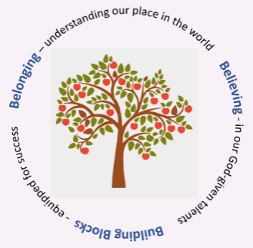When we talk about this with our children, we talk about our 3Bs: **Belonging, Believing & Building Blocks**

We are working on the incorporation of the United Nations Convention on the Rights of the Child into the life and work of the school. We are also learning about sustainability as a Laudato Si school. We work with the St Modan’s Learning Community and Lornshill Learning Community.

Our Gospel Values are the foundation of our school. All members of our community are encouraged to live these values and restorative conversations are structured around them:

* Love
* Hope
* Justice
* Gentleness
* Compassion
* Forgiveness

Our Gospel Values support us in our quest to be an inclusive and welcoming school for all of our children and families. We believe that our diversity is our strength. Our school is fortunate to include children whose families come from all over the world.

At St Bernadette’s we recognise parents as first educators of faith in our children. We work in partnership with home and parish to support formation of the whole child. We work closely with Father Mike at St. Bernadette’s RC Church and the Diocese of Dunkeld.

Religious Education supports the development of self-awareness, relationships with others and the realm of beliefs, values and practices.

The school is committed to supporting the development of it’s pupils as whole people and responsible citizens and as a result, wishes to encourage their development in spiritual, moral, social and cultural terms.

We attend Mass every term and more frequently during Lent and Advent.

Development of Pupils' Spiritual, Moral, Cultural and Social Values

The school is committed to supporting the development of its pupils as whole people and as a result, wishes to encourage their development in spiritual, moral, social and cultural terms.

These key human aspects of learning are supported through the following arrangements by:-

* Creating a school ethos which, in every way possible, gives value to these aspects of development, especially by providing an overall atmosphere that is both caring and challenging and which provides opportunities for the development of personal responsibility.
* Promoting social and moral learning through the way in which disciplinary issues are handled.
* Ensuring that staff and adults within the school provide positive models for pupils.
* Arranging regular gatherings of the school as a community and using such occasions to encourage and reinforce the values on which the school is based.
* Enriching the curriculum in all appropriate areas with an emphasis on spiritual, moral, social and cultural development.
* Providing opportunities within the curriculum to advance personal and social development.
* Providing a programme of religious education in which consideration will be given to responses to basic questions relating to the meaning, value and purpose of human life.
* Providing a programme of moral education.
* Taking every appropriate opportunity to acknowledge, value and appreciate the various cultures and heritage of the pupils and to encourage them to appreciate and value the cultures and heritage of others.

## We have recently achieved our Bronze award in becoming a Rights Respecting School. We are now working towards our Silver Award. In a Rights Respecting School, children, young people and the school community learn about children ‘rights together, putting them into practice every day.

**23.Pupil Conduct**

A partnership between the school and parents is necessary in order to ensure the best possible standards of pupil conduct.

Pupils are expected to set themselves high standards in appearance and behaviour. School rules are devised to encourage the maximum amount of self-discipline. The rules make clear what is expected of pupils, and how they are required to behave. The general aim is to produce an atmosphere of friendly co-operation, encouraging respect and consideration for other persons and for property.

.

**Our School Rules**

 In St Bernadette’s we all:

1. Work hard and follow instructions

2. Walk carefully and quietly in the school

3. Show kindness to all

4. Look after school property and grounds

5. Show respect for everyone

**Restorative Approach to Bullying Behaviour**

Whilst many believe that children who display bullying behaviour should be punished, it is widely accepted that this type of response can at times be ineffective, and make the situation worse.

The adoption of restorative approaches is a more effective response than traditional punishments. Pupils are given the opportunity to accept responsibility for their actions, recognise the harm done and are supported to find restorative responses to the harm they have caused.

There are times sanctions are appropriate; exclusion is seen as a last resort and carried out when incidents fall within the legislation criteria.

Clackmannanshire Council has a responsibility to provide an education for all pupils and to challenge and address bullying behaviour. Whilst appropriate action will be taken by the school, it is also important that all parents involved, work with the school to resolve any issues in the best interests of their child or young person.

In St Bernadette’s we encourage all pupils to think of behaviour in terms of making good choices that allow them to be their best selves. Children understand that when they do not make good choices, their behaviour can negatively impact on themselves or others in terms of damaging relationships, impeding learning or loss of privileges.

Positive behaviour, commitment to learning and wider achievements are celebrated at weekly school assemblies at which 2 or 3 Headteacher Awards are given to children from each class.

**Relationships**

Our ethos is based on our Faith; our belief that all members of our school family are called to love and support each other. The idea of the school community being an extended family for our children is integral to the work that we do to promote good relationships. Our expectation is that we will all – staff, children and our families - work together to achieve the best possible outcomes for all of our learners.

We know that children and young people will fall out and disagree with each other as they form and build relationships. This is a normal part of growing up and most children and young people have the ability to bounce back from this type of behaviour. It is important to discuss how they feel and help them to develop resilience to manage their relationships. Where there is conflict between children, we seek to repair the relationship where appropriate, ensuring that all parties feel safe. We do everything in our power to prevent such behaviour amongst our pupils, and to deal effectively with any incidents that might occur. Please be assured that incidents of bullying in St. Bernadette’s Primary School are few and far between. We believe that a strong, positive school ethos and constant work on building a caring school community, together with close contact with parents, offer the best way forward.

The Parent Council added; We really appreciate the open culture that is nurtured within the school. Staff will always consider parent council feedback fairly and this supports us being able to work in partnership with them. All concerns are treated with seriousness and staff are well equipped to support pupils with empathy.

**24. Curriculum for Excellence**

Bringing **learning to life** and **life to learning**

Curriculum for Excellence is a framework for learning and teaching used across Scotland for all 3-18 year olds – wherever they learn. It aims to **raise standards**, prepare our children for a future they do not yet know and equip them for jobs of tomorrow in a fast changing world. Curriculum for excellence was fully implemented in 2016.

Glow, Scotland’s unique, world leading, online network supports learners and teachers and plans are already in place for parents across the country to have access to Glow. Parents should ask the school how to arrange access to Glow and a user name and password will be issued.

Teachers and practitioners will share information to plan a child’s ‘learning journey’ from 3-18, helping their progression from nursery to primary, primary to secondary and beyond, ensuring each transition is smooth. They’ll ensure children continue to work at a pace they can cope with and with challenge they can thrive on.

Curriculum for Excellence balances the importance of **knowledge** and **skills**.

Every child is entitled to a **broad and deep** general education, whatever their level and ability. Every single teacher and practitioner is responsible for the development of **literacy and numeracy and health and wellbeing** from Early Level through to Senior Phase.

It develops **skills** for learning, life and work, bringing real life into the classroom, making learning relevant and helping young people apply lessons to their life beyond the classroom. It links **knowledge** in one subject area to another helping make connections in their learning. It develops skills which can enable children to think for themselves, make sound judgements, challenge, enquire and find solutions.

**Assessing** **progress**  is carried out in a range of ways to meet children’s needs, ensuring children achieve their potential.

There is an entitlement to personal **support** to help young people fulfil their potential and make the most of their opportunities with **additional support** wherever that’s needed. There is emphasis on looking after our children’s **health and wellbeing;**  ensuring that school is a place where children feel safe and secure.

Ultimately, Curriculum for Excellence aims to improve our children’s life chances, to nurture **successful** learners, **confident** individuals, **effective** contributors, and **responsible** citizens, building on Scotland’s reputation for great education.

**Literacy & English**

Language is at the heart of children’s learning. It develops children’s abilities to listen, talk, read and write for many purposes. Through language children gain knowledge and acquire skills. It enables them to express themselves creatively and imaginatively as they become enthusiastic and critical readers of stories, poetry and drama as well as non-fiction and media texts. Language is central to learning and has a critical role across the curriculum.

We build on, expand and enrich the language which the child brings to school and encourage confidence, enjoyment and positive attitudes in its use. Our language and literacy curriculum provides a literacy framework which will develop children’s skills and knowledge so that they realise their full potential in the understanding and use of language.

**Numeracy & Mathematics**

Numeracy and Mathematics play an important role in our lives. It is used in everyday activities such as buying food and clothes, managing time and playing games. Through applications developed in historical and cultural context, mathematics has been one of the most decisive factors in shaping the modern world.

Our Numeracy and Mathematics curriculum supports children as they acquire skills in mathematical thinking, develop confidence in using and applying mathematics and learn to enjoy its challenges. We make imaginative, effective use of technologies, resources and teaching approaches and provide opportunities for children to take part in problem solving activities –applying their learning and using mathematical processes and knowledge in mental calculations.

**Religious Education**

At St Bernadette’s we recognise parents as first educators of faith in our children. We work in partnership with home and parish to support formation of the whole child.

Discussion of religious and moral issues should be open and pupils should be encouraged to express their own views and feelings and to listen with respect to the views and feelings of others.

The school is committed to supporting the development of it’s pupils as whole people and responsible citizens and as a result, wishes to encourage their development in spiritual, moral, social and cultural terms.

St Bernadette's is a Roman Catholic school and we implement ‘This is our Faith’ - a Religious Education Programme which is designed to teach pupils elements of their faith and to deepen in them their own personal faith. The programme is also designed to develop in each pupil a sense of moral awareness and autonomy. These guidelines have been written and approved by diocesan advisers.

While recognising the rights of parents to withdraw their children from religious education and religious observance in schools, (as enshrined in the Education Act 1980 and the Scottish Office Circular 6/91), we expect parents who choose to send their children to a Catholic School, to recognise the implications of that decision. It would therefore be in unusual circumstances that parents would request to withdraw their children from religious education and religious observance in a Catholic School. Such circumstances should in the first instance be subject to discussion between parents and the Head Teacher.

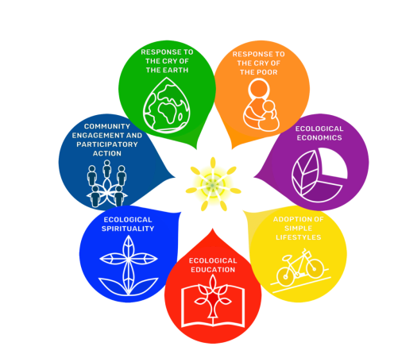

**Health and Wellbeing (Health Education, Physical Education, Personal and Social Development)**

The development lines are; Mental, emotional, social and physical wellbeing, Planning for choices and changes, Physical Education, physical activity and sport, Food and Health, Substance misuse, Relationships, sexual health and parenthood. We offer opportunities for children to explore and clarify their attitudes and values about health and lifestyle issues, develop personal and inter-personal skills and increase their knowledge and understanding of health and lifestyle issues. Children are encouraged to value themselves, grow in confidence and increasingly take responsibility for their own health. Every morning we have a soft start to allow children to come in to school to start the day.

We strive to continue to be a Health Promoting School – encouraging every child to eat healthily and be as active as they can, stay safe and be happy.

Our Relationships, Sexual Health and Parenthood Education is delivered in the context of our faith. Further information on our resources – God’s Loving Plan and This Is Our Faith can be found on the SCES website at https://sces.org.uk/catholic_school_parents/.

Our PE curriculum reflects a broad range of sport and physical activities and is enhanced by the work of Sports Development coaches. Children have the opportunity to apply the skills learned in PE when participating in local tournaments and competitions.

**Social Studies**

Social Studies integrate the main ways in which children learn about the world. The development lines of Social Studies are; *People, Past Events and Societies*, *People, Place and Environments* and *People in Society, Economy and Business*.

We have a carefully planned framework for the delivery of Social Studies across a level. This framework recognises multi-age classes and allows staff to plan to ensure the children will have a breadth and balance of knowledge, understanding and enquiry skills and will be developing their capacities as successful learners, confident individuals, effective contributors and responsible citizens. Increasingly, staff and children are also developing contexts for learning which are creative and vary each year in response to national and global events.

Staff and pupils will plan and learn most aspects of social studies using interdisciplinary approaches – this way the learning engages the children, excites them and is relevant to their real lives now and in the future. In doing this, the children will transfer skills learned in other curricular areas and practically apply them within an appropriate context for learning.

Children will develop through the 4 capacities and understanding of rights and responsibilities, the importance of active citizenship and the central concept of equality in a democratic, fair and caring multi- cultural society.

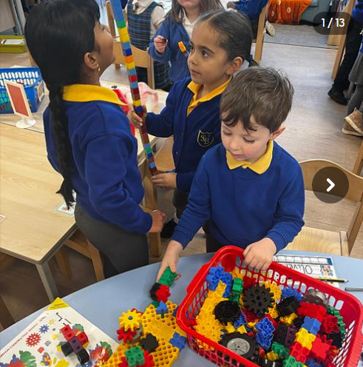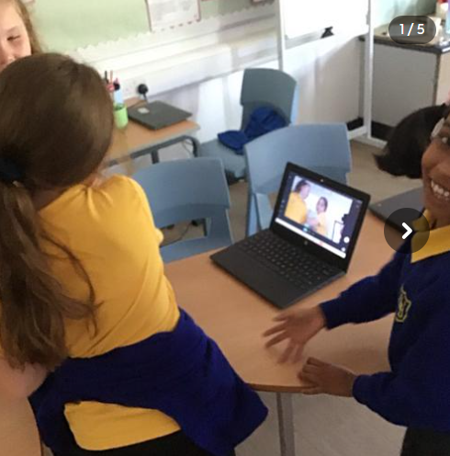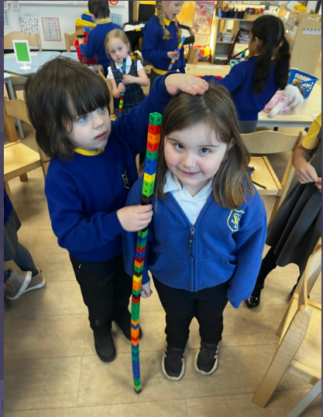

**Expressive Arts (Music, Drama, Dance)**

The Expressive Arts are fundamental in enriching the quality of teaching and learning across the curriculum through nurturing and promoting individual creative and aesthetic talents and enhancing learning through partnership with peers, creative adults, professional arts and cultural organisations. Children develop an understanding and appreciation of the power and diversity of the arts. We have an Art Teacher who comes into school on a Tuesday and works with each class for an hour.

**Sciences**

Children’s skills and knowledge are developed through opportunities to explore and investigate. The development lines for science are; Planet Earth, Energy in the Environment, Forces and Motions, Life and Cells, Communication, Materials and Topical Science. Staff will plan and teach some aspects of Science using interdisciplinary approaches.

**Technologies (ICT, Technology and Enterprise)**

Technologies include creative, practical and work-related experiences and outcomes in craft, design, engineering, graphics, food, textile and information technologies. These enable children to become informed, skilful, thoughtful, adaptable and enterprising citizens.

All children will be actively involved in Enterprise activities, developing knowledge and skills which will prove invaluable in real life.

Information and Communications Technology has the potential to enhance the quality of learning and teaching across the Curriculum. It provides both the context and the necessary tools for cross-curricular learning, developing knowledge and understanding of the world in which our children live.

The use of ICT to support and enrich the curriculum in this school will contribute significantly to the preparation of learners for taking their place in a rapidly changing technological world.

We have netbooks that allow children to connect to the internet and to develop their research and IT skills. Class computers are also linked to this network-allowing file sharing between classes. All classes have Internet access. Every classroom has access to an Interactive Whiteboard to enrich pupils’ learning experiences. The school has clear policy and guidelines on Internet use to ensure pupils only access appropriate websites. We also teach the importance of Internet safety.

**Modern Languages**

Learning other languages enables children and young people to make connections with different people and their cultures and to play a fuller part as global citizens. At St. Bernadette’s all children will experience French and Spanish as part of the 1+2 strategy.

We also work in partnership with St Modan’s who deliver a block of Spanish to our P7/6 learners.

**Assessment and Reporting**

Children's progress and attitude to work are continually monitored throughout the year and recorded on an individual basis to monitor progress and development. Interviews will be arranged for each pupil in the late Autumn and late Spring to discuss the progress and, in June, a report is issued that describes the child’s attainment and attitudes to learning and others.

Please contact the headteacher if you would like any further information about the curriculum within our school.

**Read, Write, Count with the First Minister**

Read, Write, Count with the First Minister is a programme that aims to support parental engagement in literacy and numeracy through the gifting of books and supporting materials to families. Gift bags are distributed annually to all children from birth to and P3 pupils in Scotland by Scottish Book Trust. Bookbug bags are gifted to Primary 1 children and Read, Write, Count bags are gifted to Primary 2 and 3. The bags contain literacy and numeracy materials to support children’s learning, as well as advice and support to parents. Schools build excitement and enthusiasm about the books before children take them home to their families.

Studies show a direct link between a strong family learning environment and progress in reading, writing and counting. In addition to the activity booklet included in the bags the Scottish Book Trust offers a range of hints, tips and advice to help parents engage in their child’s learning on the [website.](https://www.scottishbooktrust.com/reading-and-stories/about-read-write-count)

**Active Learning**

Curriculum for Excellence emphasises the value of an active learning approach. Active learning is engagement of the brain whilst in the early years, children will have a range of learning experiences that include planned and purposeful play and stimulating learning which engages and challenges children’s thinking using real life and imaginary situations. As children progress through school they continue to be involved in active learning experiences which give them ownership of their own learning, encourage co-operative working and utilise skills required for learning, life and work.

**Planning Children’s and Young People’s Learning**

Teachers in nursery, primary and secondary schools share their learning intentions with pupils, parents and carers. This takes place on a day-to-day basis, by agreeing the aims of an individual piece of work.

Longer-term planning also takes place in a variety of forms. Pupils in primary schools negotiate with their teachers their aims for the next block of learning. At the end of the block progress against these aims is assessed by the teacher and pupil, and new targets are set for the following block of learning.

In secondary schools, pupils periodically review progress against targets and negotiate new ones with their pastoral teacher.

In St Bernadette’s children are given many opportunities to be involved in planning and decision making in the school. Children are asked their views at St Bernadette’s in assemblies and other ways. We use – you said- we did.

The children are involved in what topics or IDL they would like to learn about and co construct learning with the class teacher.

Children are asked their views in meetings and they also share that termly with their teachers and it is recorded in Progress.

We are establishing groups or Master classes in which children will be allowed choice in which group they would like to attend on a Friday in learning new skills. Parents will also be asked to be involved in this to vary the skills that the children can learn.

# Homework

The school has a clearly defined policy on homework, a copy of which can be obtained from the Head Teacher or from the school website.

Pupils are given homework to support their learning and to encourage them to become more organised and self-supporting in their learning. Homework can arise from all curricular areas, and may include written, oral or practical activities. The tasks should interesting, worthwhile and challenging for the child.

Parents are encouraged to help pupils with their homework as a means of keeping them up to date with the work of the class and the child’s progress and to promote partnership between the school and parents. Homework provides an opportunity to consolidate what has been learned in class, and makes you aware of what your child is learning. Homework is also an integral part of school work. Parental interest and co-operation in ensuring homework is undertaken is appreciated. The school encourages parents to sign each homework task.

**Care of Books / Materials**

To enable us to provide the best possible education for your child, every care should be taken to look after the school’s resources and facilities. Parents are asked to remind their child(ren) that all school equipment and fitments should be used with care.

**Sensitive Aspects of Learning**

**Health and Wellbeing (Health Education, Physical Education, Personal and Social Development)** The development lines are; Mental, emotional, social and physical wellbeing, Planning for choices and changes, Physical Education, physical activity and sport, Food and Health, Substance misuse, Relationships, sexual health and parenthood. We offer opportunities for children to explore and clarify their attitudes and values about health and lifestyle issues, develop personal and inter-personal skills and increase their knowledge and understanding of health and lifestyle issues. Children are encouraged to value themselves, grow in confidence and increasingly take responsibility for their own health.

We strive to continue to be a Health Promoting School – encouraging every child to eat healthily and be as active as they can, stay safe and be happy.

Our Relationships, Sexual Health and Parenthood Education is delivered in the context of our faith. Further information on our resources – God’s Loving Plan and This Is Our Faith can be found on the SCES website at https://sces.org.uk/catholic_school_parents/.

**Religious Instruction and Observance**

**Religious Instruction**

Schools have a statutory duty to provide opportunities for Religious Instruction in the timetable. This aims to promote a knowledge of the Christian and other faiths and encourage children and young people to develop enquiring minds through investigating spiritual, moral and philosophical issues.

Ultimately, pupils in the upper secondary school can gain a qualification through the study of Religious, Moral and Philosophical Studies at Higher and Advanced Higher Levels. These courses further develop young people’s skills in logical thinking, methodical enquiry and ways of expressing ideas effectively.

**Religious Observance/Time for Reflection**

Religious Observance, which may take the form of a Time for Reflection, is held at least six times a year, in addition to traditional celebrations central to the life of the school community. Religious Observance will often (but not necessarily) take the form of an assembly.

**Withdrawal from Religious Instruction and Religious Observance/Time for Reflection**

Parents who wish to exercise their right to withdraw their child from religious instruction and/or observance are encouraged to initially discuss their intention with the Headteacher prior to making their decision known to the school in writing.

**A Charter for Catholic Schools in Scotland**

The mission of the Catholic school is to develop as a community of faith and learning, providing the highest quality of education, and offering formation through the promotion of Gospel values, through celebration and worship, and through service to the common good.

All Catholic schools in Scotland, in honouring Jesus Christ as the Way, the Truth and the Life, will feature the following characteristics:

✴ a commitment to the integrated education and formation of the whole person, in close partnership with parents as the first educators of their children;

✴ an inclusive ethos which aims to honour the life, dignity and voice of each person, made in the image of God;

✴ a commitment to the search for wisdom in life and to the pursuit of excellence, through the development of each person’s unique God-given talents;

✴ a commitment to the spiritual formation of the school community, through the shared experience of prayer and liturgy, and in partnership with local parishes;

✴ the provision of religious education programmes which will enable young people to develop their understanding of Gospel values and of how to apply them to life;

✴ a commitment to uphold the moral teaching, faith tradition and sacramental life of the Catholic Church;

✴ a commitment to communicate Catholic social teaching and thereby to promote social justice and opportunity for all;

✴ a commitment to ecumenical action and the unity of Christians;

✴ the promotion of respect for different beliefs and cultures and for inter-faith dialogue;

✴ a commitment to support the continuing professional and spiritual development of staff.

All staff appointed to a Catholic school are expected to support and promote the aims, mission, values and ethos of the school, as illustrated in this Charter.

**Facilities for Physical Education and Outdoor Activities**

The gym hall has a variety of apparatus for physical education within the school. As part of the school’s physical education programme, pupils may also use the facilities of the local sports complex, swimming pool or ski slope.

Our classes have PE on a Monday and Tuesday.

We have use of the main hall and the smaller gym hall which is upstairs.

During the better weather we use the MUGA which is outside within the school grounds.

**Active Schools**

The fundamental aim of Active Schools is to give school-aged children the tools, motivation and the opportunities to be more active throughout their school years and into adulthood. These opportunities are available before, during and after school, as well as in the wider community. For further information contact the Active Schools Team on 01259 450000 or visit our website <https://www.clacks.gov.uk/learning/activeschools/>

# Assessment and Reporting

As pupils progress through school, teachers use a range of assessment strategies. Pupils are also involved in assessing their own progress and developing their next steps.

We recognise that pupils do not develop and progress at the same rate and adapt teaching approaches for each child accordingly. Please contact the school as soon as possible if you have any concerns about your child’s progress.

Parents have the opportunity to find out about their child’s learning through a range of means –

* Parent Information Evenings
* Ongoing discussion with teachers and managers
* Open evenings and/or afternoons meet the teacher events
* Folios of work
* Online information such as Class Dojo or Twitter

Parents are welcome to contact the school at any time to ask for information or for an appointment to consult with the Head Teacher or class teacher.

Parental Contact is arranged throughout the session as follows:-

October: Pupil Progress Meetings

February: Interim Report

March: Pupil Progress Meetings

June: Final Report

**25.Getting It Right For Every Child (GIRFEC)**

Taking care of our children's well-being and making sure they are alright - even before they are born - helps us ensure the most positive outcomes for them later in life. It gives them the potential to grow up ready to succeed and play their part in society.

Getting it Right for Every Children (GIRFEC) is the Scottish Government’s approach to improve children’s services. The wellbeing of all children and young people is at the heart of GIRFEC. Services must work together with children, young people and their families to provide quick and effective support when it is needed

The Children and Young People Act (Scotland) 2014 will mean key parts of GIRFEC become law.

**Wellbeing**

The Getting it Right approach looks at eight areas of 'well-being'. These are recognised as areas in which children and young people need to progress in order to do well now and in the future. They allow those responsible for the care and support of children - including members of their own families - to look at a situation in a structured way that will help them identify any needs and concerns and plan with the child and family any action they need to take. The eight well-being indicators are:

* Safe
* Healthy
* Achieving
* Nurtured
* Active
* Responsible
* Respected
* Included

The approach gives them a common language and a way to gather information about a child's world, making sure the child is growing and developing, and has everything they need from the people who look after them both at home and in the wider community. It also encourages practitioners to think about who else might need to be involved (for example a teacher might need to contact other professionals to make sure that an education improvement plan with the child and family was meeting all the child's needs).

Children, young people and their parents may require additional support at different times in their life e.g. following a bereavement, illness, transition, when experiencing anxiety, behaviour issues, during or after changes in family circumstances.

Support should be tailored to meet the individual needs of children & families, when they need it and as locally as possible.

Individual or group work can be delivered in school, home or in the community.

A request for support can be made through a member of school staff (named person) who will be able to talk with you, gather information & your family’s views. This helps identify the most appropriate service.

Family Support services work in partnership with families, schools and other agencies to support young people’s wellbeing.

**Protecting Children and Young People**

All children have a right to be protected from harm, abuse and neglect. The vision of the Forth Valley Child Protection Committee is that “It’s everyone's job to make sure that children in the Forth Valley are safe."

Education Service has an important role in identifying children who have been abused or are at risk of being abused.

Clackmannanshire Council has clear procedures for all staff to follow. Headteachers or designated member of staff are instructed to notify Clackmannanshire Council and Social Work Services when a member of staff has a suspicion that a child might have been abused or be at risk of abuse.

Social Work Services will make a decision on whether or not an investigation is necessary and will advise accordingly. In every situation, the welfare of the child overrides other considerations.

**National Missing Persons Framework for Scotland**

The Scottish Government [National Missing Persons Framework for Scotland](https://www.gov.scot/binaries/content/documents/govscot/publications/strategy-plan/2017/05/national-missing-persons-framework-scotland/documents/00517676-pdf/00517676-pdf/govscot%3Adocument/00517676.pdf) describes a missing person as anyone whose whereabouts are unknown and:

· where the circumstances are out of character

· the context suggests the person may be subject to crime

· the person is at risk of harm to themselves or another

The Framework sets out the following four objectives;

* To introduce preventative measures to reduce the number of episodes of people going missing.
* To respond consistently and appropriately to missing person episodes.
* To provide the best possible support to missing people and their families.
* To protect vulnerable people to reduce the risk of harm.

All partner agencies, including Education, have a part to play in meeting these four objectives and schools refer to the Policy and Procedures to Support Attendance in Clackmannanshire Educational Establishments.

**26.Additional Support Needs**

As with all local authority schools in Scotland, this school operates under the terms of the Education (Additional Support for Learning) Scotland Act (2004) as amended 2009 and its accompanying Additional Support for Learning:Statutory Guidance 2017. Further details of the policies and procedures can be found on the Clackmannanshire Council website: <https://www.clacks.gov.uk/learning/asl/> These procedures have been strengthened through the Children and Young People (Scotland) Act (2014).

Schools and Early Learning Centres (ELC) work closely with children/young people parents/carers and other agencies and professionals such as Social Work Services, Educational Psychology Service and the National Health Service to ensure that decisions are made jointly with parents, children and young people with regards to the best possible education to meet the needs of the child within the resources available.

**Support for Pupils**

Pupils’ additional support needs will be identified and addressed through the Getting It Right For Every Child (GIRFEC) processes. This involves close collaboration between the child/young person , the parent or carer, and the staff in school – they are the core part of the Team Around the Child (TAC). Others involved in your child’s education and well-being will also be part of the TAC , and will help to complete a holistic assessment where appropriate. The TAC will also identify targets for an education plan and review as appropriate. If you believe your child may have an unidentified additional support need, your first point of contact should be the child’s class teacher or Pupil Support Teacher.

The school makes provision for pupils with additional support needs throughout their education:

* each teacher differentiates the curriculum within their class to provide educational targets and objectives suited to their age and stage of development
* the school has an experienced Support for Learning Teacher to co-ordinate and organise support for children
* the school can call on the time of a Support for Learning Assistant for exceptional cases
* The school can also make referrals to other services to request support for children and young people.

**Disputes and Resolution in Additional Support Needs**

Schools and Early Years facilities do their best to support and be responsive to the needs of children and young people and their families. Nevertheless, problems may arise, and it is important to deal with these as soon as possible.

In the first instant it is most appropriate to contact the school or ELC directly, and if the matter cannot be satisfactorily resolved, you may wish to discuss with the Quality Improvement Officer Additional Support for Learning (ASL) or the Senior Manger Inclusion and Communities.. If this cannot be resolved at this level, Children’s Services also commission independent mediation through Children in Scotland. Their services, called Resolve, may be arranged by the Additional Support for Learning Support Officer, or accessed directly by parents on 0131 222 2456 or **https://resolvemediation.org.uk/**

Parents, carers and children with additional support needs can also seek independent advice and support through:

* Enquire – the Scottish advice and information Service for additional support for learning: [www.enquire.org.uk](http://www.enquire.org.uk), 0345 123 2303

* Take Note: National Advocacy Service for Additional Support Needs (Barnados in association with the Scottish Child Law Centre) [www.sclc.org.uk](http://www.sclc.org.uk), 01316676633.
* Let’s Talk ASN, c/o Govan Law Centre, [letstalkasn@edlaw-org.uk](mailto:letstalkasn@edlaw-org.uk), 0141-445-1955

**27.Educational Psychology Service**

A new Directory of Support for Mental Health and Wellbeing is now available.

**Who we are?**

We are a small team of Educational Psychologists, managed by a Principal Educational Psychologist. We provide an educational psychology service to all schools and Early Learning and Childcare Centres (ELCs) within Clackmannanshire.

**What we do?**

Educational Psychologists (EPs) work together with families, and ELCs and other professionals, to help meet children and young people’s educational needs.

We want to make sure that our children and young people are safe, healthy, achieving, nurtured, responsible, respected and included in line with GIRFEC wellbeing indicators.

**How to involve an Educational Psychologist**

In most cases, referrals to the Educational Psychology Service (EPS) come through the Staged Intervention process in schools/ELCs. Your child’s school/ELC will seek your permission to consult with us about your child. A lot of the time we can provide advice and support through a one-off consultation but, where appropriate, we may become part of Team Around the Child (TAC) meetings if we need more information.

When we attend a meeting in school or ELC we can use the information gathered at this meeting/consultation to help us to assess what kind of support may help your child or young person meet their potential at school/ELC.

Sometimes we need to gather more information because all of our questions were not able to be answered during the TAC meeting or phone consultation.

In these cases, following a TAC or phone consultation, we may come into school or ELC

• to observe your child or young person

• hand out questionnaires to those who know them well

• talk to your child’s teacher

• ask other services who are working with your child for information

• to meet with your child to do more assessment

These steps are agreed together with you and the team around your child.

The school then arranges another TAC so that we can all work together to create the best plan of support in line with the information gathered.

Once we have finished an assessment, we will usually discharge your child or young person from our service. However, we can be invited back in for consultation or further assessment at any time.

We work within the Staged Intervention process to ensure that your child/ young person is getting the right sort of help at the right time.

**Education initiatives**

As well as providing a service to children and families, we also work with the local authority on, for example, policies and whole authority initiatives such as Readiness for Learning.

More information

• Refer to our information leaflets

• Flip Clacks contains more detailed information about ways you can support your child at home

• Directory of Support for Mental Health and Wellbeing in Clackmannanshire

Contact us

You can contact us in writing, by telephone, email or online form. Details are available below.

Please note if someone wishes to consult about a child or young person, they must have consent from the person who has parental rights and responsibilities.

Important: If you are emailing [**psychological@clacks.gov.uk**](mailto:psychological@clacks.gov.uk) then please don't send us detailed, personal or sensitive information. This is to protect your confidentiality. We will contact you if we need more details.

Our Privacy Notice is available to refer to.

Related Pages

• Getting it Right for Every Child (GIRFEC)

• Reporting Child Protection Concerns

• The Scottish Attainment Challenge

• Working with Children & Families

Related Publications & Documents

• Leaflets produced by the Educational Psychology Service on specific topics

External Links

• Children in Scotland

• Directory of Support for Mental Health and Wellbeing in Clackmannanshire

• Education Scotland

• Enquire

• Kooth

• ParentZone

For Further Information Contact

Educational Psychology Service

Kilncraigs, Greenside Street, Alloa, FK10 1EB

Tel: 01259 226000 / 450000

Email: [psychological@clacks.gov.uk](mailto:psychological@clacks.gov.uk)

Or use the on-line contact form

**28.Transitions**

**Nursery**

Children are enrolled for P1 in January of the year in which they will begin school. Prospective pupils and families visit the school to enrol. Children who are not baptised Catholics should enrol at their catchment school and make a placing request at <https://www.clacks.gov.uk/learning/placementrequests/>. In May, we then have weekly visits for children to join their future classmates in Literacy and Numeracy learning activities as well as games. The children are also invited to have a school lunch along with the current P1s. Parents are invited to an Information-Sharing Workshop.

**Nursery Class Provision**

For more information about Early Learning and Childcare (Nursery) provision, please refer to the Clackmannanshire Council website at <https://www.clacks.gov.uk/learning/nurseryenrolment/>

**Transition from Nursery to Primary**

Before leaving nursery, a transition plan will be agreed between nursery and school for all children. This ensures a smooth transition and continuity of education for the child transferring to primary. Nurseries and primary schools have a variety of systems in place which support the transition process for children.

**Primary School Admissions**

For further information on Primary School Admissions and Enrolment, please refer to the Clackmannanshire Council website at <https://www.clacks.gov.uk/learning/schoolenrolment/>

# Primary to Secondary Transfer

Visits to secondary schools are organised before the summer holidays and children from other catchment schools who will be attending the same secondary school will have the opportunity to meet and get to know each other and their teachers as well as to experience some learning in the secondary school setting. Most secondary schools have an open evening where parents can find out information about which subjects will be taught in S1, uniform policy, lunchtime arrangements, school clubs, etc.

If you wish your child to attend a secondary school other than the catchment secondary school for your home address, you will be required to make a Placement Request as detailed in the Placement Request section of the website - https://www.clacks.gov.uk/learning/placementrequests/.

Parents of children who are planning to change from denominational to non-denominational or vice-versa between primary and secondary school should ensure that both the primary school and the intended secondary school know what is to happen.

###### Catchment Secondary School

**Secondary School**

At the end of P7, most of our pupils transfer to St Modan’s High School in Stirling. There is close contact between the schools and an effective transition programme is in place to make the transfer as smooth as possible for all pupils. Children who are baptised Catholic are automatically entitled to a place while all other children must make a Placing Request before the end of March. This is easily done on the Stirling Council website <https://www.stirling.gov.uk/learning-education/schools/enrolling-your-child-at-school/placing-requests/>.

The transition programme includes three visits in both in P6 and P7 followed by an activity day at the end of the year. Staff visit pupils in St Bernadette’s and consultation meetings are held to ensure a happy and progressive transition. P7 pupils enjoy a residential with children from the St Modan’s cluster school, St. Mungo’s, Alloa.

St Modan's High School

Royal Stewart Way

Stirling

FK7 7WS

Scotland

Telephone: 01786 470962

Website: <http://stmodans.co.uk> Email: stmodanshs@stirling.gov.uk

Rector: Mrs Claire Friel

Our other associated secondary is Lornshill Academy and our children transferring there go through the transition programme alongside pupils from Abercromby. Our school works closely with both the St Modan’s and Lornshill learning communities.

Children transferring into or out of our school with additional support needs will be supported through consultation, information sharing, joint planning and, where appropriate, additional visits.

# Placement Requests

As a parent, you have the right to make a Placement Request for your child(ren) to be educated in a school other than the local school.

For further details of Placement Requests - see Clackmannanshire Council website - <https://www.clacks.gov.uk/learning/placementrequests/>

**Mid Session Transfers**

You may make a Placing Request at any time during a school session. If your child is experiencing problems at school, you are advised to discuss the matter with the Head Teacher prior to making a Placing Request. Completing the Application Form does not guarantee a place for your child at your chosen school. Your Placing Request will only be granted if there are surplus places available at the school.

**Transport for Placement Requests**

If a Placing Request is successful, parents will be responsible for the safety and transportation costs of their child to and from their chosen school.

**29. Raising Attainment**

Raising attainment, monitoring performance and using the resulting information to secure improvement is an important part of the work of head teachers, school staff and officers within Education Services. Head Teachers regularly track pupils’ progress and achievements ensuring progress is maintained and identifying effective supports as required.

**Standards and Quality Report**

Every year,each school publishes a Standards and Quality report which highlights the school’s major achievements.

You can find a copy of our Standard and Quality report here:

<https://blogs.glowscotland.org.uk/cl/public/sbps/uploads/sites/5341/2023/09/01153858/Standards-and-Quality-St-Bs-2022-23.docx-Google-Docs.pdf>

**School Improvement Plan**

Every school has an Improvement Plan, which sets out their priorities and targets for the year. Each year the plan is audited against set performance criteria to check that targets have been met and to determine the way forward for the school. The school promotes a collective vision for development, and improvement is shared and understood by all members of the school community. We use a variety of methods to collect information about our school and use this to inform our actions and next steps in our Improvement Plan.

You can find a copy of our School Improvement Plan here:

<https://blogs.glowscotland.org.uk/cl/public/sbps/uploads/sites/5341/2024/09/06092320/School-Improvement-Plan-Published.docx>

Our main priorities are:

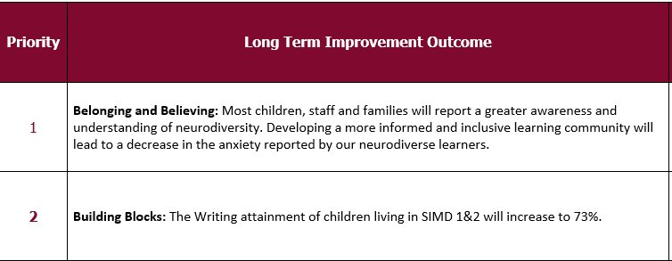

**Pupil Equity Fund (PEF) Plans**

Pupil Equity Funding is allocated directly to schools to close the poverty related attainment gap. Schools in Scotland have been allocated funding for pupils in P1-S3 known to be eligible for free school meals. This funding is to be spent at the discretion of Headteachers working in partnership with each other and their local authority. Pupil Equity Funding is being provided as part of the Attainment Scotland Fund which will be invested over the current Parliamentary term to tackle the poverty related attainment gap.

On our website there are detailed links for the planned expenditure of our Pupil Equity Fund, it details how we will close the gap in attainment and how we involve parents in deciding the expenditure plans.

[**https://blogs.glowscotland.org.uk/cl/public/sbps/uploads/sites/5341/2024/09/06091219/Pupil-Equity-Fund-Planning-St-Bernadettes-2024-25.docx**](https://blogs.glowscotland.org.uk/cl/public/sbps/uploads/sites/5341/2024/09/06091219/Pupil-Equity-Fund-Planning-St-Bernadettes-2024-25.docx)

#### **30.Transferring Educational Data About Pupils**

The Scottish Government and its partners collect and use information about pupils in schools (e.g. the number and characteristics of pupils, their attendance, absence and exclusions, their attainment and their destination when leaving school) to help to improve education across Scotland. This note explains why we need this information, how we use it and what we do to protect the information supplied to us.

**Why do we need your data?**

In order to make the best decisions about how to improve our education service, Scottish Government, education authorities and other partners such as the SQA and Skills Development Scotland need accurate, up-to-date data about our pupils. We are keen to help all our pupils do well in all aspects of school life and achieve better examination results. Accurate and up-to-date data allows us to:

* plan and deliver better policies for the benefit of all pupils
* plan and deliver better policies for the benefit of specific groups of pupils
* better understand some of the factors which influence pupil attainment and achievement
* share good practice
* target resources better
* enhance the quality of research to improve the lives of young people in Scotland

**Data policy**

Information about pupils’ education is collected through our statistical surveys in partnership between the Scottish Government and Local Authorities through the ScotXed Programme which aims to help schools and Local Authorities by supporting efficient collection, processing and dissemination of statistical information. The Scottish Government then provides analysis of the data to support research, planning, management and monitoring of education services as well as to produce National Statistics publications.

Education data within Scottish Government is managed effectively by secure systems and is exploited as a valuable corporate resource, subject to confidentiality restraints. As part of its data policy, Scottish Government will not publish or make publicly available any information that allows individual pupils to be identified, nor will data be used by Scottish Government to take any actions in respect of individuals. Data is held securely and no information on individual pupils can or would be made publicly available by Scottish Government.

**The individual data about pupils in schools collected by Scottish Government through statistical surveys is used only for the statistical and research purposes for which it is collected**.

**Your data protection rights**

The collection, transfer, processing and sharing of ScotXed data is done in accordance with the Data Protection Act (1998). We also comply with the National Statistics Code of Practice requirements and other legislation related to safeguarding the confidentiality of data. The Data Protection Act gives you the right to know how we will use your data. This note can give only a brief description of how we use data. Fuller details of each individual ScotXed survey, including the purpose of each and the published data, can be found on the ScotXed website (http://www.gov.scot/Topics/Statistics/ScotXed). Pupil names and addresses (other than postcode) are never collected in any ScotXed statistical survey.

Scottish Government works with a range of partners including Education Scotland, Skills Development Scotland and the SQA. On occasion, in order to help meet our aim of improving the life of young people in Scotland, we may make individual data available to partners such as the National Registers of Scotland to carry out research relating to the national population census and also to academic institutions and organisations to carry out additional research and statistical analysis which helps inform policy development and contributes to improving outcomes for Scotland’s people. In order to carry out this research to support better decisions, policy making and practice, data may be linked to information from other sources.

Any sharing or linkage of data will be done under the strict control of Scottish Government, and will be consistent with our data policy and the National Data Linkage Guiding Principles. This will ensure that no individual level data will be made public as a result of the data sharing and that these data will not be used to take any actions in respect of an individual. Decisions on the sharing or linkage of data will be taken in consultation with relevant colleagues and individuals within and outwith Scottish Government. At all times pupils’ rights under the Data Protection Act and other relevant legislation will be ensured.

**Concerns**

If you have any concerns about the ScotXed data collections you can email the Head of Schools Analysis, Mick Wilson, at [mick.wilson@scotland.gsi.gov.uk](mailto:mick.wilson@scotland.gsi.gov.uk) or write to Education Analytical Services, Area 2D, Victoria Quay, Leith, EH6 6QQ.

### Websites

You may find the following websites useful.

* [http://www.parentzonescotland.gov.uk](http://www.parentzonescotland.gov.uk/)- parents can find out about everything from school term dates to exam results. This site also offers information for pre-5 and post school. It also lists relevant publications for parents and provides hyper-links to other useful organisations.
* Parent Club Scotland: The Scottish Government’s advice and support service to parents, carers and families. Wide range of advice, hints and tips on social distancing, health information as well as learning at home. [www.parentclub.scot/](http://www.parentclub.scot/)
* Parenting Across Scotland: General parenting advice and support on a range of issues, https:// [www.parentingacrossscotland.org/](http://www.parentingacrossscotland.org/)
* [www.hmie.gov.uk](http://www.hmie.gov.uk) - parents can access school and local authority inspection reports and find out more about the work of Education Scotland.
* <http://www.scottishschoolsonline.gov.uk> - parents can find out about individual schools. They can choose a school and select what type of information they need such as Education Scotland reports, exam results, stay on rates and free school meal entitlement.
* <https://www.clacks.gov.uk/learning/> Clackmannanshire Council’s website – education pages
* <http://www.childline.org.uk/Explore/Bullying/Pages/Bullyinginfo.aspx> - contains information for parents and children on varying forms of bullying and provides help for parents and children who are affected by bullying.
* <http://www.respectme.org.uk/> - Scotland’s anti-bullying service. Contains information for parents and children on varying forms of bullying and provides help for parents and children who are affected by bullying
* Scotland Learns: Education Scotland has set up a new website with ideas, hints and tips for parents and carers to support learning at home - [https://education.gov.scot/improvement/scotland-learns/](https://education.gov.scot/improvement/scotland-learns/%20) - a parent newsletter will be issued every week with new ideas.
* National Parent Forum of Scotland (NPFS) Educational Resources: A list of resources updated regularly for ideas and activities for learning at home. <https://www.npfs.org.uk/2020/03/19/schoolclosures-educational-resources-for-parents-and-families/>
* UNCRC : The Convention has 54 articles that **cover all aspects of a child’s life a**nd set out the civil, political, economic, social and cultural rights. <https://www.unicef.org.uk/what-we-do/un-convention-child-rights/#:~:text=The%20UN%20Convention%20on>

# Glossary –

ASL – Additional Support for Learning

ASN – Additional Support Needs

CFE - Curriculum for Excellence

CLD – Community Learning and Development

DHT - Depute Headteacher

EMA – Education Maintenance Allowance

ELC - Early Learning and Childcare

SMT- Senior Management Team

FOI – Freedom of Information

FVNHS - Forth Valley National Health Service

GIRFEC – Getting it Right for Every Child

Glow - Scottish Schools National Intranet (Glow doesn’t stand for anything)

HT - Headteacher

LIPs - Local Improvement Priorities

NIF - National Improvement Framework (for Education)

NPFS - National Parent Forum of Scotland

PC - Parent Council

PEF - Pupil Equity Funding

PLPs - Personal Learning Plans (personal learning planning)

PT - Principal Teacher

PTA/PA - Parent/Teacher Association/Parents Association

SEEMiS - Management Information Systems (SEEMiS is the pupil database)

SIP - School Improvement Plan

SPTC - Scottish Parent Teacher Council (now called Connect)

SQA – Scottish Qualifications Authority

UNCRC – United Nations Convention on Rights of a Child