Improvement Plan 2021/2022

St Bernadette’s RCPS

School Vision and Aims
Our ethos is rooted in our Faith. All members of our school community are encouraged to live the Gospel Values, loving and supporting each other while striving to develop our unique gifts and abilities. We aim to enable each of our children to achieve their God – given potential.
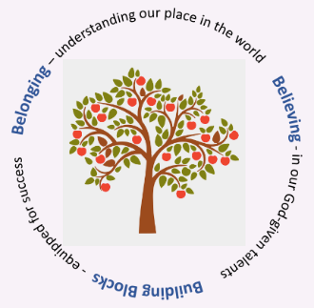
Our vision for our children is that they;
- develop a strong connection to their environment and a determination to contribute to it;
- are empowered to make choices that enhance their health and wellbeing throughout their lives;
- develop the skills for learning, life and work that they will need to thrive in the workplace.

When we talk about this with our children, we talk about our 3Bs: Belonging, Believing & Building Blocks

Our School Improvement Plan has been developed in consultation with staff, families and children. It is also a reflection of our Standards & Quality Report. This plan is part of a 3 year plan whose elements are described in the overview shown below.
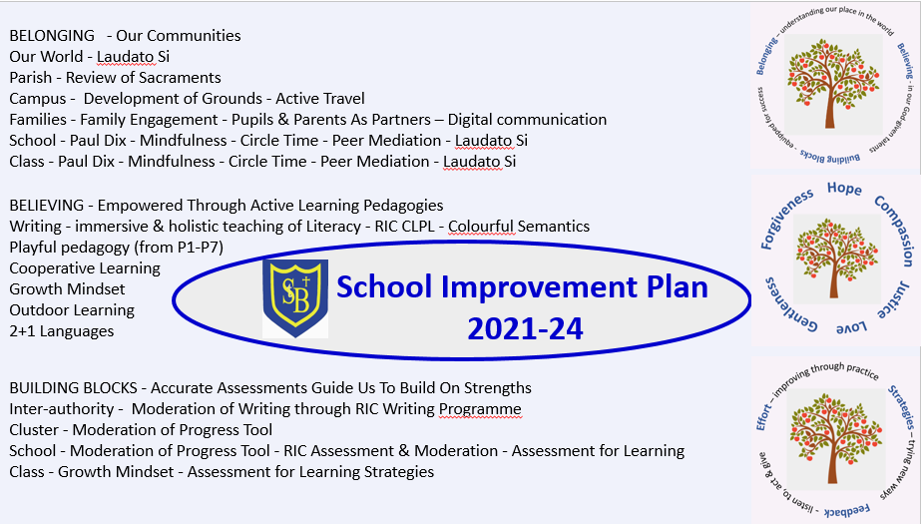

Overview

Headteacher: | N. McElroy

Total PEF Allocation: | £24094

Priority | Long Term Improvement Outcome | Accountable Person | Cost  (for PEF priorities only)
1 | Belonging: By May 2022, our children and families survey findings will show an increase of at least 10% in the participants’ sense of being empowered in the development of our community of learning. | K. McDonald | £3766.22
2 | Believing: By May 2022, our children’s survey findings will show an increase of at least 5% in the children’s sense of being engaged in their learning. | N. McElroy | £3041.46
3 | Building blocks: By May 2022, the Attainment Gap in Literacy and Numeracy will have narrowed by at least 10%. | N. McElroy | £15484.04
 | Contribution toward HR & Finance |  | £1802.28

Priority 1
Priority One: Belonging

Long Term Improvement Outcome
By May 2022, our children and families survey findings will show an increase of at least 10% in the participants’ sense of being empowered in the development of our community.
All of our families, regardless of socio-economic status, should feel that they are empowered members of our community who can work in partnership with the school in their child’s best interests.
Improvement Outcomes
Children, across the school, will be supported by families who have access to live/recorded Google Meet tutorials on the areas that families identify as most difficult in terms of home learning.
Throughout the year, identified and self-referred families will report feeling more confident and valued as partners in learning after taking part in our new ‘Supporting your Child’ intervention.
P5 children will be offered the opportunity to develop their leadership skills as Digital Leads.
Families and P6 children will be empowered in relation to decision-making in the school through the Pupils & Parents as Partners (PPP) programme.
All children in P7 will be offered the opportunity to develop their leadership skills through the revived House System.
All children will be offered leadership opportunities through the Laudato Si global sustainability programme.
More children will report that they feel supported to resolve disputes and to manage their emotions.
Children experience innovations in teaching and learning due to enhanced teacher leadership.
Priority Two: Believing

Long Term Improvement Outcome
By May 2022, our children’s survey findings will show an increase of at least 5% in the children’s sense of being engaged in their learning.

Improvement Outcomes
Children will report feeling more engaged and enthusiastic in writing lessons as they experience consistent writing lessons that are incorporate reading, talking and listening.
Children will experience learning activities that involve more playful approaches to learning.
Children’s assessments will include more puzzles and quizzes in order to reduce the stress of a test.
Children will experience more engaging Numeracy lessons through outdoor learning activities.
Children will experience one Cooperative Learning Strategy per term and will evaluate these strategies so that their voice influences the development of our pedagogy

Priority Three: Building Blocks

Long Term Improvement Outcome
(Aspirational, Transformational; relates to improved outcomes for learners)
By May 2022, the Attainment Gap in Literacy and Numeracy will have narrowed by at least 10%. All of our children should be given the tools that they need to engage with their learning and to succeed to the best of their ability without being adversely affected by the poverty-related attainment gap.

Improvement Outcomes
Children will have a stronger understanding of sentence structure through the introduction of the Colourful Semantics programme
Children who are not on track will make accelerated progress through receiving targeted interventions in reading, writing and numeracy - those who live in SIMD 1 & 2 and who are not on track will receive additional support sessions from PEF-funded staff members.
Children’s strengths and needs will be more robustly analysed and interventions more carefully targeted due to the introduction of a new system to make the recording of assessment data consistent across the school.
Children will experience greater consistency in Numeracy teaching through the school’s participation in the RIC (Regional Improvement Collaborative) moderation programme
Children will experience greater consistency in Literacy teaching through the school’s participation in the RIC (Regional Improvement Collaborative) moderation programme
Children will experience lessons that provide more scaffolding so that all children are able to participate in the learning.
s

