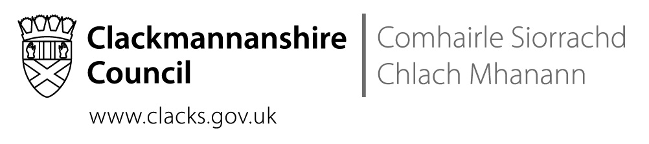
St Bernadette’s RC Primary School
The Orchard, Tullibody, FK10 2SD
Tel No 01259 723973

 | Direct contact: | Nuala McElroy, Headteacher
 | Telephone: | 01259 723973
 | Email: | stbernadette@edu.clacks.gov.uk
 | Our ref:
 | Date: | 12th November 2019

Dear Parents and Carers,

Thank you to all our parents who made our Parents’ Evening such a positive and collaborative evening. Our staff felt grateful for your openness and support. We know we are very lucky at St Bernadette’s in having incredibly supportive families.

Thank you also to all of you who were able to join Bishop Stephen at our Dedication Mass. All the invited guests were extremely impressed by our children’s manners, behaviour, respect, reading and singing. Once again, your children were a credit to you.

Sadly, one person who wasn’t there was Fr. Mike who has spent the last week in hospital. Please keep him in your prayers – he is at the heart of our school family and we miss him. Our children made cards for Fr Mike to tell him about the Mass and to wish him to get well. The depth of the children’s affection and the kindness of their wishes were beautiful.

Thank you for your continued support.

Nuala McElroy

Parent Council
At the Parent Council AGM, Mrs Sharkey was reappointed as Chair and Mrs Reynolds and Mr Duke were appointed as Co-Vice Chairs. Mrs Stevenson is Treasurer and Mrs Hagerty is Secretary. Thank you so much to Mrs McCann and Mrs Roscilli, who stepped down from the roles of Vice Chair and Treasurer, for all their service to our school.

The Parent Council ran a successful Halloween Disco and are now planning the Christmas Fair on the 30th of November. Funds raised by these events subsidise school trips and allow us to offer the children free experiences such as the pantomime next week. Please support them in their activities.

Sharing Our Literacy Learning
We are looking forward to welcoming you into our school on the afternoon of the 21st of November at 2.15pm. The purpose of the session is to share with you some of the ways that our children learn to explore the meaning of a text.

Tempest Photography
I hope you were pleased with your Tempest photographs. If you wish to order any, please return your form as soon as possible.

Flu Immunisation
You should have received an email explaining that there is a shortage of flu vaccine at the moment. P1-3 will be immunised on the 26th of November. We hope that P4-7 will be immunised at a later date. I will inform you as soon as I have more information. In the meantime, if you feel that your P4-7 child needs immunised, please approach your GP.

Nativity
As a Catholic school, our special events often take place in the church. So at Christmas, our big celebration is the end of term Mass on the 18th of December at 9.30am. We will have Mass and our children will act out, narrate and sing the story of the Nativity. All of our families are welcome to join us.

Fundraising
. | Every child and staff member has contributed a self-portrait to a fundraising tea towel. We will be selling them at the Christmas Fayre but they will also be available from the school at a cost of £3.50.
Communication
Several of our families have expressed concerns about their child’s image being shared on Twitter. This has led to teachers becoming reluctant to share news via Twitter because they are nervous about the prospect of sharing an image by mistake.
As a ‘closed’ alternative to Twitter, we will be using the Connectus app as a way to share news about learning and all the fun and interesting things going on at school. We will be sending out leaflets at the start of December, giving you information on how to download the app. The St Bernadette’s page on the app will have a PIN number which will only be shared with parents.

The St. Modan’s Community Concert
P6 and P7 will be performing on the evening of the St. Modan’s Community Concert on the 11th of December. Further details will follow.

Glee
Mrs Morgan, Miss Glencross and Miss Crawford are working hard with our P5-7 performers at their weekly afterschool Glee Club. The performance will be in March at the Alloa Town Hall. Further details to follow.

ParentPay
With great reluctance, I have had to refer families on to the council’s creditors section as a result of school lunch debt. I have never done this before but have felt compelled to do it when no payments have been made but school dinners have continued to be taken, making the debt rise even more. If you have an issue with school lunch debt, please don’t ignore the letters. Get in touch and we can come to an arrangement such as switching to packed lunches and then paying down the debt a couple of pounds each week. Please reconsider applying for free school meals if you are struggling. We will help you if we can.

Provisional Dates for Diary
Please note that these dates may change in response to changing circumstances.

Tues, 19th Nov | Mother Goose pantomime in school
Thurs, 21st Nov | Sharing Our Literacy Learning session @ 2.15pm
Tues 26th Nov | Flu Immunisation P1-3
28 – 29th Nov | INSERVICE DAYS – School closed to pupils
30th Nov | Parent Council Christmas Fair
Weds 4th Dec | Advent Mass at Church @9.30am
Weds 11th Dec | Advent Mass at Church @9.30am
Weds 11th Dec | St. Modan’s Community Concert at St. Modan’s High School
Weds 18th Dec | Advent Mass and Nativity at Church @9.30am
23rd Dec – 3rd Jan | CHRISTMAS HOLIDAYS
Weds 15th Jan | P6 & P7 transition visits to St Modan’s
Weds 22nd Jan | P6 & P7 transition visits to St Modan’s
Weds 29th Jan | P6 & P7 transition visits to St Modan’s
17-18 Feb | INSERVICE DAYS – School closed to pupils
19-21 Feb | HALF-TERM HOLIDAYS
Weds 11th Mar | Lenten Mass at Church @9.30am
Weds 18th Mar | Lenten Mass at Church @9.30am
Weds 25th Mar | Lenten Mass at Church @9.30am
Fri 27th Mar | P3 Sacrament of Reconciliation @ 9.30am in Church (Catholic children)
Weds 1st Apr | Lenten Mass at Church @9.30am
6 – 17 Apr | EASTER HOLIDAYS
Fri 1st May | INSERVICE DAY – School closed to pupils
Fri 8th May | MAY HOLIDAY
13 – 15 May | P7 Lockerbie Manor residential
Sun 17th May | P7 Confirmation @ 11.30am in Church (Catholic children)
25-26 May | P7 transition days at St Modan’s HS
Sun 7th June | P4 Communion @ 11.30am in Church (Catholic Children)

