St. Bernadette’s RC PS
Standards and Quality Report
2018-19
Our final Mass in our original building.

Our Context
St. Bernadette’s RC Primary is a denominational school serving Alva, Menstrie and Tullibody. We are situated at the foot of the Ochil Hills, We have strong links to our parish and local community. The school roll in June 2019 was 135. Our associated denominational high school is St. Modan’s RC High School.
2018-19 was the last year that we spent in the original home of St Bernadette’s RCPS. It was a very busy year as we prepared for the move to our new home in the Tullibody South Campus.

School Vision and Aims
Our ethos is rooted in our Faith. All members of our school community are encouraged to live the Gospel Values, loving and supporting each other while striving to develop our unique gifts and abilities. We aim to enable each of our children to achieve their God – given potential.
Our vision for our children is that they;
- develop the skills for learning, life and work that they will need to thrive in the workplace;
- develop a strong connection to their environment and a determination to contribute to it;
- are empowered to make choices that enhance their health and wellbeing throughout their lives.

Our Values
Our values underpin our relationships and make clear our expectations of how we live and work as a family. Our children understand that these Gospel Values are our foundation.
Our Attainment
The Scottish Government gathers information on our attainment as assessed through Teachers’ Professional Judgement, recording the number attaining Early Level at P1, First Level at P4 and Second Level at P7. As we are a small school, those numbers are considered together.
Comparing our attainment results year-on-year is not a reliable indicator of success because our class sizes are small and because we have so many children joining the school halfway through their school careers.

The National Improvement Framework
Overall attainment
This table shows the number of children achieving the expected CfE Levels at P1, P4 and P7. You will see that attainment in Literacy has risen and that we maintained our high attainment in Numeracy. These results are particularly good given the significant periods of staff absence in 2018-19.
Year | Listening & Talking % | Reading % | Writing % | Numeracy %
2017-18 | 88 | 79 | 75 | 86
2018-19 | 91 | 82 | 82 | 86

The Attainment Gap
The Scottish Index of Multiple Deprivations (SIMD) indicates that 38% of our families were living in Deciles 1 & 2 in 2018-19 and that 35% of our families were living in Deciles 1 & 2 in 2017-18. In line with government policy, we compare the attainment of children living in SIMD Deciles 1 & 2 with the attainment of children living in SIMD Deciles 3-10. The Attainment Gap is the difference between the attainment of the two groups of children.

This year’s results indicate that we have not been successful in reducing the Attainment Gap this; that the children living in SIMD 3-10 are making more progress than the children in SIMD1-2. These figures may, in part, show the impact of staff absence on our programmes of one-to-one and small group support for targeted children living in SIMD 1 & 2.

Year | Children in SIMD 1 & 2  Achieving Levels  Listening & Talking | Children in SIMD 3-10  Achieving Level  Listening & Talking | Attainment GAP  Listening and Talking
2017-18 | 80% | 92% | 12%
2018-19 | 86% | 94% | 8%

Year | Children in SIMD 1 & 2  Achieving Levels  Reading | Children in SIMD 3-10  Achieving Levels  Reading | Attainment GAP  Reading
2017-18 | 70% | 84% | 14%
2018-19 | 67% | 89% | 22%

Year | Children in SIMD 1 & 2  Achieving Levels  Writing | Children in SIMD 3-10  Achieving Levels  Writing | Attainment GAP  Writing
2017-18 | 65% | 81% | 16%
2018-19 | 67% | 86% | 19%

Year | Children in SIMD 1 & 2  Achieving Levels  Numeracy | Children in SIMD 3-10  Achieving Levels  Numeracy | Attainment GAP  Numeracy
2017-18 | 90% | 84% | -6%
2018-19 | 81% | 89% | 5%

Next steps: Our School Improvement Plan for 2019-20 includes work on improving teachers’ skills and confidence in regard to assessment and the use of new teaching approaches that should benefit all learners. Our Pupil Equity Fund is paying for Miss McDonald and Miss Wright to support targeted children.

Health and Wellbeing
Our children’s health and wellbeing was supported in a variety of ways as detailed in the report on Priority 3. However, towards the end of term, our children and their families were expressing a good deal of anxiety about the move to the new school. This was reflected in our assessments of our children’s wellbeing and informed the plan for 2019-20.

Employability
Our work with Robertsons Construction and the construction equipment that Mr Lochrie gave us, have increased our children’s awareness of the variety of employment opportunities. We will be building on this work with the increased emphasis on creativity and digital literacy that is part of the improvement plan for 2019-20.

Reporting on the Quality Indicators
1.3 Leadership of change - Good
The headteacher is taking part in the SCEL Excellence in Headship programme, and attended the Columba 1400 residential. A class teacher undertook the Clackmannanshire Council Leadership programme. All teachers took on leadership roles as part of the School Improvement Plan. The children have taken on leadership roles through Pupil Council, the House System, Robertson’s Reporters and in informing planning. The headteacher received positive feedback after a visit from Education Scotland, looking at the theme of Empowerment.

2.3 Learning, teaching and assessment – Good
Teachers have undertaken a significant amount of professional learning this year in Numeracy and Literacy. The Equitable Literacy Review Team observed teaching and learning in the school and interviewed children and staff. They found that the school was making good progress in implementing the Equitable Literacy programme. The teachers have been developing their assessment skills through the local authority’s Teacher Learning Community programme.

  - Ensuring wellbeing, equity and inclusion – Good
The school was audited as part of a pilot programme for the initiative, The Cost of the School Day. The number of ways in which we work to lessen the impact of poverty on our children’s lives was recognised when our children were then asked to present our audit findings to the Clackmannanshire Council Tackling Poverty Summit. Our Faith underpins our commitment to social justice and the common good, pushing us to be creative in promoting equity for all.

3.2 Raising attainment and achievement - Good
Our attainment continued to rise in 2018-19 except in Numeracy where we maintained our high attainment. In Reading, we have spent a lot of time and resources on making reading more enjoyable and persuading all children to see themselves as readers. In 2019-20, we will work to ensure that the children’s love of reading feeds into an increased enthusiasm for writing. We will also be focusing on providing targeted support in Writing in order to narrow the Attainment Gap. Our new approaches and resources in Numeracy have led to high attainment and we will be continuing to embed this more active and experience-based methodology in 2019-20.

School Improvement Plan 2018-19
Priority 1 Literacy
Outcome (transformational)
Proposed intervention
We will ensure consistency and progression through:
- Undertaking staff development on Reading through the Strathclyde University Reading Programme
- Introducing Clicker 7 to support writing at all stages
- Focusing on closing the vocabulary gap through WordAware
- Providing more one-to-one and small group support through employing 0.1FTE of a support assistant
- Providing more one-to-one and small group support through employing 0.2FTE of a teacher
- Staff moderation of planning, delivering and assessing literacy lessons through the Tapestry programme

Start Date | Time Allocation | Progress Review Date | Completion Date
August 2018 | 2 years | February 2019 | June 2020

Progress | Impact | Evidence
The staff undertook the local authority training on Equitable Literacy. The Equitable Literacy Review found that the school was making good progress towards implementing  Bug Club was introduced to P4-7 and has proved popular with pupils and staff. It provides a framework for guided groupwork.  We changed the way that we delivered 1:2:1 reading input for children who were struggling with reading.  We continue to raise attainment in reading.  We have not succeeded in narrowing the Attainment Gap in reading. | Children are enthusiastic and more confident in their response to reading and comprehension tasks.  P4-7 staff are confident that our children are enjoying more challenging comprehension activities due to the mixed-ability, group methodology.  A majority of the targeted children made very good progress although, often, they still have work to do to be reading at their chronological age.  Children are more confident in their reading.  Children living in poverty are not attaining as well as their peers who live in more affluent homes. | The report from the Equitable Literacy Review Team.  Reports from children and staff  Running records and progress through reading books.  Teacher Professional Judgement and NGRT Reading Assessments.  Teacher Professional Judgements and NGRT Reading Assessments.

Next Steps: Due to the staff absences, we had additional PEF funds at the end of the 2018-19 PEF period and we spent that on more books for the library and for classes. We also bought Bug Club for P1-3 and will be introducing that in 2019-20. We will also be further developing and embedding our Equitable Literacy approaches.
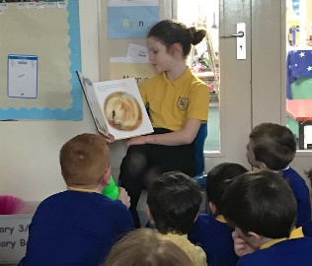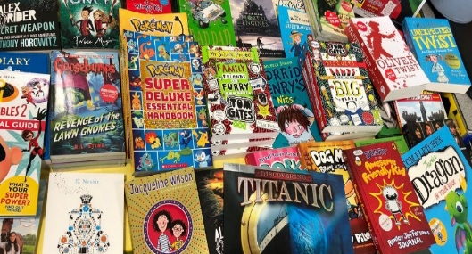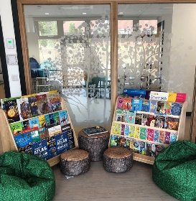
Priority 2: Numeracy
Outcome (transformational)
Proposed intervention

We will achieve consistency and progression in teaching and a rise in attainment through
- Building capacity through working with Leigh Graham of the authority’s Improving Outcomes Team
- Employing a support for learning assistant to provide 1-2-1 and small group support
- Providing more one-to-one and small group support through employing 0.2FTE of a teacher
- Promoting experiential maths learning through the purchase of concrete materials and maths games

Start Date | Time Allocation | Progress Review Date | Completion Date
August 2018 | 2 Years | February 2019 | June 2020

Progress | Impact | Evidence
We purchased a significant number of resources that children could use to reach the answer to a calculation.  Children were taught a variety of strategies to calculate the answer.  There were some Maths Recovery inputs for individuals (although not as many as we’d hoped due to staff absence).  We maintained our high attainment levels in Numeracy. | Children are confident using counting sticks, cubes etc to find the answer.  Children are confident using a variety of strategies to find the answer.  A majority of the targeted children made very good progress although, often, they still have work to do to be working at the age-appropriate level.  Children are confident and more positive about Maths. | Observation.  Children’s comments.  Observation.  Children’s comments.  Observation. Ongoing assessments.  Teacher Professional Judgements.

Next Steps: Due to the staff absences, we had additional PEF funds at the end of the 2018-19 PEF period and we spent that on more concrete materials for children at all stages throughout the school. We also invested £1200 in a new Maths resource that supports our new approaches to Numeracy. We will be using these resources and undertaking further training in 2019-20.

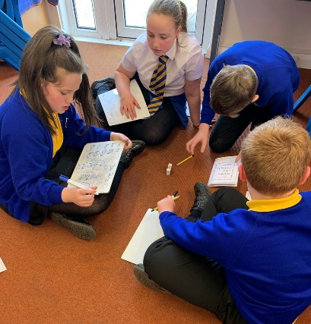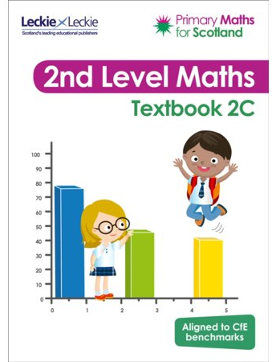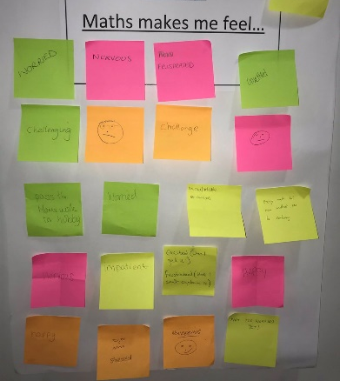
Priorty 3: Nurture and Transition
Outcome (transformational)
Proposed intervention

We will raise attainment through a programme of targeted interventions that promote our children’s wellbeing and readiness to learn.

We will develop our children’s wellbeing and readiness to learn through:
- undertaking training with Educational Psychology Services on implementing the Neurosequential Model in Education
- raising awareness of parents and staff re nurture and sensory issues, their impact on behaviour and ways to support our children;
- provision of resources that support children with sensory issues;
- employment of a support assistant, 0.3 FTE, to support our nurture policy;
- working with cluster colleagues to promote team around the family interventions.

Start Date | Time Allocation | Progress Review Date | Completion Date
August 2018 | 2 Years | October 2019 | June 2020

Progress | Impact | Evidence
We developed our programmes in the Sensory Mini-Gym to build in more personalisation and choice as well as independence.  We developed our monitoring and tracking of the Sensory Mini-Gym in order to be better able to allocate resources.  Staff spent a significant amount of time on training with the Educational Psychology Service on Readiness For Learning and learning environments.  We were able to use some of the approaches developed in the Cluster Team Around the Family working group.  Staff continued to develop their use of play for learning in line with Scottish Government policy. | Children enjoyed their sessions more and were more engaged.  Children had support that better met their needs e.g. some children had 1:2:1 time reading or playing games rather than using the gym.  Children in some classes were able to experience the new approaches and classroom layouts that we anticipated using in the new campus.  When used appropriately, they were a helpful way of structuring discussions in Team Around the Child meetings.  Children enjoyed their opportunities to learn through play. | The new Wellbeing Diaries.  The new Wellbeing Diaries.  Almost all the feedback from staff, children and parents was positive.  Feedback from parents, professional partners and staff.  Staff and children’s reports.

Next steps: Our priority is to ensure that our children and families are supported through the transition to the new campus especially during the demolition of the old Abercromby and the resulting lack of playground space. We will be undertaking further training in Circle Time. We will continue to provide one-to-one support for children through being innovative in meeting emotional, social and behavioural needs.

Priority 4: Curriculum
Outcome (transformational)
Proposed intervention
Children will develop their creativity skills, digital literacy and employability skills through the four contexts of learning.
Staff will work in partnership with parents and local organisations to develop the curriculum in order to promote these skills through
- Vertical House groups that promote the acquisition and application of practical skills
- The development of IT at all stages
- The promotion of growth mindsets
- Links to the construction of the proposed Tullibody South Campus
- Creation of skills progression pathways

Start Date | Time Allocation | Progress Review Date | Completion Date
August 2017 | 3 Years | February 2019 | June 2020

Overall Evaluation
Progress | Impact |  | Evidence
We did not make as much progress as we would have wished in this Improvement Priority due to staff absence and the amount of time spent developing Literacy, Numeracy and our work on Wellbeing and Readiness for Learning.  Children enjoyed experiences linked to the construction of the new campus including being Robertson’s Reporters or being involved in the Stakeholders’ Group planning for Tullibody South.  We bought new laptops but were often unable to connect them to the server or the internet due to wifi problems. |  | Children experienced limited opportunities to develop their creativity skills, digital literacy and employability skills.  Those children involved were able to describe aspects of the building process and to ask very pertinent questions.  Teachers and children often suffered frustration and plans had to be changed and adapted at short notice. |  | Observation  Children’s and staff comments  Children’s and staff comments  Reports to IT Customer Services

Next Steps: Due to the staff absences, we had additional PEF funds at the end of the 2018-19 PEF period and we spent that on Science and coding resources for children at all stages throughout the school. We will develop our curriculum through using these in 2019-20. We are also looking forward to using the fantastic new digital learning facilities offered by our new school to develop our children’s digital literacy and creativity.

