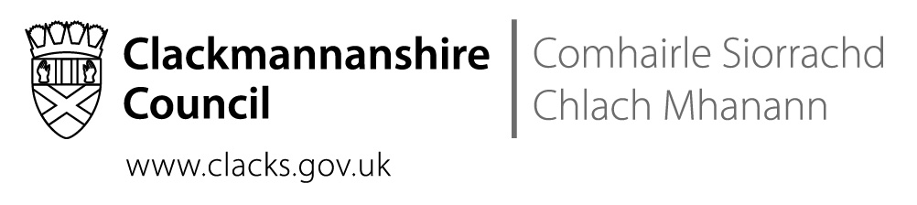
St Bernadette’s RC Primary School
The Orchard, Tullibody, FK10 2SD
Tel No 01259 723973

 | Direct contact: | Nuala McElroy, Headteacher
 | Telephone: | 01259 723973
 | Email: | stbernadette@edu.clacks.gov.uk
 | Our ref:
 | Date: | 4th December 2019

Dear Parents and Carers,

Thank you to all our families who came along to the Christmas Fair and made it such a success. Thanks especially to our Parent Council volunteers who gave up hours and hours to prepare for the Fair. They raised £826.
Over the year, the money raised by the Parent Council pays for:
- Subsidising the cost of the transport to skiing for P7
- The transport to the St Modan’s Language Day for the P7
- Subsidising the P7 residential trip
- Subsidising the cost of travel to sports events such as the rugby, badminton etc
- Subsidising the cost of transport to school trips for all classes
- Treats for the Christmas parties
- Leavers’ hoodies for P7
- Pantomimes and theatre shows

The cost of transport to sports events has become very expensive. This year, if we had charged each child the true cost of transport to the skiing or the cross country after school, we would have had to have asked each parent for approximately £15 per activity. We want to be able to offer every child the opportunity to try all sports and find where their strengths are. To do that, though, we really need your support for Parent Council fundraising.
If you can sell raffle tickets, that is great but not all families can. If you won’t be able to sell the tickets that the Parent Council sent home with your child, please return them to the school so that we can pass them on.

Thank you for your continued support.

Nuala McElroy

Christmas Jumper Day
The 13th of December is Christmas Jumper Day for Save the Children. If you have a Christmas jumper for your child, feel free to send them in with their Christmas jumper and a donation for Save the Children. This is not a non-uniform day – your child should still be wearing school trousers or a skirt.

Christmas Parties
I apologise for having to change the dates of the parties. I had agreed the 10th of December with the PE teacher but if we were to go for that date, the children would not have access to the big gym. I asked the P5s to P7s to help me to decide on alternatives. Together we have agreed on a full day of Christmas fun on the 17th.
In the morning, the children will have their dances and games in the big gym, their treats and games in class and sessions in the Immersive Room.
We’ll then have our special Christmas Lunch – the menu is attached.
In the afternoon, we plan to get together in the small gym to enjoy a Christmas Movie on our beanbags, munching popcorn.
If you do not have party clothes for your child, please get in touch with me. We can help.

Tea Towels
. | Every child and staff member has contributed a self-portrait to a fundraising tea towel. They are available from the school at a cost of £3.50. You should have received an order form from your child.

The St. Modan’s Community Concert
P6 and P7 will be performing on the evening of the St. Modan’s Community Concert on the 11th of December. Performers should be at the school by 5pm. The doors will open at 6pm for a 6.30pm start. There will be stalls selling crafts and refreshments.
St Modan’s are charging £3 per adult and £2 per concession. Each performer is limited to 2 tickets.

Walking to Mass
Going to Mass is an integral part of the life of the school. We would really like to have parents walking with us to ensure that we can maintain an appropriate child:adult ratio. We were unable to take P1-3 to Mass today because we did not have enough adults to feel really comfortable – as always, safety has to be my first priority.

School Holidays
The school closes at 1pm on the 20th of December. As the last morning is very busy with break and lunch at different times, it is essential that we carefully supervise our extremely excited children. In order to do that, we need to dismiss all the children at 1pm from the classroom rather than have children ’disappear’ over the lunch period as big brothers and sisters collect them. If anyone does come to collect a child, we will respectfully ask them to wait until 1pm.

Communication
The ‘School App for Parents’ from Connectus Tech is an extremely effective way for us to share dates and information with parents. Please download the app from Google Play or the Apple App Store. Once you find the school, you will be prompted for the security information. The User ID is StB and the PIN is 2512.
Due to concerns about the environment and the cost of photocopying, this is the last newsletter that we will be printing off and sending out as a hard copy. In future, we will email them, post them on the website and store them on the ‘School App for Parents’. If you wish a paper copy, please let the office know and we will send you one home.

Provisional Dates for Diary
Please note that these dates may change in response to changing circumstances.

Weds 11th Dec | Advent Mass at Church @9.30am
Weds 11th Dec | St. Modan’s Community Concert at St. Modan’s High School
Tues 17th Dec | All day Christmas Party and Festive Lunch
Weds 18th Dec | Advent Mass and Nativity at Church @9.30am
Friday 20th Dec | SCHOOL CLOSES - children will be dismissed from the classrooms @1pm and not before
23rd Dec – 3rd Jan | CHRISTMAS HOLIDAYS
Weds 15th Jan | P6 & P7 transition visits to St Modan’s
Weds 22nd Jan | P6 & P7 transition visits to St Modan’s
Weds 29th Jan | P6 & P7 transition visits to St Modan’s
17-18 Feb | INSERVICE DAYS – School closed to pupils
19-21 Feb | HALF-TERM HOLIDAYS
Weds 11th Mar | Lenten Mass at Church @9.30am
Weds 18th Mar | Lenten Mass at Church @9.30am
Weds 25th Mar | Lenten Mass at Church @9.30am
Fri 27th Mar | P3 Sacrament of Reconciliation @ 9.30am in Church (Catholic children)
Weds 1st Apr | Lenten Mass at Church @9.30am
6 – 17 Apr | EASTER HOLIDAYS
Fri 1st May | INSERVICE DAY – School closed to pupils
Fri 8th May | MAY HOLIDAY
13 – 15 May | P7 Lockerbie Manor residential
Sun 17th May | P7 Confirmation @ 11.30am in Church (Catholic children)
25-26 May | P7 transition days at St Modan’s HS
Sun 7th June | P4 Communion @ 11.30am in Church (Catholic Children)

