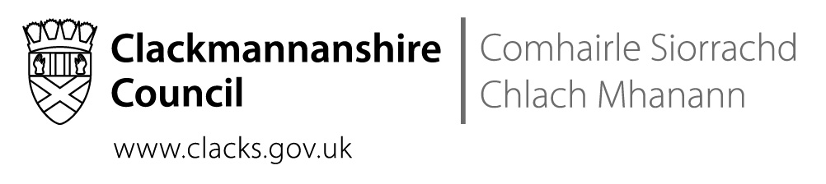
St Bernadette’s RC Primary School
The Orchard, Tullibody, FK10 2SD
Tel No 01259 723973

 | Direct contact: | Nuala McElroy, Headteacher
 | Telephone: | 01259 723973
 | Email: | stbernadette@edu.clacks.gov.uk
 | Date: | 27th March 2019
Dear Parents and Carers,

This has been an incredibly busy term as you can see detailed below. Thank you for all the ways in which you have supported our school family this year.

Thank you for your continued support,
Nuala McElroy

School Improvement Priority One: Numeracy
- Our Sharing our Learning Numeracy sessions were well attended and the feedback from parents was very positive.
- The feedback from the parents’ Numeracy workshops was also very positive.
- Mr Traquair continues to work on Numeracy facts across the school with individuals.

School Improvement Priority Two: Literacy
- Our new P4-7 Literacy resources have arrived and are being well used, staff and children find them engaging and enjoyable.
- We are awaiting the delivery of novels that were chosen by our P6-7 children.
- We continue to work on developing a love of reading in our children.
- We are trialling new approaches to reading with individual learners and seeing some very good results.

School Improvement Priority Three: Health and Wellbeing
- P7 participated extremely well in the Max in the Middle programme. They put on a fantastic performance for their parents.
- Several teachers have adopted the council’s Readiness for Learning approaches to our learning environments.
- Children are undertaking work on Growth Mindsets.
- All classes are now timetabled for the Mini Gym.
- Our P1- 3 Parents’ Group is working with Mrs Mackie every fortnight.

School Improvement Priority Four: Curriculum and DYW
- P7 have led the Lenten fundraising, organising the World Book Day Adjective Challenge; Funky Footwear Challenge and MacMillan Coffee Morning.
- P6/5 led the sponsored Scoot Aboot.
- P5-7 worked with Mrs Morgan and Miss Glencross to create an incredible Glee Choir performance at Alloa Town Hall. They were an absolute credit to themselves, the school and their families.
- Our P7 Pope Francis Faith Award participants have completed their learning journals and their journals have been verified.
- Our Pope Francis Faith Award participants are leading the school in our Lenten services.

School News
Lent
Father Mike has asked that our children support the Stations of the Cross on Palm Sunday.
The children’s participation in our Lenten Masses has been extremely impressive, their singing and behaviour were super.

Reporting
The addition of a second Parents’ Evening and the mini-reports in the Snapshot Jotters is part of a commitment to greater partnership working with families throughout the year. As a consequence, the end of year report will look different.
Thank you for the extremely high attendance at Parents’ Evening.

Volunteering
We would really appreciate the support of anyone who can come in and work in our library to help us to book band our current books and identify gaps in the types of books and the levels that we have. If you have any time to spare, we can use you! Please contact the office.

Dates for Diary

These dates are provisional and may change with circumstances.
29.03.19 | MacMillan Coffee Morning @ 9.15 – 10.30
01.04.19 – 12.04.19 | HOLIDAY
14.04.19 | Stations of the Cross @ 5pm in the Church
17.04.19 | Whole school Mass @ 9.30am
18.04.19 | Holy Thursday Mass @8pm
19.04.19 – 22.04.19 | HOLIDAY
24.04.19 | Parent Council @ 6.30pm
06.05.19 | HOLIDAY
08.05.19 | Nursery – P1 transition visit
15.05.19 | Nursery – P1 transition visit
22.05.19 | Nursery – P1 transition visit
23.05.19 | P7 Mass & Confessions
26.05.19 | Confirmation Mass @ 11.30am
29.05.19 | Nursery – P1 transition visit & parents’ session
30.05.19 | Looking Forward – Looking Back performances
10.06.19 – 12.06.19 | P7 Lockerbie Trip
12.06.19 | P4 First Communicants’ Retreat
14.06.19 | P4 First Communicant’s Confessions
16.06.19 | P4 First Communion @ 11.30am
25.06.19 | Bishop Stephen’s Mass @2pm in the Church

