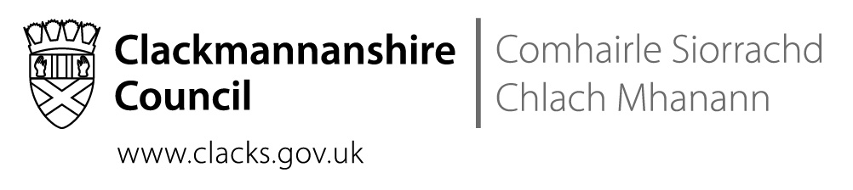
St Bernadette’s RC Primary School
The Orchard, Tullibody, FK10 2SD
Tel No 01259 723973

 | Direct contact: | Nuala McElroy, Headteacher
 | Telephone: | 01259 723973
 | Email: | stbernadette@edu.clacks.gov.uk
 | Date: | 24th October 2018
Dear Parents and Carers,

Thank you for your tremendous response to the Sharing our Learning Week. The attendance at both the class visits and the workshops was great and the feedback was very positive. We hope to share more of our work on reading with you over the course of the year. There will also be a Sharing our Numeracy Learning session in the new year.

Thank you for your continued support,
Nuala McElroy

School Improvement Priority One: Numeracy

- Our small group support of children is well underway, supported by Mr Traquair. Children are receiving targeted support and are responding well.
- A good number of the senior pupils are undertaking the Scottish Maths Challenge with Mrs Morgan and are experiencing success.

School Improvement Priority Two: Literacy

Reading
- We are over halfway through the training on the Equitable Literacy (Reading) programme that we are undertaking with Strathclyde University.
- We are also working with Emma Ritchie, the authority’s PT of Literacy, in classes. This work is allowing teachers and support staff to further develop their skills. The children are also enjoying the input from our visitor.

Spelling
- The P2/1 and P3/2 teachers enjoyed a day of training on Read Write Inc with a specialist trainer.
- Children are responding well to our new spelling approaches and teachers report that the dictated sentences are a more accurate indication of how well a child is learning their spelling than the traditional single word spelling tests that we used to do on Fridays.

Writing
- The introduction of Clicker 7 has led to a marked improvement in children’s willingness to write at length. Children are more confident and less afraid to make mistakes so some children have moved from writing 2-3 sentences to writing 2 or more paragraphs!

School Improvement Priority Three: Health and Wellbeing

- We are undertaking training during the inservice days on the Neurosequential Model in Education (NME).
- We ordered more playground equipment based on the children’s suggestions and it is being well used.
- Our use of the Mini Gym (formerly the Sensory Gym) is underway again with new programmes devised by Gillian Kenmure, Occupational Therapist.

School Improvement Priority Four: Curriculum and DYW

- Ms Barnes and Mrs Aitchison provided huge support to P5 in the enterprise project last term. The children enjoyed all aspects of the baking, marketing and selling process.
- In preparation for the Christmas Fayre, we would be very grateful to receive help from families with arts and crafts as we make products to sell.

School News

Snapshot Jotters & Parents’ Evening
As Digital Literacy and experiential learning increase in our school, you may find that there is less written work in your child’s Snapshot Jotter. Please remember that this is just a sample of all the learning that children do in school.

We have changed the format of the feedback page; the child’s reflections on their learning are still central but we have added a section in which teachers give you information about your child’s learning behaviours. It is hoped that this will inform your meeting at Parents’ Evening. You should have received your appointment by now.

In previous years, when we gave separated parents separate appointments, the feedback was that this was not helpful. In most cases, parents preferred to meet the teacher together. If that does not work for your family, and you wish an additional Parents’ Evening appointment, please contact the school.

Halloween Disco
We will be having our traditional Halloween parties on the afternoon of Wednesday the 31st of October. The Parent Council are providing snacks for the parties and we have booked a DJ so we’re looking forward to some spooky fun.

All children at P1-P5 can come to school in costume or go home to get changed at lunchtime or bring in costumes to get changed into during lunchtime. Please be aware that the wee ones can get scared so costumes should not be too grisly or gruesome. P6 and P7 must come to school in uniform as they are going to St Modan’s, they can get changed at lunchtime.

St Modan’s Transition
A reminder that the model of transition visits to St Modan’s has changed this year. The children will still have a block of visits in both P6 and P7 but there will be three longer sessions per block rather than six shorter visits. In addition, there are two P7 days in June at a time when it is especially reassuring to the children to spend time in the secondary. One day will be an activities day and the other day will involve the children following an S1 timetable and getting experience of moving around the school between lessons. Our visits will take place on 31.10.18, 07.11.18 and 14.11.18.

Mrs Burney
Mrs Burney retired at the summer after being absent through illness for the 2017-2018 session. Throughout her time at the school, she worked tirelessly to raise funds both with the Parent Council and through running her own events. She has organised an event for this Friday and will be donating some of the proceeds to our school. She supported and attended almost all Parent Council events and played a major role in the life and work of the school. In recognition, the Parent Council will make a presentation to her at Mass on the 1st of November.

If you could possibly come to Mass with us on the 1st at 1.45pm and join us in saying thank you to Mrs Burney, that would be greatly appreciated. Please note that this time has been changed as Fr Mike has to attend a Council meeting.

Dates for Diary

These dates are provisional and may change with circumstances.
22nd October – 26th October | Snapshot Jotter Week (details to follow)
30th October | Parents’ Evening (details to follow)
31st October | P6 & P7 Transition visit to St Modan’s
31st October | Halloween Party 1.15 - 3pm
1st November | Mass and Parent Council presentation to Mrs Burney @ 1.45pm
7th November | P6 & P7 Transition visit to St Modan’s
8th November | Flu Immunisations
14th November | P6 & P7 Transition visit to St Modan’s
28th-29th November | INSERVICE DAYS (School closed to children)
11th December | St Modan’s Community Concert – details to follow
24th December – 4th January | CHRISTMAS HOLIDAYS

