Mark:

20
Name: ______________________________ Class: ___________

Cells and Reproduction – Using a Microscope

- a. Complete the diagram below by filling in the missing labels.
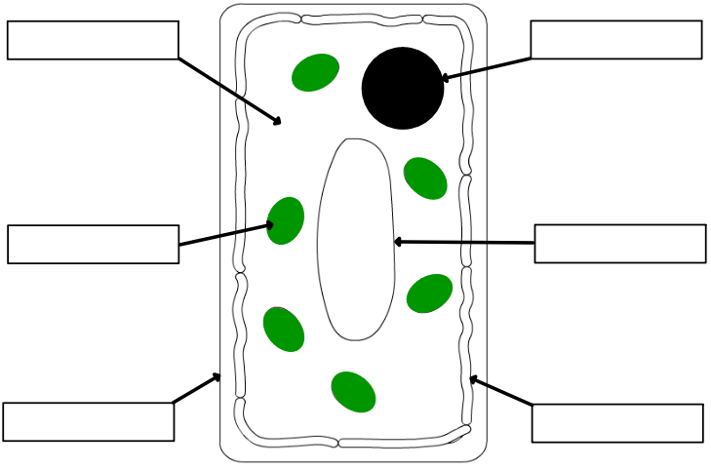

(3)
b. State two ways in which plant cells are different from animal cells.

- ______________________________________________________________

- ______________________________________________________________
(2)

- State the jobs of the following cells:
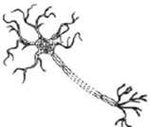
- Job of cell: ______________________________

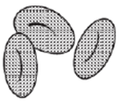
- Job of cell: ______________________________

- Job of cell: ______________________________
(3)

- Each part of a cell has a specific function. On the table below, draw an arrow to link the correct cell part to its function.

Part of Cell
Cytoplasm
Nucleus
Cell membrane
Vacuole
Chloroplast
(5)
Function
Controls what comes in and goes out of the cell
Stores water and sap in the cell
The site of chemical reactions in the cell
Site of photosynthesis
Controls the activities of the cell

- Complete the diagram below by labelling the 8 different parts of the microscope.
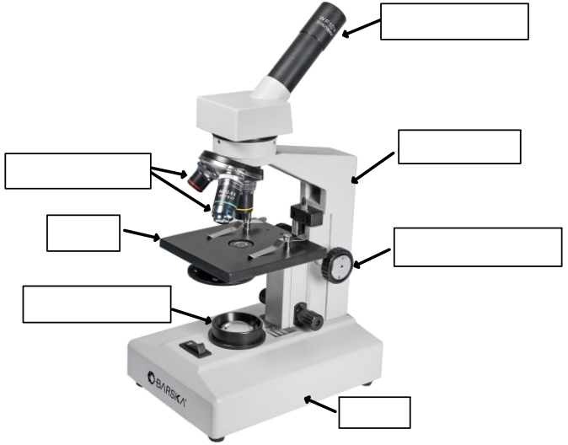
(7)

