Mark:

17
Name: ______________________________ Class: ___________

Cells and Reproduction – Fertilisation and Embryonic Development
1.
- Before a boy and girl can have children of their own, they must become sexually mature. What name is given to this process?
(1)
________________________________________________________________

- List 3 changes that happen to the body of a girl at this time:

- _____________________________________________________________

- _____________________________________________________________
(3)
- _____________________________________________________________

- List 3 changes that happen to the body of a boy at this time:

- _____________________________________________________________

- _____________________________________________________________
(3)
- _____________________________________________________________

- A survey was carried out of 300 16 year old males to find out the age at which they started puberty. The results were as follows:

Age at which puberty began | Percentage of males surveyed
11  12  13  14  15  16 | 20  20  35  10  10  5

- By what age had more than half of the males reached puberty?
(1)
____________________________________________________________

- How many of the 300 males in this group had reached puberty by age 11?
Space for calculation

(1)
__________
- Name 2 substances which can be passed from the mother to the embryo across the placenta?
2.

________________________________________________________________
(2)
________________________________________________________________

- What name is given to the structure which protects the developing embryo?
(1)
________________________________________________________________

- Why are women advised not to drink alcohol or smoke cigarettes during pregnancy?

________________________________________________________________
(1)
________________________________________________________________

- Complete the following table to show the function (job) of each structure labelled in the diagram below.

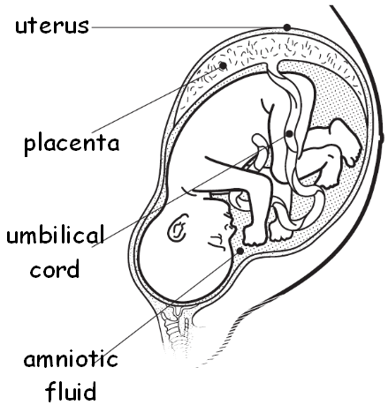  Structure | Function
 | (4)

