
Redwell Primary
Pupil Improvement Plan

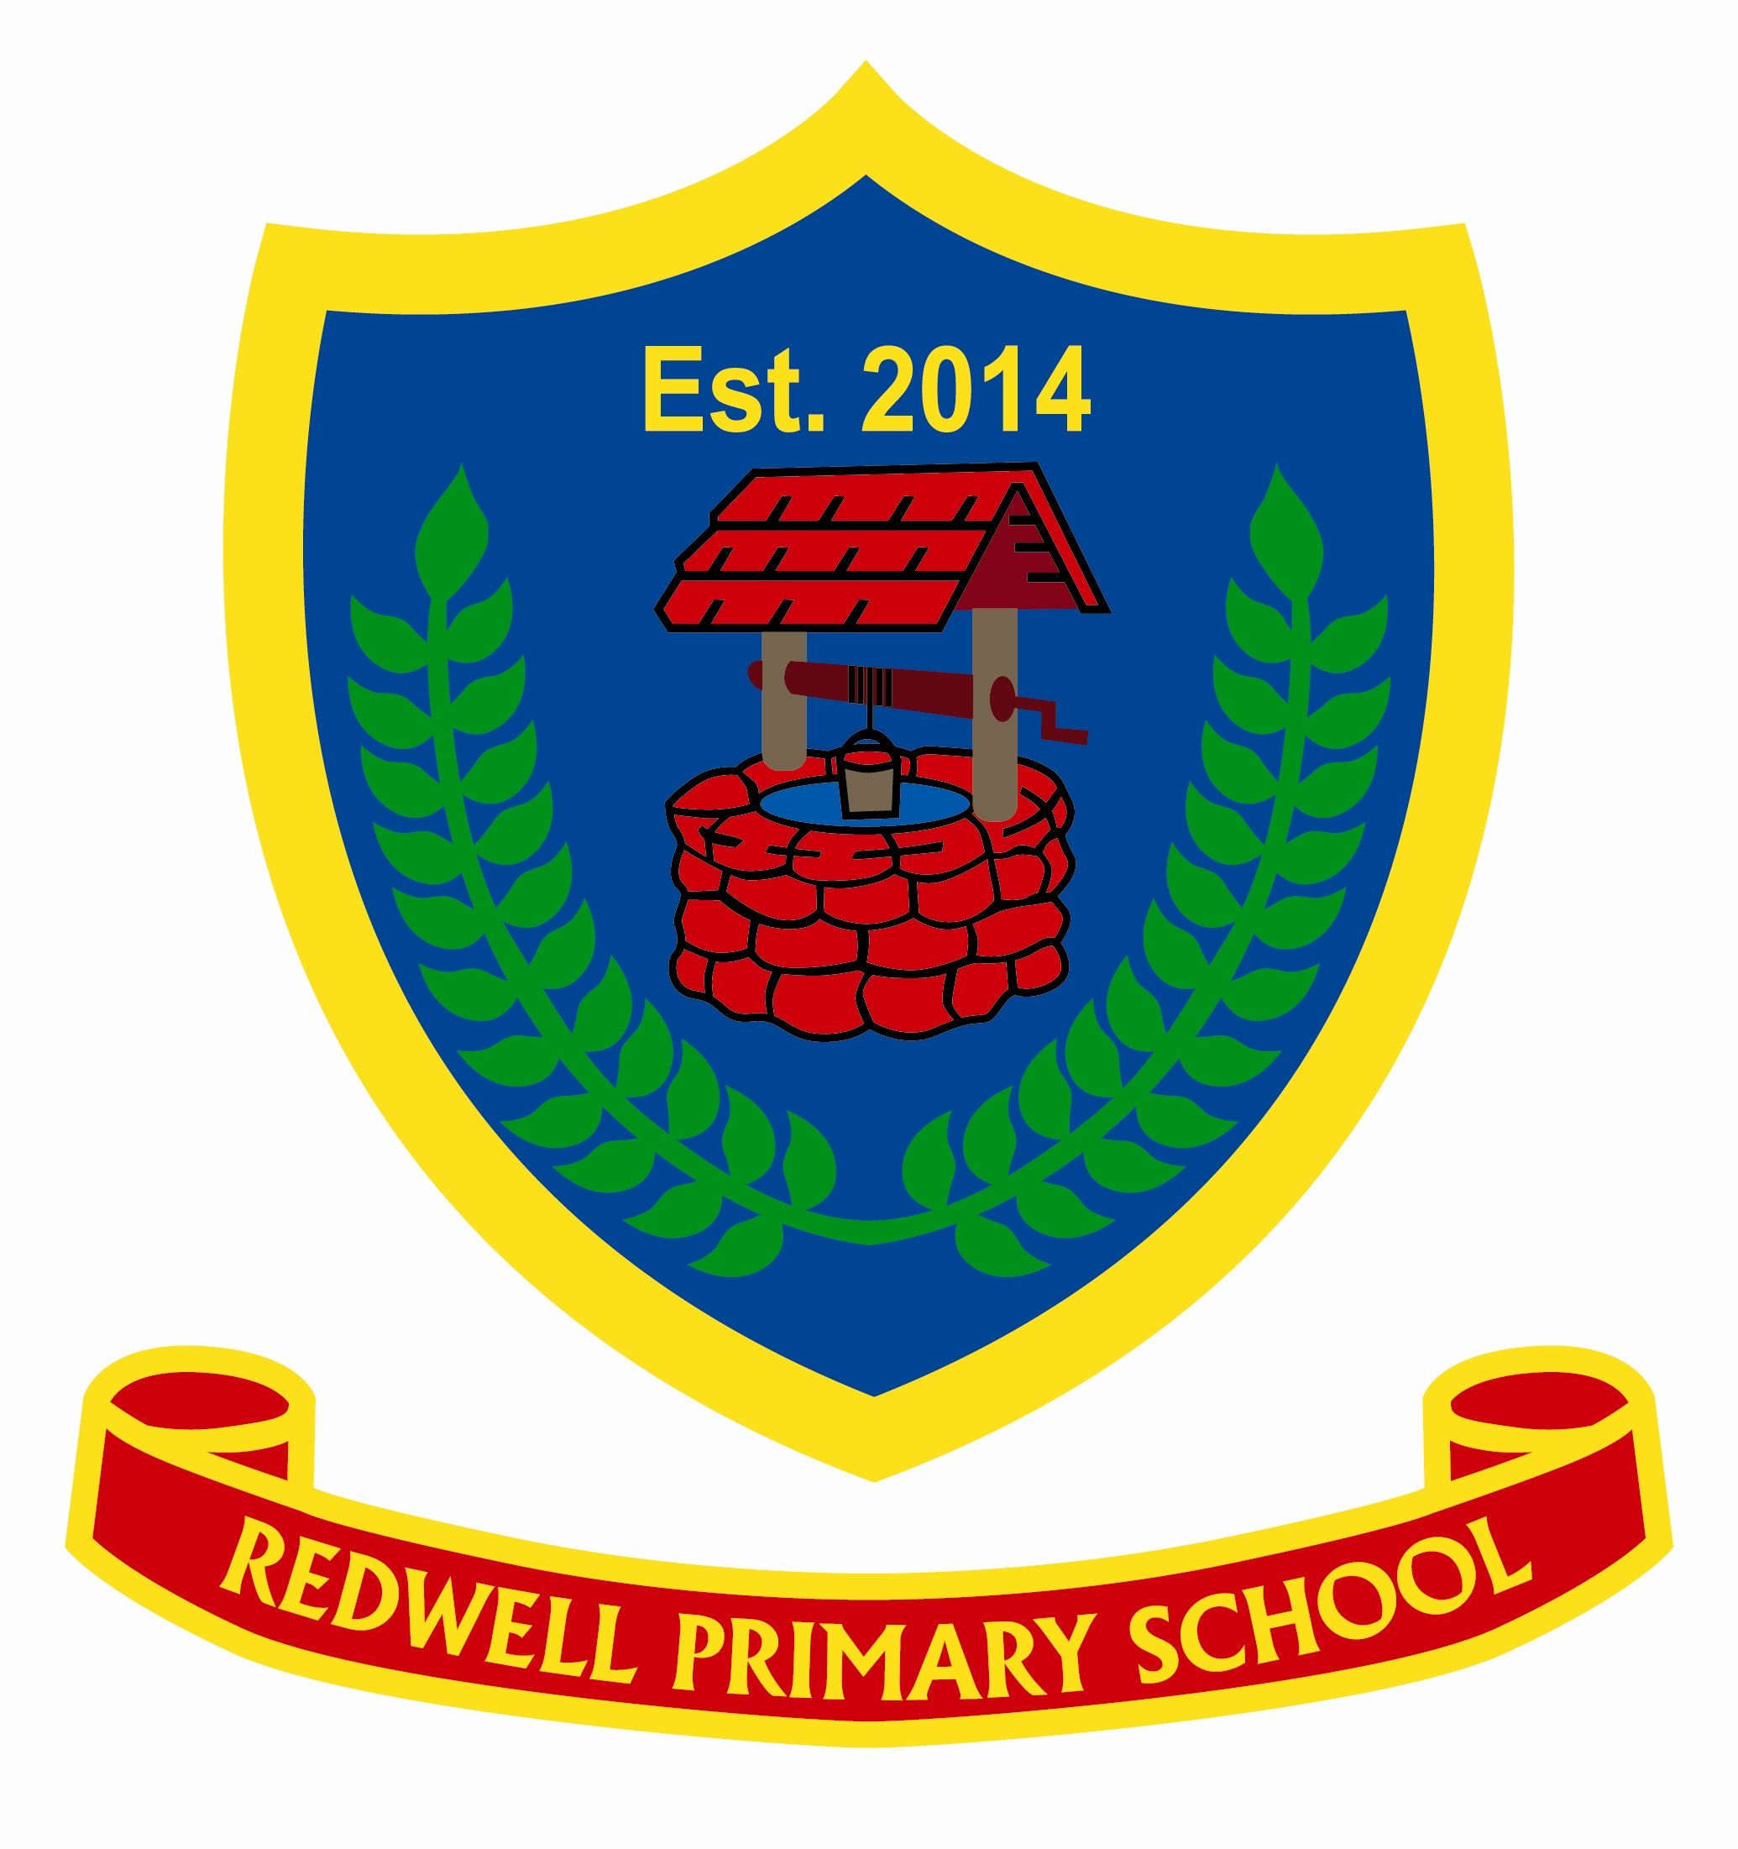
Session 2018/19

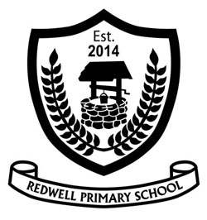 | Redwell Primary School  2018-2019
Our Context

Redwell Primary opened in 2014 and is made up of two schools (Claremont and St. John’s) that came together to become one. Our school is very big and has over 500 pupils, including 17 classes and a nursery. We are part of Alloa cluster and Alloa Academy is the high school most of the pupils will go to after Primary 7.

We have a new purpose built building that is made up of 3 wings - yellow, green and purple. In each wing there are 6 classes which each have an interactive whiteboard, there are also tablets and netbooks in each wing. Each classroom has a door which leads out to the playground to give easy access to an outdoor learning space. We have a huge playground which includes a trim trial, garden, pond, sandpit and a MUGA. We also have a double gym hall and a separate dinner hall.

At Redwell we follow the Redwell Way, pupils and staff show respect to each other and to our visitors. The Redwell Way is based on our School Charter:
- We have the right to play and the responsibility to respect school property and equipment.
- We have the right to learn and the responsibility to come to school prepared and ready to learn.
- We have the right to be safe and happy and the responsibility to be kind and gentle to others.
- We have the right to be protected and accepted and the responsibility to co-operate and allow others to play.
- We have the right to be heard and express our opinions and the responsibility to listen and show respect

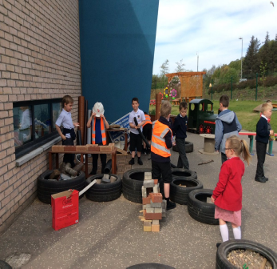
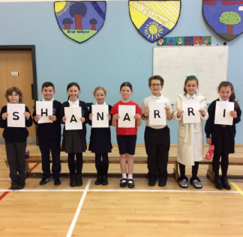
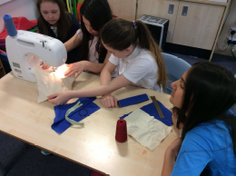
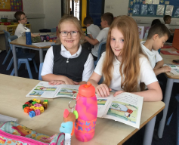
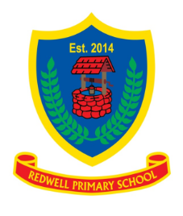

Vision Statement
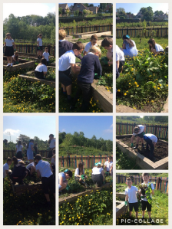

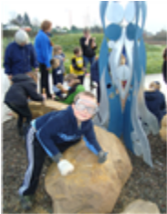
Within Redwell’s learning community, we aspire to have an enriched, inclusive and nurturing ethos which enables everyone to achieve their full potential and become lifelong learners. We celebrate achievements and diversity with a sense of pride and respect.

Curriculum Rationale
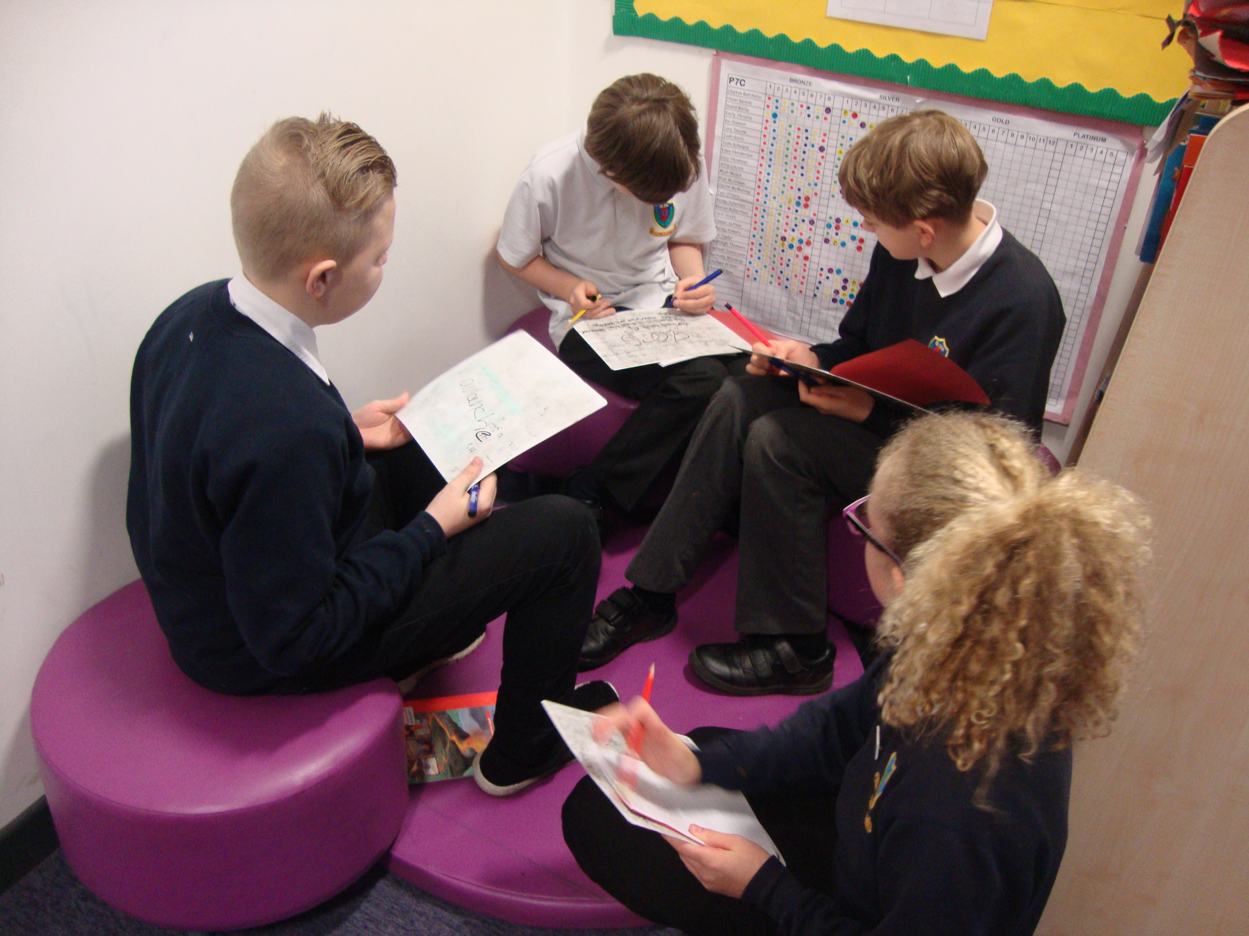
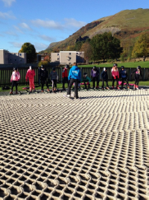
Our curriculum will ensure that our children become Confident, Responsible, Effective and Successful citizens of the future.
Subjects have clear progression pathways which ensure consistency, pace and challenge across learning providing a rich Broad General Education for all.
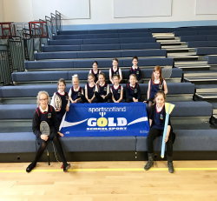
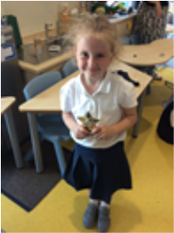

The Curriculum Topic Pathways ensure that learning is progressive through knowledge, understanding and skills and is tracked using curriculum benchmarks. They are designed to develop all children’s knowledge and understanding of their role in society from our school, to our community of Alloa, to Scotland and the world. The framework also supports opportunities for flexibility, personalisation and choice and in response to topical issues and events.
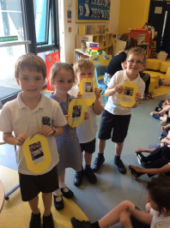
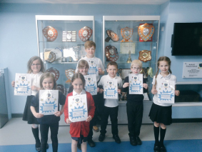
There are clear threads that link through and across the topic pathways which enable pupils to make links, apply and progress their learning in different topic subjects.
Topics provide meaningful opportunities for children to apply and extend their knowledge and skills prior learning in Literacy, Maths and Numeracy. The cross cutting themes of Sustainability, Health and Wellbeing, Developing Our Young Workforce and Enterprise are also embedded within these topic pathways.
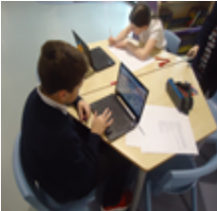
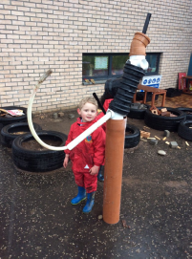
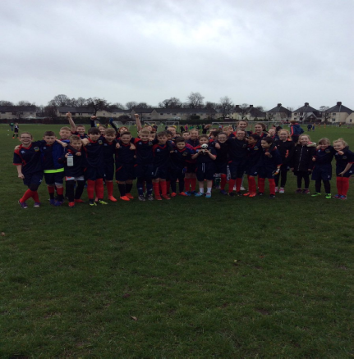
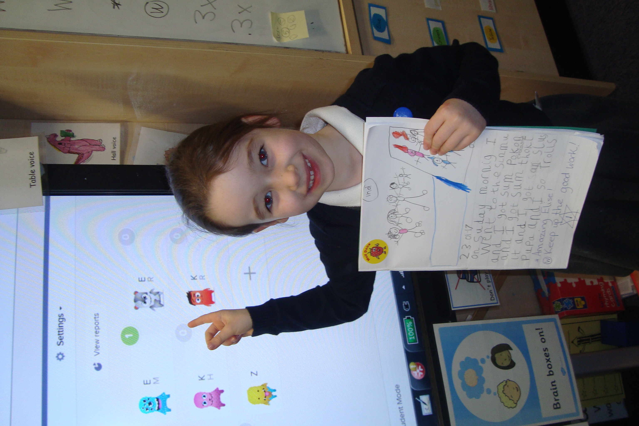
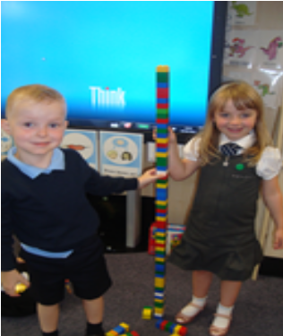
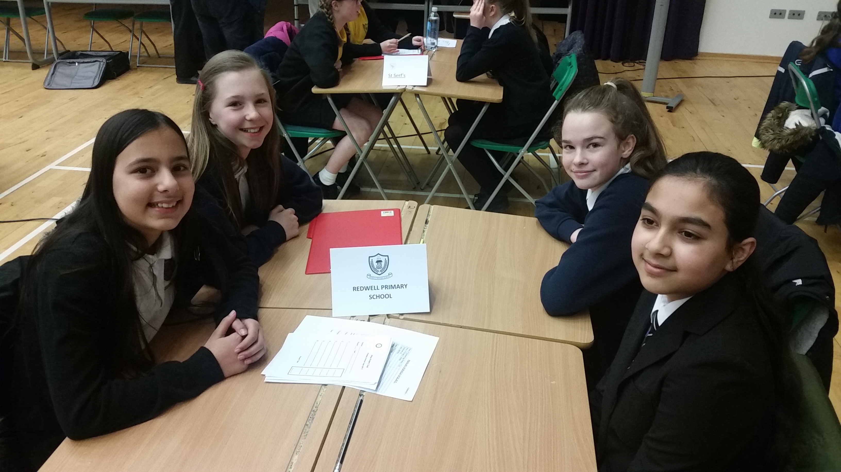
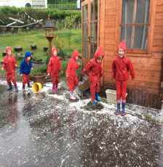

Target 1:
Develop the playground and school grounds to create a fun environment that includes all children.
Costs/Resources:
TBC
HGIOURS Theme | SIP  Priority | Actions required/Key tasks (inc. timescale) |  | Timescale | Responsibility lead person |  | Intended impact/outcomes |  | Monitoring & Evaluation
1 | 2 | Review MUGA rota system  - Discuss with Learning Assistants  - Consider if current rota is the best, how could it be developed?  - Discuss with pupil council to check with classes if they would like different sport options  Review existing playground zones and check if they are running and being used including  - Football  - Quiet area  - Reading area  - Toys  Discuss with pupil council to get pupils’ views, discuss with support staff to get their views.  Create a friendship station in the playground with a friendship bench for children who are struggling to play  - Get friendship bench  - Advertise space to pupils and staff  - Monitor the space to check if it is working |  | Jan - March  Jan - March  Jan - March | John Douglas  Dylan Carr  John Douglas  Dylan Carr  John Douglas  Dylan Carr |  | - Pupils will have more opportunities to go to the MUGA to play a wider range of sports.  - Toys will be available regardless of the weather (different toys may be out regardless of the weather).  - Areas will be available to read/ draw/ write.  - Less children will be in the playground playing by themselves.
Target 2:
Reduce amount of waste Redwell produces (recyclables/ non-recyclables and food.)
Costs/Resources:

HGIOURS Theme | SIP  Priority | Actions required/Key tasks (inc. timescale) | Timescale |  |  | Responsibility lead person |  | Intended impact/outcomes |  | Monitoring & Evaluation
4 | 2 | Reduce the amount of food waste in the dinner hall  - Eco-committee to discuss lunch choices and what to do with left over packed lunches  - Contact Class Cuisine to discuss portion sizes – potential increase in portion sizes for P4-7 and decrease for P1-3  Eco-committee to set up waste management stations throughout the school to recycle items that are currently put into general waste including pens and toothbrushes and toothpaste tubes.  - Mrs Hallahan to sign up to Terracycle scheme  - Eco-committee to run assembly in January to launch recycling scheme | Jan - March  Jan - March |  |  | Euan Morrison  Gemma Williams  Amber Akhtar  Kayla Marlin (Eco)  Euan Morrison  Gemma Williams  Amber Akhtar  Kayla Marlin (Eco) |  | - Less food waste going into the bin in the dinner hall.  - Younger pupils will waste less food as they will be able to eat the full portion.  - Redwell will recycle all used pens and tooth brushes and toothpaste tubes.  - Redwell will become a drop off point to allow community to also recycle these items.
Target : 3
Increase in personalisation and choice opportunities within classroom lessons, homework and reading
Costs/Resources:
Cauliflower Card money
HGIOURS Theme | SIP  Theme | Actions required/Key tasks (inc. timescale) | Timescale |  |  | Responsibility lead person |  | Intended impact/outcomes |  | Monitoring & Evaluation
2 | 1 | More active and interesting homework  - Review current homework across all stages  - Suggest activities that could be completed in place of, or in addition to, existing activities  Increase choice of books available in wing libraries  - Add wish list to each wing to collate ideas of books pupils want to read  - Use Cauliflower Card money to purchase books from list  More opportunities to have a say in what and how we learn at Redwell  - Review use of KWL grids (ask pupils and teachers)  - Pupil Council to gather information about what pupils would like to be learning and how they like to learn  - House and Vice Captains to meet with a group of class teachers to discuss pupil views | April - June  Dec  April - June |  |  | House and Vice Captains  - Pupil Council  John Douglas  Dylan Carr  Hannah Toovey  House and Vice Captains  - Pupil Council |  | - Pupils will enjoy homework tasks and will be more likely to complete them on time and put more effort into them.  - More pupils will choose to read more books and will enjoy the wider selection of books in the library.  - Pupils will speak positively about what they are learning and how they are learning  - Pupils will learn more as they will be learning about topics that interest them  - Pupils will have more opportunities to learn in a way they have chosen
Target : 4
Develop Golden Time to make it more of an incentive for all pupils
Costs/Resources:

HGIOURS Theme | SIP  Theme | Actions required/Key tasks (inc. timescale) | Timescale |  |  | Responsibility lead person |  | Intended impact/outcomes |  | Monitoring & Evaluation
5 | 2 | Review current Golden Time set up  - Pupil Council to gather feedback from each class about how Golden Time works for them  - Pupil Council to gather feedback about how each class would like golden time to run  - Create action plan in line with feedback from pupil council  - Implement action plan | April - June |  |  | Hannah Toovey  Millie Fraser  Finn McLaren  - Pupil Council |  | - Greater number of pupils keeping all of their golden time or more of their golden time  - Greater number of pupils achieving bronze, silver, gold and platinum awards on time

