House System

At Redwell all children part of a house group. Our houses are:

Rights Respecting Schools Charter

At Redwell we have established a charter for the Rights and Responsibilities we all share as part of our school community. Each Right is illustrated by our mascots:

At Redwell Primary School we promote and encourage positive behaviour using motivating systems and strategies to ensure that as a whole school community we are all

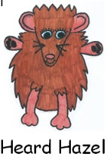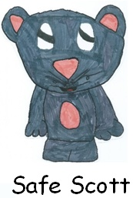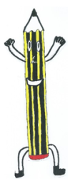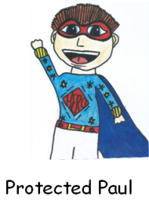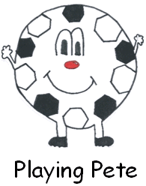

We have the right to be heard and express our opinions

We have the right to be safe and happy

We have the right to learn



We have the right to be protected and accepted

We have the right to play

When considering these themes, we encourage our pupils to make positive choices in their behaviour stemming from high expectations and shared understanding. Pupils are encouraged to show respect towards their environment and the people around them whilst building resilience and self-confidence as individuals to make the right choices.

Our approaches (as outlined in this leaflet) will build the capacity in our pupils to become

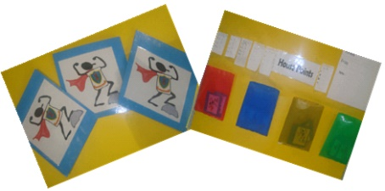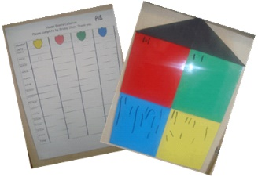

Children are encouraged to wear their coloured badge and can earn house points for making positive behaviour choices.

Children are familiar with these Rights, what it feels and looks like to experience them and what their responsibilities are in achieving them.

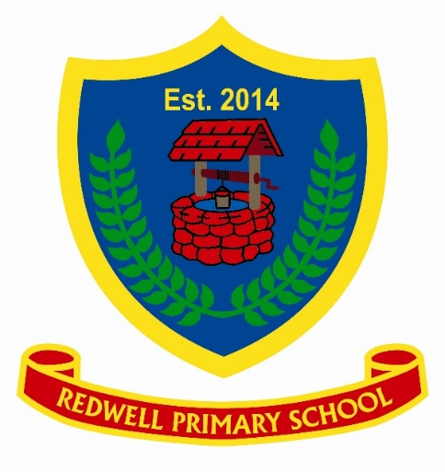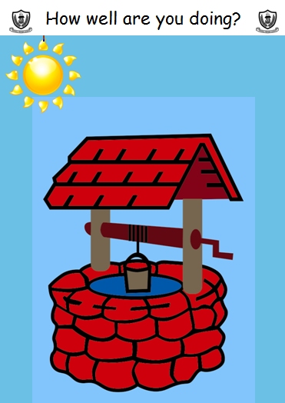

If this happens then 5 minutes of Golden time are lost.

Pupils write the reason they have lost Golden Time on a note which is kept as a record. Names are reset back into the sky after lunchtime for P1-P5 pupils but they do not reset until the following day for our more senior pupils (P6 and P7).

How Well Are You Doing?

In class, pupils use the ‘How Well are you doing?’ chart shown below as a visual motivator to stay on track with positive behaviour choices. This is very similar to a ‘traffic light’ system

Golden Time

Promoting positive behaviour at Redwell