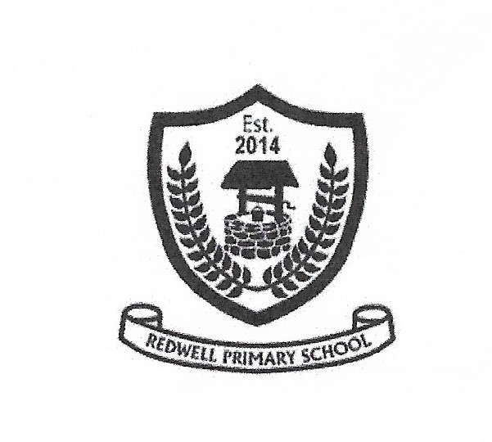

**Redwell Primary School**

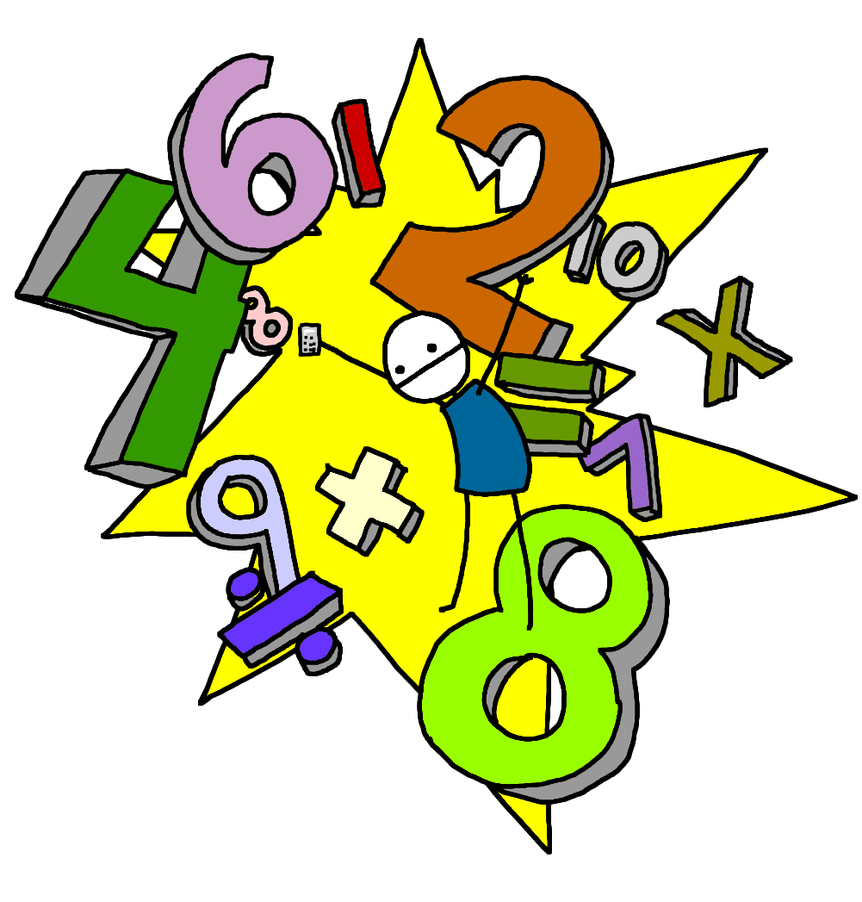

**Numeracy**

**Second Level**

***Second Level is usually covered between P5 and the end of P7 but this may be earlier or later for some learners.***

What is Numeracy and Mathematics?

Numeracy across the Curriculum

Children experience Numeracy learning on a daily basis as a stand alone subject. They will also cover aspects of numeracy within other curriculum areas such as their topic work. This allows them to make links to their mathematical knowledge and apply skills in relevant and real life situations

What will my child be learning?

How can I help my child?

**There are many useful websites to support learning within Numeracy at home:**

[www.snappymaths.com](http://www.snappymaths.com) [www.topmarks.co.uk](http://www.topmarks.co.uk)

[www.sumdog.com](http://www.sumdog.com)(Also available as an app) [www.crickweb.co.uk](http://www.crickweb.co.uk)

[www.mathsisfun.com](http://www.mathsisfun.com) [www.coolmath-games.com](http://www.coolmath-games.com)

[www.mathsphere.co.uk](http://www.mathsphere.co.uk) www.brainormous.com [www.readwritecount.scot/](http://www.readwritecount.scot/)

[www.primaryhomeworkhelp.co.uk/maths/](http://www.primaryhomeworkhelp.co.uk/maths/)