Redwell Primary School
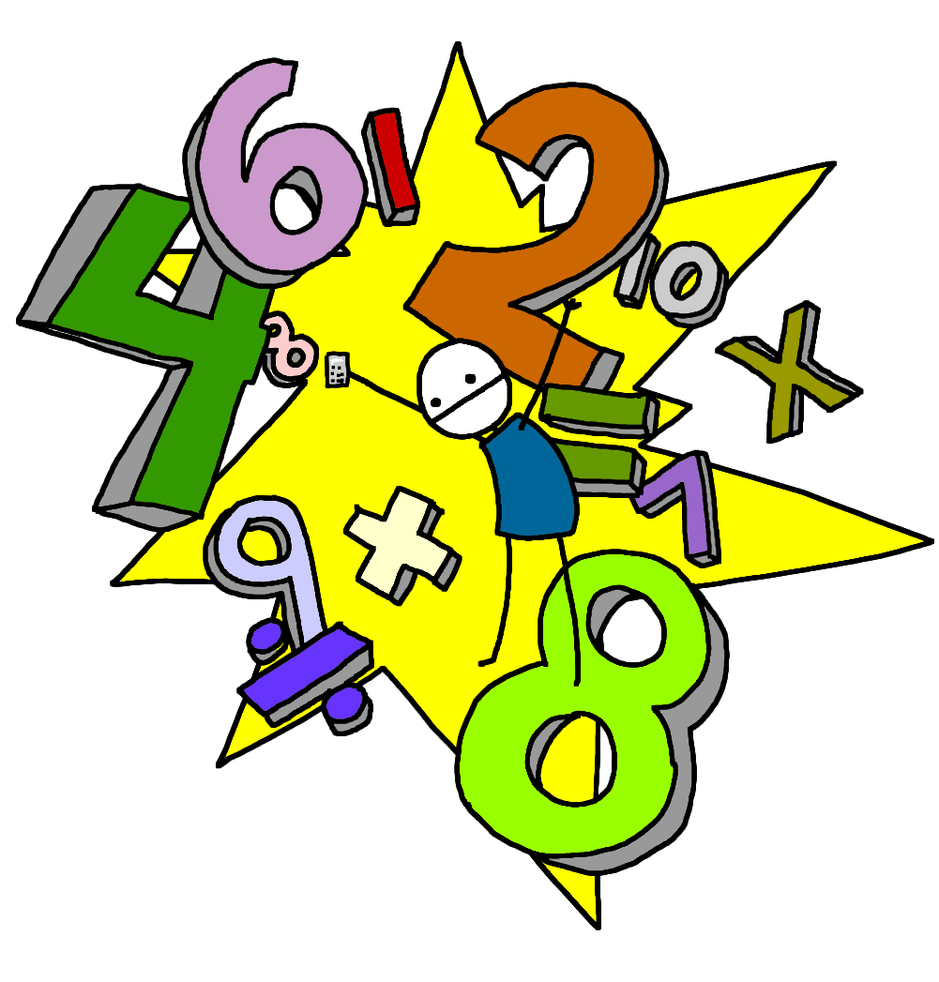
Numeracy
First Level
First Level is usually covered between P2 and the end of P4 but this may be earlier or later for some learners.
What is Numeracy and Mathematics?
Numeracy across the Curriculum
Children experience Numeracy learning on a daily basis as a stand alone subject. They will also cover aspects of numeracy within other curriculum areas such as their topic work. This allows them to make links to their mathematical knowledge and apply skills in relevant and real life situations

What will my child be learning?
How can I help my child?

There are many useful websites to support learning within Numeracy at home:
www.snappymaths.com www.topmarks.co.uk
www.sumdog.com(Also available as an app) www.crickweb.co.uk
www.mathsisfun.com www.coolmath-games.com
www.mathsphere.co.uk www.brainormous.com www.readwritecount.scot/
www.primaryhomeworkhelp.co.uk/maths/

