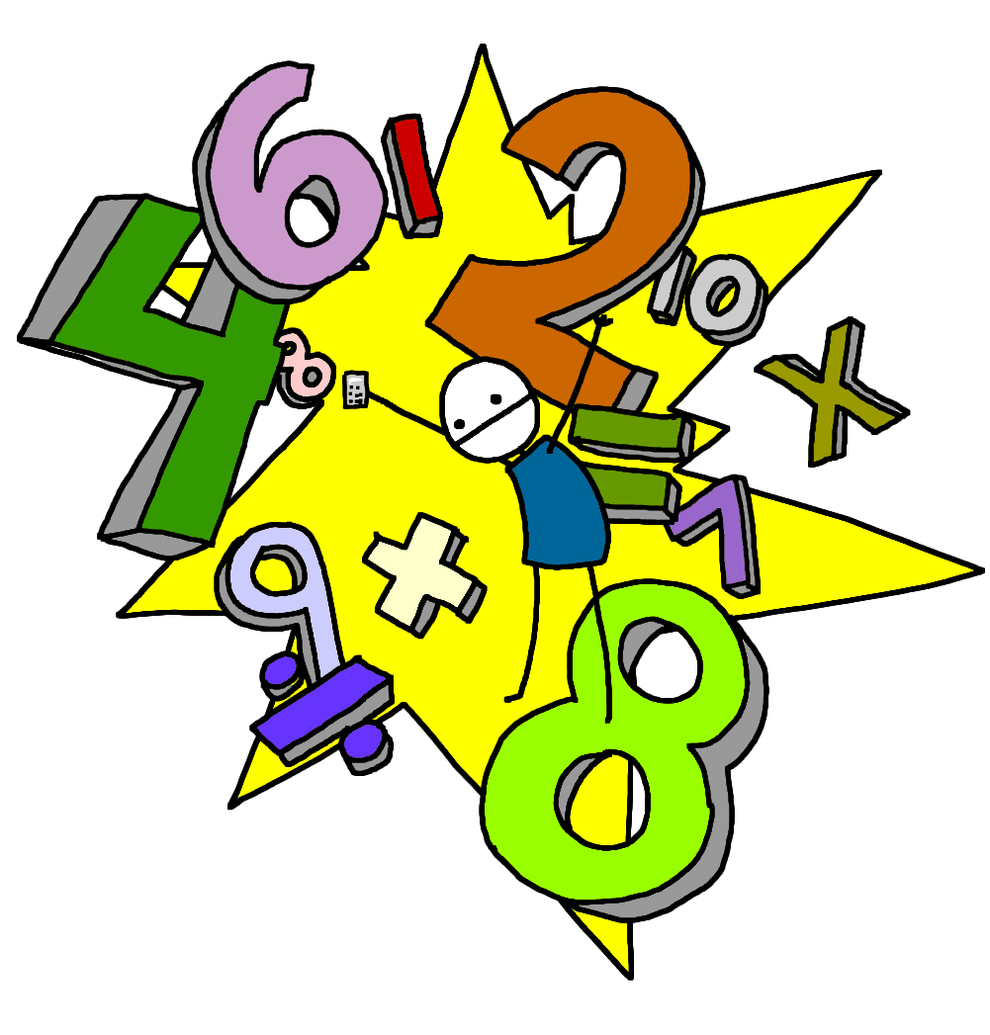

**Numeracy & Mathematics**

***Early Level is usually covered during Nursery and P1 but this may be earlier or later for some learners.***

**Early Level**

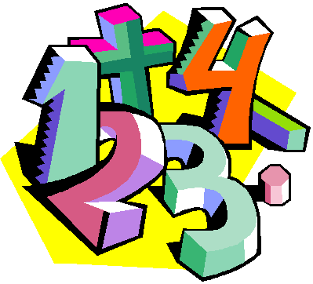

**What is Numeracy & Mathematics ???**

***‘Numeracy is important in our everyday lives, allowing us to make sense of the world around us and to manage our lives…..it equips us with the skills we need to interpret and analyse information, simplify and solve problems, assess risk and make informed choices.’* (Curriculum for Excellence)**

**The Numeracy & Mathematics Curriculum is split into the following sections:**

**Number, Money, Measure**

This includes learning how to count, read, write and order numbers; to add, subtract, multiply and divide; to work with fractions, decimals and percentages. Children will also learn to work with money and time and learn how to measure length, weight and volume.

**Shape, Position and Movement**

Children learn about the properties of 2D and 3D shapes. They also explore angles, direction and symmetry.

**Information Handling**

Children explore data and develop skills in analysis. They construct and interpret tables, charts, diagrams and graphs and learn how to carry out surveys and record data from different sources.

**Numeracy across the Curriculum**

Children experience Numeracy learning on a daily basis as a stand alone subject. They will also cover aspects of numeracy within other curriculum areas such as their topic work. This allows them to make links to their mathematical knowledge and apply skills in relevant and real life situations

**What will my child learn within Early Level?**

* Say forward and backward number word sequences (to 10 then 20 then at least 30)
* say the next 2, 3, 4 numbers in a number word sequence and number before/ after
* Sequence, order, identify and recognise numerals to at least 20
* Work out what the missing number is on a number line or a ruler
* Make patterns to 10 in different ways using objects or fingers eg. (7 and 3)( 5 and 5)
* Recognise quickly how many are in a group by not counting eg. Dots on a dice, fingers on a hand, domino patterns
* Count items in two sets and add them together
* Work out one more than and one less than (0–10 then 0-20)
* Count in 2s (up to 10 then 20) starting from 0 then Count in 10s (up to 100)
* Say the number before, after and between numbers up to 10 then 20
* Simple addition and subtraction to at least 10. Use materials to physically add or take away then move to written recording (7+3=10) (10-7=3) Include learning ‘doubles’ eg. (2+2) (4+4)

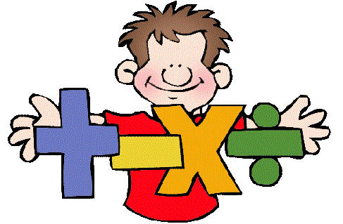

* Sort objects by colour, type, size and shape
* Measure two objects and say which is longer/shorter/taller/ heavier
* Know the order of months in a year and recognise the four seasons
* Understand first, second, middle, last, same as, more than, less than
* Say days of the week in order. Know day before and after and the language: yesterday, today and tomorrow
* Recognise the 2D shapes: circle, rectangle, triangle, square and 3D shapes: cube, cuboid, cone, cylinder, sphere
* Use 1p coins to make values up to 10p. Recognise different coins. Work out change from 10p
* Carry out a survey, record using tally marks then display information on graphs, pictograms or diagrams
* Weigh objects and tell which is heavier or lighter
* Tell the time using digital and analogue clocks, o’clock and half past
* Tell when something is full or empty
* Order numbers 1st, 2nd, 3rd etc
* 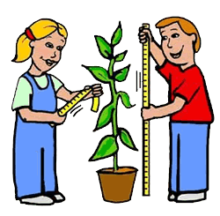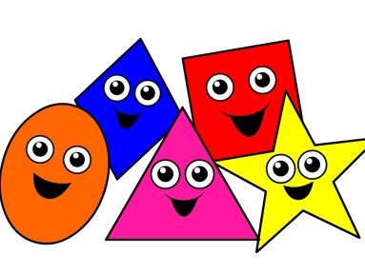Show what a half and quarter is. Share objects into equal sets

**How can I help my child?**

**Numeracy & Mathematics is all around us as we go about our day to day life. There are many opportunities to engage children in using their skills within real life experiences. Here are just a few examples:**

* **Cooking and baking**: weighing ingredients, calculating timings, dividing into portions etc.
* **D.I.Y**: measuring length, height, calculating areas, using measuring equipment, talking about symmetry and shape
* **Shopping**: handling different coins/ notes, paying for items, checking change, working to a budget, price comparison, using online shopping sites or catalogues
* **Time**: telling the time on a watch, computer, phone or different types of clocks, identifying the time on a tv schedule, looking at bus or train timetables, flight times when going on holiday
* **Information Handling**: discuss graphs or tables on the news/ online, carry out a survey when out and about eg. Car colours/ types of pets/ trees
* **Calendar**: refer to days, weeks, months and seasons, talk about what day/ month comes next/ before
* **Number**: some traditional board games support mental agility and problem solving perfectly: dominoes, snakes and ladders, card games etc.
* **Distance**: when out for a walk or at home, calculate how many steps it will take to get to a place/ compare distances
* **Direction**: use simple maps, a compass or sat nav devices to discuss directions N, S, E, W, give instructions to walk forwards/ backwards and turn towards different directions
* **Shape:** talk about the properties of different shapes by using food. Cereal, pasta, biscuits are perfect for sorting and comparing. Food boxes are also good for recognising as 3D shapes such as cubes/ cuboids and cylinders.



**There are many useful websites to support learning within Numeracy at home:**

[www.snappymaths.com](http://www.snappymaths.com) [www.topmarks.co.uk](http://www.topmarks.co.uk)

[www.sumdog.com](http://www.sumdog.com) [www.crickweb.co.uk](http://www.crickweb.co.uk)

[www.mathsisfun.com](http://www.mathsisfun.com) [www.coolmath-games.com](http://www.coolmath-games.com)

[www.mathsphere.co.uk](http://www.mathsphere.co.uk) [www.primaryhomeworkhelp.co.uk/maths/](http://www.primaryhomeworkhelp.co.uk/maths/)

[www.brainormous.com](http://www.brainormous.com) [www.readwritecount.scot/](http://www.readwritecount.scot/)