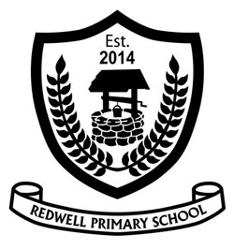
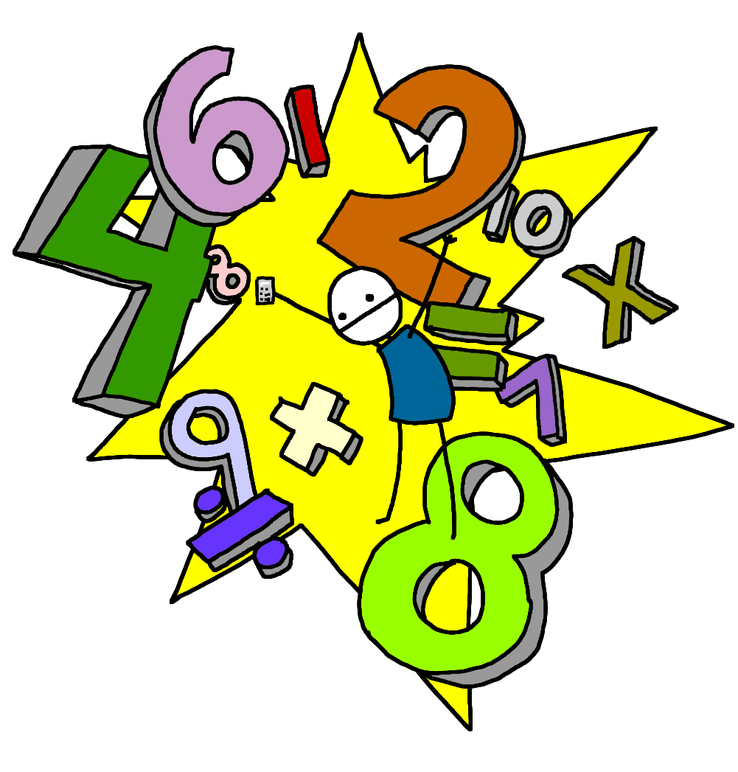
Second Level is usually covered between P5 and the end of P7 but this may be earlier or later for some learners.

Second Level
Numeracy & Mathematics
Redwell Primary
School
What is Numeracy & Mathematics ???
‘Numeracy is important in our everyday lives, allowing us to make sense of the world around us and to manage our lives…..it equips us with the skills we need to interpret and analyse information, simplify and solve problems, assess risk and make informed choices.’ (Curriculum for Excellence)
The Numeracy & Mathematics Curriculum is split into the following sections:
Number, Money, Measure
This includes learning how to count, read, write and order numbers; to add, subtract, multiply and divide; to work with fractions, decimals and percentages. Children will also learn to work with money and time and learn how to measure length, weight and volume.
Shape, Position and Movement
Children learn about the properties of 2D and 3D shapes. They also explore angles, direction and symmetry.
Information Handling
Children explore data and develop skills in analysis. They construct and interpret tables, charts, diagrams and graphs and learn how to carry out surveys and record data from different sources.
Numeracy across the Curriculum
Children experience Numeracy learning on a daily basis as a stand alone subject. They will also cover aspects of numeracy within other curriculum areas such as their topic work. This allows them to make links to their mathematical knowledge and apply skills in relevant and real life situations

What will my child learn within Second Level?

- Read, write, order and count numbers up to 100 000 then up to 1 000 000
- Read, write and order decimal numbers that have 1, 2 and 3 decimal places
- Add and subtract multiples of 10, 100, 1000 with whole numbers and decimal fractions
- Multiply and divide 2, 3 then 4 digit numbers including decimals by 10, 100 then 1000 eg. 2534 x 100 or 12.78 x 100
- Round 3 or 4 digit numbers to nearest 10, 100 then 1000
- Identify the place value of digits in whole numbers up to 1 000 000 using ‘hundred thousands’,‘ten thousands’, ‘thousands’, ‘hundreds’, ‘tens’ and ‘ones’
- Confident application of times tables facts and linking of tables facts knowledge when working with division
- Round decimal fractions to at least 2 decimal places
- Work out any percentage of an amount eg. What is 25% of 140
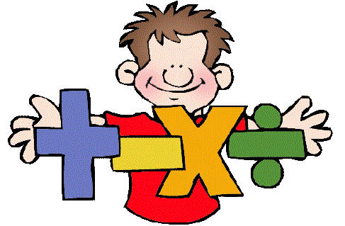
- Work out and find equivalents of simple fractions, decimals and percentages

- Simplify fractions and find equivalent fractions eg. ½ is equivalent to 4/8
- Calculate durations of time in hours and minutes using the 12 and 24 hour clock
- Tell the time from analogue and digital clocks in minutes to/ from the hour
- Discuss properties of 3D shapes to include vertices, corners, faces and use nets to build 3D models
- Use the vocabulary: radius, circumference and diameter when talking about circles
- Use knowledge of acute, obtuse and straight angles to solve problems measuring angles in degrees
- Relate knowledge of angles to position and direction when talking about compass points
- Work confidently with calculations involving money. Understand about profit and loss and working within a budget
- Independently collect, organise, display and interpret information using a range of graphs, databases, tables and pie charts
- Confidently use imperial measures when working with volume, capacity, weight, length and area. Convert between mm, cm, m, km when measuring length/ distance
- Use knowledge of scale to draw diagrams, plans and designs
- Work out what the symbol represents when working with basic equations eg. 5a + 2a = 14 so a= 2
How can I help my child?
Numeracy & Mathematics is around us as we go about our day to day life. There are many opportunities to engage children in using their skills within real life experiences. Here are just a few examples:
- Cooking and baking: weighing ingredients, calculating timings, working out quantity of ingredients for number of people
- D.I.Y: measuring length, height, calculating areas, using measuring equipment, talking about symmetry and shape, perimeter and scale
- Shopping: handling different coins/ notes, paying for items, checking change, working to a budget, price comparison, using online shopping sites or catalogues, experience of bank/ credit cards
- Time: telling the time on a watch, computer, phone or different types of clocks, identifying the time on a tv schedule, looking at bus or train timetables, flight times when going on holiday, speed and distance calculations when travelling
- Information Handling: analyse graphs or tables on the news/ online, carry out a survey when out and about , work out averages
- Calendar: refer to days, weeks, months and seasons, talk about what day/ month comes next/ before, plan events and an itinerary for trips
- Number: some traditional board games support mental agility and problem solving perfectly: dominoes, snakes and ladders, card games etc.
- Distance: when out for a walk or at home, calculate how many steps it will take to get to a place/ compare distances
- Direction: use maps, a compass or sat nav device to explore directions. Plan a route
- Money: in a sale, work out how much items will cost using knowledge of percentages eg. 50% or 20% off

There are many useful websites to support learning within Numeracy at home:
www.snappymaths.com www.topmarks.co.uk
www.sumdog.com www.crickweb.co.uk
www.mathsisfun.com www.coolmath-games.com
www.mathsphere.co.uk www.primaryhomeworkhelp.co.uk/maths/
www.brainormous.com www.readwritecount.scot/

