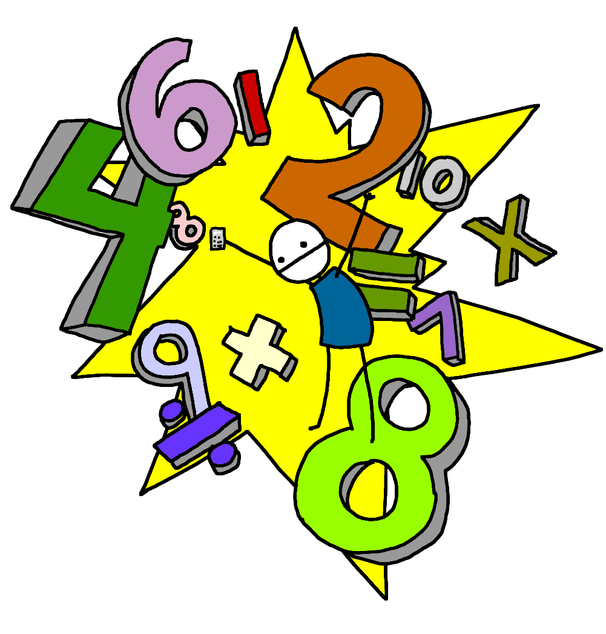
First Level is usually covered between P2 and the end of P4 but this may be earlier or later for some learners.
First Level
Numeracy & Mathematics
Redwell Primary
School
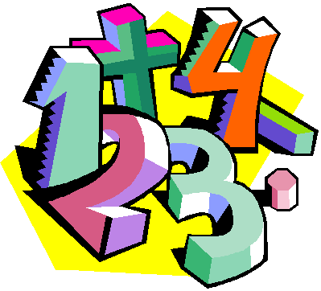
What is Numeracy & Mathematics ???
‘Numeracy is important in our everyday lives, allowing us to make sense of the world around us and to manage our lives…..it equips us with the skills we need to interpret and analyse information, simplify and solve problems, assess risk and make informed choices.’ (Curriculum for Excellence)
The Numeracy & Mathematics Curriculum is split into the following sections:
Number, Money, Measure
This includes learning how to count, read, write and order numbers; to add, subtract, multiply and divide; to work with fractions, decimals and percentages. Children will also learn to work with money and time and learn how to measure length, weight and volume.
Shape, Position and Movement
Children learn about the properties of 2D and 3D shapes. They also explore angles, direction and symmetry.
Information Handling
Children explore data and develop skills in analysis. They construct and interpret tables, charts, diagrams and graphs and learn how to carry out surveys and record data from different sources.
Numeracy across the Curriculum
Children experience Numeracy learning on a daily basis as a stand alone subject. They will also cover aspects of numeracy within other curriculum areas such as their topic work. This allows them to make links to their mathematical knowledge and apply skills in relevant and real life situations

What will my child learn within First Level?

- Estimate the position of any number up to 100 on a number line/square
- Round numbers to the nearest 10 then larger numbers to the nearest 100
- Sequence, order, identify and recognise numerals to 100 then up to at least 1000, begin recognising numbers to 10,000
- Say forward and backward number word sequences (to at least 100) then counting on or back in 2s, 10s, 5s, 3s and 4s
- Recognise, sequence and order multiples of 100 (to at least 1000)
- Describe the place value of each digit in a number to at least 1000 eg. (5762 = 5000, 700, 60, 2) Use the terms ‘thousands, hundreds, tens and ones’
- Solve addition and subtraction calculations involving 3 digit numbers or more. Use a variety of mental strategies and written recording
- Multiplication facts (x2, x5, x10, x3, x4 and onwards) Solving problems which link this knowledge to division calculations
- Multiply a two digit number by a single digit eg. 23 x3, mentally and in written form
- Work with the symbols for ‘more than’ > and ‘less than’ <
- Use fractions when dividing numbers eg. Find a third of 24. Use visual diagrams to break a whole into smaller equal parts
- Understand simple equivalent fractions eg. One half is equal to two quarters
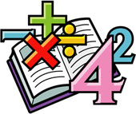
- Use a variety of coins and notes to pay for items and work out change up to £1 then beyond to larger amounts

- Identify times on the hour, half past, quarter past and quarter to on both analogue and digital clocks then tell the time in 5 minute intervals
- Use a 12 hour timetable to work out time durations, beginning to use the 24 hour clock when talking about time
- Measure and estimate using cm, m, g, kg, ml, l. Read scales on a variety of measuring tools
- Know that a 90 degree turn is a right angle when talking about compass directions. Recognise angles that are more and less than 90 degrees. Use the language of clockwise and anti-clockwise when working with directions
- know the properties of 2D shapes such as pentagons, hexagons and octagons, Talk about edges, vertices and faces when working with 3D shapes
- Identify a line of symmetry and draw the other half of a symmetrical shape
- Carry out a survey, record using tally marks then display information. Construct graphs, bar charts and tables. Interpret findings and analyse data
How can I help my child?
Numeracy & Mathematics is around us as we go about our day to day life. There are many opportunities to engage children in using their skills within real life experiences. Here are just a few examples:
- Cooking and baking: weighing ingredients, calculating timings, working out quantity of ingredients for number of people
- D.I.Y: measuring length, height, calculating areas, using measuring equipment, talking about symmetry and shape, perimeter and scale
- Shopping: handling different coins/ notes, paying for items, checking change, working to a budget, price comparison, using online shopping sites or catalogues, experience of bank/ credit cards
- Time: telling the time on a watch, computer, phone or different types of clocks, identifying the time on a tv schedule, looking at bus or train timetables, flight times when going on holiday, speed and distance calculations when travelling
- Information Handling: analyse graphs or tables on the news/ online, carry out a survey when out and about , work out averages
- Calendar: refer to days, weeks, months and seasons, talk about what day/ month comes next/ before, plan events and an itinerary for trips
- Number: some traditional board games support mental agility and problem solving perfectly: dominoes, snakes and ladders, card games etc.
- Distance: when out for a walk or at home, calculate how many steps it will take to get to a place/ compare distances
- Direction: use maps, a compass or sat nav device to explore directions. Plan a route
- Money: in a sale, work out how much items will cost using knowledge of percentages eg. 50% or 20% off

There are many useful websites to support learning within Numeracy at home:
www.snappymaths.com www.topmarks.co.uk
www.sumdog.com www.crickweb.co.uk
www.mathsisfun.com www.coolmath-games.com
www.mathsphere.co.uk www.primaryhomeworkhelp.co.uk/maths/
www.brainormous.com www.readwritecount.scot/

