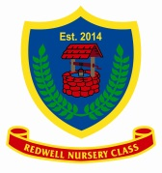
28th March 2019
Redwell Nursery Class
World Book Day

We are celebrating World Book Day on Friday 8th March 2019. We invite your child to dress up on Friday as their favourite character or come in PJ’s for their session times. Your child is welcome to share their favourite stories and books from home. We will be joining the yellow wing throughout the day for story times with different readers!
Many thanks in advance

Redwell Nursery Team

