Muckhart Primary School

Standards and Quality Report 2021-22
#smallbutmighty
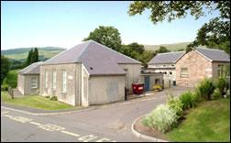

“Home of Natural Learning”
Our Context:
Muckhart Primary is a small rural school with a current roll of 43. The school was built in 1845 and is situated at the centre of the original parish; this explains why the school is not in the centre of the village. The school is situated on the road to Muckhart Golf Club approximately half a mile from the centre of the village. Over the years the school has been modernised and new parts added on. We have extensive outdoor areas which we regularly use for teaching. We are an outdoor-loving school. We have strong community links and use the village and surrounding areas regularly to develop learning.
This session we have 3 classes. P1/2 Seamab Class and P3/4/5 Ben Nevis Class and P6/7 Skythorn Class. We have 2 permanent teachers; who have been teaching in the school for 6 years. A long-term supply teacher, teaches P6/7 3 days a week; sharing the class with the HT since January 2022. We have 2 part-time Learning Assistants as well as an Administrator. We have handyman support for 3 hours per week. Children receive 1 hour art teaching per week and are taught 2 hours PE by a PE specialist. This allows Class Teachers their non-class contact time.
Pre -Covid we were well supported by parents and other community volunteers; this support has been permitted to start again for the final term of the session. In “normal” times our library is organised by parent/carer volunteers on a Tuesday and our garden is maintained, along with the children, by former pupils on a Friday. Usually community members come at key times throughout the week to support the learning, but this has been curtailed this session.
The school has a friendly and welcoming feel and a positive ethos. We work together for the benefit of all as one “Muckhart family”. Children are confident and happy in their learning. One parent recently commented: “There is a very strong sense of family and community within the school which not only embraces our children, but also extends to the families of the school to promote a close positive partnership and encourage family engagement in learning. We love that our children attend a school which promotes kindness and empathy. A school where every child is seen and appreciated for who they are alongside a firm emphasis on developing a strong moral compass for life helping to ensure our children are kind and empathetic as well as responsible, honest and accountable. We feel very fortunate to be part of such a warm and supportive school with leadership and staff who really care about our children.”
Another parent described the atmosphere in our school as being “like a comfy, cosy cardigan”
For the purpose of this report we are reporting our progress against the National Improvement Framework priorities and drivers. This report reflects progress made towards achieving our priorities, session 2021-22.
Lesley McGlinchie Headteacher
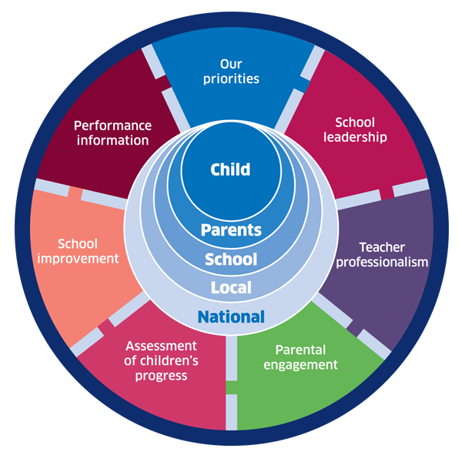
June 2022

Muckhart Primary School - Review of Progress to June 2022
NIF Improvement Priority 1: Improvement in attainment, particularly in literacy and numeracy
NIF Drivers: Teacher Professionalism and Assessment of Children’s Progress
HGIOS4 QI: 2.2 Curriculum, 2.3 Learning, Teaching and Assessment, 3.2 Raising Attainment and Achievement
- The Headteacher and staff continue to work in partnership with the Local Authority and cluster schools to drive forward improvement
- Our teaching staff have continued to develop their own professional learning especially in the area of teaching creative writing. One teacher has undertaken Coaching and Mentoring CLPL which she has used to support one of our Learning Assistants as he develops the numeracy intervention Building Blocks. The teacher who attended Coaching and Mentoring CLPL evaluated the CLPL: “I engaged with academic research to develop my knowledge and understanding of effective coaching and mentoring strategies; enabling me to become a better leader of learning”
- Both teachers have undertaken moderation CLPL; working with colleagues across the RIC to moderate learning. Teachers felt the moderation sessions were informative and well structured. The sessions brought “high quality assessments” back into focus as an area of personal development and as an area to develop across the school
- Staff continue to regularly plan together to ensure progression in learning at all stages. Our team is well established and relationships are positive. Staff welcomed a new probationer teacher to our team; working well to mentor and support her professional development.
- Teachers’ initiative, leadership and whole school ownership is encouraged by the Headteacher, and welcomed by staff.
- Staff demonstrate a strong commitment to continuous improvement and raising attainment for all children. Staff work well together and there is a great sense of collegiality and shared responsibility for all children within school. Quality Improvement and Assessment procedures are embedded. Learning Assistants understand clearly the importance of their role in raising attainment.
- Children are able to talk well about their learning. Children attend Learner Conversation events with their parents, twice per session, to discuss their progress and agree their next steps
- The biggest transformation to our curriculum this session has been the introduction of a play pedagogy in P1/2. Both the HT and Class Teacher have attended extensive and detailed online CLPL sessions which have enabled us to introduce and begin to embed play pedagogy in P1/2. Mrs Gallagher the P1/2 Class Teacher has noted “the children are resilient and solve disagreements by talking to each other without needing adult support because they have learned to negotiate, share and compromise through play. I have more time for direct, quality teaching with smaller groups; knowing that the children are engaged and learning through play. The classroom feels warm, welcoming, calm and productive and visitors have commented on this.”
- Both Learning Assistants have, over time, been upskilled in understanding teaching methodologies and the importance of sharing Learning Intentions and Success Criteria
- In the past, all staff have been part of Clackmannanshire’s Equitable Literacy Project, working alongside Prof Sue Ellis from Strathclyde University. Children continue to talk about books: children across the school are excited to do a Book Blessing at Assembly; recommending books they have read to friends and adults in school. Children love reading and reading for pleasure is a key element of our literacy curriculum
- This session, Learning Assistants have been trained in small group interventions. One LA was trained in “Building Blocks” – a new Clackmannanshire initiative developed to support children needing extra numeracy practice. “Building Blocks” intervention has ensured one child achieved First Level numeracy – albeit a small- scale success but still an important impact on the child’s attainment.
- One LA was trained in “Write On” – a literacy intervention to support writing across the curriculum especially at First Level. Children learning in this small group showed huge increase in engagement and enjoyment of writing. They took ownership of the project, were excited to take part and were proud of their learning. All children in the small group increased their scores significantly from pre to post assessment.
- Teachers are more confident using a variety of genre as instructional text and have a greater awareness of quality text. We have increased the selection of non-fiction books for younger learners. Teachers have added diversity into the literature they share with classes. We have bought a wide range of diverse books about children from different backgrounds and cultures.
- Engagement and enjoyment in reading has continued to improve for the majority of pupils and is very well supported at home. Many children, especially in the upper school, are willing to explore reading in more depth with increasing independence. Focused whole class novel studies have captured children’s imagination and broadened their horizons – ensuring breadth and depth in the literacy curriculum. Audio books have been a good investment especially for those with challenges to literacy attainment
- Dyslexia friendly reading materials have been built on from last session and still remain popular. Dyslexic children work together with the Support for Learning teacher to understand dyslexia and develop strategies to support them. Dyslexia is talked about freely in classes; helping learners to understand themselves and be more accepting of diversity of others. Recently, children with DCD (dyspraxia) shared a power point they had made, with the whole school, to explain what DCD means and the impact it has on them
- Learning Assistants work with individual children across the school on individual interventions such as “Toe by Toe” which supports reading and “Power of 2” and “Plus 1” which support number sense. The impact of these interventions has been significant. Children working on “Toe by Toe” to improve reading have increased their PM Benchmark level by over 10 levels in a short space of time. This focused intervention has boosted phonics skills perhaps not as well embedded due to Covid periods of Remote Learning. Children working on “Plus 1” and “Power of 2” have shown increased confidence in numeracy lessons and continued intervention next session will, I am confident, embed the children’s numeracy confidence
- Children typing rather than handwriting continues to engage more reluctant writers by reducing the processing required to write an interesting story. Typing supported learners to produce more work and feel a sense of achievement and aided proof reading. Some children speak their writing into a google doc.
- A significant Local Authority spend on infrastructure, in May of 2021, has enabled learners and teachers to be online more often and more consistently
- We use “Language Angels” an online language tool to support the teaching of French across the school, and German in P5-7. A grandmother of two of our children has started coming into school to support the teaching of French in P1/2 – through story and song.
- Teacher Professional Judgement, supported by Scottish Government’s SNSA, of Reading at Early Level (P1), First Level (P4) and Second Level (P7) recorded most children achieving by June 2022. The majority of parents and carers continue to support their children’s learning very well; in partnership with teachers.
- From the achievement data noted in Reading, it is clear to see the impact the long-term improvement model in reading has had on our learners and on the confidence in our teachers and Learning Assistants.
- Teacher Professional Judgement of Listening and Talking at Early Level (P1), First Level (P4) and Second Level (P7) recorded most learners achieving by June 2022.
- Teacher Professional Judgement, supported by Scottish Government’s SNSA, of Writing at Early Level (P1) and Second Level (P7), recorded most learners achieving by June 2022. At First Level (P4), the majority of P4 learners achieving First Level by June 2022. Clearly the focus of SIP/PEF 2022-23 will continue to be in improving attainment in writing across the school. The school roll consists of 60% boys and 40 % girls. Many children have barriers to achievement in writing.
- Writing is still a challenging area of literacy for many children especially at First Level. The teaching of creative writing is definitely an area which was the most difficult to teach remotely. The engagement of a large section of the school in story writing has been severely impacted by spells of Remote Learning. Children, generally, are not drawn to self-direct learning in writing as it is such an abstract and open-ended task.
- Teacher Professional Judgement, supported by Scottish Government’s SNSA, in Numeracy at Second Level (P7), recorded most learners achieved Second Level, the majority of P4 learners achieved First Level and the majority of learners at the end of P1, achieved Early Level. The phased planning model developed by Clacks Improving Outcomes team is easy to follow and assess and enables clear pinpointing of gaps in learning.

Muckhart Primary School - Review of Progress to June 2022
NIF Improvement Priority 2: Improvements in Children and Young People’s Health and Wellbeing
NIF Drivers: School Improvement and Assessment of Children’s Progress
HGIOS4 QI: 2.2 Curriculum, 3.1 Ensuring Wellbeing, Equity and Inclusion
- With the continuing focus on Zones of Regulation, children are beginning to understand their emotions and increase their ability to self-regulate. Staff have a greater understanding of the sensory processes involved in children being ready to learn
- Staff have completed Clacks Academy nurture and R4L training modules
- The purchase of “Emotion Works” – a whole school resource to support emotions and wellbeing as we recovered from Covid – proved a valuable learning tool and complemented well our current practice. Children at Early Level, when asked why learning about feelings was important, responded “if you don’t know what your feelings are called, you can’t tell someone else” and “we need to be able to work out how someone is feeling”
- Parents/carers commented on Emotion Works “how fortunate we are that conversations around emotions have been totally normalised for the children at Muckhart and just what a difference that could make for their future” and “it is so heartening to hear my child talking about his feelings and triggers for different emotions so eloquently”
- Daily Health and Wellbeing check-ins, started during lockdown, have continued across the school
- Weekly assemblies, themed to promote positive wellbeing and happiness, have continued throughout the session – these are based around Adrian Bethune’s book “Wellbeing in the Primary Classroom”
- Children from P3-7 benefitted from a resilience-building day out to Lendrick Muir activity centre; linked to one of our new values of “determination”. Children supported each other in a really positive manner. They challenged themselves to complete activities even when they found things difficult. The aim to nudge children into their challenge zone and out of their comfort zone was achieved for the majority. Children, after the outing, said they had a feeling of achievement.
- This term – term 4 – we are planning and rehearsing an exciting outdoor promenade telling the story of The Japanese Garden at Cowden entitled “The Garden Ella Grew”. This is open to parents/carers and also to the whole community, to view. Working alongside Illuminate UK and the Education Outreach officer at The Japanese Garden at Cowden, we have been rehearsing in school and on site. Children will act as Tour Guides to explain to the audience the symbols and meaning of the garden, the history of the garden and also the history of a remarkable local hero – Ella Christie. We are proud to have been invited by Ella Christie’s family to re-tell her amazing story. Children have benefitted from drama lessons from Illuminate UK and also a bespoke script written especially for our small school. The impact of this project on children’s confidence is plain to see. For the majority of children this project has taken them out of their comfort zone but they have shown resilience and determination and the desire to perform to the best of their ability
- Recently we have begun to use the Education Scotland CIRCLE framework. This is a resource designed to support inclusive learning and collaborative working to ensure the engagement and achievement of all learners. We will develop and embed this next session; looking carefully at our environment and learning spaces as we condense 3 classes into 2.
- The health and wellbeing needs of targeted and vulnerable learners, and their families, continues to be prioritised through open and honest conversations, individual support and engagement
- Parents/carers think that ”emotional wellbeing has been a key part of the return to the classroom” and “staff have gone over and above to ensure everyone in the Muckhart family feels valued and included”
- Teaching and learning in HWB and particularly in Relationships, Sexual Health and Parenting has improved considerably with the introduction of appropriate resources and teaching materials. Parents have a shared understanding of what and how we are teaching this area due to information sharing at Parent Council and beyond
- We value pupils’ achievements both in school and out. We celebrate achievements in a variety of ways including Newsletters, Twitter, the School Website, Weekly Praise Assemblies and the end of year pupil reports.
- The extra-curricular club programme was partially curtailed this session due to Covid restrictions however, in Term 4 we enjoyed Multi sports clubs after school. We worked closely with Active Schools to enable our P5-7 class to be trained in Bikeability Levels 1 and 2. Working closely with Active Schools, we also took part in a number of cross cluster virtual sporting events and P6/7 enjoyed a day of ski-ing at Firpark and took part in the County Athletics at Lornshill Academy
- Our P7 WoW monitors have promoted Active Travel this session. Last session, the monitors promoted the Living Streets WoW badge design and one of our P1 learners won the badge design competition out of 90,000 national entrants. We held a special assembly outdoors so that Living Streets could present a trophy and a large badge was presented for the pupil to keep. We continue to be in the Top 10 of small schools for the number of children who travel to school actively. Increased activity leads to improvements in health and wellbeing and impacts positively on children’s readiness to learn.
- We started off the session in August 2021 with our new values of kindness, honesty and determination. All stakeholders voted these as the most important for our Muckhart learners. Over the course of the session, we refreshed our curriculum rationale and session 22-23 will see this become embedded into our way of doing things.

#smallbutmighty

Muckhart Primary School - Review of Progress to June 2022
NIF Improvement Priority 3: Closing the attainment gap between the most and least disadvantaged children
NIF Driver: School Improvement and Assessment of Children’s Progress
HGIOS4 QI: 1.5 Management of Resources to promote equity, 2.2 Curriculum, 2.4 Personalised Support, 3.2 Raising Attainment and Achievement
- We continue to ensure all pupils have access to GLOW and Microsoft Office 365 – home learning is added to the Google Classrooms and children often learn using Google Classroom and Google docs. If there was to be a closure of school for any reason, the children would all be familiar with Google Classroom, and therefore confident working online
- We continue to engage with the local charity “Tech4allscotland” to obtain second hand, reconditioned laptops, to ensure every child had home access to a laptop.
- The Headteacher, Class Teachers and Learning Assistants all know our children and their families extremely well.
- The use of a Shanarri Pupil Voice recording sheet helps to capture the views of the children for Staged Intervention meetings
- The school provides targeted support for pupils through participation in the Scottish Attainment Challenge opportunities offered by the Local Authority; and utilising the Pupil Equity Fund carefully with evidence based approaches to the fore
- There is a great commitment from all staff to raising attainment across the school and closing the poverty related attainment gap. There is a clearer understanding of the importance of analysing data to identify gaps and inform next steps in learning.
- Parents are well informed of their children’s learning through termly newsletters, Twitter, Facebook, Parent Council partnerships and sharing the learning opportunities
- “Focus for Learning” information is sent to all parents/carers at the start of each term so that parents/carers understand how they can support the learning at home
- Children worked in vertical groups to develop the wider life and ethos of our school. This session the Learning Together groups were Digital – updating the website and overseeing IT equipment and online safety, Community - raising awareness of charities and Developing Young Workforce. The impact of these groups has been hampered this session due to Covid restrictions.

#smallbutmighty

Muckhart Primary School - Review of Progress to June 2022
NIF Improvement Priority 4: Improvement in employability skills and sustained, positive destinations for all young people.
NIF Driver: Assessment of Children’s Progress & Performance Information

HGIOS4 QI: 2.2: Curriculum, 2.4 Personalised Support, 3.2: Raising Attainment & Achievement, 3.3: Creativity and Employability
- Educators have high aspirations for all our children. The children are actively engaged in learning and see themselves as learners
- Educators continued to engage with CLPL from SSERC which increased their knowledge and understanding of the teaching of science. We used one of the workshops “Fun with Forensics” to teach a whole school STEM challenge. Children found the STEM Forensics challenge “brilliant” and “I liked it because we were playing and learning”
- Educators use the Clacks STEM Glow Tile to plan and assess STEM learning
- In session 19/20, our parents/carers led STEM learning across the school. They worked together with partners from Clacks Council and Forth Valley College to develop a series of creative and imaginative STEM lessons over the course of the session. At the outset few children knew what STEM meant and few understood the difference between a “soft” and “hard” skill. By March 2020, nearly every child knew and understood the importance of developing skills and the importance of STEM. This project has been paused due to Covid, but we will reframe it moving forward now; linking it to Participatory Budgeting.
The following areas will be our focus in session 2022/23
To improve learners’ experiences and raise attainment in Literacy and Numeracy –
- Improved teaching of writing; linked to “Write On” approach
- Most learners “back on track” in areas of literacy and numeracy

To reduce the poverty related attainment gap through targeted approaches -
- New ways to engage families will be in place, linked to Family Learning opportunities alongside a “Think Tank” of stakeholders keen to take part in participatory budgeting

To address academic, social, emotional and environmental barriers to learning -
- Our whole school nurturing ethos will remain embedded through NME approaches and we will continue the re-design of our classrooms to better meet the needs of our pupils
- Play pedagogy will be embedded as we move to two classes in session 2022-23: as we consider how we can cater for the needs of all our children in multi-composite classes
- Outdoor approaches and spaces for learning will be further developed
- “Emotion Works” a HWB whole school curriculum project will remain embedded

Focus on Developing the Young Workforce -
- Our Muckhart learners will begin to develop skills for lifelong learning through opportunities to engage in Learning Together groups focusing on DYW

Coronavirus: Covid-19 School Closure –periods of Remote Learning: March – June 2020 and January – April 2021

From March 2020 until June 2020 and January 2021 until April 2021, Muckhart learners, as with all learners across Scotland, were learning at home in periods of Remote Learning. In November of 2020, Muckhart PS was closed for a further two weeks. Children had 3 days of Remote Learning due to staff illness in January 2022. Our learners and families transitioned really well to periods of Remote Learning. Through continued review and adaptation, we ensured a clear and shared understanding of the remote learning approach across the whole school community.

It is worth noting that as of June 2022, all of the children in our school, have had 2 sessions of interrupted learning. This has had impact on attainment, on readiness to learn, social skills, on children’s ability to play, to share and on their resilience. Children currently in P1 and P2 missed chunks of time where they would benefit from mixing with others and from play at nursery. There is an increasing number of children coming to school with anxiety issues. For these reasons Health and Wellbeing, play and learning outdoors, remain at the heart of our Muckhart PS curriculum.

We learn a lot, we are a colourful family. I love it here. (P4)

We are very lucky to have a school so tuned in to HWB (P3 Parent)

Muckhart Primary is a very special school. We have fun and learn at the same time. (P4)

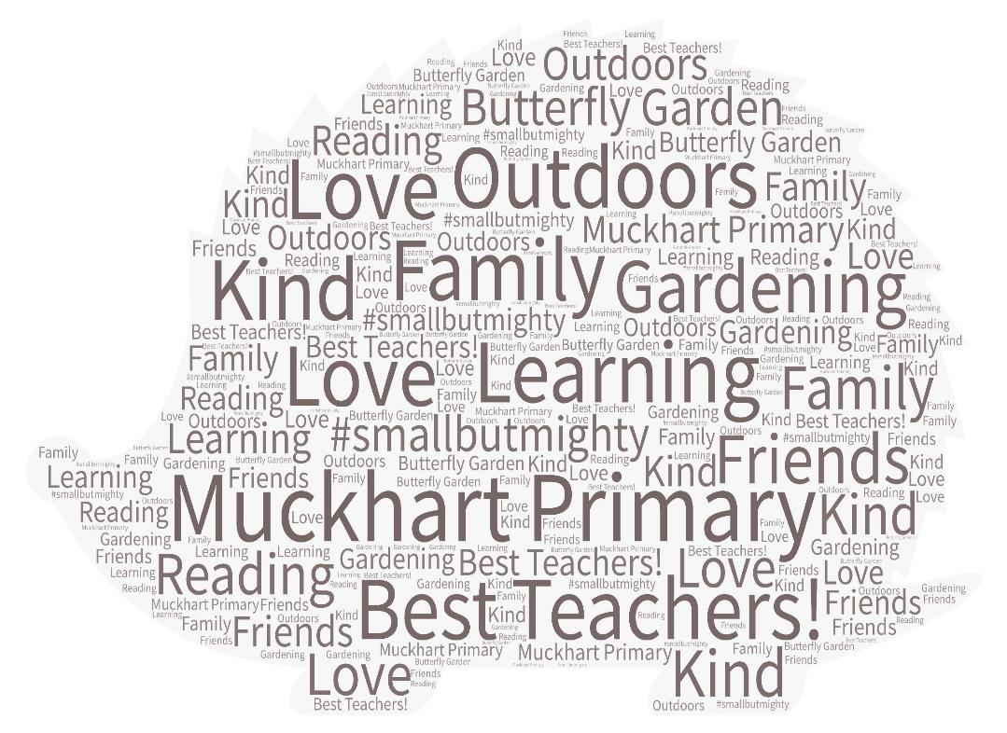
Muckhart means being happy and surrounded by friends (P5)
Muckhart means no matter what you like or what you do you will be accepted. No matter what shape or size you will be loved. It’s a place of learning and fun; working together as a family. #smallbutmighty (P7 Learner)

Muckhart PS makes me feel braver and happy
(P2)
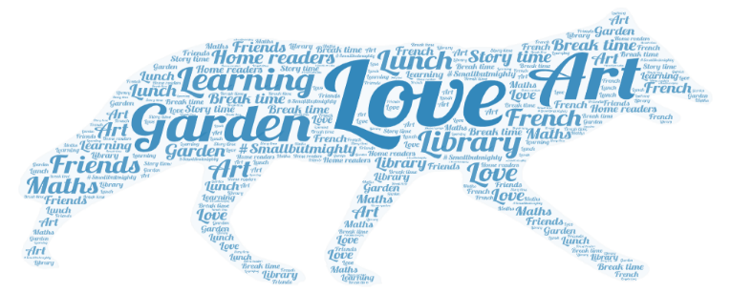
Our Capacity for Improvement
How Good is Our School 4 Quality Indicators

Quality indicator | School self-evaluation 2021-22 | Authority Review in 2018 | Inspection evaluation
1.3 Leadership of change | 5 | 4 | Not inspected
2.3 Learning, teaching and  assessment | 4 | 4 | Not inspected
3.1 Ensuring wellbeing, equity  and inclusion | 5 | 5 | Not inspected
3.2 Raising attainment and  achievement | 4 | 4 | Not inspected

