MUCKHART PRIMARY SCHOOL

“Home of natural learning”
Relationships
Our Values

Be
- Respectful
- Responsible
- Honest
Interventions
When we see someone not meeting expectations
- I am here to help
- I notice that ……………..
- I need you to …………….
- I expect ………………..
Our Visible and Audible Adult Consistencies
We believe
- All behaviour is communication
- Mistakes are part of the learning process
- Relationships are key
We do
- Model positive and respectful relationships
- Praise in public – use meaningful specific praise
- Reprimand in private
- Have restorative conversation in the right space at the right time
We say
- I noticed ………………………….
- Thank you for ……………………………..
- It would be even better if …………………..

Our Relentless Routines for High Expectations
- Meet and Greet
- End and Send
- Hand up for silence (stop, look, listen)
- Wonderful Walking
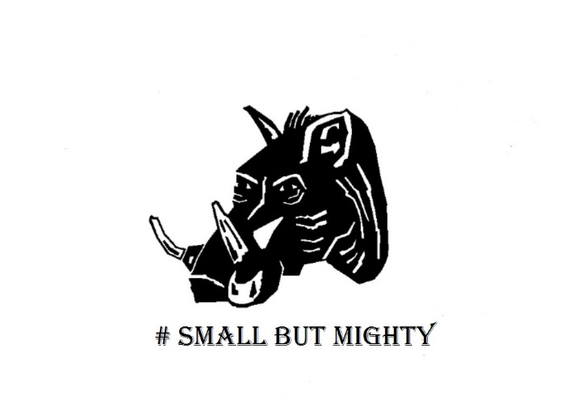
Restorative 5 follow up
- What happened?
- What were you thinking at the time?
- How did this make ____________feel?
- What should we do to put this right?
- How can we do things differently in the future?

5 questions we use to help children think and reflect on what’s happened

- Used as close to the incident as possible
- By the nearest available responsible person
Naming and faming positive behaviours
- Recognition board in each class
- Whole school recognition boards
- Over and above celebrated at Assembly
- Children collect pine cones to ‘earn’ a whole school trip
- Children earn value tickets (RRH) to spend termly at Golden Day
- Children’s achievements celebrated at Assembly

