Muckhart Primary School

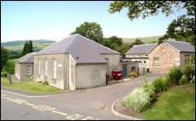
“Home of Natural Learning”
Our Travel Plan

2020-21

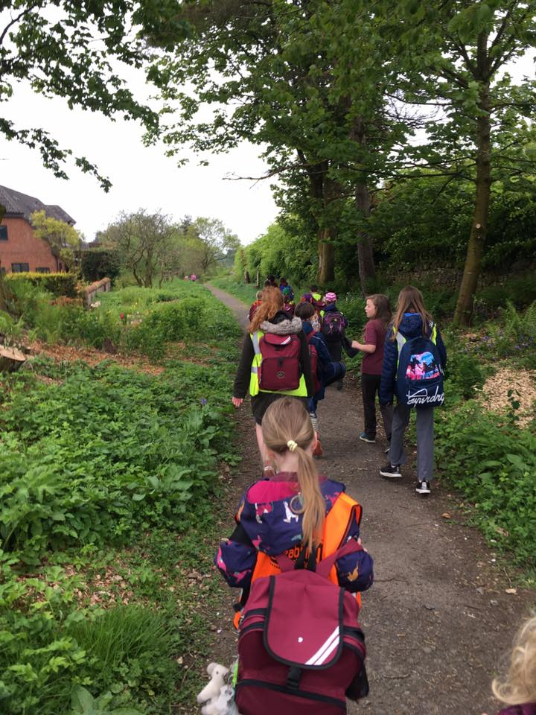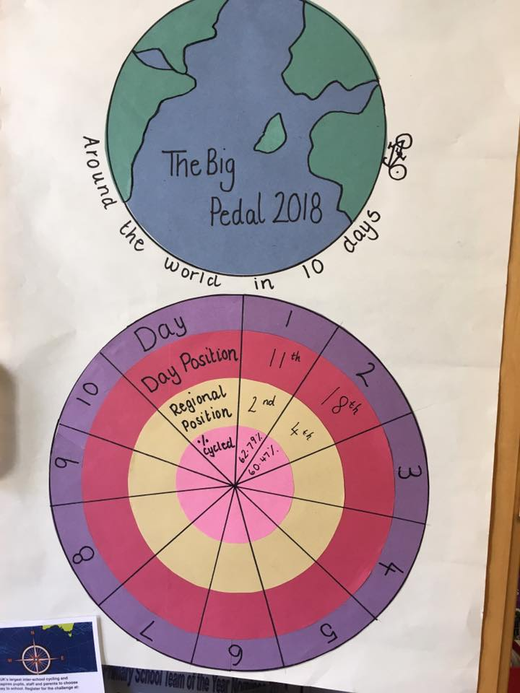
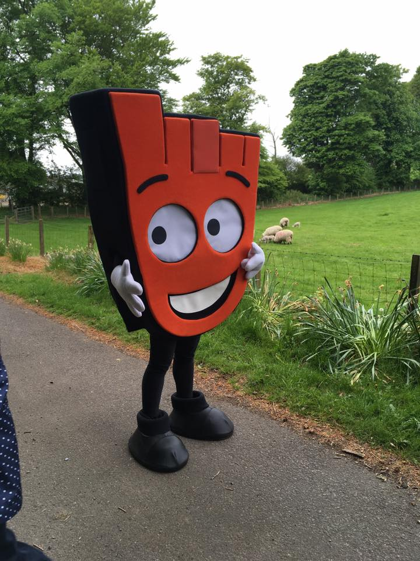
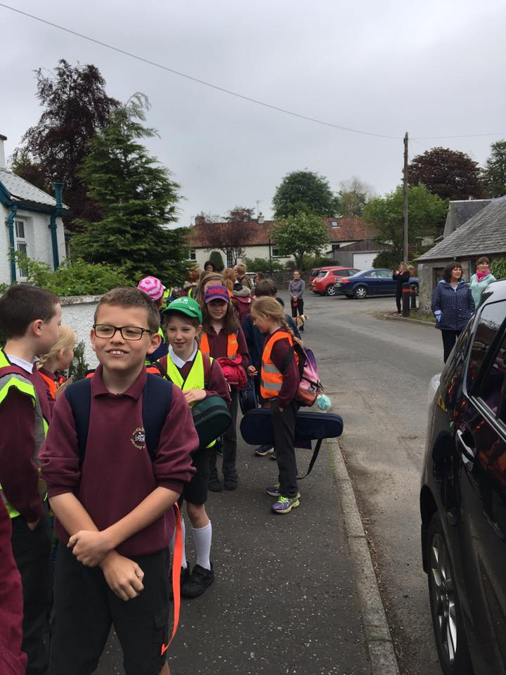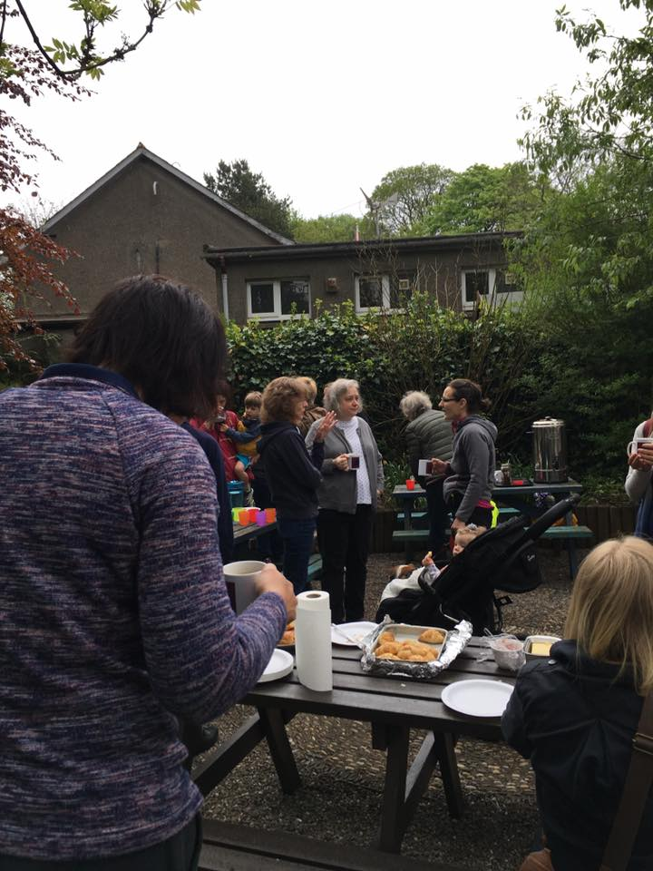

Our Context:
Muckhart is a small village on the edge of Clackmannanshire near Dollar. We have 3 classes this session with a total of 42 pupils and 7 staff members. The school is located on the road to Muckhart Golf Club, approximately half a mile from the centre of the village. We have extensive outdoor areas which we regularly use for teaching. We love to learn outdoors and encouraging active travel chimes well with our outdoor ethos of “Home of Natural Learning”. We want our families to feel safe, therefore we have developed this plan to provide information to families on how to travel safely and actively to school. Please read this document carefully and consider your travel options.
There is a walking path from Coronation Hall to the bottom gate of the Muckhart playground. Breakfast Club starts at 8.30am. School starts at 9.15am and we have supervision in the playground from 9.00am. Congestion in the morning isn’t too big an issue due to children being dropped off or arriving at school at staggered times between 8.30am and 9.15am. At home time we have a bit more congestion as we have 36 families doing pick-ups. Some families do already walk or scoot to school.

What is a School Travel Plan?
A travel plan is a document compiled by a school which sets out a package of short, medium and long term measures to encourage more children to choose alternatives to the car when making the journey to and from school. We want to encourage children and families to travel to and from school in a sustainable, active and safe way. It signifies an all-round commitment to develop safer routes to school and encourage active travel.
The need for travel plans has arisen due to growing concerns over:
Increasing congestion associated with the ‘school run’
Pupil health concerns concerning inactive lifestyles
The need for pupils to gain ‘road sense’ and independence
Road safety issues and concerns partly generated by school run related traffic
Air quality and climate change
Less Local Authority funding available which requires targeting

Our Aims:
To actively encourage and increase awareness of healthy, environmental and socially friendly travel choices amongst pupils, staff, parents and the wider community
To increase the numbers of children travelling actively to school and therefore reduce the volume of vehicles on the school run
To improve safety on the journey to and from school
To increase the number of pupils participating in road safety education

School Travel Plan Action Group:
This plan will be monitored and developed by our school Eco Group, WoW Monitors, Parent Council volunteers and Mrs McGlinchie

Present Travel Patterns
Local children often walk, cycle or scoot to school. There are bicycle racks to park bicycles and scooters. The car park can be accessed only by staff before 9am. The gate to the car park is closed at 9am as the car park also forms part of the playground. Visitors and parent/carer cars can be parked on the road outside the school. However this is a narrow road and cars should be parked with consideration to our neighbours and neighbouring farms. On approach to the school there is a 20mph zone and zig zags on the road. Parents are not permitted to use the school entrance as a turning point. We have an Eco Committee, we take part in The Big Pedal every year, our children are part of the Living Streets WoW Project and our older children are taught Bikeability Level 1,2 and 3.
Our Travel Survey:
In a recent survey – completed by 24 families – we found that 13 travel actively to school and 1 already uses Park and Stride. However of the 24, 10 used the car. A few of those surveyed would be keen to use Park and Stride or a regular Walking Bus if it was supervised to ensure safety. Two have mentioned the safety of the rural roads as a reason they don’t walk and a few live out with catchment and time does not allow Park and Stride.

Tips to keep you safe when walking to school
- Plan your route to school at home first. The path from the village is a safe route. The zebra crossing in the village can be used.
- Make sure cars stop before stepping onto the zebra crossing
- Be bright and be seen. The more you stand out the more drivers will see you and slow down
- Be careful of driveways and narrow entrances – stay alert and pay attention at all times
Tips to keep you safe when cycling and scooting to school
Where children can do so safely, we actively encourage children to bike or scoot to school.
- Please wear a helmet and wear something bright
- Please don’t cycle or scoot in the playground and consider other pedestrians when cycling or scooting down school path
- Maintain your bike. Check your brakes and tyre pressure.
If you are taking the car you can help:
- Park and Stride – park at the Coronation Hall and walk down school path. This will help ease congestion and help get the family more active
- By planning ahead and giving yourself plenty of time in order to account for any unexpected delays and time to find a responsible place to park
- Keep your speed low
- Don’t park on the zig-zags and please don’t reverse into the school entrance
- Please be careful not to block the narrow road outside school or park on a bend

Our School Site

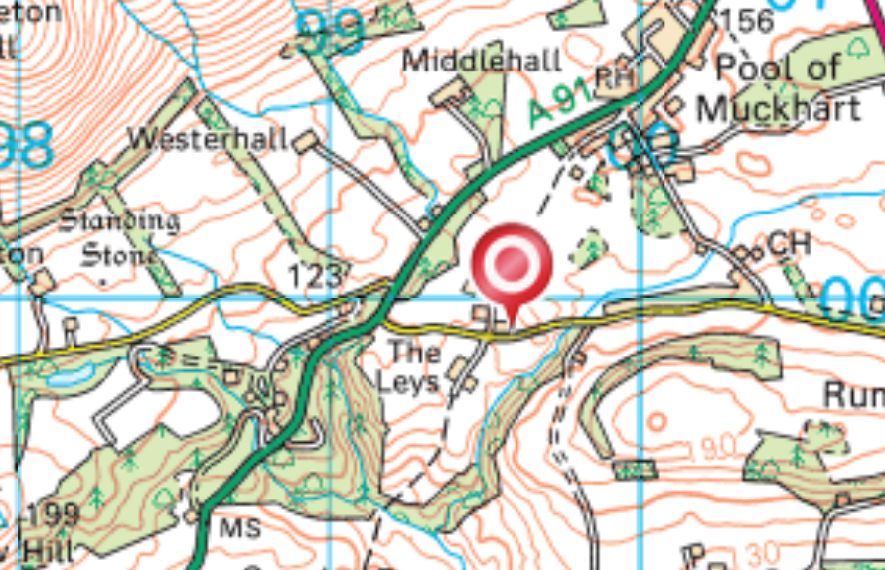
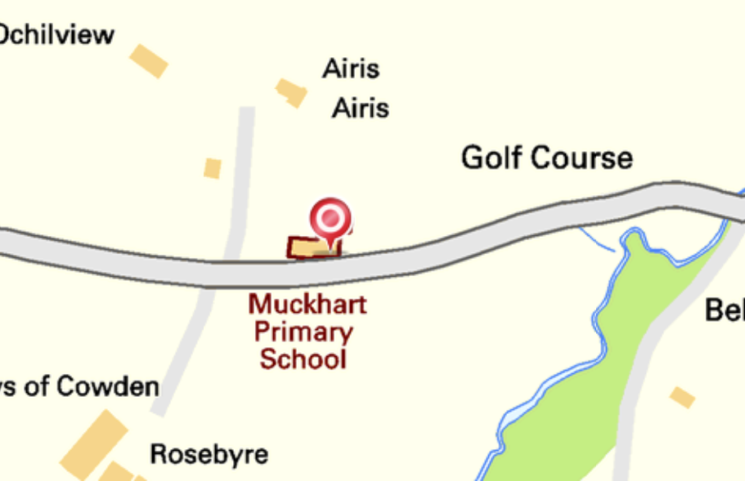

Objectives and Targets:

To promote healthy, active travel choices for pupils on their school journey

To increase the number of pupils travelling to school actively (walking, cycling, scooting) by 10% by the end of June 2021.

Our Action Plan
Measure | Who | Responsibility | Timescale | Comments/Progress
Write to Clacks Council and Community Council to request repainting of zebra crossing | HT, Eco Committee, Parent Council | HT  Roads Maintenance, Clacks Council | Before end Jan 2020 | This is hopefully being actioned early 2021
Write to Clacks Council to request pre-warning signage before the zebra crossing | HT, Eco Committee | HT  Roads Dept, Clacks Council | Before end Jan 2020 | New signage hopefully early 2021
Develop a Park and Stride Club- sticker for cars and pack for children | HT Eco Committee Parent Council | HT | Before May 2021
Investigate Cycle Friendly School | HT  Donna Cromb | HT  Donna Cromb | Before May 2021
Walking Bus – Walk to School Week (3rd week in May 2021) | HT Eco Committee | HT  Donna Cromb | May 2021
Promote Big Pedal and understand why it tails off | HT Miss Cannon | HT | May 2021
Plan Road Safety focus weeks across the school | HT  CTs | CTs | End June 2021 and ongoing

Promotion of the Travel Plan:
-a copy of this travel plan will be available on the school website
-paper copies will be shared with parents at Parent Council meetings
-information regarding the travel plan will be shared on our school noticeboard
-an update on our travel plan will be shared on our termly school newsletter
-we will announce progress made on Facebook and Twitter

Monitoring and Review:

This plan will be reviewed and revised in June 2020 and thereafter annually alongside our School Improvement Plan
The Head Teacher, parents and Eco Committee will conduct a further survey in June 2020
Our Action Plan will be updated annually in June

Signed agreement:

The Headteacher, teachers, parents and pupils of Muckhart Primary School agree to their School Travel Plan and its objectives

Signed: …………………………………………………………… teacher(s)

Signed: …………………………………………………………… parent(s)

Signed: …………………………………………………………… pupil(s)

