**Muckhart Primary School**

**“Home of Natural Learning”**

**Literacy and English**

**Learning and Teaching Guidance**

**Based on Clackmannanshire Council’s Equitable Literacy Professional Learning**



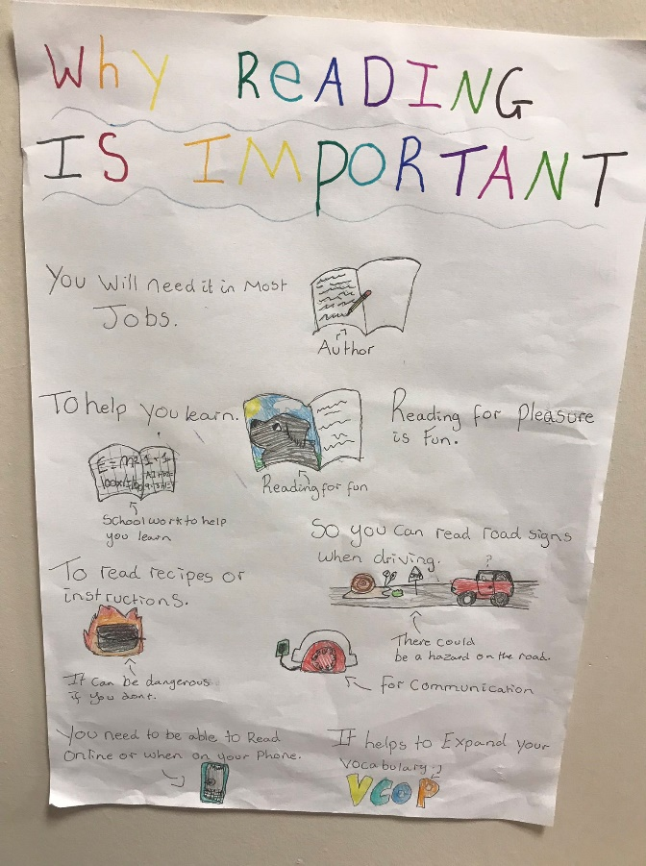

Aims

Our aim is to ensure that all children and young people develop the Literacy and English skills they need to reach their full potential in order to achieve success in life, learning and work.  We recognise that reading is perhaps the single most important element in learning so developing a love of reading is essential.  At Muckhart we strive to develop curious thinkers for whom reading can open up a new world and expand their minds.

Outcomes for Learners

* Every child achieves the highest standards in Literacy set out within Curriculum for Excellence.
* Learners will experience a progressive curriculum that enables them to work to their full potential.
* All children will be successful, independent learners in literacy who confidently further their own learning through a natural curiosity – enabling them to take responsibility for their own learning.
* Children will identify themselves as readers through a love reading.

All Educators Will

* Have a shared understanding of how children progress in learning and of effective learning, teaching and assessment strategies.
* Demonstrate a knowledge and confidence of effective pedagogical approaches.
* Provide a curriculum rich in high-quality, equitable experiences to engage, motivate and inspire learners; ensuring that every child has the same opportunity to succeed.

“Your imagination grows so big when you read.”

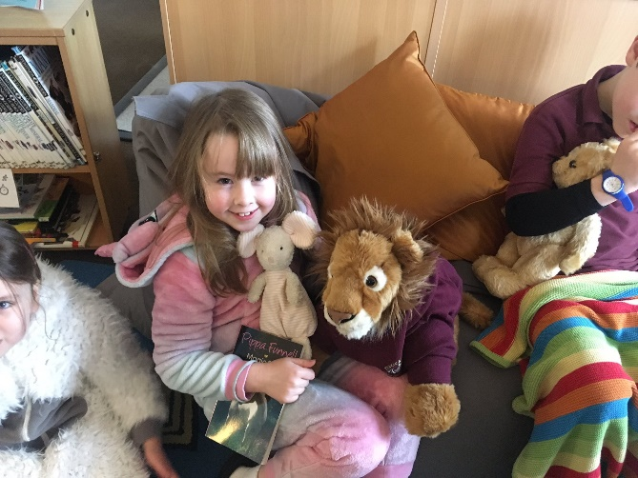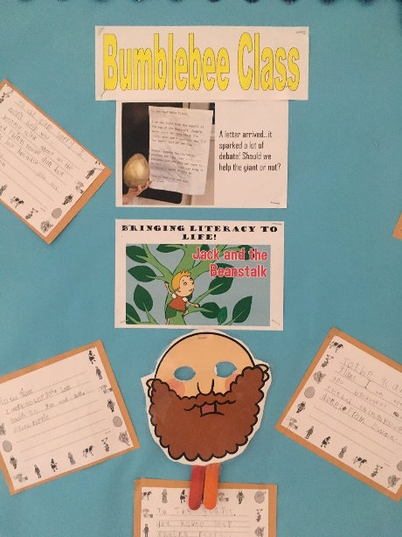



3 Domain Model

Our approach to Literacy is based on the 3 Domain Model. This model considers the cognitive skills, cultural capital and personal identity of learners. It supports our overall aims for learners.

Cultural and Social Capital

We recognise that children come to school with funds of knowledge based on their home experiences. It is important to build on this to promote a positive reading culture. In Muckhart we:

* Provide reading materials linked to children’s interests and knowledge as well as giving them access to current, quality texts.
* Encourage children to take ownership of reading spaces
* Encourage children and adults to share “Book Blessings”.
* Provide a library service (run by volunteers) with books that are frequently updated.
* Teach using quality texts. We design comprehension lessons to change and challenge children’s experience of a text. This might include drama, discussion and active comprehension or play opportunities.

“DEAR Time is a place to set your mind free. It makes me imagine things.”

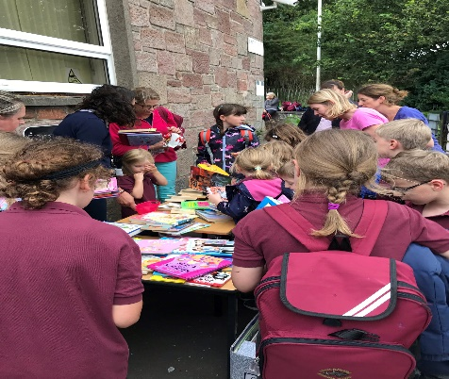

Personal and Social Identity

In Muckhart all children are supported to identify themselves as readers. Some less experienced readers may need more encouragement. We achieve this through:

* Varied reading opportunities (DEAR time, home readers, chill/challenge books)
* Creating reading networks by encouraging children to talk about what they are reading
* Promoting a positive mind-set towards reading and providing tailored support for those who need it.
* Providing time to choose texts and read in relaxing spaces with friends

Cognitive Skills and Knowledge

At Early Level we focus on developing **Phonological Awareness**. To be successful in later reading and spelling, children should be able to identify and generate rhyme, break words into syllables, identify the position of sounds they hear (in words) and segment and blend sounds.

Once children have developed a secure phonological awareness they receive direct teaching of **phonics**. Alongside learning letters and sounds, children begin learning **sight words**.

Once children have developed their ability to blend sounds and recognise some sight vocabulary, they begin learning to use **reading strategies**. Initially these will be: sounding out and blending letters, using the pictures to support them as they read and listening to themselves read to ensure it makes sense. Following on from this, children will develop a range of reading strategies, including, but not limited to:

* Using syllables to decode words
* Self-correcting
* Reading around the word to make sense of it
* Attending to punctuation
* Asking questions that will clarify understanding

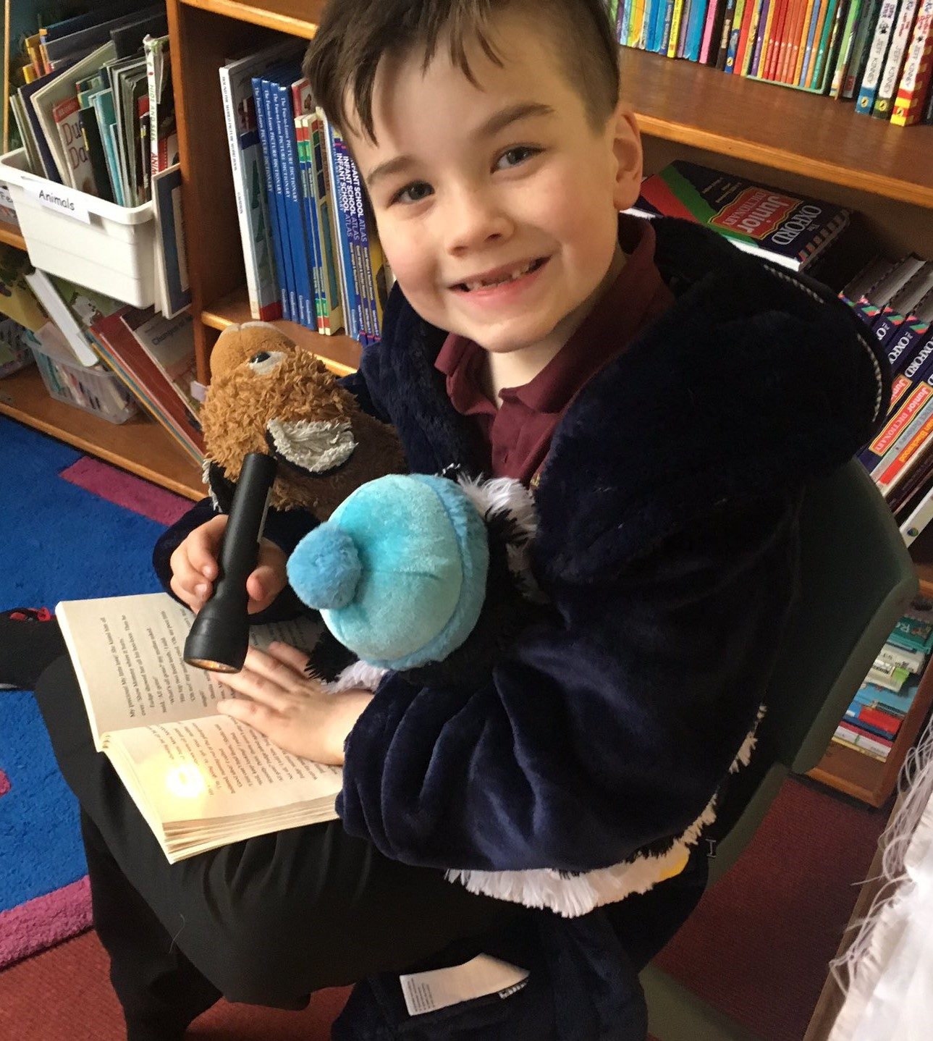

Children’s reading is monitored regularly through running records to ensure the text level is correct. Educators then use the following cues to coach readers:

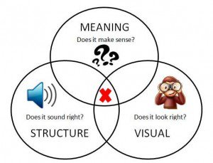

At all stages of learning it is essential to teach **comprehension strategies**. In Muckhart Primary, comprehension is developed across the school using Aiden Chambers’ **3 Sharings** model.

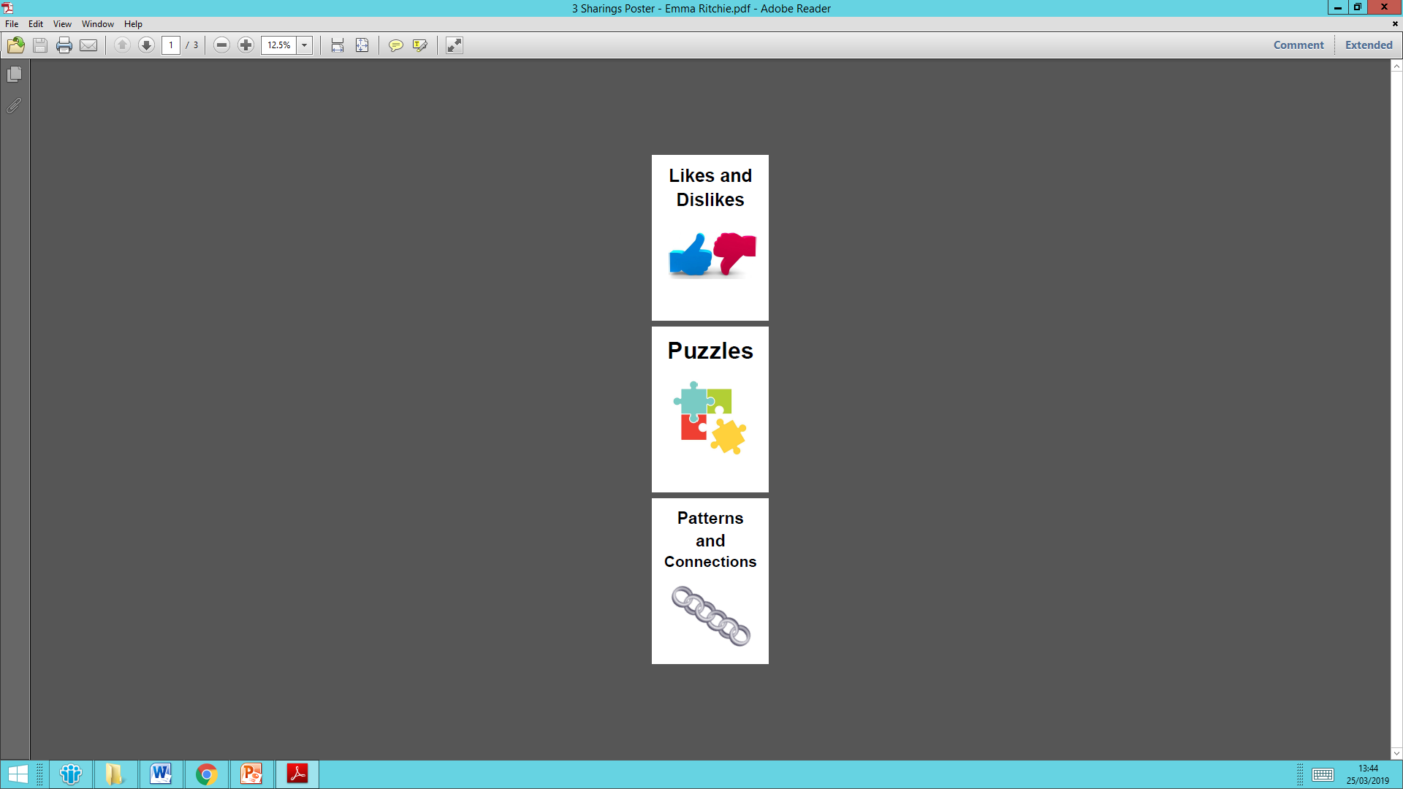

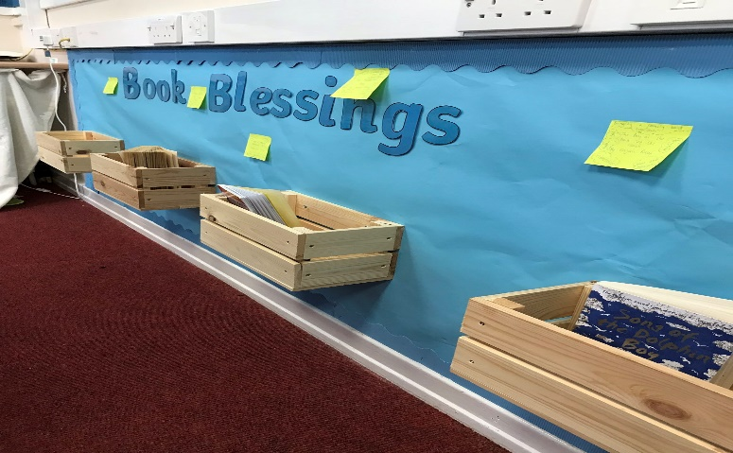

At Early Level, comprehension is largely developed through discussion. While this continues across all levels, more formal teaching of comprehension strategies is introduced from First Level through the following strategies:

* Making connections
* Visualising
* Predicting Summarising
* Questioning
* Clarifying
* Inferring
* Evaluating
* Making connections

All of these strategies can be taught both through **guided reading** - where texts read are at an instructional level - and **shared reading**, where texts can be pitched at a higher level as understanding is achieved through whole class collaboration.

Creating a literacy rich environment that displays key learning, children’s work and extends vocabulary will also support the acquisition of literacy skills. Children will also be taught skills for writing, including grammar, spelling and handwriting. Where possible, this will be linked to class literacy themes. Learning is planned through clear progression pathways but is responsive to the learner’s needs.

To promote engagement with literature and provide opportunities for applying comprehension strategies we regularly teach using shared texts.

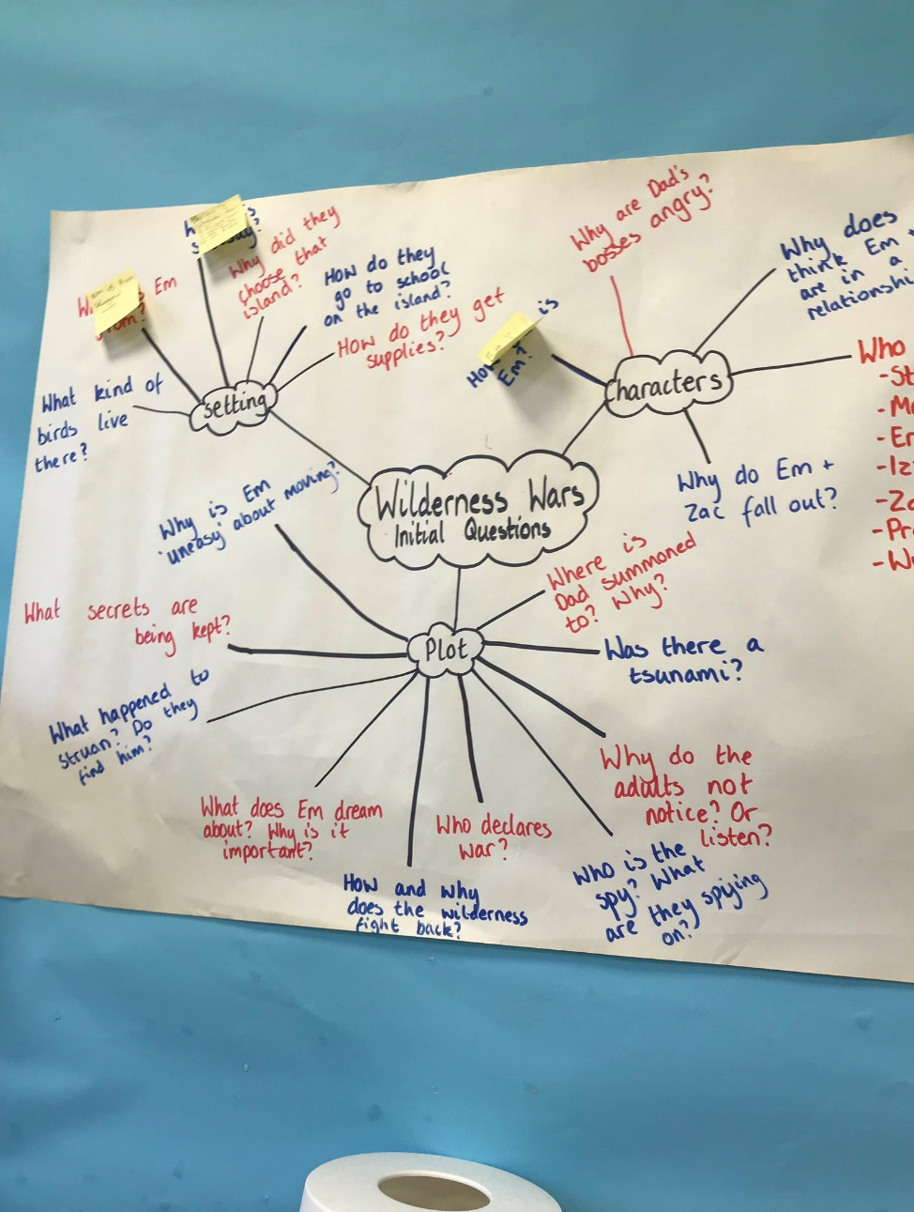 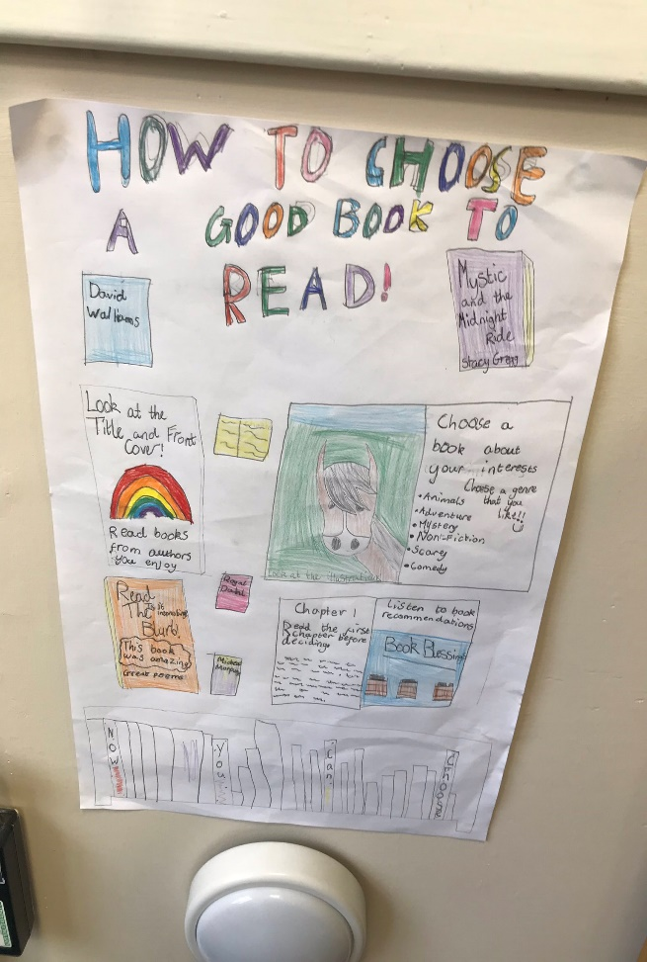

Muckhart Primary Non-Negotiables

**Attend to data from all three domains.** Use it to design a fruitful ‘learning mix’ and be thoughtful about how to intervene. Use it for assessment meetings with other professionals.

**Get the text level right**. An instructional text for best progress should be 90-95% accurate with good comprehension on first reading. ‘Easy reading’ will be 96%+.

**Let them work out words.** Model how to work out words using a range of cues and strategies and coach children to do this rather than pre-learning the words before reading the book.

**Increase ‘time on task’.** Use ‘independent-simultaneous reading’ rather than ‘round-robin reading’.

**Monitor and record progress.** Use running records as a pedagogical tool to monitor the book level, the cues and strategies. Use it as a management tool to actively track progress.

**Promote reading engagement.** Increase the quantity, breadth, fluency and willingness to ‘have a go’ through low-stakes activities- using & promoting social networks around reading, regular free-choice opportunities and frequent ‘easy-reads’ (of library and scheme books).

**Children are read to daily.** Choose intellectually, emotionally and linguistically interesting texts that children couldn’t access alone. Aim for an enjoyable, engaging experience.

**Focus comprehension lessons on knowledge and interest, not just skills.** Use ‘reader response’ to share and increase understanding of the social and physical world. Reading breeds knowledge so promote it in how your pupils think about, and talk about, books.

**Demonstrate the point of being literate.** Every day provide interesting, interactive tasks that demonstrate how literacy can be personally useful to pupils.

**Teach for a ‘growth mindset’.** Teach children to ‘have a go’, to push themselves and that ‘practice works’. Get them to notice and use new vocabulary, to say when they don’t understand and share when they do. Help them to persist with challenging texts, to talk about them, re-read, ask others, clarify what puzzles them, explain what they like and make links to their own lives.

**Attend to pupils’ social aspirations as readers/writers.** Consider the image they want to project, their friendships, social networks, books and tasks. How are they positioned as learners and readers by classmates, the teacher, their families and themselves? Is it helpful?

**Teach a language-rich, knowledge-rich curriculum.** Knowledge breeds knowledge. Complex ideas prompt a need for complex language. Celebrate knowledge. It matters.