Nursery Class Newsletter
September 2017
The Nursery team would like to thank all parents and carers who were able to join us at our Open Evening on Thursday 14th September. We are looking for feedback relating to the information given and any other recommendations which we will take on board for our Open Evening next year. There will be a board in the foyer where you can do this. All the information from the Open Evening can be found on the Nursery blog. Thank you
Sponsored Walk
The Nursery children are taking part in a sponsored walk on Monday 25th Setember. We are raising funds to help buy pedal bikes for the children. If you are able to come and join us, please add your name to the parent helper list in the Nursery foyer. The morning children will be leaving at 9:30am and afternoon children between 1 and 1:15pm.

Harvest
The children have been busy picking apples and plums from the trees in our Nursery garden. They helped Miss Wright to cut up plums and make plum tarts to take home. We have been selling the apples from the garden for £1 a bag. We are hoping to spend the money raised on the residents at Menstrie House. We had fun picking potatoes which we had grown over the summer. This time we decided to grow purple potatoes. The children had fun looking, smelling and tasting the different foods.
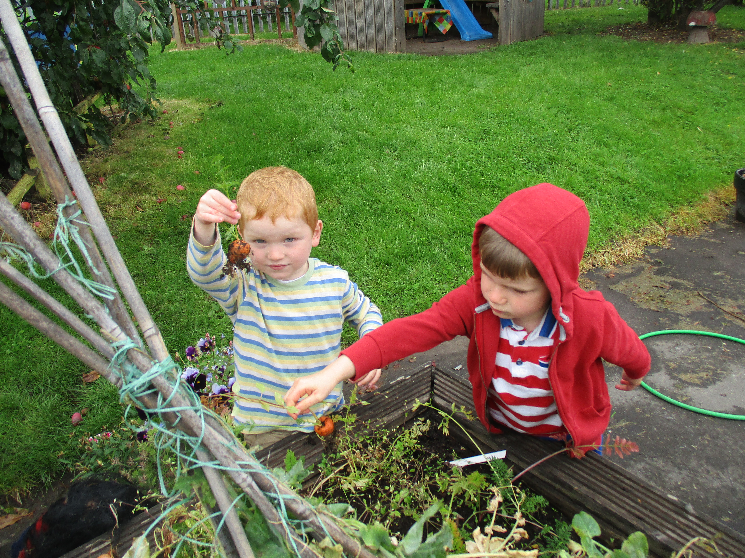

Daily Mile
The Nursery children (and staff) have started to complete a ‘daily mile.’ This can be running, jogging or walking for 15 minutes every day during the Nursery session. The UK Chief Medical Officers published guidance which highlights some of the benefits of physical activity, such as building confidence and skills, improving concentration and learning, and improving sleep, as well as being good fun and good for health. We ask that your child has suitable footwear on at Nursery so we can complete our ‘Daily Mile.’ Thank you.

Menstrie House Visit
We were invited to visit Menstrie House to continue to keep our links with the community. The residents had Shetland ponies from the Therapy Centre visiting. The children enjoyed petting the ponies; Flicker and Wilson. They took the ponies out into the garden and enjoyed taking them for a walk.

“They just taste like potatoes.” Archie Fraser
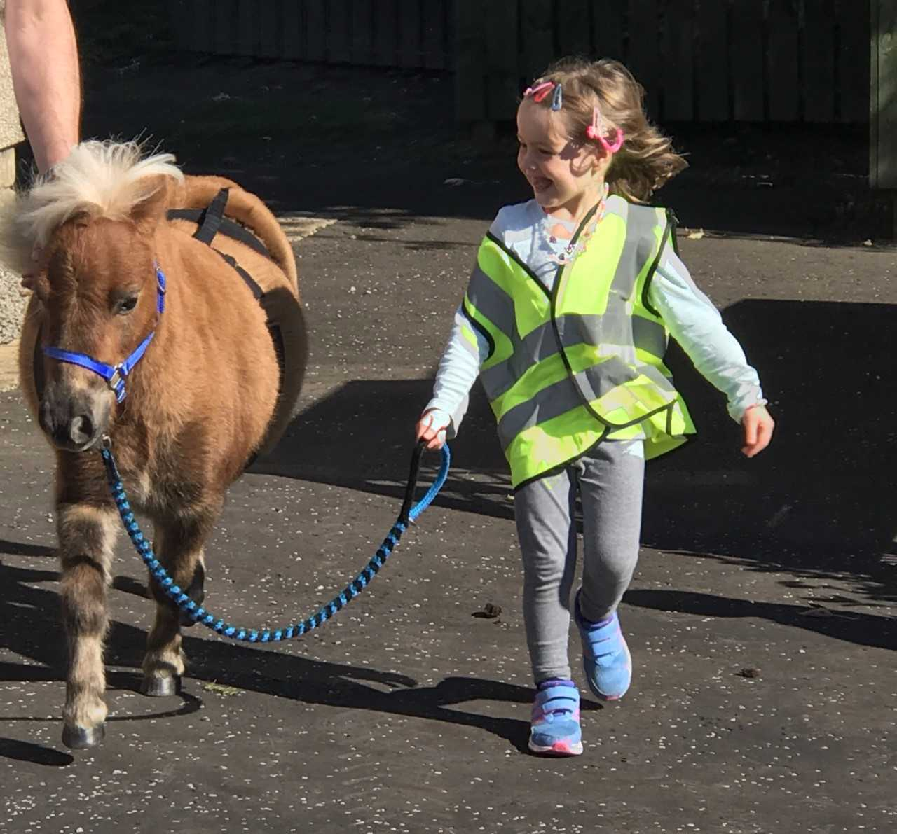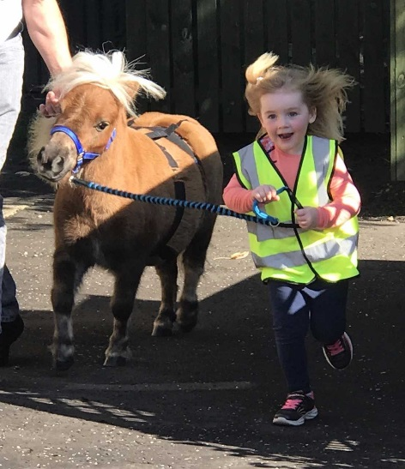

Change of Clothing
Please can we ask that you provide a change of clothing for your child in case they have an ‘accident’ or get wet or muddy from outdoors. This should be left in a bag on your child’s peg in the foyer. If your child is in nappies or pull-ups could you leave a supply in their bag along with wipes so we are able to change your child. Thank you.

Sickness
If your child has sickness or diarrhoea, it is important that you keep them off Nursery for 48 hours. Please phone and let staff know if your child is off Nursery for any reason e.g. sickness, bugs, holidays. The Nursery phone number is 01259 760690 option 2.

Lunches
If your child stays for lunch at Nursery, please provide them with a drink and a healthy, balanced lunch. We ask that you put an ice-pack inside your child’s lunch box to keep their lunch chilled as we do not have the facilities to keep lunch in fridges. If your child has grapes for part of their lunch, please can you cut them length ways as full grapes can be a choking hazard for young children.

Autumn Walk
We will be going on our autumn walk on Wednesday 25Th October. We will be looking for parent helpers to join us. Please keep an eye open for the parent helper list which will be displayed in the Nursery foyer after the October holidays.
Play on Pedals
If your child has been selected for the first block of ‘Play on Pedals’, this will begin on Wednesday 27th September. Please ensure your child has appropriate footwear and wears either jeans, leggings or joggys. All pre-school children will be participating in this programme throughout this school year.

E-Learning Journals
You should have now received your child’s first observations on their individual E-Journal. If you are having trouble accessing your child’s E-Journal online, please check our Nursery blog for information on how to set up your account. If you have done this and can still not log-in, please speak to Miss McEwan.

Dates for the Diary
- Monday 25th September – Sponsored walk
- Wednesday 27th September – Play on Pedals first session
- Week beginning Monday 9th October – October holiday
- Wednesday 25th October – Autumn walk
- Tuesday 31st October – Halloween Party
- Thursday 23rd and Friday 24th November – Inservice days
- Monday 27th November – Christmas Fayre
- Wednesday 13th December – Nativity show
- Friday 22nd December – Finish for Christmas holidays
- Monday 8th January – Return to Nursery after Christmas holidays

