Nursery Class Newsletter
October 2017

Play On Pedals
Miss McEwan and Ms Williamson have been busy teaching small groups of pre-school children how to use a balance bike. This happens every Wednesday morning and afternoon. The activities are fun and can be based around numeracy e.g. ‘What’s the Time Mr. Wolf?’ This allows the children to practice taking big, fast steps, giving them the opportunity to practice their balancing skills on the bikes. The children who are currently part of the Play on Pedals programme are making great progress. We have been learning how to keep ourselves and others safe when we are on the bikes, why we need to wear a helmet, how to balance and we are currently learning how to glide using the balance bikes. This programme will be offered to all pre-school children over the school year.
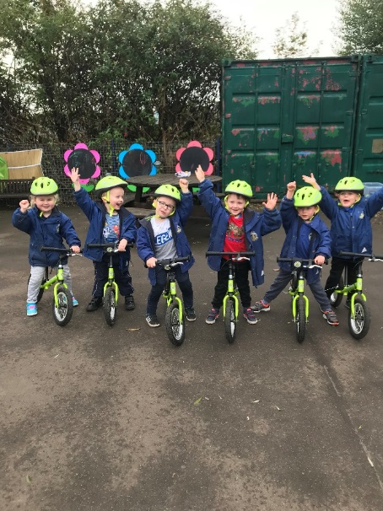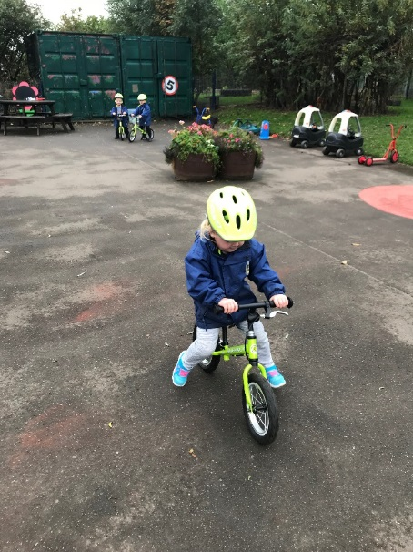

Sponsored Walk
We would like to say a huge congratulations to all of the nursery children who participated in our Sponsored Walk on Monday 25th September and to all of the families and friends who sponsored them. We managed to raise £400!! We have used this money to purchase two bikes and two helmets for the children and an adult bike and two helmets for the staff so they can deliver the Play on Pedals Programme.
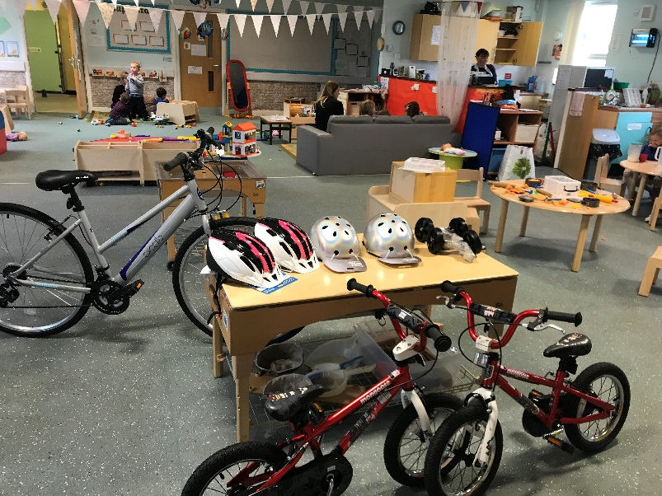

Wee Scones Café
Our pre-school children have been busy helping out at our Wee Scones Café on a Tuesday afternoon and Thursday morning. They have been helping to serve cakes, diluting juice and tea or coffee to customers. The children have been welcoming in the customers and showing them to their table, taking their orders, serving the customers and charging them a small fee of £1. We have incorporated numeracy and literacy into this experience for our learners. Keep an eye open for your invite.
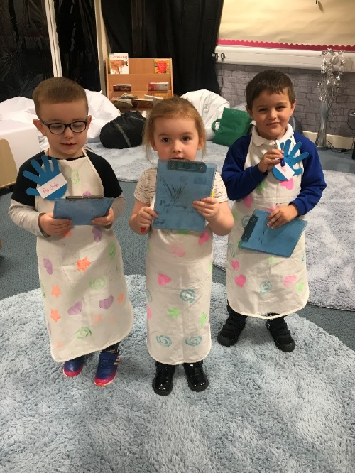

E-Journals
As you will be aware, we are now using E-Journals for observing your children. If you are having trouble logging into the system please speak to Miss McEwan. As a parent/carer, you are able to add your own photos from home to the gallery section. If the keyworker publishes the observation at the time of the activity, you should receive an email alerting you that an observation has been published. If the observation is published at a later date, you may not receive an email. Please check your child’s E-Journal regularly and feel free to add comments or upload photos to the gallery.
Peep
Peep (peers early education partnership) is a universal programme. The Peep Programme aims to help parents and carers to:
* enhance the quality of the home learning environment by valuing and extending everyday learning opportunities
* develop secure attachment relationships with their babies and children
* help improve children’s communication and language, social and emotional development, early literacy and maths and health and physical development.
Ms Russell will be running a Peep group every Wednesday from 2pm-2:50pm starting on Wednesday 1st November. If you would like you and your child to be part of this programme, please give your name to either Miss McEwan or Ms Russell.
Lending Library
Your child will receive their own canvas book bag and will be able to choose one book at a time to take home. As soon as they are finished with the book they have chosen, they may bring it back and choose another one.
Please note: you must return the book you have borrowed in order to borrow another book.
Key workers will organise the books for the children in their groups.

Wellcomm Screening
All pre-school children have now been screened using the Wellcomm screener (language programme). If you would like to discuss your child’s results, please arrange a date/time with Miss Wright. Thank you.
Snack Menu
We will be offering a new snack for the children based around ‘Setting the Table.’ This gives childcare settings nutritional guidance and food standards from NHS Scotland. The snack menu will be based on a four weekly cycle. The allergens from snack will be displayed alongside the snack menu in the foyer. We will be offering toast, beans, bagels, pancakes, fruit and veg (each day), Weetabix, English muffins, pitta breads, breadsticks and natural yoghurt.

Prams and Buggies
If you have a buggy or pram could you please leave this outside of the main Nursery entrance under the canopy for fire safety regulations. This will also allow for more space within the Nursery foyer for the children. Thank you.

Blog Reminder
Just a reminder that we have a Nursery blog which is updated on a regular basis. You can access our blog by visiting:
blogs.glowscotland.org.uk/cl/misswright

Dates for the Diary
- Tuesday 31st October – Halloween Party
- Monday 6th November – Parents appointments with Mrs Nimmo (Star)
- Tuesday 7th November – Parents appointments with Ms Russell (Sun)
- Wednesday 8th November – Parents appointments with Mrs Stanners/Miss Tasker (Cloud)
- Thursday 9th November – Parents appointments with Miss Wright (Rainbow)
- Friday 10th November – Parents appointments with Ms Williamson (Moon)
- Friday 17th November – Children in Need
- Thursday 23rd and Friday 24th November – Inservice days (nursery closed)
- Monday 27th November – Christmas fayre
- Wednesday 13th December – Nursery Nativity
- Friday 22nd December – Nursery Christmas Party
- Friday 22nd December – Last day of term

