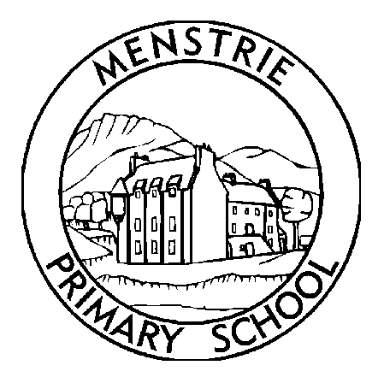

Making Frobscottle

Our class Assembly

Storytelling



**Learning Highlights**

Term 2

October 2018

Welcome to our Term 2 Newsletter. I can’t believe it is October already, what a fast, fun first term. The class have settled in really well now and have been learning lots since our last letter. These newsletters will keep you updated but I am available at the start and end of each day in the playground and you can contact me through the school email.

Numeracy and Mathematics

This term we will be focussing on our number sequences with a big focus on addition, subtraction and number bonds. In term 1 we really focussed on consolidating numbers to 20 then moved on to numbers to 100, which will be beneficial when applying that knowledge this term. We will also be looking at symmetrical patterns, area and shapes in the environment and data handling which will link well with our Lego topic.

Literacy and English

Read, Write, Inc is in full swing now and Primary 2 are progressing well. In addition to the Read, Write Inc books Oxford Reading Tree will also be used for some groups. We would always encourage additional books to be accessed at home to challenge and practise decoding skills and for enjoyment. Using all of these resources, the children should progress with their fluency, expression, comprehension and spelling- all key skills of a good reader. Primary 2 have also been focusing on storytelling as a foundation for imaginative writing. We have been using Pie Corbett’s approach of ‘Talk for writing’ and the children really enjoy re-telling their own focus story. Their stories have really impressed the Primary 2 teachers.

Cross – Curricular Topic

We will be starting a new topic in Term 2- My Lego City. This isn’t just a chance to play with Lego but an opportunity to explore the Social Studies and Technologies area of the curriculum. We will learn about cities, what makes a city, comparing it to the local community. We will look at job roles, housing and we will be evaluating structures such as bridges and designing our own.

Expressive Arts and Physical Education

PE with Miss Johnston will take place on a Monday and Wednesday. We have also been doing some drama in class which we will continue in Term 2. We will continue to use drama to explore characters, tell a story and assess comprehension. These activities may seem like games to the children but there are many benefits to doing drama such as building confidence, language and communication skills and helping concentration.

Achievements

Please share any achievements and learning from home – such as sporting achievements, any new skills attempted or mastered (riding a bike etc), interesting places visited or anything else which has generated interest and excitement!

**Dates for your diary**

**Non uniform days**

26th October/ 30th November

**Outdoor Classroom Day-**

31st October

**In Service days-**

29th and 30th November

**Interim Reports-**

Monday 5th Nov

**Christmas Panto-**

18th Dec

**Christmas Party-**

19th December

**It’s Christmas!!-**

School closes Friday 21st Dec 1pm

**P2 Newsletter**