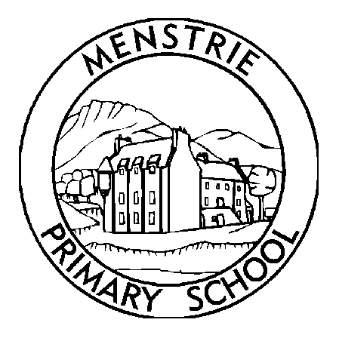
Menstrie Primary School
Newsletter
December 2023

FESTIVE SEASON IS HERE!  It’s hard to believe that we are now entering into the festive season. I have tried to make sure all of the planned festive activities are listed in the dates section. For Christmas parties children are welcome to bring party clothes to change into after the lunch time break if they wish to do so. If for any reason you do not wish your child to take part in any of the festive activities please email the school including your child’s name and class menstrie@edu.clacks.gov.uk and we will inform the relevant teacher  DOGS, PARKING AND BIKES/SCOOTERS  Dogs should not be brought into the playground. If your are collecting your child at the end of the day with a dog, please remain outside the playground, behind the fencing. Some children and adults can be anxious over dogs so please be mindful of this and ensure there is sufficient space to get to get through the gates – thankyou.  There are ongoing issues with parking around the school. With cars being parked on the yellow lines as well as across local resident’s driveways/garage entrances. Please can I reiterate how important it is to be park with caution? Parking on double yellow lines is not only illegal but it increases the risk for pupils who are crossing the road. Where possible can I encourage you to park and stride to avoid the congestion.  We now have a fantastic new bike and scooter station at the back of the school. We encourage children to scoot or cycle to school but please make sure helmets are worn at all times and to remember that children and adults should not be cycling in the playground.  CHRISTMAS LUNCH AND CHRISMTAS JUMPER DAY  The school Christmas lunch is on the 13th December. On this day it is a set menu and there are no choices available. If your child does not like the Christmas lunch menu then they should come with a packed lunch. Pupils and staff are welcome to wear Christmas jumpers on this day too.  PUPIL COUNCIL  On behalf of the Pupil Council, we would like to thank you for spending and being kind. We raised the amazing amount of £217.85 for Children in Need.  Thanks Lochlan H and Emilia.  SCHOOL ATTENDANCE  It goes without say that attendance at school is really important. Developing social skills, life skills and friendships. I have attached an info graphic for you which has been distributed by Education Services.  P1 ENROLMENT FOR SESSION 24/25  The 2024/2025 school year starts on 14 August 2024 and this is the only date for beginning school education for that year. All children who are five years old on or before 14 August 2024 are of school age and must start their primary school education on 14 August 2024. Children who are five years old between 15 August 2024 and 28 February 2025 may start their primary school education on 14 August 2024.  If your child is starting their primary school education in August 2024, or if you are choosing to defer their entry into primary school to August 2025, you must enrol them at their catchment school.  FINALLY  If at any time you have any questions or concerns, please do not hesitate to contact me.  www.menstrie.clacks.gov.uk  Tel: 01259 452316  Fax: 01259 769188  Email: menstrie@edu.clacks.gov.uk  Twitter@MenstriePrimary |  | CLASS ASSEMBLIES  This week it is the turn of the P4s class and their assembly takes place on Thursday 30th November at 9.30am. Parents of pupils in the P4s class are welcome to come along to the assembly.  FLU VACCINE  The rescheduled flue immunisation takes place this Friday 1st December. Pupils in the P7B class have their transition day to Alva Academy on this day. I have been in contact with the immunisation team and the pupils will get their flu immunisation once they return from the Academy which is expected to be at about 2.15pm.  VALIDATED SELF-EVALUATION (VSE)  Over the past few weeks we had various visitors who were part of the VSE team. I’m pleased to report that the team felt that the school self-evaluation was, in the main, an accurate reflection of what they saw during their visit, during the parent, staff and pupil focus groups and during the observations of lessons. Main strengths identified were;  - A strong and supportive staff group  - A positive warm ethos with respectful relationships within the school  - Pupils were friendly and helpful and spoke positively of their school.  Areas for development include;  - A re-visit of the vision and values of the school  - Differentiation of learning  PARENT COUNCIL  The next parent council meeting takes place in the school tonight on Monday 11th December at 6.15pm. All parents/carers are welcome to attend parent council meetings.  UPCOMING EVENTS  DATES  These are the provisional dates for the term ahead. Please note they are subject to change and some times need confirmed.  BRONZE MPOWA awards 29/11/23 2.20pm  P7 Skiing P7B 30/11/23 Time TBC  P5W STEM Day 30/11/23 All day  P4 Assembly 30/11/23 9.30am  Flu Immunisation 1/12/23 All day  P7B transition day at Alva Academy 1/12/23 All day  Menstrie ELC Christmas Fayre 2/12/23 10.30 - 12  P5’s at Church event all day 4/12/23 TBC  Community and Parent Council organised Santas Grotto and Movie Night at Dumyat 10/12/23 TBC  Parent Council Meeting 11/12/23 6.15pm  P1 Nativity and Christmas Concert 12/12/23 AM  P1 Nativity and Christmas Concert 12/12/23 PM  P1 Nativity and Christmas Concert 13/12/23 AM  P1’s singing at bowling club 13/12/23 2pm  Christmas lunch and Christmas Jumper day 13/12/23 All day  P4/5 Christmas Party 14/12/23 PM  Parent Council Craft and “Elfridges” 15/12/23 All day  P2/3 Christmas Party 19/12/23 PM  P5W Enterprise afternoon 19/12/23 2.15pm  School Pantomime in School 20/12/23 1.30pm  P6/7 Christmas Ceilidh 20/12/23 Evening  P1 Christmas Party 21/12/23 PM  Christmas Church Service 22/12/23 9.30am  Christmas Holidays start at 1pm 22/12/23 1pm  Schools re-open for Spring Term 7/1/24 9.00am  P1 enrolments 15/1/24 All day  Non-Uniform day 26/1/24 All day

