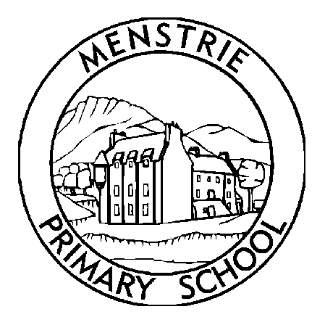
Menstrie Primary School
Newsletter
October 2020

As we are nearing the end of term, I wanted to thank you all again for your continued support and to congratulate the children on coping so well with such a different return to school.  STAFFING CHANGES  We would like to congratulate Mrs Campbell (Acting Depute Headteacher) for being appointed as a Permanent Depute Headteacher at Doune Primary School. While we are all very sad to see her go, we wish her all the best in her new role. We would like to thank Mrs Campbell for all of her hardwork at Menstrie Primary. Mrs Campbell’s last day at Menstrie Primary will be Friday 13th November. We will let parents know who will be replacing Mrs Campbell as soon as we can.  SCHOOL HOLIDAYS  The school will close for the October break at 3pm on Friday 9th October. We return to school on Monday 26th October. We hope you all have a well earned rest.  CHANGE TO INSERVICE DAY  Agreement has been reached within the LNCT that the Inservice day provisionally set for 30th April will now be held on Friday 27th November. Please note that the school will not be open to pupils on Friday 27th November.  NO NUT PRODUCTS IN SCHOOL  Please can I remind families that nuts and products containing nuts, eg Nutella should NOT be brought to school. We have some children in school who have a significant nut allergy and it is of the upmost importance that we keep them safe. Thank you for your continued support.  SUITABLE CLOTHING  As we are trying to spend more time outdoors it is essential that pupils always come to school with a waterproof jacket and suitable clothing for all weathers. At present P.E. cannot take place indoors and we are only in for break times when it is not safe to do so. We are also continuing to build on the use of the outdoor space and outdoor learning and need to be able to do this on a regular basis.  We are unable to provide children with waterproof clothing if they have not brought their own in.  CURRICULUM/ASSESSMENT/HOMEWORK  We have recently had correspondence from parents regarding the curriculum, assessment and homework. We realise that things have been different this year due to the situation we are in and can understand that there may be some concerns regarding this. The staff have been working incredibly hard to bring our pupils back to school safely, working on their health and wellbeing and also finding out where our pupils are in terms of their learning. To do this properly, this does take time, but it is really important that we do this well to ensure that the groundwork is firmly in place for optimum, future learning to take place. We have been following and working with Scottish Government, Clackmannanshire Council and Educational Psychology guidance to ensure that we are doing what is best for the children in our school. There will be further information sent out to parents regarding assessment and reporting in the near future.  With the restrictions we have in place, we are also having to look at how we manage homework within the school and to review what we are doing. To ensure that our homework is appropriate and best suited to our families and meets our learners needs, we would be very grateful if you could fill in a short survey for us on your views of homework and how you would like this to look. This will allow us to take your views on homework forward and will help our staff develop this within their classes. Could you please complete the questionnaire by Monday 5th October. Please scan the QR code to access the survey.  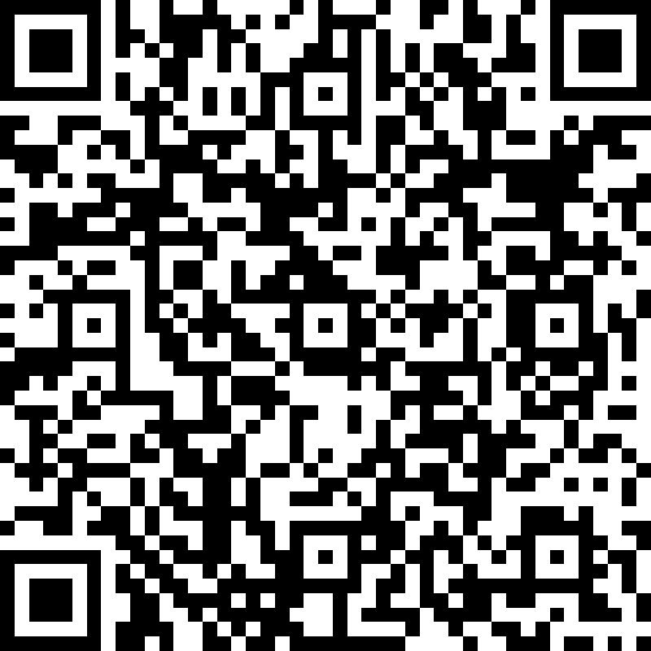  We will also share a link to the survey by email.  HELP AND SUPPORT  We are very aware that these times are very unsettling and can be very difficult for families both emotionally and financially. Please do not hesitate to contact us if you have any worries or concerns as we may be able to offer support and point you in the right direction for any support available. We want to do all we can to support our families and community. As mentioned in previous communication from the Parent Council there is also support available from there too. Please also note the help numbers/email addresses at the back of this newsletter.  ---------------------------------------------------------------------------------  HELP IS AVAILABLE  Clackmannanshire Council, the local community council and the school are keen to help support families as much as they can during this difficult time. A number of services are available;  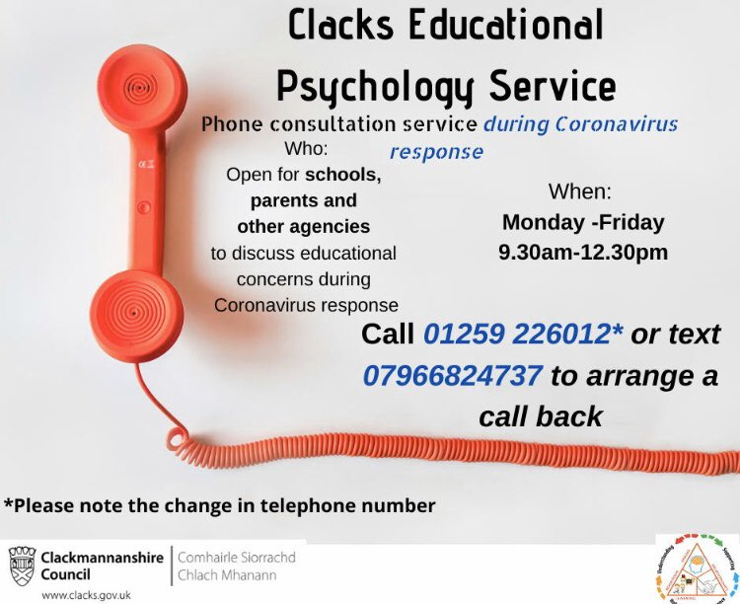  - Clacks Educational Psychology Services are offering a phone consultation service for schools, parents and other agencies. Phone lines are open Monday – Friday 9.30am - 12.30pm 01259 226012 or text 07966824737 to arrange a call back.  - Financial support is available via the Scottish Welfare Fund. Please see Clackmannanshire Council Website  - Clackmannanshire Council have dedicated pages on their website with the latest information on Coronavirus from the government and NHS. This also covers the impact on the services they provide http://socsi.in/2czV0  - Vulnerable adults are still at risk of abuse or neglect during the Covid-19 pandemic. If you see something, are told something, or something doesn’t feel right, you need to report it http://socsi.in/0kA8T  - Child Protection - What would you do if you were worried about a child's safety? Say something! Child abuse is never acceptable for any reason. And during #Covid19, it's even more important to keep eyes & ears open. Guidance & advice at http://childprotection.scot |  | VISITORS TO THE SCHOOL  As part of our risk assessment and national guidelines, can we please remind you that we cannot welcome many visitors into our school. We ask that parents continue to email the school at menstrie@edu.clacks.gov.uk if they have any queries or concerns and someone will get back to you.  BOOK SHORTAGE  Thank you so much to those who have returned school books since returning in August. Please continue to look for and return any school reading books which may be at home. Books which we are especially keen to have returned have coloured stickers on them, indicating which reading band they are from.  UPDATE FROM PARENT COUNCIL  We held our Annual General meeting on 23rd September and have now formed our new Parent Council for 2020/21. A very warm welcome to returning members and new parents and carers joining. A new chair, vice-chair, secretary and treasurer were appointed. Thanks to those taking up the posts and to those who have stood down. We look forward to working with parents, carers and the school for another academic year.  Due to current restrictions unfortunately there will be no Halloween discos this year; however we have seen some innovate ways to still have some Halloween fun -such as follow the Halloween trail (pumpkins in windows)!  Details of our next meeting will be issued in due course. However if you wish to get in touch please do email on: menstrieparentcouncil@gmail.com and follow our Facebook page where we will share information.  CONTACT DETAILS  It is even more crucial at this time that contact details are up to date. Please make the school aware of any changes to address, phone number or email address. To help avoid transferring paper etc between home and school, we will be sending most letters home by email. Please let us know if you are not receiving these so we can fix this.  CAR PARKING  Can I please remind all parents that the car park can not be used for drop offs or pick ups throughout the day. There is a disabled car parking space and this can be used by those who display a disabled badge.  ACCESS TO SCHOOL  Due to the large number of pupils we have, we do not use a one way system for children entering and leaving the school grounds. Children and parents of P1 and P2 parents can enter and leave the school using any of the main gates as restricting gates would cause congestion at certain areas. However we do ask that no children and parents use the gate which links the school and the nursery (beside where the bike racks are). We are putting a map of the school up on the school website which has the gates numbered and a video to explain the system, you will be sent a link by email when this is available. The nursery does use a one way system, all of their pupils come with a parent and the parents need to be socially distanced while dropping off and picking up. Please do not hesitate to contact me if you require any further information or would like to chat about this.  FINALLY  If at any time you have any questions or concerns, please do not hesitate to contact me.  Mandi Murray  Acting Headteacher  www.menstrie.clacks.gov.uk  Tel: 01259 760690 Fax: 01259 769188  Email: menstrie@edu.clacks.gov.uk  ------------------------------------------------------------  - Clackmannanshire Education Resources have a “parent hub” which has a particular focus on Health and Wellbeing. There is a range of supports for families, children and young people. This “parent hub” on FLIPClacks provides information on services and resources and has links to local organisations that are providing help and guidance https://flipclacks.org/  - Parent Hub Scotland - We know how hard it is for parents right now so we’re sharing tips to help keep the kids busy & make the most of this time. And we want to share your tips too! Post your ideas using #ParentClubTips & help us help other parents across Scotland. http://parentclub.scot/articles/parent-club-tips-coping-coronavirus…

