Menstrie Primary School
Newsletter
September 2020

WELCOME  We are incredibly proud of how well our pupils and families have settled back in to school and how hard our school staff and partners have worked to allow this to happen. It has certainly been a different experience from our usual return to school in August but the pupils, parent body and whole school team have been outstanding. Thank you so much.  PLAYGROUND PROCEDURES  As we begin our full fourth week back in school, we would like to thank you for your continued support and understanding during these times. Can we please remind you all of a few important procedures we have in place to help keep our children and community safe?  Firstly, only parents of Primary 1 and Primary 2 children should be in the playground, unless pre-arranged with the school.  As the playground/field is used for PE and also for outdoor learning, could we also ask that Primary 1 and Primary 2 parents try to arrive as close to 2.45/2.50pm as possible for pick up, as parents/carers arriving early, can be distracting for the children and can encroach upon teaching and learning space. If you arrive before this time, we ask that you keep outside of the gates until this time. Once in the school playground please stand up by the fence or along the side of the adventure trail, avoiding any lessons which are taking place.  Finally, please note that parents must not use the route around the back of the school to access or leave the nursery. As you may be aware, the majority of our pupils leave their classrooms from their fire doors around the back of the school. The path way for these children is a narrow route around the side of the school and there is not enough room for traffic going both ways. There have also been occasions when parents/nursery children have came round this way and have been unable to avoid PE/outdoor learning lessons which have been taking place in the school playground. Due to this, it is essential that parents do not use this route while going to or leaving the nursery. I fully understand that having to walk around the front of the school will take a little longer, however to fully meet our social distancing rules and protocols regarding adults and to avoid congestion, this has to be adhered to.  Thank you again for your patience and understanding with these matters. Please do not hesitate to contact me if you have any queries or concerns.  MEET THE TEACHER EVENT  Normally in September we would invite you in to school to see what we have been doing. As we cannot invite parents in for a ‘meet the teacher’ evening, staff are working on either videos or presentations for parents to share the information usually shared during this event. We will also be giving a presentation on the curriculum at this time and looking at pupil health and wellbeing. All of this will be available online for parents by Friday 18th September. Further information will be shared nearer the time.  SUITABLE CLOTHING  As we are trying to spend more time outdoors it is essential that pupils always come to school with a waterproof jacket and suitable clothing for all weathers. At present P.E. cannot take place indoors and we are only in for break times when it is not safe to do so. We are also continuing to build on the use of the outdoor space and outdoor learning and need to be able to do this on a regular basis.  We are unable to provide children with waterproof clothing if they have not brought their own in.  CONTACT DETAILS  It is even more crucial at this time that contact details are up to date. Please make the school aware of any changes to address, phone number or email address. To help avoid transferring paper etc between home and school, we will be sending most letters home by email. Please let us know if you are not receiving these so we can fix this.  ---------------------------------------------------------------------------------  HELP IS AVAILABLE  Clackmannanshire Council, the local community council and the school are keen to help support families as much as they can during this difficult time. A number of services are available;  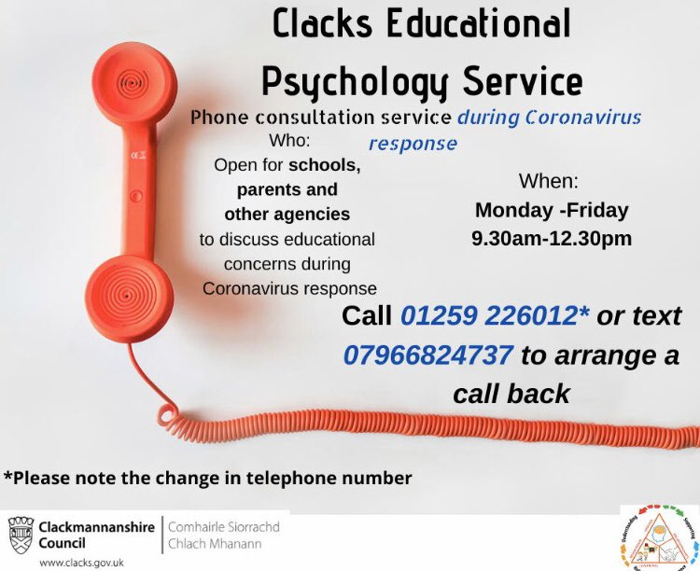  - Clacks Educational Psychology Services are offering a phone consultation service for schools, parents and other agencies. Phone lines are open Monday – Friday 9.30am - 12.30pm 01259 226012 or text 07966824737 to arrange a call back.  - Financial support is available via the Scottish Welfare Fund. Please see Clackmannanshire Council Website  - Clackmannanshire Council have dedicated pages on their website with the latest information on Coronavirus from the government and NHS. This also covers the impact on the services they provide http://socsi.in/2czV0  - Vulnerable adults are still at risk of abuse or neglect during the Covid-19 pandemic. If you see something, are told something, or something doesn’t feel right, you need to report it http://socsi.in/0kA8T  - Child Protection - What would you do if you were worried about a child's safety? Say something! Child abuse is never acceptable for any reason. And during #Covid19, it's even more important to keep eyes & ears open. Guidance & advice at http://childprotection.scot |  | VISITORS TO THE SCHOOL  As part of our risk assessment and national guidelines, we cannot welcome many visitors into our school. We ask that parents continue to email the school at menstrie@edu.clacks.gov.uk if they have any queries or concerns and someone will get back to them. Staged Intervention meetings will likely be held remotely using an online platform however there may be times when this is not possible and separate, risk assessed situations may occur.  BOOK SHORTAGE  Just before lockdown, we never envisaged that we would be out of school for this amount of time. As a result of this, many books from school were sent home or not gathered back in. We urgently need parents and pupils to search within their houses to help recover any books which may still be at home. We are missing many of our reading books and novels, and this will have implications for the reading books which we can send home. Please help us by having a thorough look at home and sending any books found back in to school as soon as possible. Thank you.  UPDATE FROM PARENT COUNCIL  A very warm welcome back to our families and huge thanks to the school for adapting the teaching and learning environment.  The Annual General Meeting (AGM) of the Parent Council will take place virtually on 23rd September at 6.30pm. This is open to all parent / carers with children at the school. Anyone attending the AGM can become part of the Parent Council for the academic year. A number of our office bearers will be stepping back including our chair who has taken in the role for the last 3 years. It is a great opportunity to get in involved in a range of activities and positive working with the school for the benefit of all children.  The agenda, log on details and information on the roles will be emailed from the school this week. However if you have any questions, queries or wish any more information meantime please email menstrieparentcouncil@gmail.com  GOOGLE CLASSROOM  Google classroom accounts are currently being set up and families and pupils will be encouraged to engage with these. It may also be used for homework. These accounts and systems are important to ensure that if there was a time when blended learning had to be accessed, we would be ready to start immediately.  FINALLY  If at any time you have any questions or concerns, please do not hesitate to contact me.  Mandi Murray  Acting Headteacher  www.menstrie.clacks.gov.uk  Tel: 01259 760690 Fax: 01259 769188  Email: menstrie@edu.clacks.gov.uk  ------------------------------------------------------------  Clackmannanshire Education Resources have a “parent hub” which has a particular focus on Health and Wellbeing. There is a range of supports for families, children and young people. This “parent hub” on FLIPClacks provides information on services and resources and has links to local organisations that are providing help and guidance https://flipclacks.org/  - Parent Hub Scotland - We know how hard it is for parents right now so we’re sharing tips to help keep the kids busy & make the most of this time. And we want to share your tips too! Post your ideas using #ParentClubTips & help us help other parents across Scotland. http://parentclub.scot/articles/parent-club-tips-coping-coronavirus…

