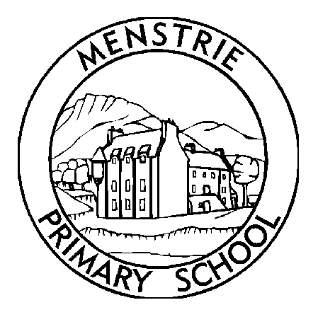
Google Classroom
Relaunch

A new Google Classroom has been set up for all pupils have been invited to join.

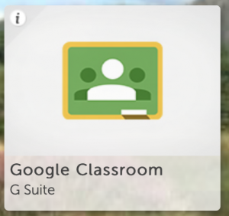
To keep the success of Google Classroom going following our return, all learners are asked to log in and complete the short weekly task posted. Over time this may develop into homework options.

Keeping this tool going is not only great for building digital literacy among learners, it is also a key part in helping us adapt to the ‘new normal’ and prepares us for any unforeseen closures.

Helpful instructions are overleaf and help videos have been made and are on the Menstrie Primary School website.

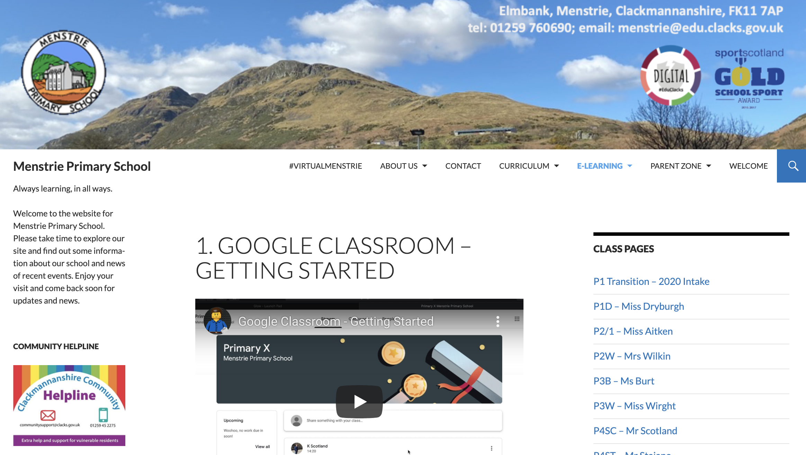

Details of the learners log-in details are below but if you are having any issues logging in or forgotten their password – don’t panic. Just send an e-mail to…
menstrie@edu.clacks.gov.uk

Kind regards,

Mr Scotland and Mr Staimo

Name: xxx

Glow Username: xxx
Glow Password: xxx
Glow E-mail address: xxx

NOTE: If using the Google Classroom App or Google Slides, enter the following as the e-mail address: xxxxx
You will then be redirected to Glow to enter your usual details above.

Pupils have signed up to a Google Classroom in school and assignments (classwork and homework) can be made available on this. Pupils log into this through Glow and can create files here too.
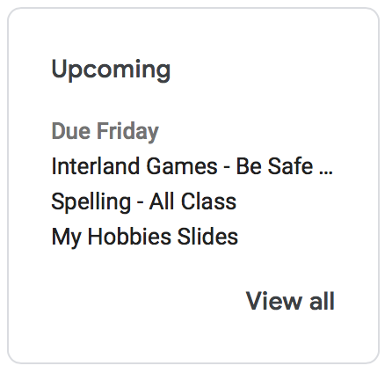
What assignments do I have?
Log into Google Classroom, click on classwork and it will show any tasks. Any assignments that are due soon will be displayed in the ‘Upcoming’ box on the left of the screen.

Where do assignments get saved?
They are saved in the Class Drive folder. To access, click on classwork then on ‘Class Drive folder’ at the top right of the page.

Two important folders are also shared with you by the class teacher. To access, click on the ‘Shared with me’ link at the left of the page.
- An individual pupil file that only you and the teacher access.
- Useful files where important documents, help sheets and letters can be saved.

Helping each other
Learners can ask each other questions under each assignment or on the classroom stream. This is our online collaborative space.

Online code of conduct
Learners are reminded of responsible internet use and comments in the classroom are monitored. Those that breach the class rules will be blocked from making comments.

Google Classroom App [FREE DOWNLOAD]
An app is available for phones/tablets. Learners only need to log in once on their device.

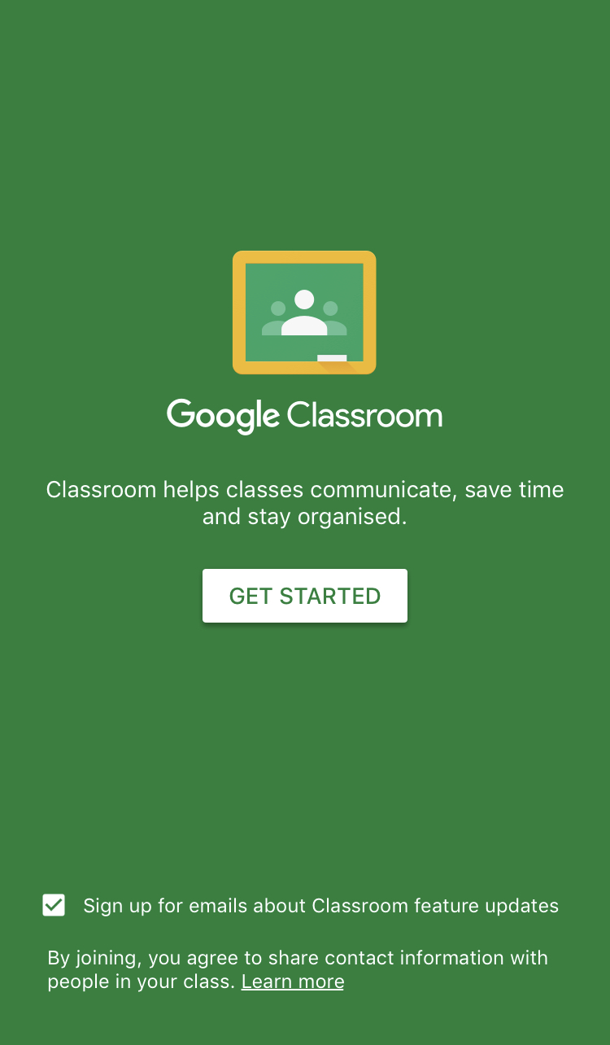 | 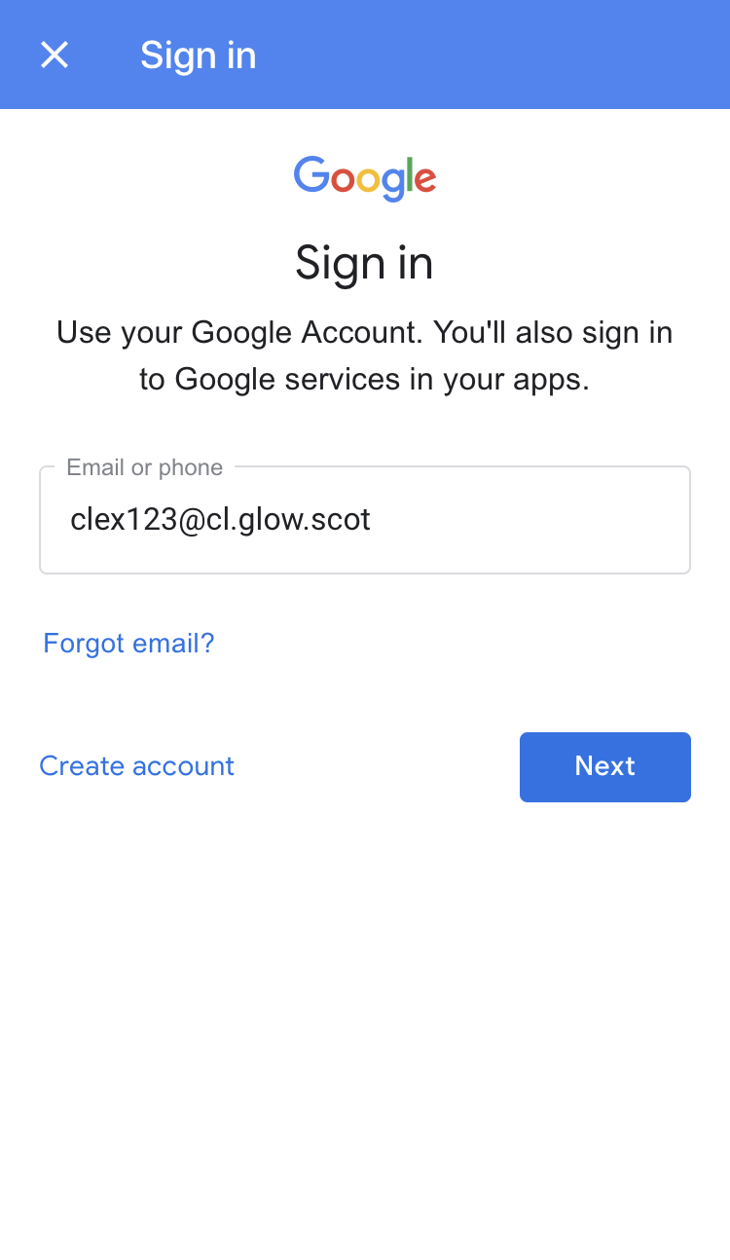 | 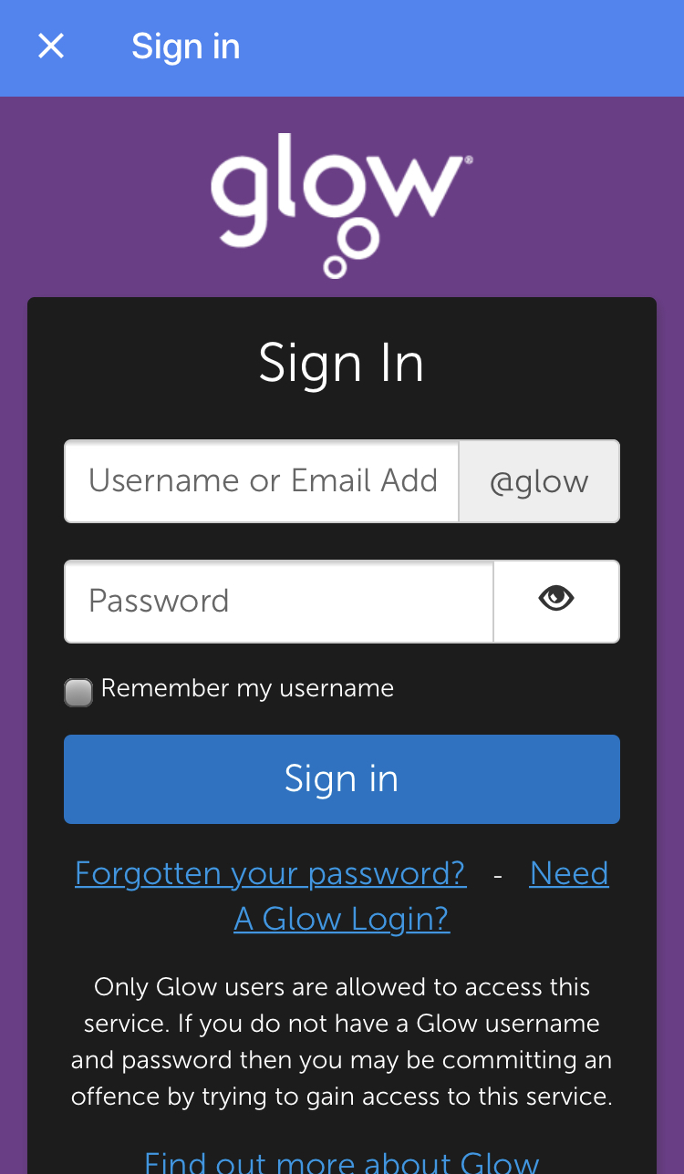
- Download the app then click ‘Get Started’. | - On the green log in page, enter your Glow username in the following format… clex134@cl.glow.scot …then click ‘next. | - You will then be taken to the Glow log in page where you should enter your usual username and password.

Further Help
Guidance and help videos have been created to cover the essentials and are available on the Menstrie Primary School website.
- Getting Started and Making a Comment
- What work do I have? and Do I have corrections?
- Completing Assignments (Creating, updating and uploading attachments)
- View ALL my completed work (using Google Drive)

