@Virtual Menstrie Presents
School Community Quiz Trail

Map

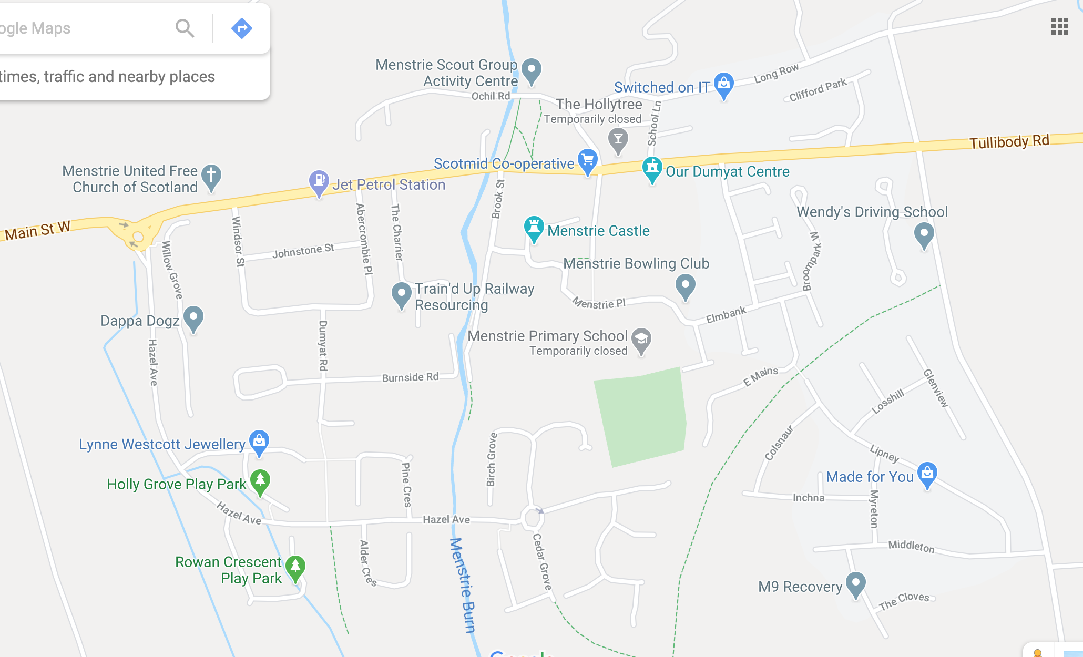
8
2
1
7
10
5
4
9
3
6

