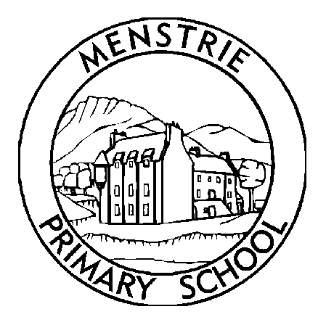
Menstrie Primary School
Newsletter
May 2020

STAFFING  As you will all know I have now returned to work from maternity leave. As I said in the short video it is far from the return to work, I expected given these unprecedented times, however I am delighted to be back and look forward to supporting our families and staff. I would like to thank all the staff for their hard work and dedication that they have shown and continue to show to our families, especially during these challenging times. A special thanks must go to Mrs Murray whom, I’m sure you will agree with me, has been a fantastic acting head and has shown excellent leadership skills throughout the past year and even more so during these recent weeks. Mrs Murray will now be working in her substantive post as Depute Head and I am delighted to let you know that Mrs Campbell will continue to work in the school as acting Depute until further notice.  SESSION 2020/2021  Due to the current COVID 19 situation it is difficult to plan ahead. We do not know what the situation is going to be with regards to COVID 19, for us as individuals, families or indeed schools in August. Bearing this in mind I feel that it is important to stress that any information given regarding class organisation, classes and teachers is very much a guide and has the potential to change in a number of ways, especially when we move into the recovery phase. Given these unprecedented set of circumstances I ask you to be mindful of this, to understand that changes will happen and to trust that we will keep you informed as quickly and efficiently as we can.  Next session (bearing in mind that changes are almost inevitable) we will have 13 classes, one of which will be a composite class. The class organisation and teachers are yet to be confirmed. We will also welcome two new probationers and wish our current probationers well as they move into new posts in August.  For P7 pupils there is a fantastic new weblink for transition to Alva Academy https://sites.google.com/cl.glow.scot/alvaacademyp7transition/home  Nursery to P1 planning is underway and school staff will be working with staff in the nursery to ensure as smooth a plan as possible. More information will follow shortly.  VE DAY  On Friday 8th May it is VE Day (Victory in Europe). This marks the 75th anniversary of the end of the 2nd World War. Friday is a bank holiday and so teachers will not be posting work for the children, although the hubs will remain open. For obvious reasons street parties, parades etc can not take place, however there are some events that you can do to celebrate at home. Join the 2 minute silence at 11,00an, join the national toast at 3pm and decorate your homes in bunting.  HELP IS AVAILABLE  Clackmannanshire Council, the local community council and the school are keen to help support families as much as they can during this difficult time. A number of services are available;  - 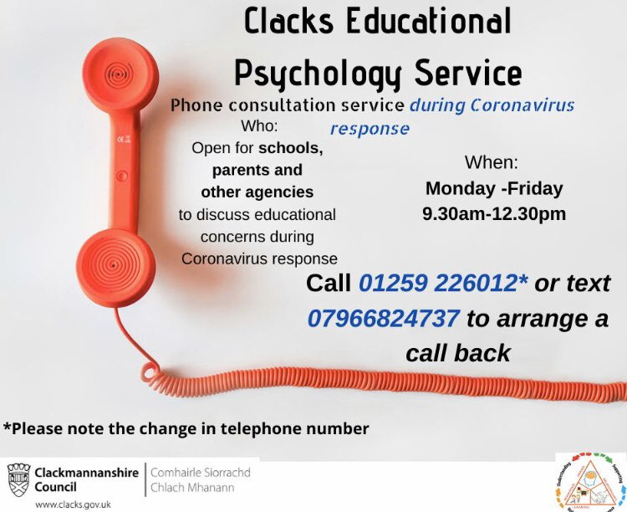  - Clacks Educational Psychology Services are offering a phone consultation service for schools, parents and other agencies. Phone lines are open Monday – Friday 9.30am - 12.30pm 01259 226012 or text 07966824737 to arrange a call back.  - Financial support is available via the Scottish Welfare Fund. Please see Clackmannanshire Council Website  - Clackmannanshire Council have dedicated pages on their website with the latest information on Coronavirus from the government and NHS. This also covers the impact on the services they provide http://socsi.in/2czV0  - Vulnerable adults are still at risk of abuse or neglect during the Covid-19 pandemic. If you see something, are told something, or something doesn’t feel right, you need to report it http://socsi.in/0kA8T  - Child Protection - What would you do if you were worried about a child's safety? Say something! Child abuse is never acceptable for any reason. And during #Covid19, it's even more important to keep eyes & ears open. Guidance & advice at http://childprotection.scot |  | ONLINE ASSEMBLIES  On Monday morning I will continue to upload a short video each week. We are also going to introduce a weekly online achievement assembly. This will follow a similar format to our normal achievement assemblies, and we hope that you will join in by watching the video and celebrating the achievements of others. The first of these assemblies will take place on Friday 15th May.  STATIONERY BOX  A box of stationery items has been put in the Scotmid. I know that many families have accessed this and whilst it has been replenished stock is running low. We are keen to ensure that we carefully follow government guidelines on social distancing, and we would ask that if you require any resources to email the school. We will then try our best to respond and ensure that any items you need are delivered to your home. This won't be an instant service as due to essential travel restrictions we can't have staff members travelling each day.  DALGUISE  Payments for Dalguise will be reimbursed from the council. Mrs Murray and Mrs Lafferty will be working on this as a matter of urgency, but please bear with us as we try to process this.  FINALLY  If at any time you have any questions or concerns, please do not hesitate to contact me.  Lisanne J Henderson  Headteacher  www.menstrie.clacks.gov.uk  Tel: 01259 760690 Fax: 01259 769188  Email: menstrie@edu.clacks.gov.uk  - Clackmannanshire Education Resources have a “parent hub” which has a particular focus on Health and Wellbeing. There is a range of supports for families, children and young people. This “parent hub” on FLIPClacks provides information on services and resources and has links to local organisations that are providing help and guidance https://flipclacks.org/  - Menstrie Community Council along with the school have been helping to provide food parcels for those who might need some support. If you would like this support or know of someone in the local community who might need this support, please contact the school via the email address.  - Parent Hub Scotland - We know how hard it is for parents right now so we’re sharing tips to help keep the kids busy & make the most of this time. And we want to share your tips too! Post your ideas using #ParentClubTips & help us help other parents across Scotland. http://parentclub.scot/articles/parent-club-tips-coping-coronavirus…

