Menstrie Primary School
Teams Chat Guide for Pupils

Pupils and teachers are able to chat to each other online using a tool called Microsoft Teams.
Your class teacher will set up the time and create the online meeting first for you.
You will be able to see and hear your class teacher. You will only be able to hear your friends however as pupils cannot use the video chat function.
This guide is useful if logging on using a laptop/computer and using sites like Google Chrome. If you have a tablet, there may be slight differences and the guide will explain what to do.

STEP 1: Log in to your glow dashboard.

STEP 2: Click on the Calendar icon.
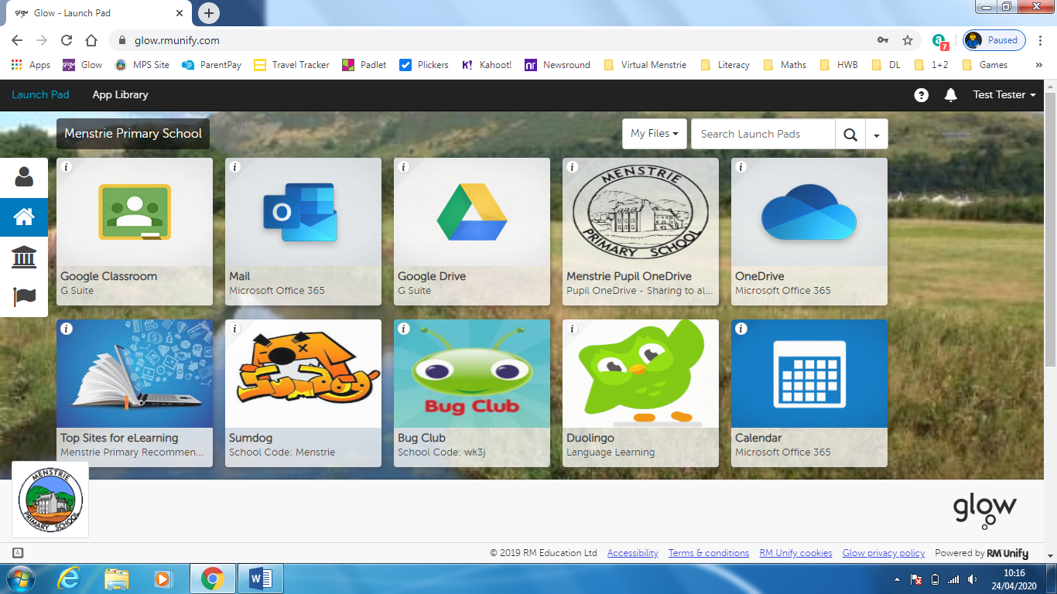

STEP 3: You will see the meeting that has been set up by your class teacher appear as below. Click ‘Join Team Meeting’.
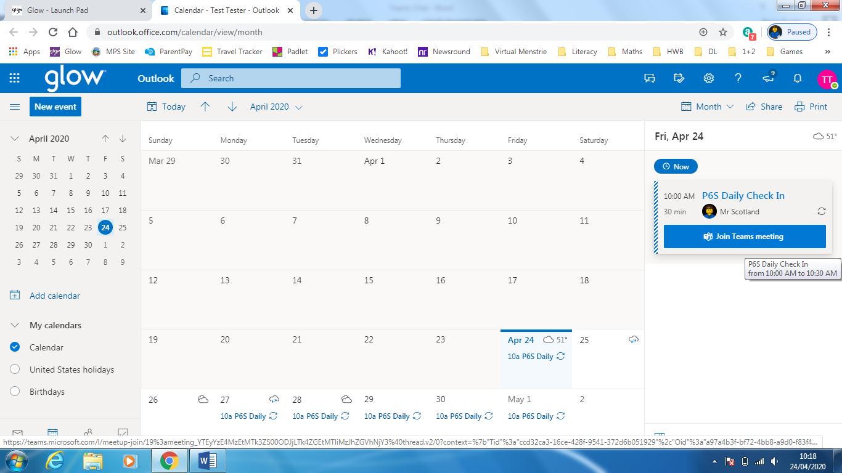

STEP 4: Click ‘Continue on this browser’. (You can download the app and log in with your glow log in details but this way is much easier).
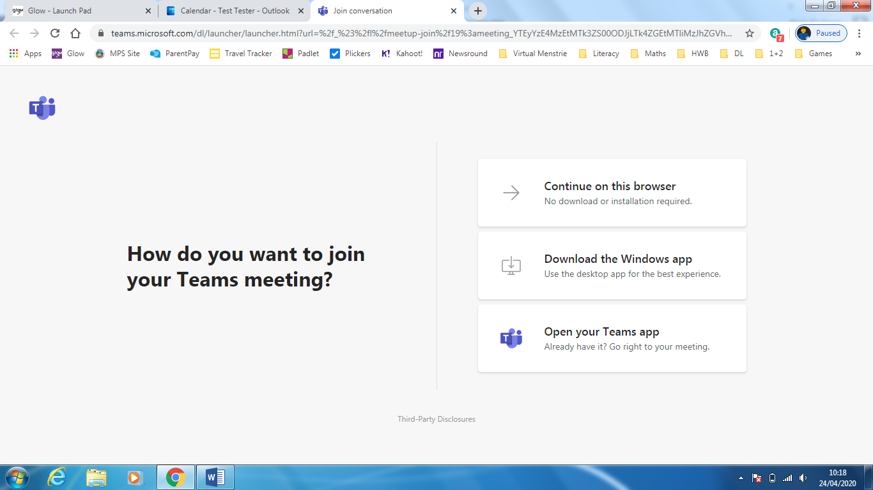
If you are logging in on a tablet/phone, you will see a message like that below. You will need to download the free ‘Microsoft Teams’ app. Download this and log in using your glow user name and password.

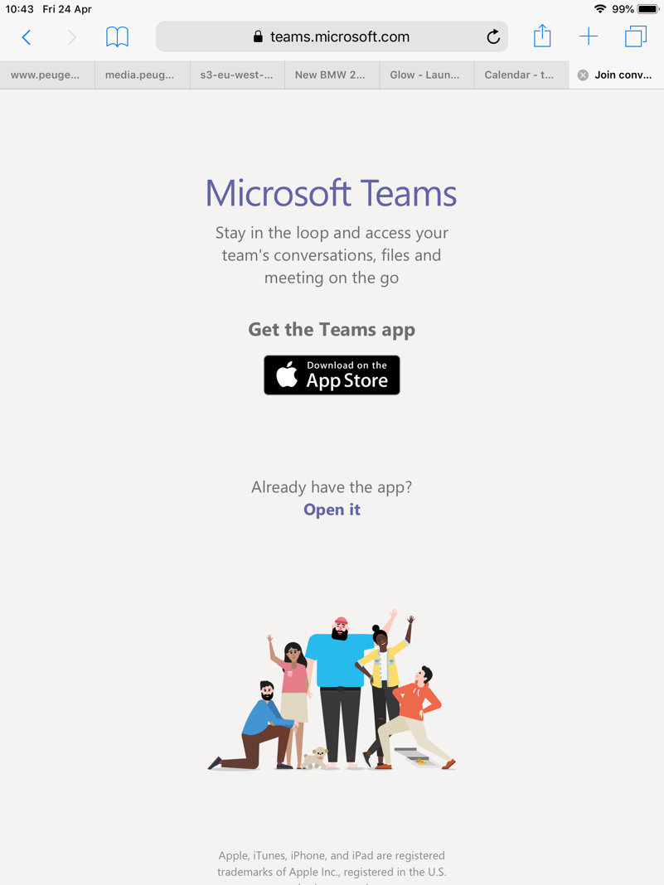
STEP 5: Click ‘Join now’ button.
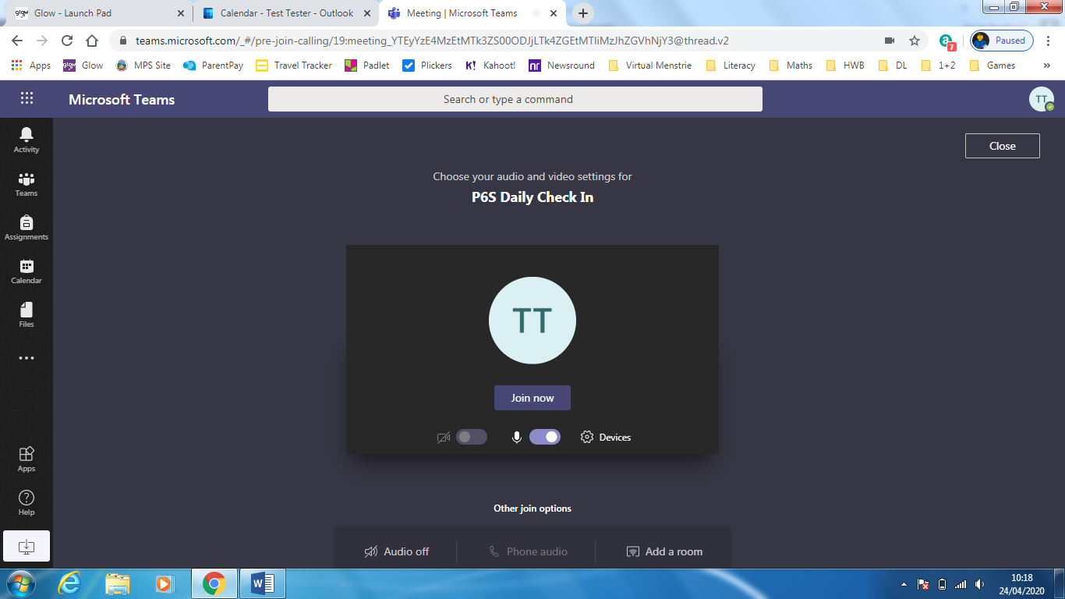

If you are logging in on a tablet/phone, your screen will look like this. Click on ‘Join’.
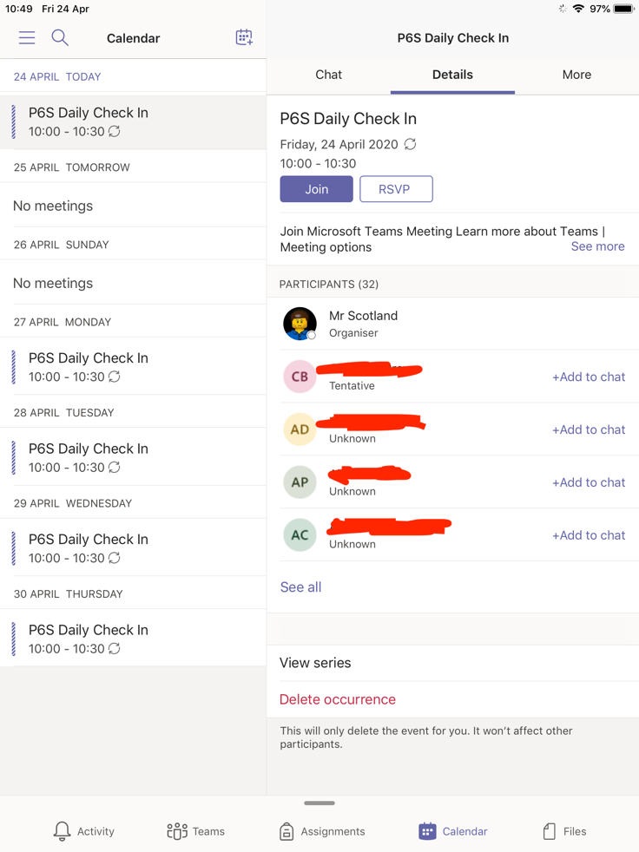
Step 6: Once in the chat, you can switch your microphone on and off by clicking on the microphone icon. To hand up, click on the red button.
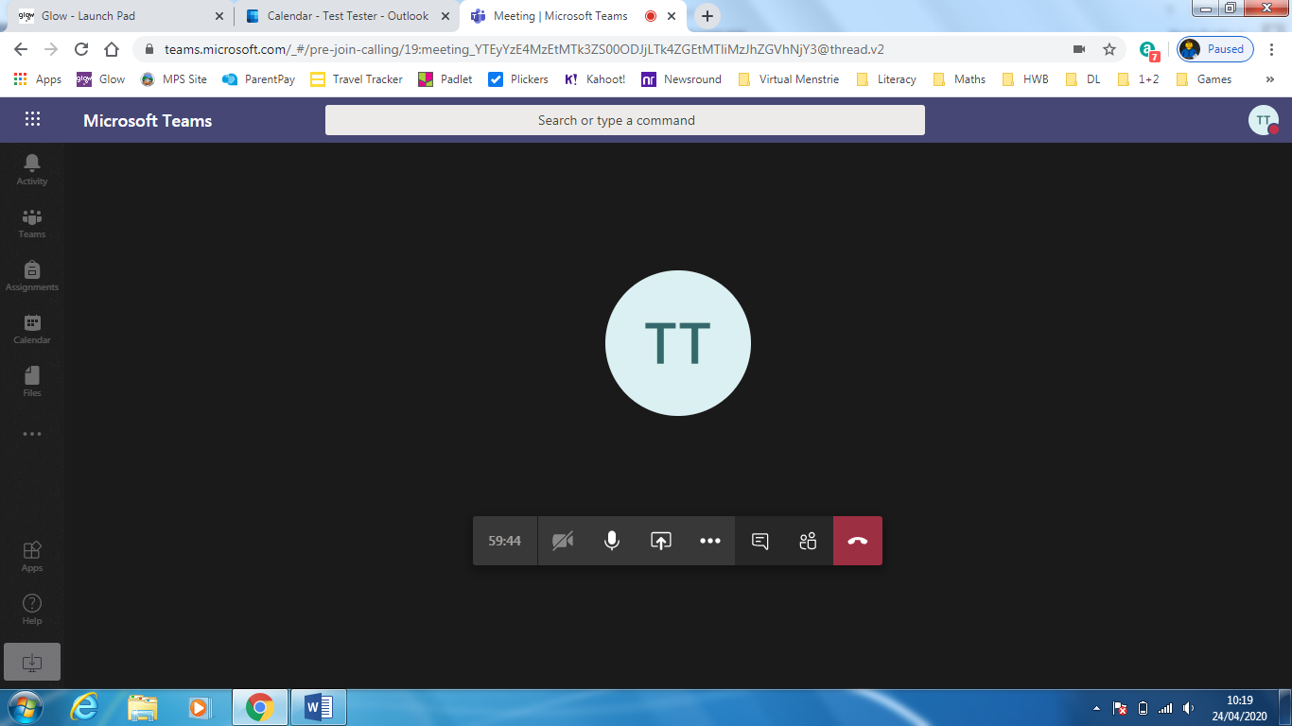

Step 7: When your class teacher joins the chat, you will see them appear on screen. They will be able to hear you but not see you.
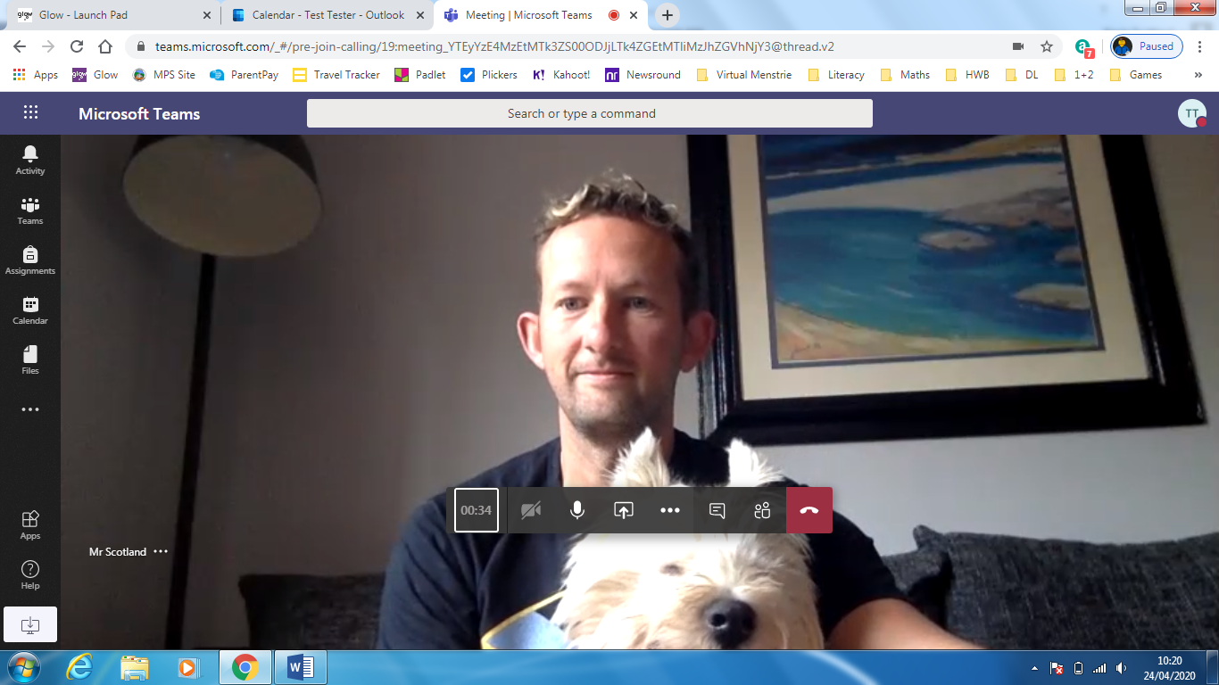

Step 7: When you are finished, click the red button to hang up and remember to log out on your device.

