Sumdog Spelling
- Log into Sumdog as normal.
- When you are at the games page, click on the ‘Tasks’ button at the left.
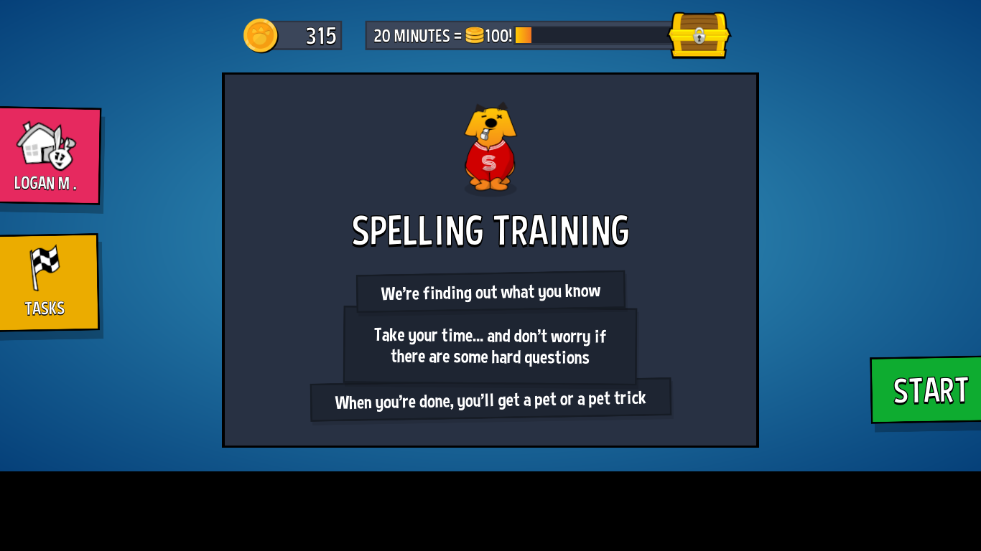

- From the list, select ‘Spelling Training’.
- Now play any game to practice spelling words.

