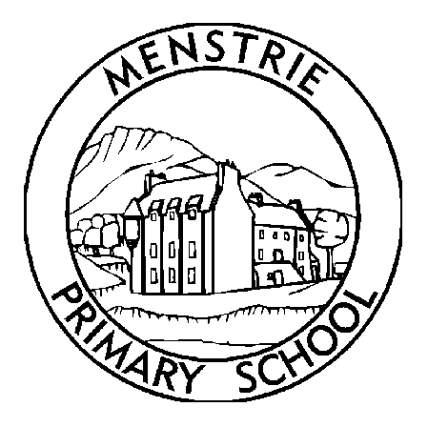
Menstrie Primary School
Newsletter
December 2018

MEDICATION AND ALLERGIES  Please could parents/carer ensure that if your child has any allergies that they inform the class teacher in writing. If medical needs change throughout the years, please let us know so that we can keep our forms updated.  Please can I also remind parents that pupils should NOT bring with them nut based products, eg Nutella, snickers bars and breakfast cereal bars which contain nuts. We have children in the school with severe nut allergies and we want to keep everyone safe.  Many thanks for your ongoing support with this.  PARENT PAY  Parent pay will be gradually introduced to Clackmannanshire Schools and letters will be distributed about this shortly. It is expected that this will go live in January.  The link below will lead you to promotional material, encouraging parents to use ParentPay:  https://www.parentpay.com/DOCH/school-support/index.html@page_id=258.html  CLICKER 7  We have recently introduced Clicker 7 to school. This is an online literacy toolkit which can help support aspects of the curriculum such as writing and reading. The school has purchased a OneSchool Site License which includes home access for pupils. If you wish your child to be able to access this from home, please ask the class teacher for a letter. The letter will contain a unique serial number which will allow you to the software from home.  CHRISTMAS LUNCH AND EARLY LUNCHES  On Friday 14th December there will be a menu change as we have our school Christmas Lunch. On this day the menu will be soup, turkey, roast potatoes, sprouts and pigs in blankets with an ice cream dessert. A vegetarian option will also be available. Please note that there is NO other choices on this day and so if your child does not like turkey then they would be best to have a packed lunch.  Over the festive season, and due to special events happening in the school pupils will have an early lunch, which means they will have lunch 15 minutes earlier than normal, on the following days.  Wednesday 12th December  Friday 14th December  Tuesday 18th December  PERIOD POVERTY  Students at schools, colleges and universities across Scotland will have access to free sanitary products as part of a £5.2m scheme to fight period poverty. Menstrie Primary School has sanitary products available in the disabled toilet in the P5 – P7 upper area. We would be pleased if parents and carers could speak with their children about this, letting them know that the products are available for them to discreetly access. P6 and P7 teachers will ensure that this is included as part of the health education programme in P6 and P7. For further information please contact Mr Pennie or Mrs Wright at the school.  More information can be found on the Council website:-  https://www.clacks.gov.uk/learning/sanitaryprov/  CHRISTMAS CHURCH SERVICE  The Church Service will take place on Friday 21st December at 9.30am. Parents and friends of the school are welcome to join us for this service. |  | BREAKFAST CLUB  Pupils are able to attend breakfast club each morning at 8.30am. It has become increasingly popular and parents must be aware that pupils are expected to have something to eat for breakfast before the children play. Pupils are able to stay in the lunch hall where the supervision of breakfast club (there is a small box of books and toys available for the pupils) or once they have eaten their breakfast pupils can go into the playground to meet up with their friends, however there is no outside supervision.  PANTOMINE  On the afternoon of Tuesday 18th December, the pantomime Aladdin will be coming to the school. Payment should now have been made for this and if pupils have not paid then it will be assumed that the pupil does not wish to attend.  CHRISTMAS PARTIES  With the exception of the P6/7 Christmas Ceilidh which takes place in the evening, all other parties take place in the afternoon at school. Pupils can bring a change of clothes with them and get changed after the lunchtime bell or pupils may wish to go home for a home lunch and get changed into party clothes. Please note that pupils going home, should bring a note for their teacher to let them know and pupils in P1 – P3 should be collected by an adult at the front door.  PARKING AND STREET CONGESTION  Please take care when approaching the school. A number of cars have been travelling very fast and also parking in inappropriate places. Recently police have been in attendance. Please take care and park safely. Please can also remind families who visit the school to be courteous of the local neighbourhood and not part across garage entrances and driveways. Local residents need to be able to access their property.  UPCOMING EVENTS  Parent Council Meeting 06/12/18 6.15pm at the Forge  P1 Show PM 10/12/18 1.30pm  Nursery Show AM 11/12/18 9.30 – 10.00 then 10.45 – 11.15  P1Show AM & PM 12/12/18 9.30am and 1.30pm  P5 Christmas Party 13/12/18 PM  Christmas Jumper Day 14/12/18 All day  SCHOOL CHRISTMAS LUNCH 14/12/18 11.45, 12.00, 12.15  P4 Christmas Party 14/12/18 PM  P3 Christmas Party 17/12/18 PM  PANTOMINE - ALADDIN 18/12/18 PM  P2 Christmas Party 19/12/18 PM  P6/7 Christmas Ceilidh 19/12/18 7.00 – 9.00pm  P1 Christmas Party 20/12/18 PM  Christmas Church Service 21/12/18 9.30am  Winter Term Ends 21/12/18 1pm  Spring Term Begins 07/01/19 9.00am  Scottish Week 21/01/19 All week  P2S Assembly 25/01/19 10.30am  P7 Assembly 30/01/19 2.15pm  FINALLY  If at any time you have any questions or concerns, please do not hesitate to contact me.  www.menstrie.clacks.gov.uk  Tel: 01259 760690  Fax: 01259 769188  Email: menstrie@edu.clacks.gov.uk  Twitter@MenstriePrimary

