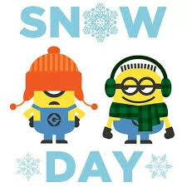
Snow Day Activities
Primary Two

Read a book to an adult. | Make an illustrated animal alphabet.  A a ape  Bb bear | Build a snowman. Write a set of instructions explaining how to build a snowman | Go on a word search around the house or in a kitchen cupboard. Write a list of words you can find on jars, tins, letters, newspapers, posters etc.
Watch at the window very quietly for two minutes. Draw the birds which you can see and write their names if you know them. | Practise writing all your tricky words with a stick in the snow. | Use buttons or pennies. How many stories of 13 can you write? 13+0=13 | Learn a short winter poem off by heart.
Go on a winter walk and collect things to make a winter picture. Make a picture. | Watch a TV programme and write down a new fact you have learned. | Count how many times you can hop in one minute? | Use a ruler. Find 5 things in your house shorter than a ruler. Draw them. Find five things longer than a ruler. Draw them.
Design and make a simple bird feeder. Hang it outside. | Find 5 different ways to make 20p. Use coins to draw them. | Go outside with a camera and take pictures that show signs of winter. How many different signs can you see? | Write a diary, remember the date and lots of information. You could add photographs and drawings too.

