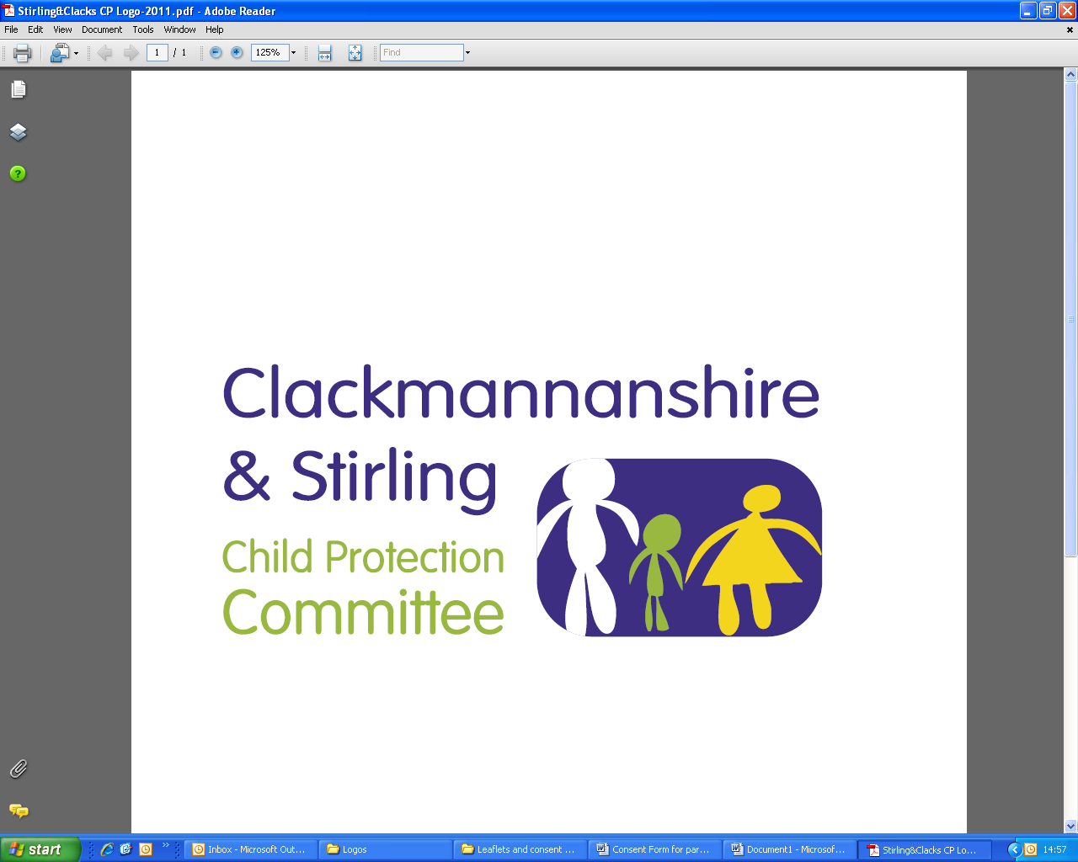
Public Protection Multi-Agency
Workforce Learning and Practice Development

Course Title: Safe & Together Briefing
This 2-hour briefing introduces the Principles and Components of Safe & Together.

The mission of Safe & Together is to create, nurture and sustain a global network of domestic abuse informed child welfare professionals, communities and systems.

Dates | Venue | Times
Friday, 16 April 2021 | Microsoft Teams | 10.00am – 12.00pm
Thursday, 27 May 2021 | Microsoft Teams | 2.00 pm – 4.00 pm
Wednesday, 4 August 2021 | Microsoft Teams | 10.00am – 12.00pm

LEARNING OUTCOMES:

  - To introduce a perpetrator pattern framework
  - To introduce and understand the Safe & Together model principles and components and how those guide practice
  - To introduce how to use the Safe & Together model as a way to enhance good practice
  - To share information about 4-day CORE Training and 1-day Overview Training

WHO IS THE TRAINING AIMED AT: Social Workers - Children, Adults and Criminal Justice, Housing Officers, Health Visitors, Midwives, Residential Social Workers, Family Support Workers, 3rd Sector, MHO’s, CPN’s, Substance Use Workers and Guidance Teachers

This course must be booked in advance and confirmation that a place has been booked will be sent via email, please make sure you have entered a valid email address.

If you require this training for your position and are a Clackmannanshire, NHS Forth Valley, Emergency Service or 3rd Sector employee please email ssld@clacks.gov.uk. If you are a Stirling employee please request your place using Erin. In all situations you will be contacted confirming your place.

