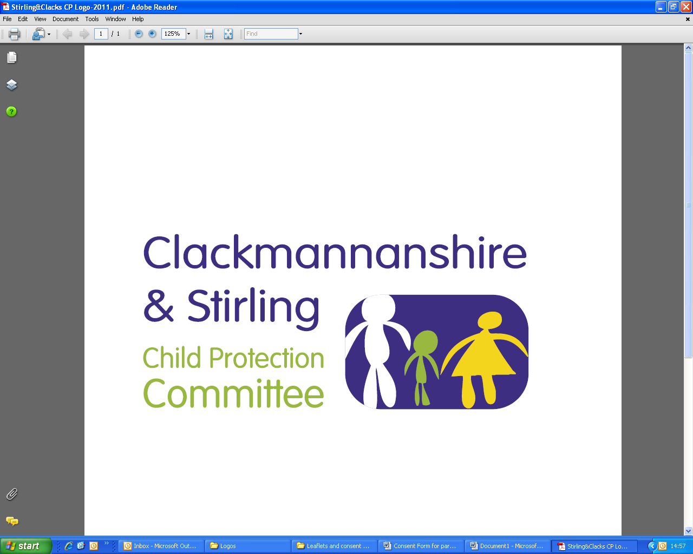
Public Protection Multi-Agency
Workforce Learning and Practice Development

Course Title: Responding to Trauma and the impact for children and young people living with Domestic Abuse

Course Aims: This course will enable participants to:

- Understand how living with domestic abuse impacts on children and young people
- Understand the impact of domestic abuse and the associated trauma in relation to child development
- Consider how practice is enhanced in understanding and responding to children & young people
- Explore practical safety planning & tools for engagement

Dates | Venue | Times
Wednesday, 19 May 2021 | Microsoft Teams | 9.30 am – 12.30 pm
Wednesday, 22 September 2021 | Microsoft Teams | 9.30 am – 12.30 pm

LEARNING OUTCOMES: After attending this course participants will have knowledge of:

- Domestic abuse as a child protection issue
- The extent to which children are exploited by perpetrators of domestic abuse
- The impact of domestic abuse on child & adolescent development
- The elements of safe practice and sensitive services to support children and young people experiencing domestic abuse
- Understanding your role in supporting children & Young people who are experience domestic abuse

THIS TRAINING IS THE AIMED AT:

- Children & Families Social Workers
- Family Support Workers
- Residential Social Workers
- Foster Carers
- Principal Guidance Teachers
- Pupil Support Workers
- Pupil Support Worker Assistants
- Early Years Practitioners

This course must be booked in advance and confirmation that a place has been booked will be sent via email, please make sure you have entered a valid email address.

If you require this training for your position and are a Clackmannanshire, NHS Forth Valley, Emergency Service or 3rd Sector employee please email ssld@clacks.gov.uk. If you are a Stirling employee please request your place using Erin. In all situations you will be contacted confirming your place.

