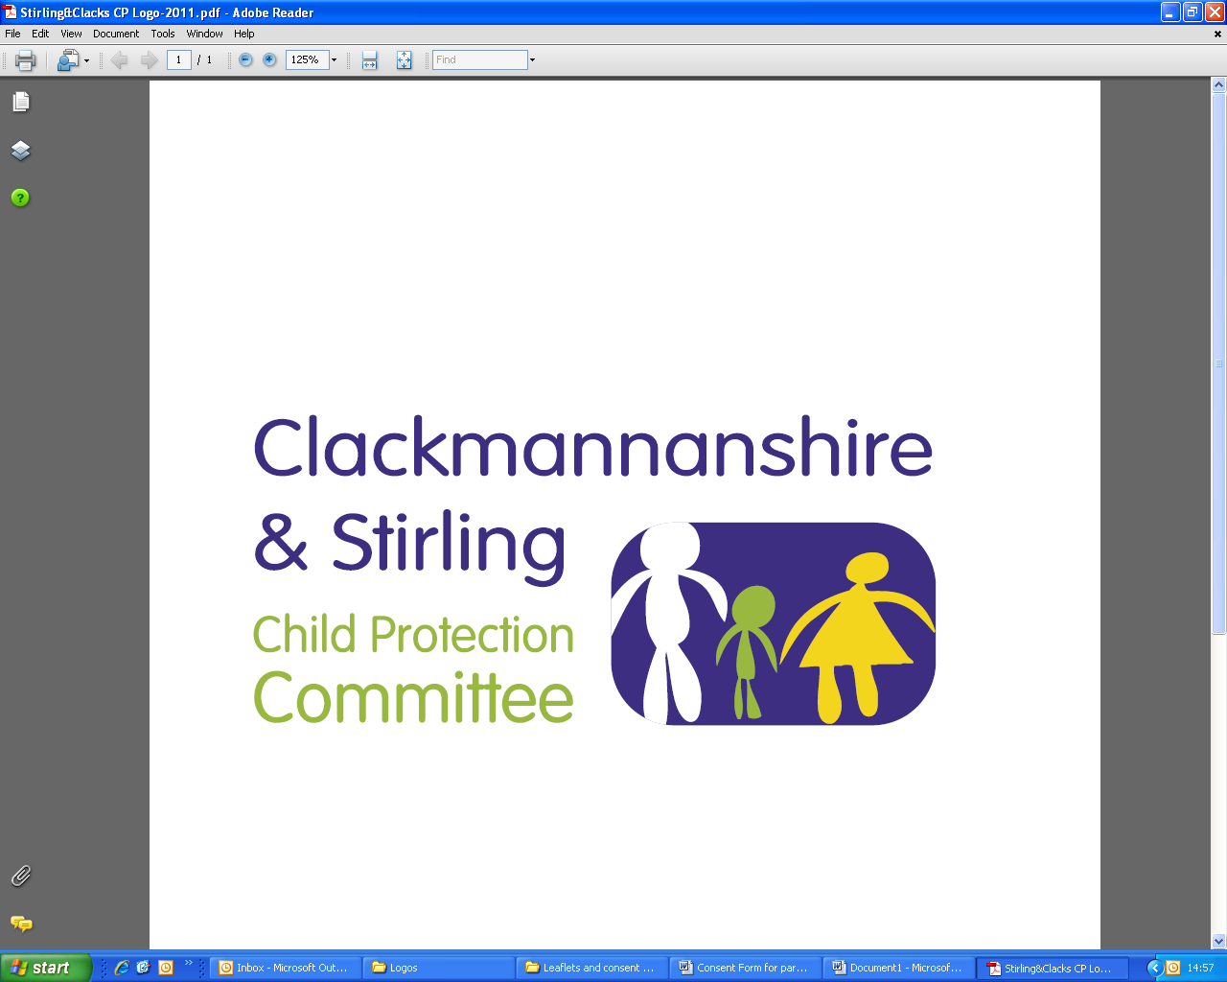
Public Protection Multi-Agency
Workforce Learning and Practice Development

Course Title: Working with Children Affected by Domestic Abuse, Parental Substance Use and Parental Mental Health issues
This session will identify the impact on children and young people of living in situations of domestic abuse, parental substance use and parental mental health issues, including child protection concerns.
Applicants must have previously completed Intra-Agency Child Protection Processes Roles and Responsibilities training.

This training will be delivered using Microsoft Teams. You will need to ensure you can access Microsoft Teams and your computer/tablet has a webcam and a microphone.

Dates | Venue | Times
Tuesday, 11 May 2021 | Microsoft Teams | 10.00am – 2.30pm
Thursday, 16 September 2021 | Microsoft Teams | 10.00am – 2.30pm

LEARNING OUTCOMES: After attending this course you will:

- to give attendees a greater knowledge of domestic abuse, parental substance use and parental mental ill health issues
- to develop a greater understanding of how these issues impact on children and young people
- to identify links between these issues and child protection concerns

WHO IS THE TRAINING AIMED AT:

- Health Visitors | - Midwives
- Children’s Social Workers | - Substance Use Workers
- Residential Social Workers | - Education - promoted posts
- Family Support Workers | - Foster Carers
- Early Years Practitioners | - Housing Officers
- 3rd Sector

This course must be booked in advance and confirmation that a place has been booked will be sent via email, please make sure you have entered a valid email address.

If you require this training for your position and are a Clackmannanshire, NHS Forth Valley, Emergency Service or 3rd Sector employee, please email ssld@clacks.gov.uk. If you are a Stirling employee please request your place using Erin. In all situations you will be contacted confirming your place.

