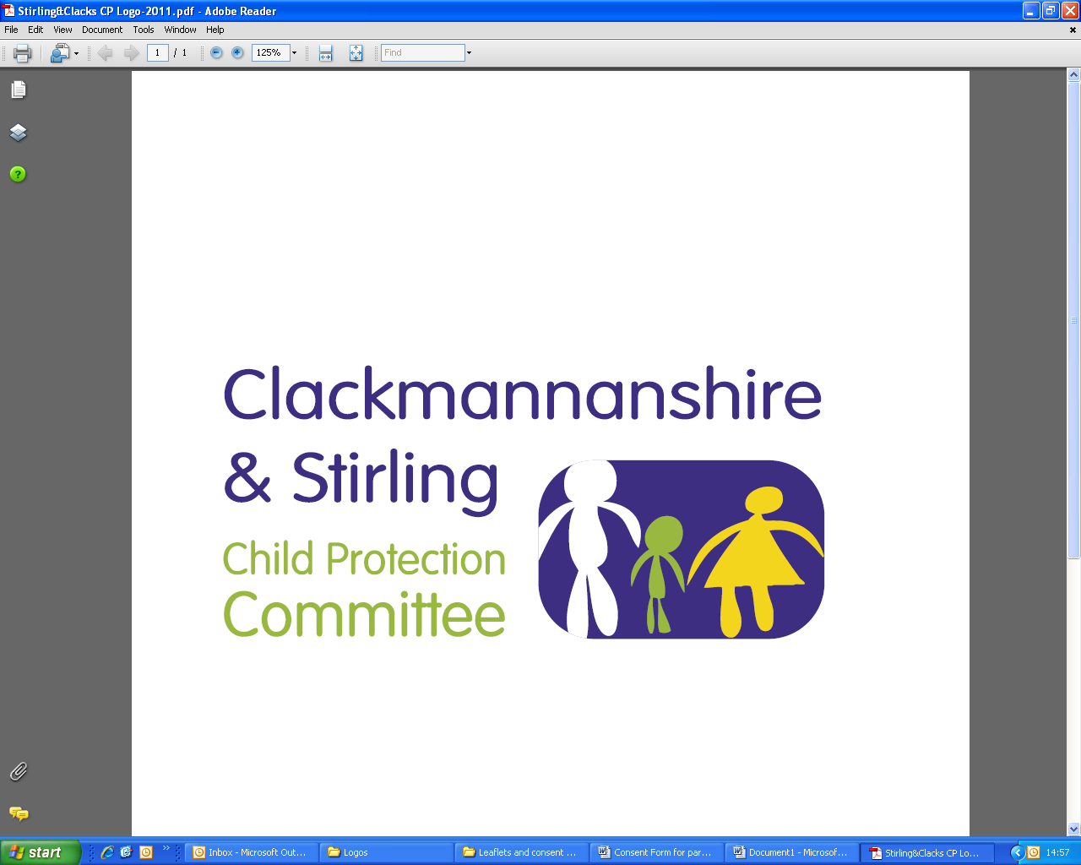
Public Protection Multi-Agency
Workforce Learning and Practice Development

Course Title: Protecting Children and Young People with Disabilities
This course aims to highlight the vulnerability of disabled children and support practitioners when there are concerns about neglect or harm. Disability awareness and effective communication go hand in hand with ensuring these children and young people are safe. The training is co-facilitated in partnership with Action for Children. As you will appreciate there is a lot of information that needs to be disseminated. Therefore two weeks prior to the training pre course reading will be emailed to you which we would ask you to complete prior to the attending the training.

Dates | Venue | Times
Friday, 30 April 2021 | MS Teams | 9.30am – 12.30 pm
Monday, 30 August 2021 | MS Teams | 9.30am – 12.30 pm

LEARNING OUTCOMES:

By the end of the training you will be able to;

- Describe the specific vulnerabilities of disabled children
- Have an understanding of the evidence from research
- Identify barriers to disclosure and detection
- Apply ways to minimise vulnerability
- Use skills in engaging with children and young people
WHO IS THE TRAINING AIMED AT?

- Foster Carers | - Youth Workers
- Social Workers | - School Nurses
- Family Support Workers | - 3rd Sector Partners
- Pupil Support Assistants | - Health Visitors
- Special Needs Teachers
- Learning Support Workers

This course must be booked in advance and confirmation that a place has been booked will be sent via email, please make sure you have entered a valid email address.

If you require this training for your position and are a Clackmannanshire, NHS Forth Valley, Emergency Service or 3rd Sector employee please email ssld@clacks.gov.uk. If you are a Stirling employee please request your place using Erin. In all situations you will be contacted confirming your place.

