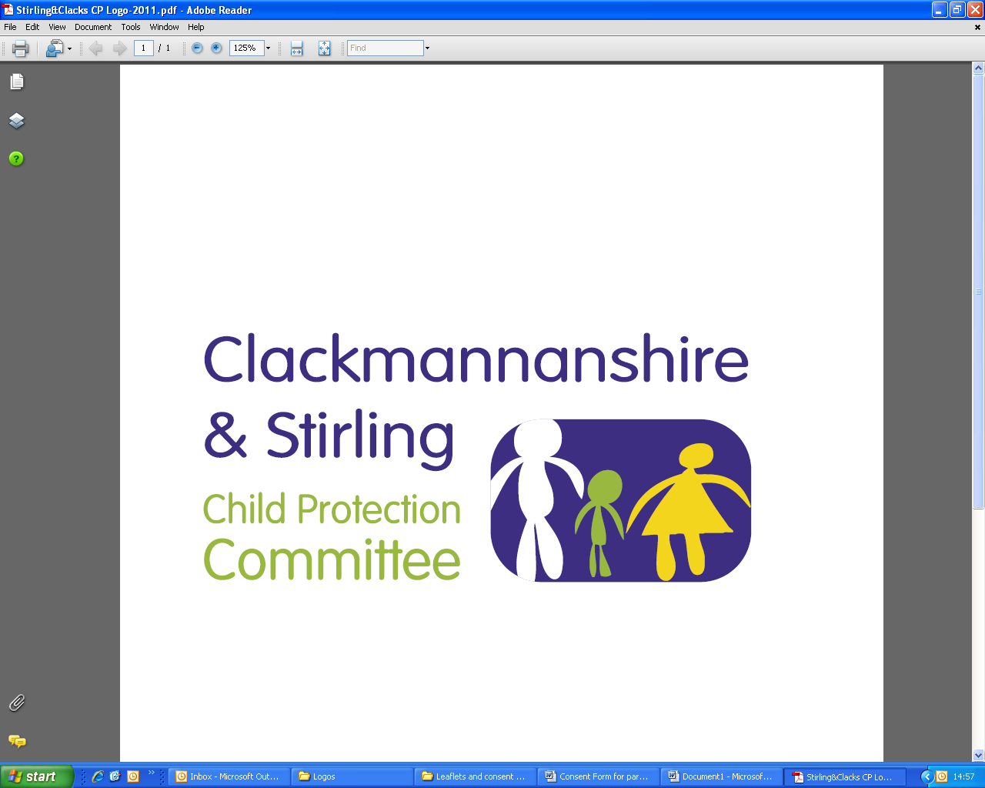
Public Protection Multi-Agency
Workforce Learning and Practice Development

Course Title: Child Protection for the General Contact Workforce
This training is also available online as a refresher through e-learning. This course is to be completed online every 2 years.

The general contact workforce is defined as those who, as part of their job are likely to
come into contact with children and young people.

Dates | Venue | Times
Tuesday, 13 April 2021 | Microsoft Teams | 2.00 pm – 4.00 pm
Friday, 7 May 2021 | Microsoft Teams | 10.00am – 12.00pm
Wednesday, 16 June 2021 | Microsoft Teams | 10.00am – 12.00pm
Monday, 12 July 2021 | Microsoft Teams | 2.00 pm – 4.00 pm
Friday, 27 August 2021 | Microsoft Teams | 10.00am – 12.00pm
Monday, 27 September 2021 | Microsoft Teams | 2.00 pm – 4.00 pm

LEARNING OUTCOMES: After attending this session you will:

- develop an awareness of the national policies and local procedures in child protection
- Know how to recognise the signs and indicators of child abuse and neglect
- have an understanding of your role in child protection and be aware of the referral process and how to report concerns/disclosures

WHO IS THE TRAINING AIMED AT: The target audience is staff from all agencies that may come into contact with children/young people or are involved with their parents/carers as part of their duties. For people who have not had any previous child protection training or who are in need of a refresher.

This course must be booked in advance and confirmation that a place has been booked will be sent via email, please make sure you have entered a valid email address.

If you require this training for your position and are a Clackmannanshire, NHS Forth Valley, Emergency Service or 3rd Sector employee please email ssld@clacks.gov.uk. If you are a Stirling employee please request your place using Erin. In all situations you will be contacted confirming your place.

