Supporting Bereavement Planning as Part of the COVID 19 Response

Education Guidance for Establishments

April 2020

CONTENTS
Foreward | p. 3
- Preparation of Staff | p. 4
- Information Sharing | p. 4 - 5
- Communication with Centre Staff | p. 5
- Communication with the Media | p. 5
- Ongoing Support for Families | p. 6
- Other sources of support | p.6
- Ongoing Monitoring and Supports when Schools Return | p. 7
- Resources | p. 9

FOREWARD
With regret, the next phase of the Education Service’s response to COVID 19 needs to be preparation for the loss of members of the community to the virus and other related factors, and the impact this will have on families and staff.
Deaths in our community due to COVID 19 will be particularly challenging because they will have happened very suddenly, families may have been separated at the time of death, families are isolated from their normal support networks and the usual process of saying goodbye will be very restricted with funerals taking in a very different format. Furthermore, several families may be impacted by loss so the ‘specialness’ of a child’s important person dying may not receive as much attention as before the crisis.
It is also important to note that an increase in deaths associated with Covid-19 but not as a direct consequence of it, is expected. Sensitively, we need to prepare for these deaths occurring in our community by taking the following actions outlined in the remaining sections of this Guidance.

- PREPARATION OF STAFF
All senior leaders should familiarise themselves with the following resources and be ready to share them with affected staff members and parents at an appropriate time.

Specific advice about COVID 19 deaths:
www.winstonswish.org/telling-a-child-someone-died-from-coronavirus/
This has lots of phrases to help support a conversation.

www.cruse.org.uk/coronavirus/children-and-young-people

More general advice about bereavement and loss in children:
www.cruse.org.uk/get-help/for-parents
This has separate tiles to support understanding of the grieving process.
There are also further resources available on the CLPL Google Classroom under ‘Bereavement and Loss’

General advice about bereavement and loss for adults:
https://www.cruse.org.uk/get-help/about-grief

- INFORMATION SHARING
Contact should be made with the family and condolences shared. If the family give permission, news can be further shared within the school community if appropriate.

Due to school closures alternatives to goodbye could include ideas from this website:
www.winstonswish.org/coronavirus-funerals-alternative-goodbyes/ .

Families may also wish to be guided through these options as they plan goodbyes.

www.nelsonsjourney.org.uk/covid-19-funeralguidance/ has suggestions.

Tribute pages are one way a school could co-ordinate a response to the loss of members of the community during school closures. An example of one way to structure such a tribute is provided below from Winston’s Wish:
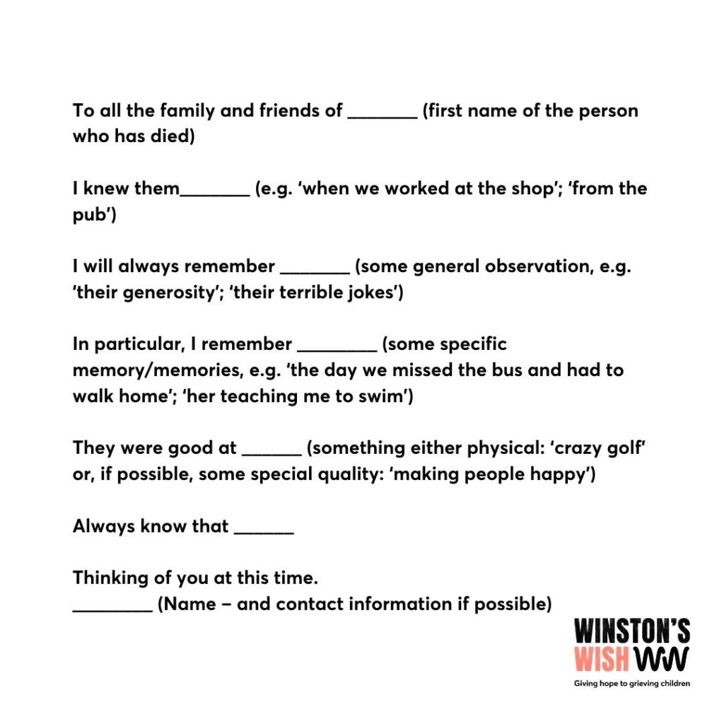

- COMMUNICATION WITH CENTRE STAFF
Centre staff should be informed immediately by establishments as soon as they know about the death of a pupil, parent or member of staff. Centre staff should then be regularly updated about the situation as further information becomes available.
Please ‘phone either Lynda McDonald on 07853 414 212 or Cathy Quinn on 07540 467 781 during the lockdown.

- COMMUNICATION WITH THE MEDIA
Any media queries or requests for interviews or comment relating to any Covid-19 deaths should be directed to the Communications Team who will, if appropriate, issue a statement on behalf of the establishment. The Communications Team can be contacted on press@clacks.gov.uk.

- ONGOING SUPPORT FOR FAMILIES
The most effective support is delivered by adults well known to the child and family so families should be allocated a liaison member of staff well known to them. This member of staff needs to have read the above resources in Sections 1 and 2 of this guidance and check in regularly with the family to support their emotional health and wellbeing and be responsive to their needs.

The Educational Psychology Service will be working with the Education Authority to support the wellbeing of staff, children and families through these difficult times.

Further advice and support can be sought from the Educational Psychology Service Telephone Consultation Service every morning from 9.30-12.30 on 01259 226 012.

- OTHER SOURCES OF SUPPORT

There are resources available at FLIPClacks.org in the COVID-19 Parent Support Hub for parents and on the CLPL Google Classroom for staff wishing to learn more about bereavement and loss.

These websites also contain lots of helpful information

Child Bereavement UK 0800 02 888 40 support@childbereavement.org
Winston’s Wish 08088 020 021 ask@winstonswish.org also an online chat forum on a Wednesday and Friday 12-4pm
Cruse 0808 808 1677 helpline@cruse.org.uk
Hope Again is at hopeagain@cruse.org.uk
Grief Encounter 0808 802 0111 web chat at www.griefencounter.org.uk grieftalk@griefencounter.org.uk

There are 2 apps to support bereavement:
Smiles and Tears This is from Nelson’s Journey developed alongside Children in Need. It has a place to store memories and get support with feelings.
Apart of Me This is a game designed to help you cope with the death of a loved one.

Supporting bereaved pupils will be very stressful for staff who may already be struggling with their own reactions and emotions. All adults supporting children and young people need to look after themselves and practice self-care. Specific support to help staff members deal with feelings of grief and loss can be found at:

PAM Assist - 24/7 on 0800 882 4102 or via www.pamassist.co.uk

Wellbeing Scotland Services for Adults – 01324 630100 or text 07912 759 655 for a call back, email info@wellbeingscotland.org or find them at www.wellbeingscotland.org , www.facebook.com/WellbeingScotland/
and twitter.com/wellbeingscot

- ONGOING MONITORING AND SUPPORT WHEN SCHOOLS RETURN
Children and staff members affected by loss during the school closures will have further feelings of grief as they reconnect with their peers and compare experiences. Consideration needs to be given to a slow reintroduction to school to re-establish connections, re-establish routines and give time for sharing of experiences over the Covid 19 school closures. Thought should be given as to how any experiences of loss can be acknowledged as a school community if appropriate, for example a memory wall. In addition, particular groups of children and staff may be more vulnerable to the effects of the school closures due to adverse life experiences and may need ongoing monitoring and support.

It will be appropriate to consider the use of universal curricular programmes to address grief and loss for all pupils (see Resources section below), as well as more targeted interventions for any children and young people who are specifically affected by these issues and / or such as peer-education programmes like Seasons for Growth or individual therapeutic interventions such as counselling or trauma-focused therapy like EMDR.

Finally, a trauma recovery plan is being developed to help schools support all pupils, parents/ carers and staff when a return to school is possible and will be available from May 2020. In the meantime, further advice can also be sought from the Educational Psychology Service on 01259 226 012.

- RESOURCES
Below are a list of resources that schools may wish to purchase/explore. A Curricular programme is being developed by Clacks and will be available soon.
 | Pre School | Primary | Secondary
Books | When Uncle Bob Died Althea  Amazon ISBN 978-1405219013  Dear Grandma Bunny Dick Bruna  Amazon ISBN 13: 978-0953912360  When Someone Very Special Dies  Marge Heegard  Amazon ISBN 978-0962050206  Always and Forever  Alan Durant  Amazon ISBN 978-0552567657 | Muddles, Puddles and Sunshine  Diana Crossley  Amazon ISBN 13: 978 - 1869890582.  The Invisible String  Patricia Karst  Amazon ISBN 13: 978-0875167343  Beginnings and Endings  with Lifetimes in Between  Mellonie and Ingpen  Amazon ISBN 13: 978-1855617605  Death: What's Happening?  Karen Bryant- Molee  Amazon ISBN 13: 978-0750213790.  What on Earth do you do when Someone Dies?  Trevor Romain  Amazon ISBN 13: 978-1575420554 | Finding a Way Through When Someone Close has Died  Mood & WhittakerAmazon  ISBN 13: 978-1853029202.A workbook  Grief Encounter  Shelley Gilbert  Amazon ISBN-13: 978-0954843403  Flamingo Dream  Donna Jo Napoli  Amazon ISBN 13: 978-0688167967  The Charlie Barber Treatment  Carole Lloyd  Amazon ISBN 13:978-0744514889.  The Lost Boys Appreciation Society  Alan Gibbons  Amazon ISBN 13:978-3425048512
Apps |  | Smiles and Tears (from Nelson’s Journey developed alongside Children in Need. Place to store memories and get support with feelings.  Apart of Me A game designed to help you cope with the death of a loved one. | Smiles and Tears (from Nelson’s Journey developed alongside Children in Need. Place to store memories and get support with feelings  Apart of Me A game designed to help you cope with the death of a loved one.
Online |  | Grief Encounter are running sessions for bereaved families on Instagram. | Hope Again film from teenagers who have experienced loss https://youtu.be/LIWQ0mPAc6E  Other films at www.hopeagain.org.uk/hope-again-videos  Grief Encounter are running sessions for bereaved families on Instagram.
Curriculum support |  | Bespoke curriculum plans on bereavement are also being produced within Clackmannanshire  Childhood Bereavement: Developing The Curriculum and Pastoral Support.  Good Grief – Exploring feelings, loss and death with under 11s  B Ward  Amazon ISBN 13: 978 - 1853023248.  A Teacher’s Handbook of Death  Jackson and Colwell  Amazon ISBN 13: 978 – 1843100157 | Bespoke curriculum plans on bereavement are also being produced within Clackmannanshire  Supporting Young People  Coping with Grief, Loss and Death  Weymont and Rae Amazon ISBN 13: 9781412913126  A Resource Bank on Loss and Grief: ‘It hurts' M Harveywww.lulu.com ISBN: 978-090795064.11 photocopiable resources  Childhood Bereavement – Developing the Curriculum and Pastoral Support  Job and Francis  Amazon ISBN 13: 978 – 1904787143

